ENGR132: Transforming Ideas to Innovations II

(Title of the Project)

Project Deliverable 1

Index | Name | ID | Major | Section
1
2

(Course Professor)

Date: XXX
Fall 2020


Abstract (200 – 350 Words):

The sustainability of agriculture lies in optimizing the use of water through novel technologies. A prototype built around a microcontroller with the moisture sensor connected with Liquid Crystal Display (LCD) and other peripheral components helps mitigate the challenge of reducing water consumption during the irrigation process. The Fritzing software results indicate the practical implementation of such a project in real life for agricultural benefits. Arduino sketch contains the variable that reads the analogue state of the moisture sensor where the if-else conditional statement activates to trigger the LED and Buzzer used for user feedback. It works effectively by the Green LED activated when the moisture content is above the 25% threshold; otherwise, the RED LED and Buzzer activates to alert the need to irrigate the farm. The benefit of such a system is that it helps the farmer decide whether to water the plants or not based on the present moisture content. Additionally, this report presents the standards, constraints and various recommendations for improving this project for future sustainability.

Contents

1. Introduction (100 – 250 Words): 6
2. Proposed solution 7
2.1. Solution details 7
2.2. Constraints 8
2.3. Standards 10
2.4. Flowchart 10
2.5. Solution Algorithm 11
3. Detailed inputs and outputs used 12
4. Conclusion 13
5. References 13

- Introduction (100 – 250 Words):

Food is an essential and universal need inherent to our survival as human beings. The process of producing such food, Agriculture, serves as the most contributor to any nation’s GDP worldwide. The sustainability of such an industry lies in using technology to manage the existing resources, especially water. A soil monitoring system allows the farmer to minimize and optimize the irrigation water by introducing electronically-controlled systems that check the current state of moisture and activate the pumps used to irrigate large and small farms. The use of such technology reduces the workload of farmers by allowing the system to work autonomously without any human intervention. On a global scale, implementing such a system offers the benefit of saving the environment by reducing water consumption while attaining the millennium goals such as industry, innovation & Infrastructure.
This agricultural-themed idea aims to develop a working prototype that monitors and detects the moisture content in soil to activate pumps that allow the flow of water through irrigation. Additionally, it involves explaining the real-life constraints associated with producing the prototype for farmers worldwide by categorizing them as either functional, ethical, economic, quality and aesthetically related. Also, it presents the required technical requirements needed to meet the local, regional and international standards.

- Proposed solution

Solution details
The solution lies in developing a monitoring system with combined features of moisture sensing plus other complementary functionalities. It involves using a microcontroller with processing capabilities that act as the brain of the project. Arduino U.N.O., the used microcontroller, acquires the moisture sensing plus actuating the controls for the pump operations. The advantage of this approach is that it is very cheap compared to other alternative such as embedded systems like STM32 or other microcomputers like the Raspberry Pi 3+. Also, since the Uno acts as the transmitter and receiver by taking inputs from the moisture sensor and activating the pump output, it simplifies the circuit architecture. Additionally, the same topology offers flexibility when expanding the circuit to handle complex functionalities like acidity & salinity assessments using Artificial Neural Networks or other sensors like the DHT11 for monitoring humidity and temperature. Also, with the inclusion of sophisticated technique, the system allows weather forecasting and image processing that complements the intelligent irrigation or soil monitoring system.
The moisture sensor sends the analogue input to the Arduino U.N.O. microcontroller; then, it activates the irrigation system based on a threshold. The map() function uses the analog_Read value from the sensor from 0-100%; then, the if-else conditional statement triggers the Red LED while the buzzer sets the tone. Additionally, it displays the moisture content using a Liquid Crystal Display (LCD) based on the connected Enable, Digital Output pins, Read/Write.

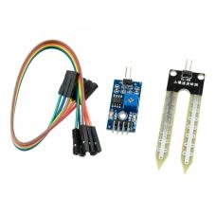
Figure illustrating: A soil moisture sensor.

Constraints
- Functional Constraints
The soil monitoring system lacks an L293D module for activating the pump (motor control) that helps in irrigating the farms. Instead, it only contains an LED and buzzer for visual and audio-sensory feedback.
- Safety Constraints
The system lacks an external power supply to ground all loose electrical connections while powering up the module through the VCC module. There any mishandling can result in possible electronic damage.
- Manufacturing Constraints
This system lacks a 3-D printed enclosure that houses all the electronic components and the necessary external power supply. In contrast, the current prototype only draws power from the host computer using the USB Type B.
- Economic Constraints
The price of the Arduino Uno R3 limits the profitability of such a system in a real-life scenario making it hard to produce mass units.
- Quality Constraints

Standard is a difficult thing to meet in producing the soil monitoring system that limits the scale of operations of the team.
- Aesthetic Constraints
The lack of a 3-D printed enclosure for housing the electrical connections using jumpers and wires makes the project clumsy that undermines the aesthetic visual outlook of this project.
- Legal/Ethical Constraints
The ethical need of meeting this project demands the adherence of philosophies of autonomy, disclosure, beneficence, Nonmaleficence, justice and utilitarianism.
- Sustainability
The estimation of the lifespan of such a module is a mystery because of the assembly of various electronic components used in this project.
- Timing Constraints
The delays used in the software configuration process is a concern since such estimations are only arbitrary constants without a basis on the mathematical calculations.

Standards
- Local standard
KNAUF SS7G5 defines the schemes and protocols of the measurement techniques and sensors when utilizing, comparing and merging the soil spectroscopy
- Regional standard
GRSS/SC 11073 outline the guidelines for multi-sensor monitoring schemes using the sensors.
- International standard
IEEE P4005: The protocol defines the standards and schemes for measuring and working with sensors, especially when utilizing various soil libraries, comparing and merging them. It also provides the measurement scheme before quantitative assessments and data manipulation.

Flowchart

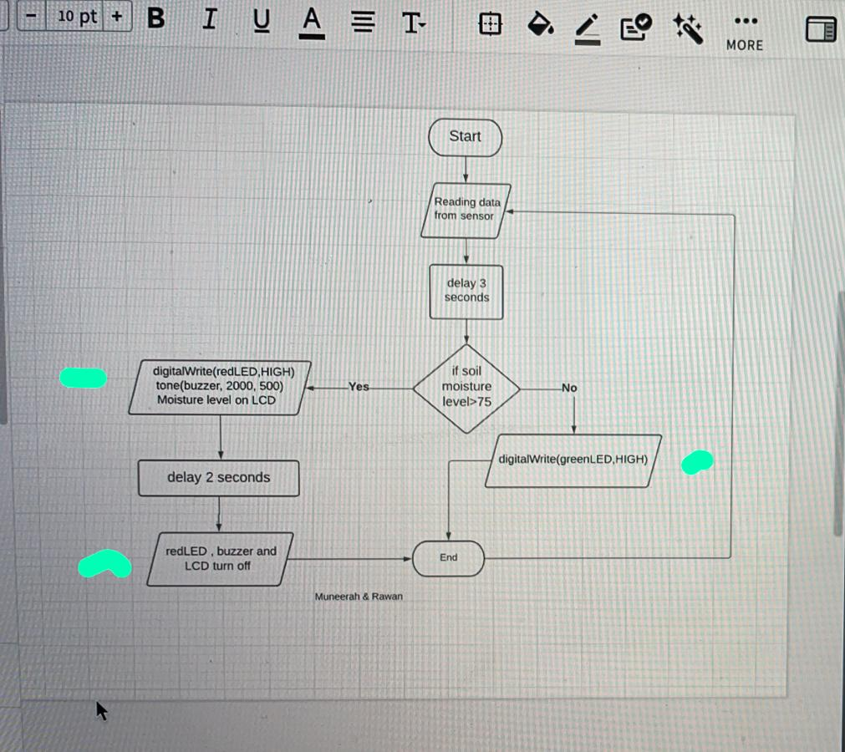

Figure showing the Flowchart for the soil monitoring system.

Solution Algorithm
The following section highlights the software simulations undertaken for this project

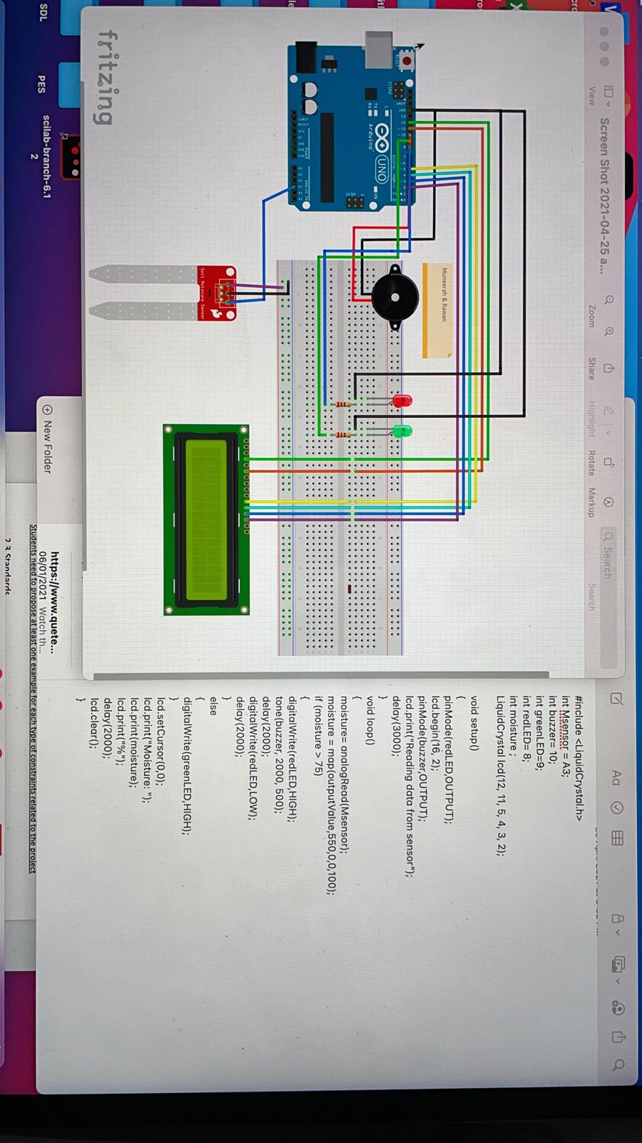

- Detailed inputs and outputs used
The inputs and outputs to the system describing all the parts used in the project. You must present your components as shown below:
Part Name | Part Number | Digital / Analog | Input / Output | Quantity
Microcontroller | UNO R3 | N/A | N/A | 1
Liquid Crystal Display | LCD | Digital | Output | 1
LED (Green and Red) | LED | Digital | Output | 2
Buzzer | 0131 | Digital | Output | 1
Moisture sensor | L2100 | Analog | Input | 1

- Conclusion

This project presents a unique solution of solving the common problem in Agricultural sustainability, i.e., minimizing water consumption by implementing innovative solutions. The system could detect and display the moisture content in soil using a moisture sensor and Liquid Crystal display. The LED and buzzer connected to the Arduino U.N.O. R3 microcontroller acting as the brain of this project provided the visual and auditory feedback based on the soil moisture content falling below a certain threshold. The future scope of this project is to add the image processing and weather forecast abilities through the introduction of Artificial intelligence while introducing a DHT11 sensor for monitoring the temperature and humidity of the environment. Additionally, the other goal is to incorporate salinity and acidity (pH) measurement for an efficient solution for farmers worldwide.
- References
- Dobriyal, P., Qureshi, A., Badola, R., & Hussain, S. A. (2012). A review of the methods available for estimating soil moisture and its implications for water resource management. Journal of Hydrology, 458, 110-117.
- Hedley, C. (2015). The role of precision agriculture for improved nutrient management on farms. Journal of the Science of Food and Agriculture, 95(1), 12-19.
- Kashyap, B., & Kumar, R. (2021). Sensing Methodologies in Agriculture for Soil Moisture and Nutrient Monitoring. IEEE Access, 9, 14095-14121.
- Mohanty, B. P., Cosh, M. H., Lakshmi, V., & Montzka, C. (2017). Soil moisture remote sensing: State‐of‐the‐science. Vadose Zone Journal, 16(1), 1-9.
- Sinfield, J. V., Fagerman, D., & Colic, O. (2010). Evaluation of sensing technologies for on-the-go detection of macro-nutrients in cultivated soils. Computers and Electronics in Agriculture, 70(1), 1-18.
- Shoshany, M., Goldshleger, N., & Chudnovsky, A. (2013). Monitoring of agricultural soil degradation by remote-sensing methods: A review. International Journal of Remote Sensing, 34(17), 6152-6181.

