ENGR132: Transforming Ideas to Innovations II

(IR TEMPERATURE MONITORING USING ARDUINO)

Project Deliverable 1

Index | Name | ID | Major | Section
1
2

(Course Professor)

Date: XXX
Fall 2020


Abstract (200 – 350 Words):

This project presents a diagnosis and detection system that works with the Internet of Things technology to offer a contactless means of detecting temperature using the infrared (I.R.) concept. The end goal is to deliver a manufacturing product that can help society detect temperature during this COVID-19 period. Additionally, this contactless I.R. sensor's other applications are in heat ventilation systems, measuring the surface and body temperature. It presents this novel concept by introducing the MLX90614 infrared sensor that works to display the temperature using the Organic L.E.D, i.e., SSD1306. Other complementary materials include; connecting wires, battery clip, pushbutton, laser diode, SSD1306 OLED display, MLX90614 IR temperature sensor, Arduino Pro Mini. The results are that such a system adequately monitors the temperature with a delay of 5ms between each reading as defined in the Arduino Integrated Development Environment (I.D.E).

Contents

1. Introduction (100 – 250 Words): 5
2. Proposed solution 6
2.1. Solution details 6
2.2. Constraints 7
2.3. Standards 8
2.4. Flowchart 9
2.5. Solution Algorithm 10
3. Detailed inputs and outputs used 11
4. Conclusion 11
5. References 12

- Introduction (100 – 250 Words):

The COVID-19 pandemic brought many challenges, i.e., social, technical, economic, environmental, and technological. But the most of all is the stringent temperature monitoring in all public and private institutions. The MLX90614 temperature sensor is the brain in these contactless Infrared Digital Temperature Sensor Thermo-guns [1]. It works based on the I.R. technology eliminating physical contact with the individuals. Technically, it communicates with microcontrollers using the Inter-Integrated Circuit protocol eliminating complex circuit configurations [2]. The goal of this detection and diagnosis system for the Coronavirus (SARS-CoV-2) in controlling the disease. It comes from the need to progress the healthcare plus managing irresistible airborne related infections that create a danger to individuals worldwide. Additionally, it seeks to form a baseline for supporting aerial and non-invasive methods of detecting the temperature, for instance, with the use of Unmanned Aerial vehicles or Drone control modules that work with the Internet of Things (IoT) and Global System of Mobile Communication (GSM) to monitor the temperature of people in public spaces.
MLX90614 Thermometer sensor consists of two devices embedded in a single sensor acting as a processing and sensing unit [3]. The I.R. Thermopile detector forms the sensor for temperature monitoring. Simultaneously, MLX90302 converts signals from the sensor to digitally readable format because of the low noise amplifier and powerful digital signal processing techniques.

- Proposed solution

Solution details
MLX90614 is made of two components that embed a single sensor; processing and sensor units. The last module comprises an infrared Thermopile Detector or MLX81101 for temperature sensing and Single Conditioning units or MLX90302 that contains a noise amplifier plus a powerful Digital Signal Processing that helps sensor with more excellent resolution and accuracy. This design offers the advantage of eliminating the need for external components interfaced with microcontrollers such as P.I.C. This module's power pins work with an operating voltage between 3.6V and 5V with a supply current of 1.5mA. It can work with or without a capacitor connecting the two pins for noise filtration, which also offers electromagnetic interference protection abilities. The Signal pins, i.e., Serial Data (S.D.A) and Serial Clock (S.C.L) offers the circuit Inter-Integrated Circuit communication that works with the microcontroller using the digital logic. The end goal is that the entire circuit offers temperature measurement capabilities for Thermal Guns for monitoring people's temperature as they enter private and public premises.

Constraints
- Functional Constraints
- WI-FI- The system lacks a temperature storage ability that uploads the sensor data to the cloud. Even though it works with the Internet of Things technology, this circuit doesn't include an ESP8266 WI-FI module that syncs the cloud data.
- Automation; The project lacks an ultrasonic diode that detects motion to activate the temperature monitoring system. Instead, it works with a switch that one has to press to activate temperature signals.
- Safety Constraints
- Damage; the system works with a 9V battery, but the MLX90614 datasheet recommends a voltage equal to the logic HIGH level, i.e., 3.7 to 5V. Unfortunately, there isn't a 5V battery to supply this voltage, making it a constraint, especially with circuit-related damages.
- Manufacturing Constraints
a) Operating voltage; the system works with a 9V battery but notes that the MLX90614 recommends a voltage equal to the logic HIGH level, i.e., 3.7 to 5V. Unfortunately, there isn't a 5V battery to supply this voltage, making it a constraint for long-term use.
- Economic Constraints
- Manufacturing cost; the Arduino plus the MLX90614 creates a considerable cost implication that limits this system's scalability.
- Quality Constraints
- Range; the system offers an 80⁰ as the Field of View that limits the distance between the individual holding the thermal gun and the contact person. Therefore, this creates a challenge in observing the 1m social distancing rule expected in this COVID-19 pandemic.
- Aesthetic Constraints
- Push-button- the colour and general structure of this switch acting as a triggering mechanism undermine this design's general aesthetic/visual appearance.
- Legal/Ethical Constraints
- Social distancing; The role of us as engineers are to protect the safety, environment, and general well-being of the public. It works with a pushbutton acting as the trigger mechanism that undermines the social distancing rule. The contact person and the one measuring the temperature should be closer to each other for the system to work as anticipated.
- Sustainability
- Lifetime; this can be a significant challenge to quantify because most of these components appear as individual units. The project works by assembling them to form a functional unit (prototype). Therefore, it can be complex to quantify the shelf life of this prototype.
- Timing Constraint
- Delay; the software code includes a 5ms delay before taking another temperature value. These arbitrary values can be a subject of interest if the individual presses the button push button once more, ending up recording values not essential.

Standards
For each standard, the team should mention its type, whether it is:
- Local standard
- GCC 2877-17: Standard guide for digital contact thermometers
- GCC E1965-98: Standard specification of I.R. thermometers for determining the patient temperature.
- Regional standard
- E2877-12: Standard guideline for developing digital contact temperature monitoring systems
- E1594-16; Standard guideline for expressing the temperature
- International standard
- IEEE 1718-2012- This technical standard gives the outline for the temperature measurement process

Flowchart
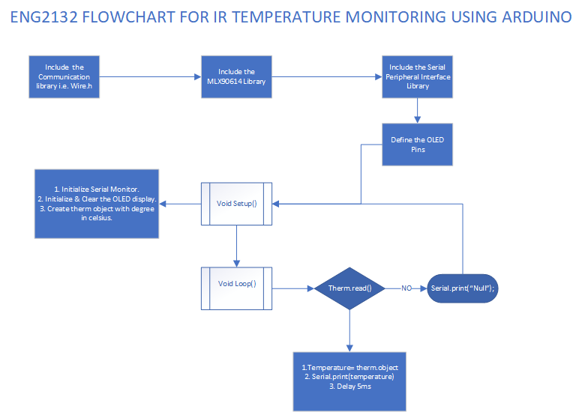

Figure showing the summary of the project in flowchart prepared using Ms Visio.

Solution Algorithm
Step 1 involves including the necessary libraries. These libraries include the I2C communication protocol or <Wire.h> and <S.P.I.h>. The other libraries for the 4-wire protocol include the SSD1306, GFX and Serial Peripheral Interface (S.P.I) for the Organic L.E.D. Display.
The void setup () involves initializing the serial monitor for code-debugging purpose and declaring the Infrared temperature sensor with the therm object that sets the temperature to the degree Celsius. Finally, this function it initializing the Display (Organic L.E.D.) after clearing the display.
Void Loop () involves reading the sensors' temperature and converting the strings displayed in the OLED. Because the system also includes the Serial monitor that helps to debug, where it later increments the value to enter the next temperature reading.
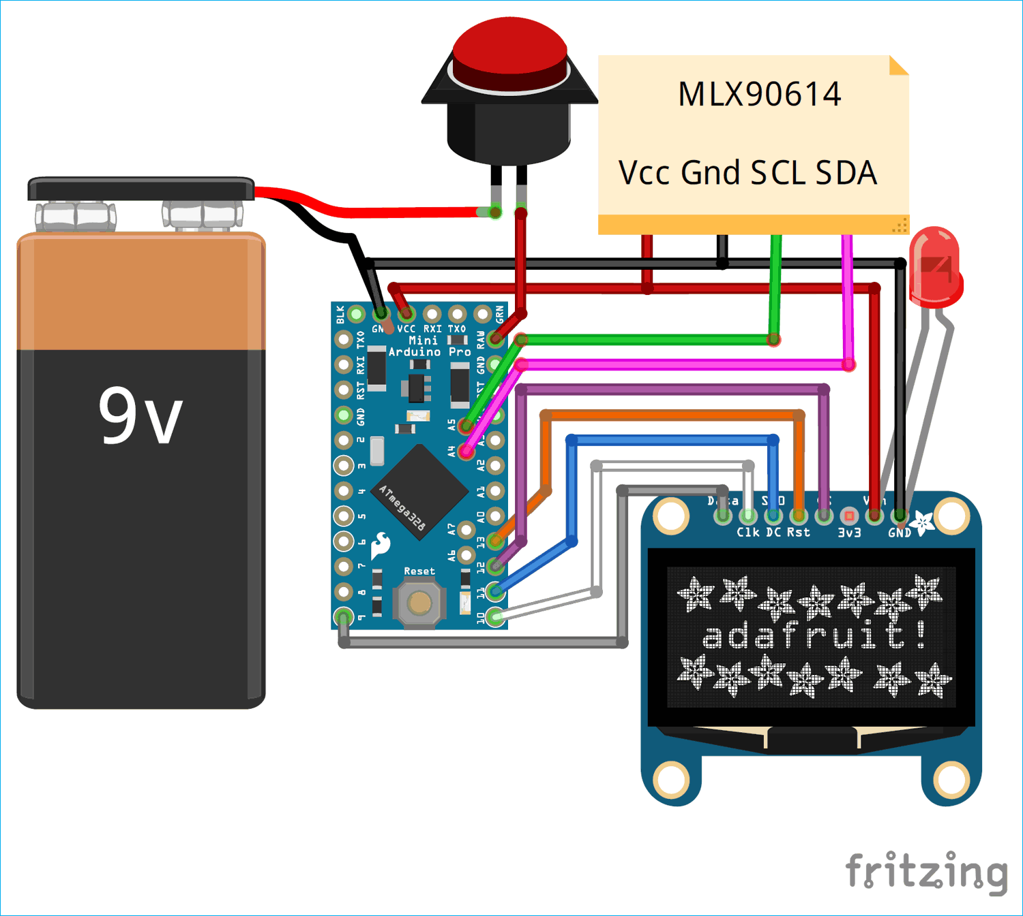

Figure showing the pictorial view of this temperature monitoring system.

- Detailed inputs and outputs used
The inputs and outputs to the system describing all the parts used in the project. You must present your components as shown below:
Part Name | Part Number | Digital / Analog | Input / Output | Quantity
16 AVG Multistrand Connecting wires | CSA FT 1 | Analog | N/A | 2m
9V Snap-type Battery Clip | CSA FT 2 | Analog | Input | 1
Push Button | CSA FT 3 | Digital | Input | 1
9V Battery | CSA FT 4 | Analog | Input | 1
Laser Diode | CSA FT 5 | Analog | Input | 1
SSD1306 OLED Display | CSA FT 6 | Digital | Output | 1
MLX90614 Infrared Temperature sensor | CSA FT 7 | Digital | Input | 1
Arduino Pro Mini | CSA FT 8 | Digital | Output and Input | 1

- Conclusion
PD1 presents a diagnosis and detection system that works with the Internet of Things technology to contactless means of detecting temperature using the infrared (I.R.) concept. The end goal is to deliver a manufacturing product that can help society detect temperature during this COVID-19 period. Additionally, this contactless I.R. sensor's other applications are in heat ventilation systems, measuring the surface and body temperature. It presents this novel concept by introducing the MLX90614 infrared sensor that works to display the temperature using the Organic L.E.D, i.e., SSD1306. Other complementary materials include; connecting wires, battery clip, pushbutton, laser diode, SSD1306 OLED display, MLX90614 IR temperature sensor, Arduino Pro Mini. The results are that such a system adequately monitors the temperature with a delay of 5ms between each reading as defined in the Arduino Integrated Development Environment (I.D.E).

- References

- Mohammed, M., Hazairin, N. A., Al-Zubaidi, S., AK, S., Mustapha, S., & Yusuf, E. (2020). Toward a novel design for coronavirus detection and diagnosis system using IoT based drone technology. Int J Psychosoc Rehabil, 24(7), 2287-2295.
- Zhang, J. (2018, March). Development of a Non-contact Infrared Thermometer. In 2017 International Conference Advanced Engineering and Technology Research (AETR 2017) (pp. 308-312). Atlantis Press.
- Jin, G., Zhang, X., Fan, W., Liu, Y., & He, P. (2015). Design of non-contact infra-red thermometer based on the sensor of MLX90614. The Open Automation and Control Systems Journal, 7(1).

