Executive Summary

This report outlines the changing nature of the world around us in the hospitality industry, giving an understanding of the ins and outs of the industry and the rapid evolving era around it. The report covers the history and current aspects of hotel rooms, as well as the new technology that can be implemented in the hotel room to create a 21st Century version of a hotel room. And defines the key factors that influence decision making on the universal remote for hotel rooms, and outlines scenarios that cover the positive and negative capabilities of implementing the universal remote in hotel rooms. The report delivers the outcomes explain the nature of creativity and innovation and examines ways to turn creativity into insight, ideas, opportunities, and action.
Research for this paper was sourced from various websites of the past and present of hotel rooms.
For the purpose of this report, specific focus is placed on to provide an understanding of ways in which hotel rooms can be updated to be of the current trends of current technology.
The report concludes that the universal remote is a good solution for easier accessibility for tasks in hotel rooms (such as turning on and off the lights and opening and closing the blinds) that also matches upon the current trends of the increasing and improving of technology.

2
Introduction
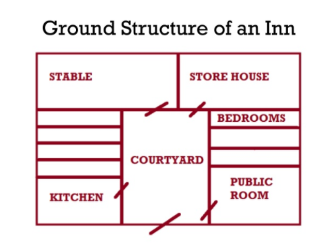
The name of my idea is called Intelligent Hotel Rooms. The idea came from the thought of hotel rooms being so outdated with its technology. The purpose of intelligent rooms is to implement a 21st century idea of a fully intelligent room where you can turn on/off the lights, close/open the blinds, have full control of the tv and more that can control the whole room with only one click of a button on an ipad, that can be located all in one place. I chose this particular service as the hospitality industry is changing everyday and is needing to stay up to date with the current trends of the transforming and updating world with new technology unfolding each day. In the hotel Industry there is a high level of competition seen, where different hotels are implementing new ways to uphold standards to get better star ratings, where the goal is to be a 5* hotel.

Findings

Reflection of the chosen Industry

The hospitality Industry goes back to the ancient Greek and Roman culture. According to Olga (2017, p 1), the rich, politicians and traders were the main customers during the 17th (source 1)
century, where inns were popular and had small
rooms and had the purpose of offering food, changing
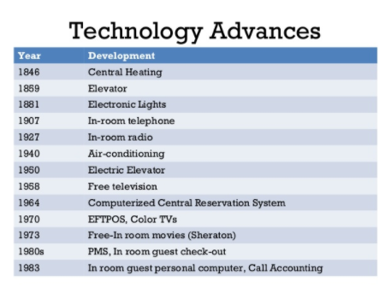
of tires, tending to horses and hosting travellers, and included the stable, store house, bedrooms, public room, kitchen and courtyard (seen in source 1). Where income started to grow for inn owners as the rich started to travel more, where inns started to inns started to become more luxurious and expand due to demand, and from this the hotel industry began to form.
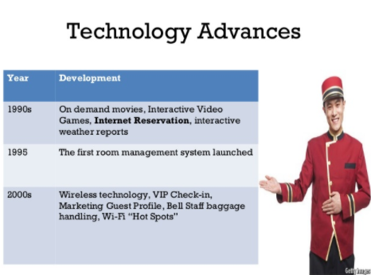
The first hotel opened up in 1829 in Boston, called the Tremont House. It was known to be the first ever hotel with indoor toilets, plumbing and baths. Perera (2015, slide 35-36) suggests that the technological advancements (source 2)
in hotels have expanded from 1840s – 1900s of central heating, elevator, electronic lights, In-room radio, air conditioning, electric elevator, free television, computerised central reservation system, EPTOS, colour tv’s, free in room movies, PMS, In room guest personal computer all the way to the 2000s current technology of wireless technology, VIP Check-in, Bell staff baggage handling, Wi-Fi, and guest profile (seen in source 2).
3
The Intelligent hotel room is a current service that is only seen in very few places that have decided to work upon creating a 21st century idea of a hotel room. It is currently performing at a well stage where everything can be done using a table. tablets. According to Leonidis, Korozi, Margetis, Grammenos, Stephanidis (2013, p4) A universal remote can be used to reduce complexity by using a limited amount of input buttons to control every electronic appliance in the hotel room (e.g blinds and lights). However, with this idea in place it can be found to be needing some improvements to be added for easier usage. With everything being accessed through a tablet, it is harder for older generations to be able to use it and would be needing improvements of a tutorial of how to use to tablet and even have everything in one place so its easier to find what you’re looking for. The important trends and developments that I’m seeking to take advantage of are the technological advancements to create a 21st century hotel room that can increase the competitive level of the hotel to stay up to the current trends of technology to stay ahead in the market.

Analysis of the key situation factors

The key factors that can influence your decision making is the creative and critical thinking, where creative thinking is the inability to image or create something new, where you can create new ideas by combining, changing, or reapplying existing ideas. And where critical thinking uses information, findings, theories, point of view to guide action. Using both critical thinking and creative thinking, it enables you to put together the information of the past and present of hotel rooms to then create an idea on the future of hotel rooms to create ways on how to improve on some of the current implementations in hotel rooms. SCAMPER can be used to brainstorm on the best design for an already existing product.

S = SUBSTITUTE: Substitute the area in which every button for different application are located and the usage of the tablet is difficult to those as it is something new and need to get improve on the system and management of the tablet.
C = COMBINE: Combine the tablet with a whole new system that is easier to use to improve productivity in hotel rooms for guests.
A = ADAPT: Adapt the current programming of the tablet
M = MAGNIFY: Alter the design and layout of the tablet to improve on the universal remote as a whole.
P = PUT TO OTHER USES: Implement more processes to the tablet to control the water temperature of showers, to change the temperature of the heating and cooling system in the room.
E = ELIMINATE: Eliminate the unnecessary aspects in the universal remote that can improve on the difficulty of using the remote as it would be something new to the world.
4
R = REARRANGE: Rearrange the tablet around so all the room abilities are in one place, and room service and concierge and in another place where it can be easily found and easy to use for those who aren’t used to the current technology.

Two Scenarios
Positive

The universal remote will be implemented in the hotel room and it adds not only efficiency to the room but also the value to it. It gives an inability to do all the room capabilities by the touch of one button on the tablet. It will give guests a sense of a 21st Century hotel room. It creates an innovation of having all the capabilities in one place that can control the whole room.
I have created this scenario as it gives a sense of the future aspects of hotel rooms that adapts the 21st Century into the creation of the room and delivers a service that can be seen as the future of technology.

Negative

The universal remote will be implemented to the hotel room and all the older generations will find it harder to use the tablet as they would have just been getting used to the 20th Century technologies that are around and by implementing the new technology will only make it harder for them to control their hotel room where it would be easier to do by hand, such as turning on and off the light as well as opening and closing the blinds.
I have created this scenario as the disadvantages of the rooms consist of the older generations that are still not used the current technology where new technology will be harder to understand the usage of them and cause problems when they are trying to use the room capabilities, where they would be more used to the regular implications of a light switch or pulling the blinds by hand.

5
Reference List

Siteminder. (c2020). What do guests say about the 10 most high-tech hotels in the world?. Retrieved 12 October, 2020, from https://www.siteminder.com/r/trends-advice/hotel-travel-industry-trends/10-worlds-high-tech-future-hotels/

Smith. (2019). This is what the hotel room of the future will look like by 2034. Retrieved 12 October, 2020, from https://www.lonelyplanet.com/articles/hotel-room-of-the-future

Taylor. (2020). This Is What The Future Of Hotels Looks Like Get Ready For Shrink Wrap And “Health Detectors”. Retrieved 13 October, 2020, from https://www.forbes.com/sites/petertaylor/2020/05/12/this-is-what-the-future-of-hotels-looks-like-get-ready-for-shrink-wrap-and-health-detectors/#2ef584b31cae

Buchan. (2020). Untouched time warp hotel rooms from the past. Retrieved 13 October, 2020, from https://www.msn.com/en-us/travel/tripideas/untouched-time-warp-hotel-rooms-from-the-past/ss-BB19smJu#image=6

Perera. (2015). Hotel past & present. Retrieved 14 October, 2020, from https://www.slideshare.net/ThushanPerera1/hotel-past-present

Olga. (2017). A Brief History of Hotels. Retrieved 14 October, 2020, from https://www.blog.bidroom.com/brief-history-hotels/

Leonidis, korozi, margetis, grammenos, stephanidis. (2013). An Intelligent Hotel Room. Retrieved 15 October, 2020, from https://www.researchgate.net/publication/258918273_An_Intelligent_Hotel_Room

6
Appendices

Slide 25, 35-36
https://www.slideshare.net/ThushanPerera1/hotel-past-present

7

