Enhanced ERD
Among the entities to consider in the ERD diagram include the following:
1. Customer entity
2.Employee entity
3. Contact entity
4. Supplier entity
5. Product entity
6.Internal role entity (internal support)
7. External role entity
8, Order entity
9. Order line entity
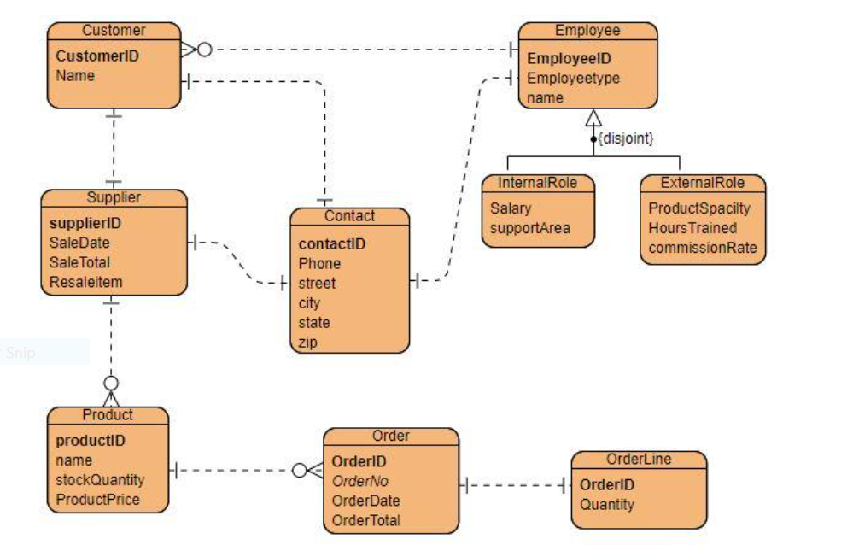
Discussion
The ERD specifies the data that will be stored in form of entities and their attributes. Besides, it shows the relationships between entities. As seen from the enhanced ERD, the relationships of the entities used include one-to-one and zero or many as shown by the notations used in the diagram. Among the entities with one-to one relationship are customer and supplier, supplier and contact, customer and contact, employee and contact, and order and order line. Entities with one-to-many relationship include product and order, supplier and product, and employee and customer.
The relationship between employee and customer is one to many based on the constraint that every customer that either makes a purchase or sells goods to the company must be associated with an employee while it does not limit the number of customers that could be attached to a single employee. Also, a customer may buy or sell many products and this is why the relationship between customer/supplier with product is one-to-many; this is the same case with product and order entities since a product is sold to more than one customer. The order entity represents the elements for customer purchases.
The enhanced ERD is basically provides detailed information regarding the data. It delves into the details and constraints of an entity. For example, in the above diagram, it shown that a customer can also be a supplier. Besides, entries made in each entity are reflected in the diagram. It shows the subclasses and superclasses in each entity as well as union types. Besides, the type of relationship inheritances as well as specialization and generalization are presented in the diagram. Overall, the enhanced ERD builds from the ERD by including variables that allow specializing, generalizing, and aggregating. While generalization adds lower-level entities into one higher level entity, specialization breaks a high-level entity into lower levels. Enhanced ER diagrams are crucial when detailed information is required. It is always logical to use the enhanced ERD when there a large amount of data to ensure the database model is understood satisfactorily.

