Problem 1
PART 1
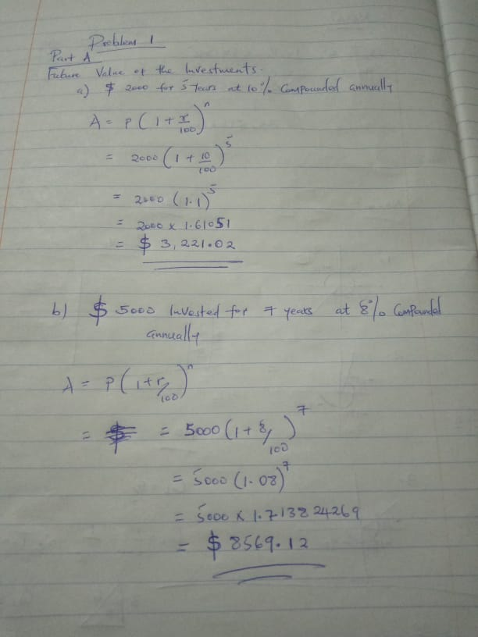
PART B
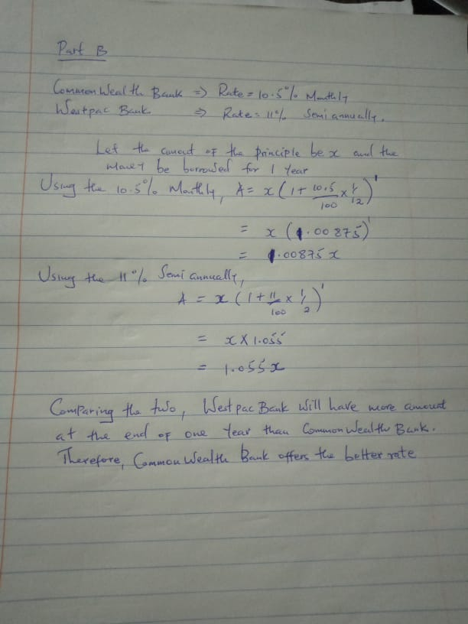

PART C
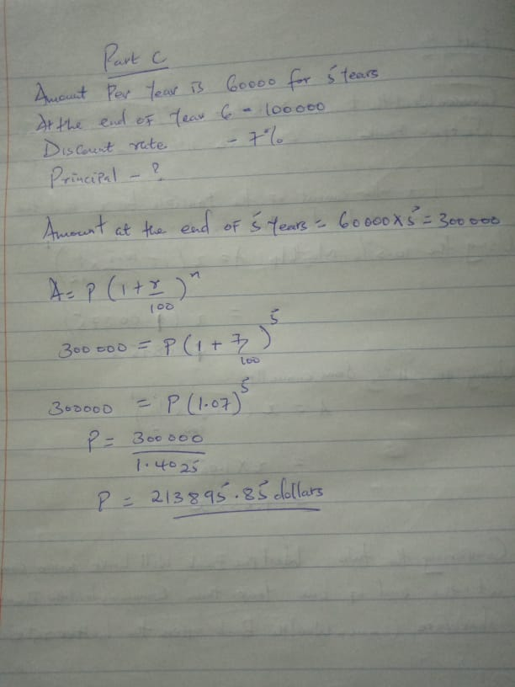

PART D
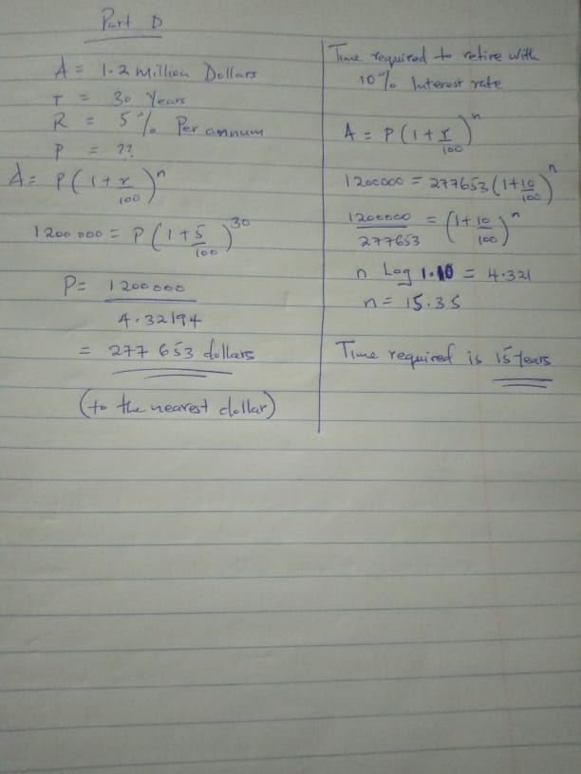
Problem 2
PART A
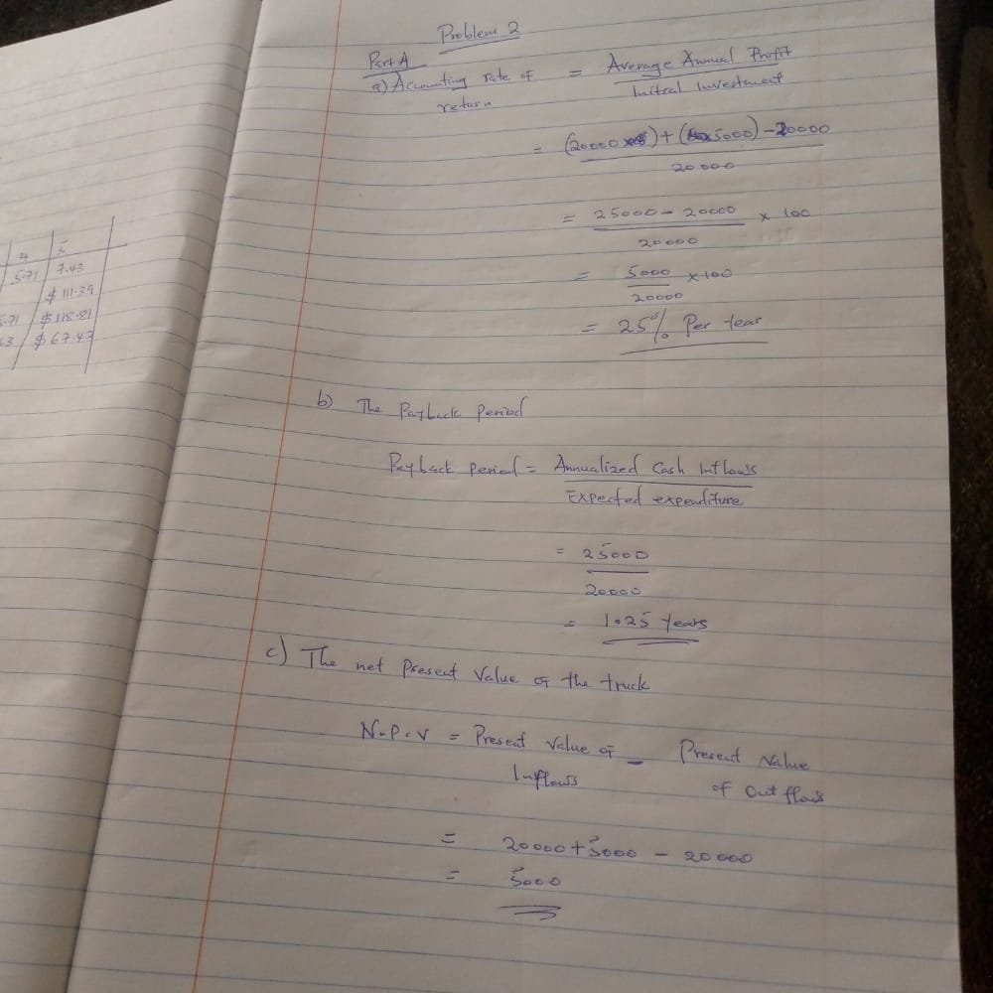

PART B
PVF(r%, n) = 1 / ( 1 + r )^n
Calculation of Depreciation per year on SLM Basis
= (Cost of the facility - salvage value or sale value after three years)/No of Years
= 300 Mill - 120 Mill / 3
= 180 Mill/3
= 60 Mill Per years
Calculation of Cash flow for three Years
S NO Particularas Year 1 Year 2 Year 3
1 Profit Before Taxes 40 30 20
2 Dereciation Per Year 60 60 60
3 Sale of Equipment after 3 years 0 0 120
4 Cash Flow (1 + 2 + 3) 100 90 200
Calculation of NPV of the Project
NPV means Net Present Value
It is the difference between Cash Inflows and Cash Outflows in today's Value
NPV = PV of Cash Inflows - PV of Cash Outflows
Year CF in Millions PVF @10 % Disc CF in Millions
0 $ (300.00) 1.0000 $ -300.00
1 $ 100.00 0.9091 $ 90.91
2 $ 90.00 0.8264 $ 74.38
3 $ 200.00 0.7513 $ 150.26
NPV
$ 15.5
PVF Calculation:
Year PVF Formula Calculation PVF(r%, n)
1 1 / ( 1 + 0.1 ) ^ 1 1 / ( 1.1 ^ 1 ) 0.9091
2 1 / ( 1 + 0.1 ) ^ 2 1 / ( 1.1 ^ 2 ) 0.8264
3 1 / ( 1 + 0.1 ) ^ 3 1 / ( 1.1 ^ 3 ) 0.7513
Part b:
If IRR > Cost of Capital - Project can be accepted - NPV > 0,
IRR = Cost of Capital - Indifferebce Point - Project will be accepted / Rejected - NPV =
IRR < Cost of Capital - Project will be rejected - NPV < 0.
In the given case NPV >0, Hence IRR > Cost of capita i,e %.

Problem 3
Part A
Zero coupon bond is also referred to as accrual bond. It is a security for a debt where no interest is paid but rather transacts at a deep discount, translating to profit upon maturity, after redemption of the face value in totality.By buying the zero-coupon bond, the investor benefits by using the bonds as measures of protection against the changes in the stock market that would occur in future. also, the zero-coupon bonds are deemed as relatively robust when compared with the other coupons.
Part B
Most of the factors that affect the yield of a bond are economic in nature. These factors include the rates of interest. This is as a result of inflation which cause the raising of the interest rate. Another factor is the rate of inflation. The rise in rate of inflation consumes the profits rendering the bonds vulnerable to yielding.
PART C
Cardinal Investment
Face value of bank bill = FV = $ 100000
Current market yield = I/Y = 3 % / annum
Number of periods till maturity in years = N = 50 days = 50 / 365 = 0.13699 years
Coupon payments = PMT = $ 0
Present value of bill today = PV = ?
Substituting the values in financial calculator we get
Present value of bill today = PV = $ 99595.89
PART D
a). Calculation of the bond price:
Formula,
Bond price = (Interest x [1- (1 + YTM)^-n] / YTM) + (Face value / (1+ YTM)^n)
where,
Interest = Coupon rate x Face value
= 6% x $1000
= $60
n = year to maturity = 5 years
YTM = Yield to maturity = 8%
Solve,
Bond price = ($60 x [1 - (1+ 0.08)^-5] / 0.08) + ($1000x [1 / (1+ 0.08)^5])
= ($60 x [1- 1/(1.08)^5] / 0.08) + ($1000x [1/(1.08)^5])
= ($60 x [1- 0.680583] / 0.08) + $1000 x 0.680583
= ($60 x 0.319417 / 0.08) + $680.583
= $239.563 + $680.583
= $920.15 (Answer)
So, the price of the bond is $920.15
b) Calculation of the price of the bond at YTM = 5%:
Bond price = ($60 x [1 - (1+ 0.05)^-5] / 0.05) + ($1000x [1 / (1+ 0.05)^5])
= ($60 x [1- 1/(1.05)^5] / 0.05) + ($1000x [1/(1.05)^5])
= ($60 x [1- 0.783526] / 0.05) + $1000 x 0.783526
= ($60 x 0.216474 / 0.05) + $783.526
= $259.769 + $783.526
= $1044.30 (Answer)
So, the price of the bond is $1044.30
c) Calculation of the price of the bond at YTM =8% (semi-annual):
Bond price = ($60/2 x [1 - (1+ 0.08/2)^-5*2] / 0.08/2) + ($1000x [1 / (1+ 0.08/2)^5*2])
= ($30 x [1- 1/(1.04)^10] / 0.04) + ($1000x [1/(1.04)^10])
= ($30 x [1- 0.675564] / 0.04) + $1000 x 0.675564
= ($30 x 0.324436 / 0.04) + $675.567
= $243.327 + $675.567
= $918.89
PART E
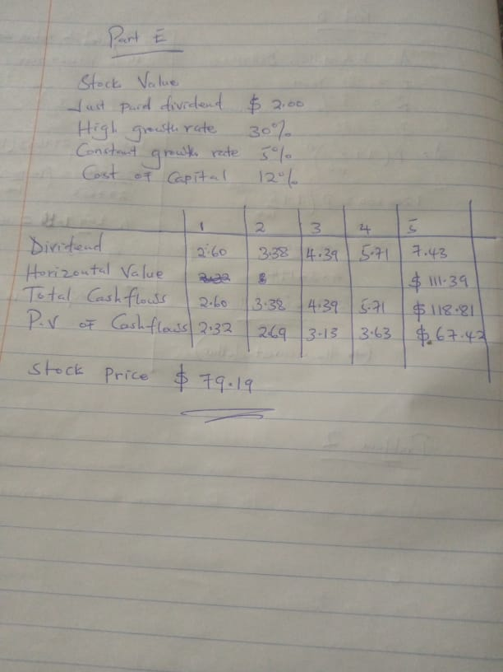

Problem 4
PART A
The return is computed as follows:
= (Current price - price one year ago + dividend) / price one year ago
= ($ 255 - $ 185 + $ 2.24) / $ 185
= $ 72.24 / $ 185
= 39.05%
PART B
The statement is Incorrect, this is because, a beta that is greater than 1.0 indicates that the security's price is theoretically more volatile than the market.
PART C
Weight of Firm A in Portfolio = 25% = 0.25
Weight of Firm B in Portfolio = 25% = 0.25
Weight of Firm C in Portfolio = 50% = 0.50
Return of Portfolio in a State of economy=(Weight of Firm A*Return of Firm A) + (Weight of Firm B*Return of Firm B) + (Weight of Firm C*Return of Firm C)
Return of Portfolio in Boom Economy = (0.25*30) + (0.25*45) + (0.5*30) = 33.75%
Return of Portfolio in Good Economy= (0.25*11) + (0.25*10) + (0.5*17) = 13.75%
Return of Portfolio in Poor Economy = (0.25*2) + (0.25*2) + (0.5*-5) = -1.5%
Return of Portfolio in Burst Economy = (0.25*-12) + (0.25*-25) + (0.5*-9) = -13.75%
Part a)
So, Expected Return of Portfolio = 8.425%
Part b)
Following is the Table for the Calculation of the Standard Deviation of the Portfolio Return:
 | Probability | Expected Return of Portfolio | Prob * Return | Deviation of Return From Mean | Squared Deviation | Prob. * Squared Deviation
 | P | X | P*X | X-E(X) | (X-E(X)) | P*(X-E(X))
Boom | 0.1 | 33.75 | 3.375 | 25.325 | 641.3556 | 64.1356
Good | 0.5 | 13.75 | 6.875 | 5.325 | 28.3556 | 14.1778
Poor | 0.3 | -1.5 | -0.45 | -9.925 | 98.5056 | 29.5517
Burst | 0.1 | -13.75 | -1.375 | -22.175 | 491.7306 | 49.1731
 |  | E(X)= | 8.4250 |  | Variance = | 157.0382
So, Standard Deviation of Portfolio's Return = 12.5315%

PART D
Expected Return = | Risk free Return + (Market Return - Risk free return)* Beta
11.2% = | 3.5% + 6.5%* Beta
7.7% = | 6.5% * Beta
Beta = | 7.7%/ 6.5%
Beta = | 1.185

Problem 5
PART A
The Weighted average cost of capital (WACC) is the cost incurred by the company to raise capital which is a combination of debt and equity. When computing WACC the after tax cost of debt is computed and then factored into WACC calculation. The after tax cost of debt(Cost of debt*(1-tax)) is computed because the interest expense associated with debt is tax deductible. So the after tax cost of debt is computed .But this does not apply to equity as the dividends paid are not tax deductible. As a result there will be no difference between before and after tax cost of equity. So after tax cost of equity is not used when calculating WACC.
PART B
- Market value of equity = shares outstanding*price per share
=4*15
=60
Market value of debt = 20*97% + 30*102%
= 50
Weight of equity = 60/(60 + 50) = .55
Weight of debt= 50/(50 + 60) =.45
B) Cost of debt = 5.4*(20*.97/(20*.97 + 30*1.02)) + 5*(30*1.02/(30*1.02 + 20*.97))
= 5.16%
Wacc = weight of equity*cost of equity + weight of debt*cost of debt*(1 - T)
= .55*12% + .45*5.16%*(1 - .3)
= 8.23%
PART C

PART D
In case of perfect capital markets, value of the firm remains unchanged
Hence, Value of equity=Value of the firm-Debt
=500000-300000
=200000

