Starbucks Corporation’s SEC 10-K Analysis Report

Acct 220 6380 Principles of Accounting I

Spring 2020

Prof. Kathleen Sobieralski

Wendy Jones

27 Feb 2020

Starbucks Corporation’s SEC 10-K Analysis Report

Starbucks Corporation’s headquarters is located in Seattle, Washington (Starbucks Corporation, 2019, pg. 2). Starbucks formed in 1985 as a premier roaster, marketer and retailer of specialty coffees in the world (Starbucks Corporation, 2019, pg. 2). They purchase, roast and cell high-quality coffee, tea and other beverages along with a small variety of foods (Starbucks Corporation, 2019, pg. 2). Starbucks sells these high quality beverages, foods and products though their licensed stores globally (Starbucks Corporation, 2019, pg. 2).

NASDAQ Global Select Market (NASDAQ) is were Starbucks Corporation’s stock trades, under the symbol SBUX (Starbucks Corporation, 2019, pg. 2). Starbucks currently operates in 81 markets worldwide. They employed approximately 346,000 people and operate 15,834 company stored across the globe (Starbucks Corporation, 2019, pg. 2).

Deloitte & Touché LLP. audited Starbucks Corporation’s SEC 10-K report. They are located in Seattle, Washington as well (Starbucks Corporation, 2019, pg. 85). They have been auditing since 1987 (Starbucks Corporation, 2019, pg. 85).

According to Note 1 in the SEC 10-K report, Starbucks Corporation’s fiscal year ends on the Sunday closest to September 30; for 2019, the fiscal year ended on September 29, 2019 (Starbucks Corporation, 2019, pg. 50). In the below analysis you will see that Starbucks Corporation continues to stand tall and grow annually.

Statement of Owners Equity:

Looking at Attachment I, Starbucks Corporation Consolidated Statement of Equity (Starbucks Corporation, 2019, pg. 48). This shows that treasury stock continuing to decrease. Taking the common stock and the potential common shares, one can see the treasury stock dropping each year. In 2017, common stock was 1,431.6 million totaled $1.4 thousand; in 2018, common stock was down to 1,309.1 million totaled $1.3 thousand and in 2019, common stock was 1,184.6 million totaling $1.2 thousand (Starbucks Corporation, 2019, pg. 48). These numbers drop every year.

Starbucks Corporation’s retained earnings (accumulated deficit) totaled $(-5,771.0 million) (Starbucks Corporation, 2019, pg. 48). Even though retired stock increased, an increase in stock as losses decline, an increase of profits and an increase in retained earnings (Starbucks Corporation, 2019, pg. 48). Starbucks Corporation had an accumulated other comprehensive income (loss) of $(-503.0 thousand) (Starbucks Corporation, 2019, pg. 48).

Starbucks Corporation’s stocks continue to grow even with the decrease in treasury stock and the loss in accumulated deficit with the retained earnings. Great news for investors.

Income Statement:

Looking at Attachment II, Starbucks Corporation Consolidated Statements of Earnings (Starbucks Corporation, 2019, pg. 44). This shows net revenue increased by about $2,000 each year. Starbucks Corporation’s gross profit continues to grow each year. In 2017, gross profit was $13,348.6 million with a gross profit percentage of 60% (59.6271%); in 2018, gross profit was $14,545.0 million with a gross profit percentage of 59% (58.8402%); and in 2019, gross profit was $17,981.7 million with a gross profit percentage of 68% (67.8335%) (Starbucks Corporation, 2019, pg. 44).

Starbucks Corporation’s net revenue increased by about $2,000 each year. In 2017, net revenue was $22,386.8 million; in 2018, $24,719.5 million, and in 2019, $26,508.6 million (Starbucks Corporation, 2019, pg. 44). The cost of Starbucks sales were like a roller coaster, in 2017, $9,038.2 million; in 2018, $10.174.5 million; and in 2019, $8,526.9 million (Starbucks Corporation, 2019, pg.44).

Starbucks Corporation’s net income was also like a roller coaster. In 2017, net income was $2,884.9 million sitting at a 13% (12.8866%) net income percentage (Starbucks Corporation, 2019, pg.44). In 2018, net income increase of about 2 million dollars, $4,518.0 million sitting at an 18% (18.2770%) net income percentage (Starbucks Corporation, 2019, pg.44). Then in 2019, net income dropped by about 1 million, $3,594.6 million sitting at a 14% (13.5599%) net income percentage (Starbucks Corporation, 2019, pg.44).

Balance Sheet:

Looking at Attachment III, Starbucks Corporation Consolidated Balance Sheets, we will only be looking at the years 2019 and 2018 (Starbucks Corporation, 2019, pg. 46). Starbucks net revenue continues to increase. In 2019, the net revenue increased by about 1 million from 2018. In 2019, the net revenue was $6,190.7 million, and in 2018, it was $5,551.2 million (Starbucks Corporation, 2019, pg. 46).

Starbucks Corporation’s sales per day grew as well, in 2019, $17,007 thousand and in 2018, $15,251 thousand in sales per day (Starbucks Corporation, 2019, pg. 46). Ending accounts receivable balance for Starbucks Corporation grew about $200 million in 2019. Ending balance in 2019 was $879,200 million, and in 2018, it was $693,100 million (Starbucks Corporation, 2019, pg. 46). The overall value of accounts receivable had increased over all from 2018 to 2019.

Starbucks cost of goods sold increased in 2019 from 2018. In 2019 cost of goods sold was $1,894.9 million, were as in 2018, it was $1,709.4 million (Starbucks Corporation, 2019, pg. 46). The cost of goods sold per day at Starbucks Corporation increased as well from 2018 to 2019. In 2019, the cost of goods sold per day was $5,205.8 million and in 2018, it was $4,696.2 million. The ending inventory balance in 2019, was $1,529.4 million, where as in 2018, it was $1,400.5 million (Starbucks Corporation, 2019, pg. 46).

According to the Starbucks Corporation SEC 10-K Report of 2019, the value of inventory increased, days sales increased, and cost of goods sold increased (Starbucks Corporation, 2019, pg. 46). The overall value of accounts receivable had increased since 2018 to 2019 (Starbucks Corporation, 2019, pg. 46).

Starbucks used 364 days and 52 weeks in year for sales in accounts receivable and days sales in inventory (Starbucks Corporation, 2019, pg. 71, para 2). The inventory description for Starbucks Corporation is an average cost inventory (Starbucks Corporation, 2019, pg. 68). Starbucks uses “price-to-be-fixed contracts”, which are contracts that Starbucks Corporation uses to makes purchase commitments on the terms that have been previously agreed. Although no fixed price is set prior to the delivery date. Until the price is fixed, Starbucks Corporation estimates the total cost of the purchase commitments (Starbucks Corporation, 2019, pg. 68).

Financial Statement:

Starbucks Corporation accounts receivable section is located in the Balance Sheet under assets: current assets. Accounts Receivable for 2019 was $879.2 million and for 2018, it was $693.1 million (Starbucks Corporation, 2019, pg. 46). Long-term debt in 2018 was $9,090.2 million and in 2019, it increased to $11,167.0 million (Starbucks Corporation, 2019, pg. 46).

Receivables, net of allowance for Doubtful Accounts, states that Starbucks Corporation’s receivables are mainly receivables for product and equipment sales (Starbucks Corporation, 2019, pg. 53, para 4). These doubtful accounts are calculations based on historical experience. “As of September 29, 2019, and September 30, 2018, inventory reserves were $33.7 million and $41.5 million. (Starbucks Corporation, 2019, pg. 53). Allowance for Doubtful Accounts is decreasing. In addition, the Starbucks sales are increasing.

According to Starbucks Corporation SEC 10-K report, the Property, Plants and Equipment (PPE) are the assets under capital leases (Starbucks Corporation, 2019, pg. 53-54). PPE values are look like a roller coaster with values going up and down: As we can see, 2019 has been a great year (Starbucks Corporation, 2019, pg. 53-54).
  - 2017, the value was $46.9 million
  - 2018, the value was $32.8 million
  - 2019, the value was $64.6 million

According to the consolidated balance sheets on page 46 of the SEC 10-K report, the PPE
Net had increased in 2019 from 2018 by about 1 million: (Starbucks Corporation, 2019, pg. 46)
- 2019, $6431.7 million
- 2018, $5,929.1 million
Starbucks Corporation’s PPE Net and accumulated depreciation is continuing to grow from year to year.

Starbucks Corporation has continued to growing each year. When comparing the last two (2) years, one can see that 2019 has been by far the best year for Starbucks Corporation. What great news for all stockholders. Increasing revenue will have many new investors attracted to Starbucks Corporation. This will help with the expansion of Starbucks Corporation’s stores, employees and consumers.

Attachment I

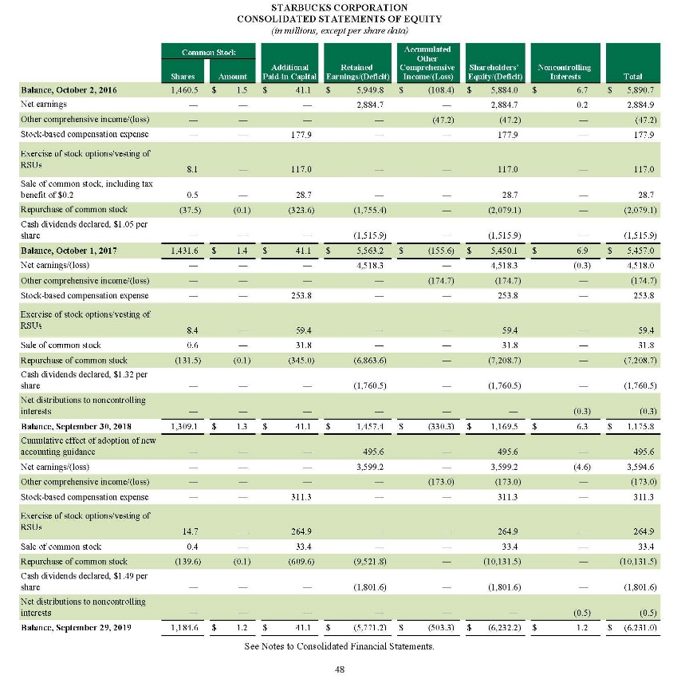

Attachment II

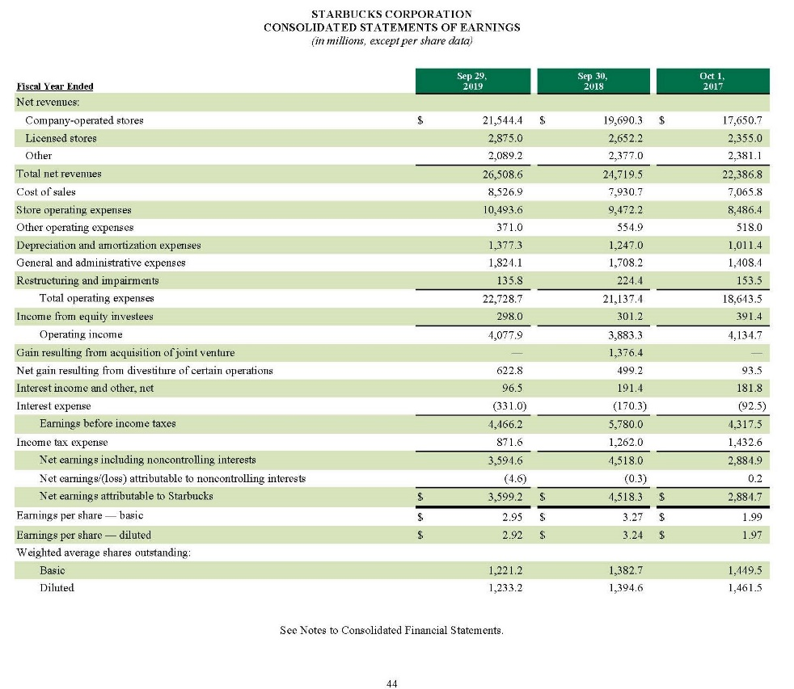

Attachment III

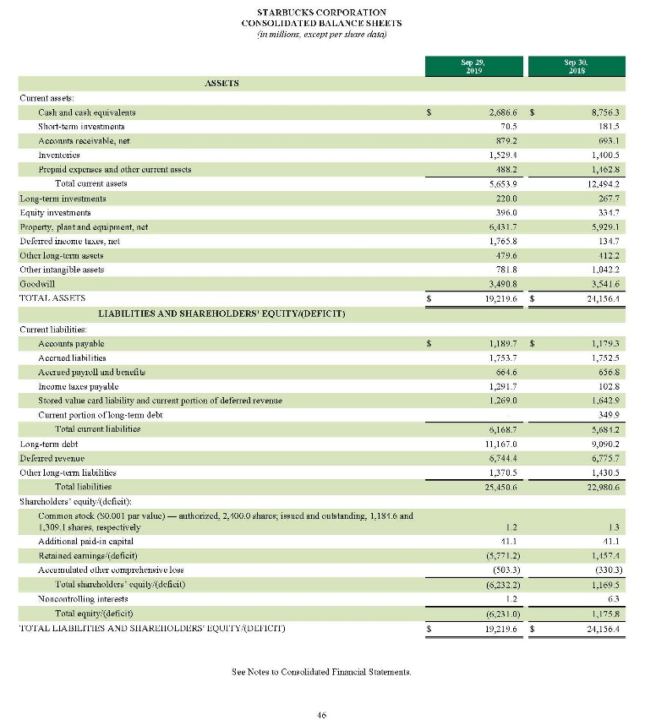

References:

Accounting 220 6380 Principles of Accounting I (2202) Course Resources. Last view: 27 Feb. 2020. Retrieved from: https://learn.umuc.edu/d2l/le/content/503556/viewContent/17830711/View

Starbucks Corporation. Form 10-K Annual Report. (2019, September 29). U.S. Securities and Exchange Commission (SEC). Retrieved from:
http://d18rn0p25nwr6d.cloudfront.net/CIK-0000829224/9886e661-6686-4373-a0a4-033929d8d8dd.pdf

