EARNINGS MANAGEMENT
Student Name
Professor Name
University Name
16 July 2020

ABSTRACT
The last ten years are marked by a limited financing period. High-level cases show the importance of financial reporting and income problems. The impact of this so-called "financial research" and the stimulus of increasing financial journals and restructuring has attracted the attention of research analysts and the popularity of newspapers around the world. Questions that require:
1) "What is Earnings management or mismanagement?" 2) "What is the importance of justice in financial reporting?" And 3) "What are the problems in identifying Earnings management? To answer the question of this study, this article reviews the article on the subject, then identifies and submits it to continuous income control.

INTRODUCTION
The primary objective of the financial statements is to "provide financial reporting information that is useful to investors and lenders and other current and potential creditors in making decisions about providing business resources" in the Board of Directors Accounting Conceptual. international standards (IASB) Financial Reporting Framework (IASB, 2010). Providing useful information can help budget users make better decisions, exercise common sense, and have contextual information that requires critical thinking. The Pathways Commission on Higher Education in Accounting, co-sponsored by the American Institute of Certified Public Accountants (AICPA) and the American Accounting Association (AAA), designed the graphic design shown to the right of Table 1 which demonstrates the reality of " What are they funding? For students, they are the best in accounting. "Evidence-based" (visual examples) show their professional caregivers that they are making complex statements that are affected and affected by the economic crisis and contribute to one. However, the "Common understanding focuses on accounting and preparing financial statements using the rules of black and white rules.
Figure 1: The Pathways Commission’s Vision Model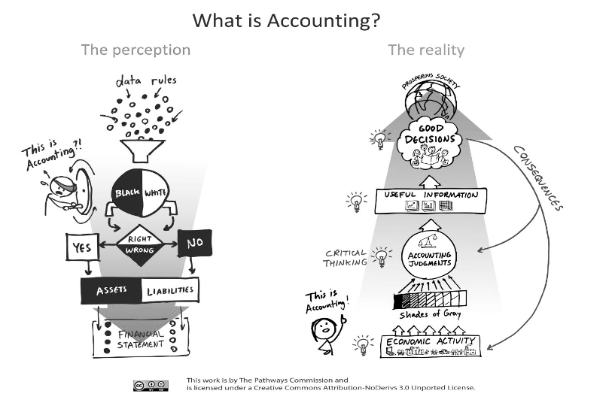
Source: The Vision Model at www.PathwaysCommission.org
Since the application of financial standards requires a lot of judgment, it also worries opportunities for Revenue. While analyzing financial statements provides assurance that such conclusions are reasonable, there are many instances where the researcher was unable to identify false or misleading statements. This is because it is difficult to determine whether there is an allowable amount of Revenue (Barth, 2018). The fact sheets present, in turn, a definition of revenue management, inter-court communication, budgeting, and revenue management, making it difficult to identify management effectively. income, examples of selected cases of earnings mangement, and a conclusion.

EARNINGS MANAGEMENT
"Earnings Management" generally focuses on artificially increasing (or decreasing) the income, earnings, or earnings per share figures through aggressive accounting tactics.
Consider these example definitions of Earnings Management
- Intentional intervention in the process of external financial information with the intention of obtaining some private profit.
- Use of judgment in financial reporting and transaction structuring to alter financial reporting to mislead some stakeholders about the underlying economic performance of the business or to influence contractual results that depend on informed accounting judgments.
- These definitions illustrate that earnings management is a complex process involving the accounting judgment that underlies not only the income statement but also the other related financial statements and disclosures.
.As can be seen in Figure 2 (McKee, 2005), each element in the financial statements is the result of the complex interaction of these two decisions by the administration: a decision of commercial structuring -A decision of financial informationThe financial statements They are first affected by business structuring decisions that involve the business in economic activities. These decisions result in transactions or changes in value that must then be recorded in accordance with generally accepted accounting principles (GAAP). Why GAAP offers both financial alternatives

Figure 2: Business Structuring Decisions versus Financial Reporting Decisions

Management’s Stucturing Decision

Generally Accepted Accounting Principles
Economic Activities

Recorded in Accounting System
Transaction or Value Change

In reporting treatments and based on judgment, various accounting decisions must be made to record transactions in the accounting system from which the financial statements and related disclosures are prepared. Example like:
- Temporary transactions to result in a favorable moment of recognition of income or expenses.
- Write contracts, such as lease and pension contracts
- GAAP requires managers to make numerous financial reporting judgments that have an impact on reported earnings. Examples of these financial reporting judgments that could subtly shade earnings in one direction or another include:
- Long-term construction contracts require planning progress on completion and costs to be met. Managers can use good news of progress in completion to increase revenue.
- Reduction of demand requires estimates of cost of living and cost protection. The Manager regulates life expectancy, uses the barrier for asset reduction and reduces cost reductions.
- Debt payments should be advertised on the actual affected web site. Managers can use the estimate of a specific amount calculated to increase revenue
- Prices should be categorized as commodity prices or period prices. By classifying the cost-effective costs of results rather than the cost period, the manager can reduce costs during product growth periods.
- Benefits in the sale of assets are fully realized at the time of purchase. Managers can timing the sale of valuables, such as securities and fixed assets to increase revenues
- Research companies should determine when technology is being achieved when programs can be implemented and put them at the cost of development. Managers can speed up this day to avoid the rapid deployment of some cost development software.
- The anticipation of the implementation of the evidence should be added and re-adjusted in the end. By making sure the products are cost effective, managers can reduce these costs now.
- Expenditures are usually regulated by cost, while other large ones are used in large quantities. By treating renewable business practices such as major recycling, managers can increase their current income.

Typically, these models present (approximate) cash flows - set up in the flow of cash flows in the calculation of income - the means by which a combined share of costs is achieved, but can also be used to achieve a required profit margin. Some argue that revenue management within reasonable limits can be beneficial for a company and add value (Yaping, 2006). In their nature, aggregate stories, require judicial opinions, and are difficult to justify intentions to study before they are completed. While analysts may examine financial statements that include human decision-making, however, they may not be able to fully match the efforts and numerous simulations accumulated in one direction or the other. . Investors develop a reasonable amount of money for an investment, but they rarely adhere to a planned accuracy within that interval. However, auditors, financial management, and regulators need to understand the motivations for earning money in order to be effective.
In a study of 347 cases of financial reporting fraud over the past decade, the Committee on Corporate Assistance (COSO) identified a number of incentives for financial reporting fraud (Beasley et al., 2010). , p. 14), including:
• Meet and evaluate the earnings of your researchers and others
• Achieve internal goals or improve the appearance of the business
• Hide damage to the financial position of the company
• Increase the value of shares
• Strengthen the financial position for financing capital or debt consolidation
• Increase management rewards by achieving objective bonuses and increasing share appreciation
• Cover damage for your own good
Oversight of revenue management is a fraudulent and misleading way of reporting. They need to show income in a particular situation or follow a trend, to see opportunities in financial situations to allow them to adjust the figure as much as possible to achieve their want or to achieve financial standards. These adjustments are doubled in reporting fraud when it falls "outside the bounds of acceptable accountants." The COSO special report also identified common financial fraud methods among 347 fraudulent companies including (Beasley et al., 2010, p. 17): *
• Accurate income identification (fraudulent accounting or initial income loss) 61%
• Overvalued assets (excluding debtors) 51%
• Low cost / duty research 14%
• Negotiation negotiations are also mentioned 24%
• Misrepresentation of transactions with partners 18%
• Other trades (acquisitions, joint ventures, etc.) 20%
* Amounts greater than 100% due to the amount of violence
Revenue registration has become a major problem now in maintenance research. It is easy to find errors in an auditor, but revenue management can include fraudulent transactions. The need to ensure that the information management is well prepared, does not provide protection when those authorities have entered into knowing false and misleading information. Auditors should be able to distinguish between falsehoods and misrepresentations. Part of the difficulty of reputable acceptance is that there is no “correct” revenue statement and the line between authoritative and financially unacceptable information can be difficult to determine, as shown in the next section.
Judgment, Estimates and Earnings Management
Appropriations, policies and specific grievances should be implemented within the GAAP framework. Many people understand that GAAP is a set of rules, procedures and agreements that define what is acceptable to report abroad, but they may be surprised at one thing, practice, and daily choices that are honest. or inappropriate. The difference between integrity and infidelity of choice is usually only to the degree to which the choice is made. The problem with most court decisions is that there is no limit to the amount of dishonesty a vote can cast. Therefore, a well-documented model, such as cost estimates, may be illegal if the size of the projected amount, but is completely honest if necessary. GAAP does not tell authorities what is normal or what is serious. It's more like a speed signal sign that just says, "Don't drive fast!"
Bad planning is a great example of applying decisions that should be done with great authority. Because the company extends debt as a prerequisite for buyers to purchase, planning to lose those who do not pay is considered a cost of the current period, although it will be lost until then. from the future, what the unpaid payer is and what the unpaid amount will be. GAAP is required to record a bad credit amount as an expense during the financial year in which the product revenue is recorded. This follows a standardized basis of the specific accumulation of expenditure and revenue estimates.
Even small changes in rates can have a significant impact on estimated earnings. For example, suppose a company has $ 200,000 in revenue before bad credit. Also, let’s say the bad news is $ 12,000, or 2% of the net profit is $ 600,000. The income statement will be as follows:

Revenue $200,000
Less: Estimated uncollectible accounts expense 12,000 Net
$ 1,88,000
However, the reality of the $ 12,000 bad news is not always clear. Over the past five years, the average cost of bad debt at the same level of sales ranged from $ 10,000 to $ 14,000 (1.33% to 3.67% of net worth) and there was no indication. clear. A financial manager who wants to report current income will be justified in using the amount of $ 10,000 for budget for this year even though $ 10,000 is the maximum. under history. That same authority could spend $ 14,000 on nursing a year economically weak.
The same rule may be justified in the use of $ 6,000 if there is evidence that credit card sales and economic growth will increase in the current financial year to reduce bad debt. in the future. What if that manager uses the $ 1,000 price tag because the number will meet the projected revenue requirement for the financial year? Or on the other hand of the amount, management can choose the right notable amount of $ 11,000 due to the company for any reason (perhaps tax evasion or seemingly uninvited) do not want to show high income. Since it does not support $ 1,000 or $ 11,000, the benefit of crossing the code may be financially viable, although GAAP does not draw a clear line for the use of the judiciary or unused
As viewed in Figure 3 taken from Dechow and Skinner (2000), the thinking of a reporting income continuum may additionally vary from questionable conservative too conservative to impartial to aggressive to fraudulent. The query turns into the place to draw the lines. Should they be extensive latitude as in Figure 3a or greater slim as in Figure 3b? The reply does make a difference. In this one instance of an instead modest distinction in estimate from $1,000 to $11,000 (.33% to 3.67% of internet sales), it makes a distinction of $.10 per share ($.99–-$.89) or about 10% of revenue per share (EPS). Given that EPS is the most regularly quoted overall performance measure for agencies and that when groups omit analysts’ revenue estimates through $.01, seventy-five percent of the time it is through greater than the estimate. Finally, reflect on the consideration that the estimate of uncollectible money owed is solely one of the dozens of estimates made through administration in getting ready the economic statements.
Figure 3 also gives a clear picture of how there is no “bright line” in GAAP to notify the managers of what can and cannot be acceptable. When this illustration depicts the magnified effect of just one judgment, it also makes the earlier stand, that management represented without various structural and estimate decisions that can affect reported earnings. Management is to make a choice that approximately reflects the company’s performance. It is not always easy to conclude that what is appropriate for a company should be suitable for another company.

Where Do You Draw the Line?
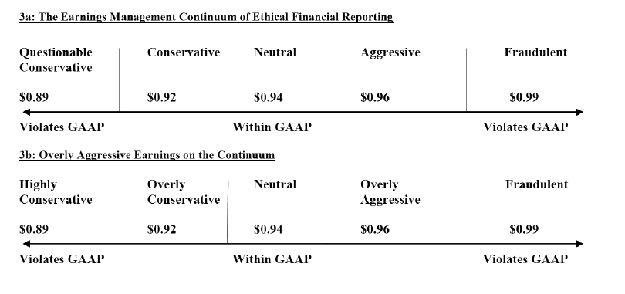
The Difficulty of Identifying Earnings Management
A commonly accepted evaluation of earnings management is that it is good at reducing lucidity by concealing the ‘true’ earnings of a company. Against this valuation there are these leading academics who contend that both the level and patterns of earnings transport information and also even if earning management obscures particulars, it can be favorable for the shareholders. Arya, Glover, and Sunder (2003) state: “That earnings management reduces transparency is a simplistic idea. The basic system of decentralization is the dissemination of information across the population. In such an environment, the managed earnings stream can convey more information than the unmanaged earnings stream.
Quantity of the earnings is the main focus of aggressive and deceptive accounting they place less significance comparing with the quality earnings. Research of financial press has found that the company’s success lies in earnings per share and, to add more the earnings per share is the most customary measure of executive performance in executive compensation (Needles et al. 2008).
Bergstresser and Philippon (2006) have proven the fact that the use of discretionary accruals to control reported earnings is more distinct at firms where the CEO’s potential total compensation is knit to the value of stock and option holdings. Furthermore, the CEOs practice exceptionally numbers of options, and they with the insiders sell large quantities of shares during years of high accruals. However, it is accepted truth that firms that are prompt to fraud investigations are penalized when SEC investigations for fraud result. (Christensen et al., 2010).
Except for a review of the past, earning management can be difficult to discover by making the research of finding the aspects of earnings management as insufficiently useful to standard setters (Healy and Wahlen, 1999). Studies have always been about the SEC enforcement actions for which empirical tests, predominantly of accruals are most substantial. For this reason, little is known about earnings management concerning many accounts. Also, comparatively less significant research examined factors that curb earnings management. For instance, as previous studies concentrate on post-audit financial statements they cannot detach manger’s attempts to manage earnings and auditors’ resolution to renounce adjustments of earnings- management. Durtschi and Easton (2005) argue that researchers and teachers cannot rely on forms of earnings distribution from previous research as evidence of earnings management until alternative, much more likely, explanations for the shapes are ruled out. Durtschi and Easton argue that despite the popularity of the notion that forms of profit distribution are evidence of profit management, they cannot be invoked because (1) the supporting evidence that this is so are rare, perhaps even non-existent and (2), alternative explanations for the forms of distributions are often very obvious. The research of Durtschi and Easton shows that the discontinuity observed in previous studies may be due to deflation rather than to the properties of profit per se. To explore this possibility, they provided evidence of significant price differences between firms reporting positive profits and firms reporting losses. The basic premise (and often the hypothesis withheld) in the growing literature that focuses on discontinuity in the distribution of deflated profits to zero is that discontinuity is a test of profit management to avoid losses. Their evidence suggests that the differential price of small losses and small gains, leading to a relatively higher profit deflator than losses, along with sample selection bias, may induce discontinuity. Similarly, the discontinuity to zero in the frequency distribution of the change in net income deflated by market capitalization at the beginning of the period is not evident in the distribution of the change in earnings per share. This is not surprising given the strong correlation between earnings per share and changes in earnings per share. In a subsequent investigation, Durtschi and Easton (2009) provided three sets of evidence that these discontinuities are likely to be caused by factors other than profit management.
They provided the following:
• A detailed analysis of the effects of sample selection in a recent study; this study erroneously concludes that the form of profit distribution is evidence of profit management
• A simple explanation of the way of profit distribution is most often noted as evidence of profit management; the ratio of earnings to prices differs based on the size and sign of earnings
• Other examples that support the main point of your article; Evidence beyond the form of distribution must be provided before researchers can conclude the presence or absence of revenue management.
Regulators consider earnings management harmful and require immediate remedial action. The SEC is always against any earnings manipulation. As Teko & Skinner (2000) speculate, financial statements and related disclosures remain intact, even if they include sufficient detail to allow investors to adjust to earnings management. The SEC's explanation for this is its mandate to ensure that the stock market is fair to buyers. However, it is the SEC’s job to serve the best interests of every legitimate and rational market participant. Earnings management is beyond criticism because it is within formal constraints; therefore, it should not be identified as the target of regulatory enforcement actions. Because people are opportunistic, Achilles cannot blame others for taking advantage of heels. For the same reason, if managers exploit the inadequacy of accounting standards and their ability to manage reported returns, it does not provide any reason for criticism, and it is inappropriate to say that the use of deficiencies undermines the purpose of the standards. It is the rule-makers who are accountable. The quality of financial statements is an indirect indicator of the quality of accounting standards. If deviations from the standards cannot be eliminated, you must learn to live with revenue management. Being within legitimate limits, profit management is beyond criticism; therefore, it should not be identified as a target for regulatory compliance actions.
Also, standard setters must keep pace with rapid changes in business practices to avoid recognition of accounting being delayed by economic events and to minimize the possibility of creative accounting practices. However, some companies openly ignore GAAP in the earnings report and ask the SEC to intervene. For example, in support of an initial public offering of $ 20 billion, the startup Groupon has highlighted in its regulatory documents a concept of result that we had not seen before in the Accounting literature: `` Adjusted consolidated operating profit for the sector '' (CSOI). According to this concept, the company has eliminated marketing costs, acquisition costs, stock compensation, interest expense, and tax payments (Cyran et al., 2011). Groupon said it had generated a profit of $ 81.6 million in the first quarter of 2011 when if only marketing expenses were deducted, the company had a loss of $ 98 million. Following SEC questions about its unusual concept of profits, Groupon said in an amended SEC statement that CSOI "should not be considered a discretionary measure of cash available to us to invest in the growth of our business or measure evaluation” (Raice and Wingfield, 2011).
In its 2001 annual report, the management of Enron stated, "We are focused on earnings per share" (Enron Corporation, 2002). Enron's cash flow performance was less than 1.0 thirteen quarters before its bankruptcy in October 2001. The measure was negative almost two years before its bankruptcy. During the last quarter, Enron (AccountingMalpractice) hid nearly $ 25 billion in liabilities, as follows (in billions)
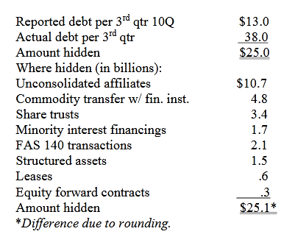
Selected Earnings Management Case Examples
1. The Microsoft Case
Microsoft did not recognize the product as a result of the US Attorney General's antitrust investigation. This is perhaps an example of very conservative unacceptable profit management depicting that not all profit management practices involve exaggeration. The Securities and Exchange Commission (SEC) considers Microsoft's accounting practices to be significantly misdiagnosed from July 1994 to June 1998. Microsoft failed to accurately report its financial results, resulting in higher revenues in some quarters and deficiencies in other quarters. The SEC said that Microsoft improved its financial results by artificially allocating large reserves to reduce revenue, with the idea of ​​changing that practice to record earnings in less profitable times. The total balance in the period under question was $ 200 million to $ 900 million. The SEC criticized the use of ‘cookie-jar’ reserves, which gives the investors an inaccurate picture of the company’s current financial performance.
2. The Time Warner Case
Based on management's analysis of sales and returns and bad debt allocations, Time Warner established reserves of $ 2,253 billion and $ 2,229 billion as of December 31, 2009, and 2008, respectively. These estimates represent around 30% of gross receivables in the two years. Management explains that this is an "area of judgment that affects reported income and net profit" and is based on an analysis of "sales of products by the seller, historical performance trends, the current economic conditions and changes in customer demand "(Times Warner Inc., 2010). This may be an example of conservative to neutral profit management.
3. The Southwest Airlines Case
After the September 11 crisis, Southwest Airlines changed the estimated lifespan of its aircraft from 22 to 27 years because improved maintenance methods allowed the company to get more useful years out of the plane. This change in accounting estimate, which does not require consistent disclosure in the auditor's report, had the effect of allowing Southwest to continue to show year-over-year profit growth. The change in estimate and its result were disclosed in a note to the financial statements. This may be an example of acceptable neutral to aggressive (not overly aggressive) profit management (Southwest Airlines Inc., 2003).
4. AT&T Inc. and Verizon Communications Cases
AT&T Inc. and Verizon Communications Inc. moved to account for retirement plans in 2010 by moving the market to the market. When the market collapsed since the financial crisis of 2008-2009, these companies suffered huge losses: AT&T to $ 23 billion and Verizon to $ 12 billion. Instead of recognizing these losses in their income statements for 2008-2009, the current U.S. government has not. The companies selected according to the standards to forgive them in future years (Rapoport 2011). Now, in the 2010 financial statements, these companies choose to change the calculation of pension funds from the market to international standards and to review the financial statements of previous years. An AT&T spokesperson said this improves accounting clarity so that "everyone can understand where the gains and losses recognized in our income statement at the end of each year are linked to actual economic events.” And a spokesperson for Verizon said that the new approach "is, in fact, a preferable accounting method and that it aligns with fair value accounting concepts and the current [IASB] proposal" (Burr, 2011). This may be an example of aggressive profit management.
5. The Dell Case
The Securities and Exchange Commission alleges that Dell misled investors by using money from chipmaker Intel. Company executives, according to the SEC, relied on Intel to make payments to meet or exceed Wall Street's expectations. "Dell was only able to consistently meet Wall Street goals during this period by breaking the rules." Without Intel's payments, Dell would have lost the consensus earnings-per-share estimate released by Wall Street analysts who tracked the company in each quarter of its fiscal years from 2002 to 2006. Exclusive payments have made up an increasing share. what Dell reported as operating profit from 10 percent in fiscal 2003 to 38 percent in fiscal 2006 and then climbed to 76 percent in the first quarter of fiscal 2007, said the SEC. In the settlement, Dell, several former executives and its founder, Michael S. Dell, agreed to pay more than $ 100 million in fines to settle the accounting fraud disclosure fees filed by the Securities and Exchange Commission (Wyatt, 2010).

Conclusion
In this paper, we discuss the profit management continuum of ethical financial reporting, highlighting the difficulty of identifying cases of profit management and providing incidents that are global in the past decade. From the extensive literature on revenue management and experience over the past decade, it is clear that reform is needed to define the limits of acceptable accounting flexibility and the balance between principles-based standards and standards-based in the rules it needs to be better understood. The need to better understand the judgment is reinforced by the efforts of the Financial Accounting Standards Board (FASB) and the International Accounting Standards Board (IASB) to approximate US GAAP and International Financial Reporting Standards (IFRS). Through principles plus standards, the absence of decisive guidelines for principled standards can create inconsistencies in the application of standards in companies and countries. On the other hand, rules-based standards are insufficiently flexible to react to a problem such as fair value, which often requires considerable judgment from experience, with limited market data.

REFERENCES
Arya, A., Glover, J., & Sunder, S. (2003). Are unmanaged earnings always better for shareholders? Accounting Horizons, Supplement 2003, 111–112.
Barth, M. E. (2018). The future of financial reporting: Insights from research.Abacus, 54(1), 66-78
Beasley, M. S., Carcello, J. V., Hermanson, D. R., & Neal, T. L. (2010). Fraudulent financial reporting 1998–2007: An analysis of U.S. public companies. Committee of Sponsoring Organizations of the Treadway Commission (COSO).
Bergstresser, D. & Philippon, D. (2006). CEO Incentives and Earnings Management. Journal of Financial Economics 80, 511–529.
Burr, B. (2011). Mark-to-market accounting helps companies shift pension plan losses. Pensions and Investments, February 21, 2011.
Christensen, T., Paik, D., & Williams, C. (2010). Market efficiency and investor reactions to SEC fraud investigations. Journal of Forensic & Investigative Accounting, Special Issue, 2(3).
Cyran, R., Currie, A., & Cox, R. (2011). Fuzzy accounting enriches Groupon. NYTimes.com,June 12. Available at: http://www.nytimes.com/2011/06/13/business/13views.htmlDechow,
Dechow, P. M. & Skinner, D. J. (2000). Earnings management: Reconciling the views of accounting academics, practitioners, and regulators. Accounting Horizons,14(2), 239.\
Durtschi, C. & Easton, P. (2005).Earnings management? The shapes of the frequency distributions of earnings metrics are not evidence ipso facto. Journal of Accounting Research, 43(4), 57–59.
Durtschi, C. & Easton, P..(2009). Earnings management? Erroneous inferences based on earnings frequency distributions. Journal of Accounting Research, 47(5), 1249–1281
Enron Corporation. (2002). 2001 Annual Report. Houston, TX
Feng, M., Ge, W., Luo, S., & Shevlin, T. (2011). Therole of CFOs in material accounting manipulations―the Executive Summary. The Conference Board, May 2011.
Healy, P. M. & Wahlen, J. M. (1999). A review of the earnings management literature and its implications for standard setting. Accounting Horizons,13(4), 365–383.
International Accounting Standards Board (IASB) (2010), The Conceptual Framework for Financial Reporting 2010, London: IASB.
Jackson, S. B. & Pitman, M. K. (2001). Auditors and earnings management. The CPA Journal, July 2001. Available at: http://www.nysscpa.org/cpajournal/2001/0700/features/f073801.htm.
Kripalani, M. (2009). India’s Madoff? Satyam scandal rocks outsourcing industry. [Electronic version]. Business Week,. January 2009. Available at: http://www.businessweek.com/globalbiz/content/jan2009/gb2009017_807784.htm.

