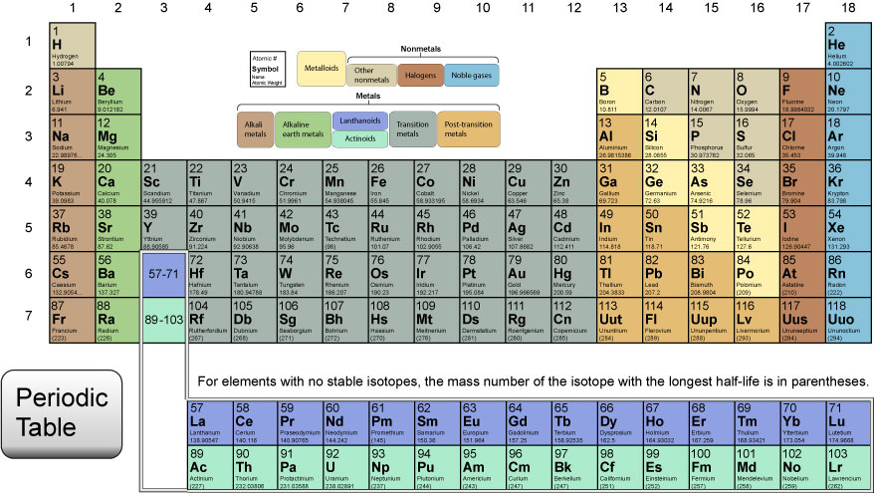

It’s Elemental!

In the first lesson of this unit, you learned about atoms and subatomic particles. You were introduced to the Periodic Table of Elements. The Periodic Table is a tool that gives information about the elements in an organized fashion. For this assessment you will demonstrate that you can use the Periodic Table as a tool by reporting on an element of your choosing. You will complete the following chart using information you get directly from the Periodic Table. You will conduct further research on your chosen element, finding reliable websites to answer the Research Questions below. Be sure to list the websites you referenced and used for research in the last section of the assessment. You should use at least two different websites as sources of information. Remember that neither Wikipedia nor blogs are reliable sources. You will not get credit for either.

Begin by choosing an element with an atomic number between one and 59. After you have chosen your element, find the following information on the Periodic Table and record it in the chart. Type your answers directly into this document.

Part I: Element Chart

1. | Element Name
2. | Element Symbol
3. | Atomic Number
4. | Atomic Mass
5. | Number of Protons
6. | Number of Neutrons
7. | Number of Electrons
8. | Number of Valence Electrons
9. | Element Type (metal, nonmetal, metalloid, noble gas, halogen)
10. | Position in the Periodic Table (group and period)

Now that you are familiar with your element, research it further by finding reliable websites that contain the following information. Type your answers directly after each question and record the URL addresses of all the sites you use.

Part II: Research Questions:

- List the melting point and boiling of your element.
- Describe at least three physical characteristics of your element.
- What state of matter or phase is your element at room temperature (gas, liquid, solid)?
- Who discovered your element and when?
- Describe at least three common uses for your element.
- What is the most interesting fact you learned about this element?

References:

Directions for Submitting Your Applied Knowledge Assessment
For this Applied Knowledge Assessment, you will be submitting ONE document for credit. Save this document with your name included in the file extension. For example:
Earth_Science_Elemental_directions_JohnSmith
After you have saved your document, submit it to be graded for your Applied Knowledge Assessment.

