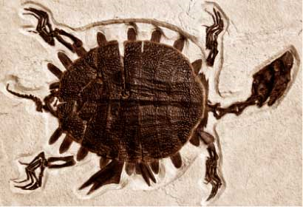
Radiocarbon Dating

The Earth’s fossil record is a very important tool geologists use to decipher the history of the planet. While finding fossils buried beneath the layers of Earth is a difficult and important job, it is not the end of the investigative process. Once fossils are discovered, geologists must determine their age. Have you ever wondered how geologists know that dinosaurs died 65 million years ago? When dinosaur fossils are found, they need to be dated. There are several radiometric dating methods, but the most common is radiocarbon dating.

Part 1: Discovery Education Video
Watch the video clip from Discovery Education on how radiocarbon dating works. This video explains how math and science work together to date ancient fossils.

Radiocarbon Dating Video

- In your own words, explain the role of carbon-14 and how it can be used to date a fossil. Be sure to include the terms carbon-14, carbon-12, and half-life in your explanation.

Part 2: Carbon-14 Dating Activity

Now, you are going to complete an activity to show how carbon-14 dating decays in a sample.

Materials:
100 M&Ms
Paper cup

Procedure:
- Place 100 M&Ms into a cup; these represent your carbon-14 atoms in a sample.
- Shake the cup and gently dump it onto a clean sheet of paper. Each shake represents one half-life.
- If the M&M has its label up, this means it has decayed. Remove it from your paper.
- Record the number of M&Ms remaining on your data table under Run 1. These are un-decayed and still present in your sample.
- Repeat steps 2-4 until all M&Ms are gone or there is only one left.
- Repeat the process two more times for a total of three trials.
- Find the average for all 3 trials
- Calculate theoretical values for this process. For example, you started with 100 M&M. After the first theoretical run, you would have 50 M&Ms left. Calculate the next runs.
- Create a line graph for Trial 1, Trail Average, and Theoretical Data. You will have three lines on one graph. Be sure you include appropriate labels and titles.
Data Table:
Run Number | M&M Data Trial 1 | M&M Data  Trial 2 | M&M Data  Trial 3 | Trial Average | Theoretical Data
Start | 100 | 100 | 100 | 100 | 100
Run 1 |  |  |  |  | 50
Run 2
Run 3
Run 4
Run 5
Run 6
Run 7
Run 8
Run 9
Run 10

Conclusion Questions:
- How close did Trial 1 Data match the Theoretical Data?

- How close does your Average match the Theoretical Data?

- Is there a difference between Trial 1 and your Average? Why did this occur?

Part 3: Research on Your Own
Use the Internet to research a specific case where radiometric dating was instrumental in a significant archeological discovery. Describe this discovery and why it was so significant in a paragraph. Be sure to cite your source of information at the end of your paragraph. Include the website(s) that you used in the reference section at the bottom of the page.

References used in research :

Directions for Submitting Your Applied Knowledge Assessment
For this Applied Knowledge Assessment, you will be submitting ONE document for credit. Save this document with your name included in the file extension. For example:
Earth_Science_Radiocarbon_Dating_JohnSmith
After you have saved your document, submit it to be graded for your Applied Knowledge Assessment.

