Question #1
Assume the United States Personal Savings equals zero. Using national income accounting concepts, show what this might mean for U.S. private investment spending and the US trade relationship with the world. How would the United States finance its investment spending? How would the US finance its government budget, especially if it becomes a budget deficit? Show and explain
The national income accounting measures economic activity of United States, it includes the total revenues from domestic businesses, wages and salaries paid, revenue from the sales and tax paid by the corporates. US is the largest exporter and importer of good s and services and also business services. The US economy is linked with global economy and it holds around 22% of total output. Thus, private investment spending and trade relationship with the rest of the world is interconnected. The Unites states makes investments in social security, Medicare, income security, health, defense etc. mainly from the tax revenues, borrowings and this will rise the aggregate demand. The major source of receipts for government is individual income taxes, social insurance, corporate taxes, custom duties, excise duties, and other taxes. Currently US government’s increased spending is rising the deficit, that drives to inflationary situation. It is having a receipts of $803 billion in 2021 but with a deficit of $573 billion.
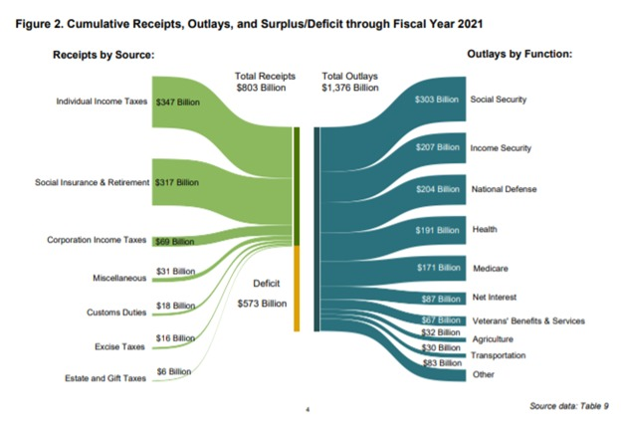
(Source: https://fiscal.treasury.gov/files/reports-statements/mts/mts1220.pdf)

Question #2
Assume the following production function. y = 15k^{1/2} as in the standard Solow Model. The "y" signifies GDP per capita, and the "k" is capital stock per person in a country. Further assume that the rate of depreciation of capital is 10%, the rate of population growth is 10%, and the national savings rate is 40%.
a. Compute the Marginal Productivity of Capital (show work) and explain what this means
y=15k^{1/2}
n=10%=0.10, Depriciation, d=10%=0.10, Saving, s=40%=0.40
MPk=dy/dk=15*1/2*k^{1/2-1}=15/2*k^{-1/2}=15/2k^{1/2}=15/2*Sqrt(k)
MPk shows how rate output will chnage it we change labour.
b. Find the steady-state of capital stock k* and explain what this means c. Find the steady-state of investment I* and explain what this means d. Find the steady-state of output y* and explain what this means
(n+1)k_{t+1}=k*(1-d)+sy
At steady point k_{t+1}=k_{t}=k*
(1+0.1)k*=k*(1-0.1)+0.4*15k^{*1/2}
1.1k*-0.9k*=0.4*15k*^{1/2}
0.2k*=0.4*15k*^{1/2}
k*^{1/2}=30
k*=900
at steady state capital stock is not grouring it is constant.
y*=15*sqrt(900=15*30=450
Ouput worker at s.s when capital in constant is 450, when i=d( i=investment)
s.s investment, i=s in solow model
i=s=$y=0.40*450=180
when capital growth is zero then
investment= depriciation.
Question #3
Continuing with the economy in question #2, consider an increase in the growth of population to 20%. Solve for the new steady state of the economy. Show work. Draw a graph of the Solow Model to explain the change. What has happened to per capita GDP and why? Explain.
When n=20%=0.20
Steady state
(n+d)k=$y
(0.20+0.10)k=0.40*15*Sqrt(k)
Sqrt(k)=20
k*=400
y=15*400^{1/2}=15*20=300
y*=300
İ=0.40*400^{1/2}=120
Due to increae in capital GDP(y) per capita decrase 450 to 300 investment or saving decrease from 180 to 120. Capital per capita decrease from 900 to 400.
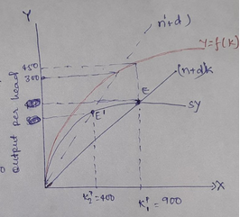
An incrase in population frowth rate causes upward shift in (n+d)k line. Curve shifts to (n+d)k to (n’+d)k decrase in capital per head causes decline in per capital output.
Question #4
Use the Solow Model to discuss the adjustment process of an economy that experiences a significant increase in its savings rate. It would seem savings is the key to more investment spending, capital accumulation, and faster growth. Is this the solution? Draw the graph and explain the process. Discuss implications.
Consider the production function:
Y(t)=F[K(t), L(t), A(t)]
Here, y is the income level
K is the capital level
L is the labour level
A is the technological co-efficient
As per Solow model,
Growth Rates of Output, g=.Y/Y
Growth Rates of capital stock gK=.K/K
Growth Rates of labor gL=.L/L
The fundamental growth accounting states that x=g−αkgk−αlgl
Here, αkgk
represents the capital share and αlgl
represents the labour share in growth
Solow model states that change in capital is due to growth rate of capital, population level and depreciation. At equilibrium,
.K/K=s(f(k))/K−depreciation−growth−population
With a significant increase in the savings rate
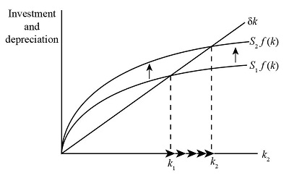
As the saving rate increases from S1 to S2, this causes an upward shift in the production process. It can be easily analyzed from the graph that with the increase in the saving rate, the capital and output level will increase.

With the increase in savings, the accumulation of capital will increase, because the growth model is equal to the investment in savings. According to the national income theory, GDP is equal to consumption, government spending, investment level and net exports. As investment increases, productivity increases. As production increases, income levels and consumption increase. This will lead to an increase in steady state level of output in the economy.

Question #5
What is the difference between the conclusions of the Solow Model and the Endogenous Growth Models? Show simple graphs of each, and discuss the differences.
Difference b/w Solow growth model and endogenous growth model
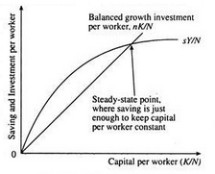
Solow growth model
• Solow growth model is based on sustained growth in living stands due to the progress in technology
• Savings lead to temporary growth with diminishing returns to capital which provides a sustainable growth.
• It is an exogenous model of economic growth, in which output level varies.
• This is more related to external forces.
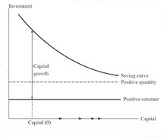
Endogenous growth model
• It is a model with growth of productivity and living standards are endogenous.
• Saving provide persistent growth
• In this model, the economic growth is the outcome of internal forces.
• According to this, productivity improvements is related to innovations and investments in human capital
Question #6:
If a country increases its savings rate, the two models (Solow vs endogenous growth) have different takes on the adjustment process and policy conclusions. Explain. Use graphs.
The Solow growth model is based on the idea that technological progress brings productivity and growth to the economy. It considers capital level per labor and workers ability and technology will increase the per capital stock per labor, but endogenous model believes investment in the human capital is basic requirement for a development of economy. The Solow growth model shows a steady growth through the savings rate and here the savings is equal to depreciation. In endogenous growth model, the savings rate is based on the internal forces and households. The, lower consumption leads to higher savings rate, country’s investment increases. This model looks for log term economic growth for the country. Thus, both models have different views on savings rate.
Question #7
Explain the nature of the Aggregate Supply Curve in the Classical Model. (Draw a simple graph and explain). Also explain the mechanisms that ensure continued full employment of labor in the classical view. (If there is a recession, how does the Classicalist school suggest an economy will return to full employment? Explain and use AS-AD graphs to show)
In the classical model of aggregate supply, the aggregate supply curve is considered to be vertical and completely unstable to any price change. The reason for this assumption is wage price flexibility. This means that any change in aggregate demand will be absorbed by the change in price level and wages that remain unchanged in actual GDP. This also means that the economy is always running for a long time and any change is temporary

For example, an increase in the general price level decreases actual wages. As nominal wages change, real wages will remain unchanged and the labor market will adjust to the full employment level. The reason is that the aggregate supply curve is vertical, which means that there is always full employment in the economy.
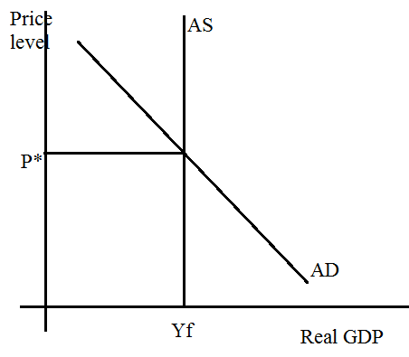
Question #8:
How does the Keynesian Aggregate Supply Curve differ from the Classicalist one? Draw a simple graph and explain. Does this difference mean anything for policy effectiveness? (If there is a recession, how does the Keynesian school suggest an economy will return to full employment? Explain and use AS-AD graphs to show)
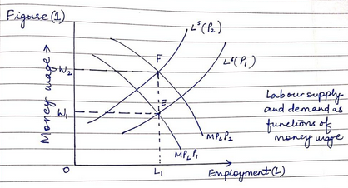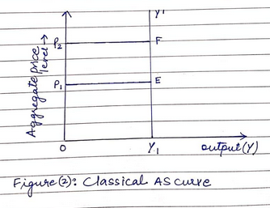
n Figure 1, the equilibrium point is E, the price level is P1, the, the cash pay ratio is W1, and the employment is L1. As prices rise to B2, the equilibrium point becomes F point F and the cash wage becomes W2, but the employment level remains stable. In the classical model, this means that output is not a function of prices. Any change in the price level leads to a proportional change in the cash wage rate. The result will have no effect on employment and output, which is why the classical total supply curve is a vertical straight line.

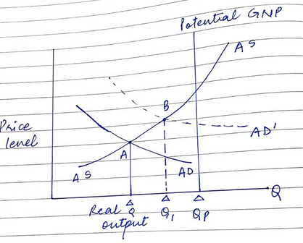
In the Keynesian model, the curve is slopes upwards so that such a distribution curve as shown above exists because as long as there are unemployed resources in the economy, AD. Shows that there is an increase of, which has no effect on prices which leads to an increase in the level of output and employment. Keynes said wages and prices were volatile due to the lack of economic mechanisms.
The Keynesian School Recession or Recession is an expansionary monetary policy, for example a recession that will help the right wing and the total demand to drive out the economy by reducing taxes or increasing government spending to stimulate consumption and investment.
The diagram above shows that the overall demand was originally in the ADR showing signs of recession, with the need for an appropriate policy to shift aggregate demand from ADr to ADf.
Question #9
Assume the following economic model
Y = C + I + G + X - M (Y: National Income, GDP)
C = 200 + .8(Y-T) (C: Consumption)
T =100 + .2Y (T: Taxes)
I = 400 (I: Private Business Investment Spending)
G= 200 (G: Government Expenditure)
X = 500 (X: Exports)
M = 500 + .1Y (M: Imports)
Questions
a. What is the equilibrium level of output Y? Show work and explain.
Y=200+.8(Y-(100+.2Y))+400+200+500-(500+.1Y)
Y=200+.8Y-.8*100-.8*.2Y+400+200+400-500-.1Y
Y=(200-64+400+200+400-500)+Y(0.8-0.16-.1)
Y=636-0.54Y
Y+0.54Y=636
1.54Y=636
Y=412.99
b. What is the spending multiplier? Show work and explain.
Spending Multiplier=1/(1−MPC)=1/(1-0.8)=1/0.2=5
In this simple case, a change in spending of $100 multiplied by the spending multiplier of 5 is equal to a change in GDP of $500.
c. If Autonomous investment increases by 100, by how much will output Y increase? Show work and explain.
Y=200+.8(Y-(100+.2Y))+500+200+500-(500+.1Y)
Y=200+.8Y-.8*100-.8*.2Y+500+200+400-500-.1Y
Y=(200-64+500+200+400-500)+Y(0.8-0.16-.1)
Y=736-0.54Y
Y+0.54Y=736
1.54Y=736
Y=477.92
d. If autonomous government spending increases by 300, by how much will output Y increase. Show work and explain.
Y=200+.8(Y-(100+.2Y))+400+300+500-(500+.1Y)
Y=200+.8Y-.8*100-.8*.2Y+400+300+400-500-.1Y
Y=(200-64+400+300+400-500)+Y(0.8-0.16-.1)
Y=736-0.54Y
Y+0.54Y=736
1.54Y=736
Y=477.92
e. Draw a Keynesian Spending graph of the economy and show the effect of the increase in government spending. Label and explain everything.
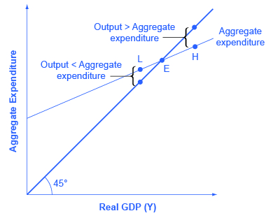
The aggregate demand is met by federal, state and local governments. Although the United States is generally regarded as a market economy, government still plays a significant role in the economy.
Question #10
Assume Country A has a Marginal Propensity to Consume equal to 0.95 while Country B has a Marginal Propensity to Consume equal to 0.40.
a. Explain what this difference means
Country A, MPC=0.95
Country B, MPC=0.40
This difference means that in Country A, there high level of consumption and low rate of saving. There is higher multiplier in Coounty A as higher the MPC higher will be the multiplier. Finally, it show that Country A is growing faster than Country B. In Country B, there will be less multiplier effect as compare to Country A because MPC of Country B is less than the Country B is less than the Country B. There is low consumption and high saving rate finally it shows that the GDP of Country B is less than the Country A.
b. Compute the Spending multiplier for each country. (Assume zero taxes, zero imports) and explain what this difference means.
Spending Multiplier for Country A 1/ 1-MPC=1/1-0.95=1/0.05=20
Spending Multiplier for Country B 1/ 1-MPC=1/1-0.40=1/0.60=1.66
This difference shows that the effect of multipler on the investment will be very high in Country A as compare to Country B.
c. If both countries increase government spending by 100, explain the results in each economy (in terms of their GDP). Show work and explain. DRAW two graphs (one for each country) which shows the increase in government spending for both and shows the spending multiplier process in action. Explain.
Suppose both the Countries the investment Level is increased by 100, then
In Country A Multiplier effect=100*20=2000
In Country A Multiplier effect=100*1.66=166
We can see that the effect of multiplier in Country A is very high . It means that in Country A, a small chnage in investment level leads the higher level of income in the Country as compare to Country B. This also sugguets that higher the MPC, higher the income level .
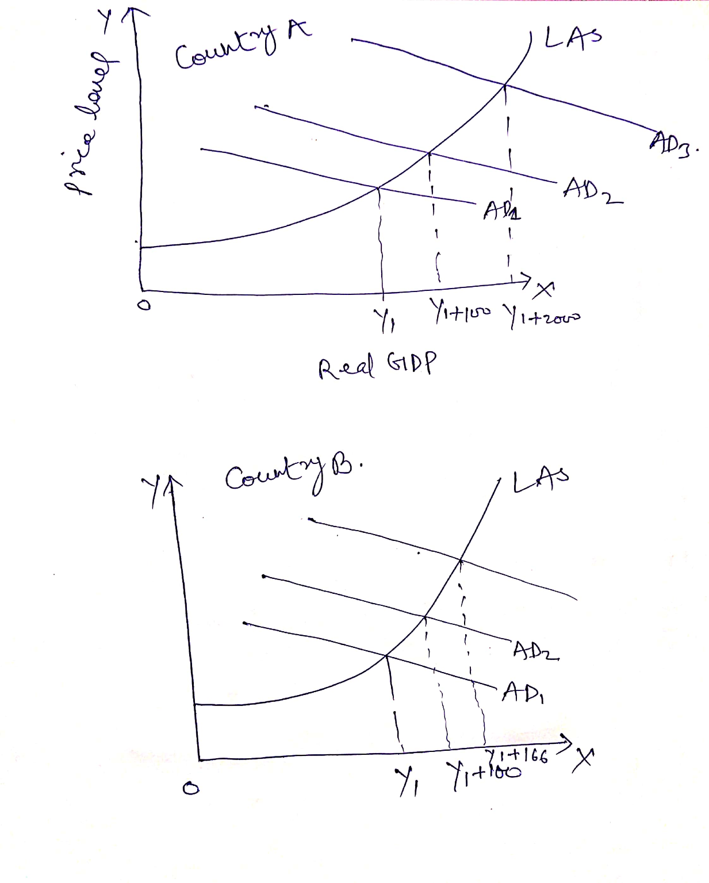
Question #11
A shift right (or downwards) of the AD Curve will cause inflation. A shift left (or upwards) of the AS Curve will also cause inflation. The first type of inflation is "Demand-Side" inflation, while the second is "Supply-Side" inflation
i. Draw an AS-AD model and show demand side inflation. List and explain all of the various sources/causes of this kind of inflation. Further, explain its typical effect on GDP
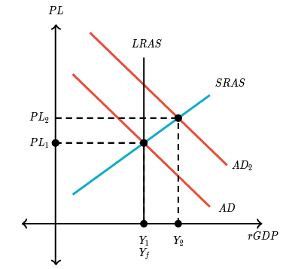
A decrease in AS would decrease output and raise the price level. This would result in more unemployment and more inflation. We call this inflation "cost-push" inflation. It is inflation caused by a decrease in AS.
ii. Draw an AS-AD model and show supply side inflation. List and explain all of the various sources/causes of this kind of inflation. Further, explain its typical effect on GDP
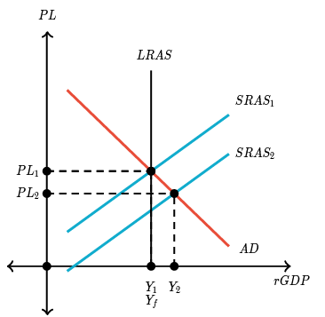
Demand-pull inflation is inflation caused by an increase in AD. As you can see on the graph below, if there is an increase in AD the price level increases. Inflation is the rate of increase in the price level.
iii. Which of the above shocks (demand side or supply side) explain the drawing of the simple Phillips Curve? Explain the connection. Draw the Phillips Curve and explain what it means.
An unexpected change that shifts SRAS; a positive supply shock increases SRAS, but a negative supply shock decreases SRAS.
iv. Which of the above shocks (demand side or supply side) explain the "Augmented" Phillips Curve? Explain the connection. Draw the Augmented Phillips Curve and explain what it means.
An unexpected change that shifts AD; a positive demand shock (such as an increase in consumer confidence) increases AD, but a negative demand shock decreases AD.
Question #12
The Coronavirus has created a massive level of unemployment in the United States and elsewhere. The result is a decrease in GDP and possible recession of many months. There are many macroeconomic forces that are likely at play. These include:
Negative Supply shock, as companies close to avoid spreading the virus
Decrease in Wealth as uncertainty caused the stock market to crash
Decrease in Consumer confidence
Worsening of Business optimism/outlook
Fall in interest rates as savings moves from stocks to safer bonds and bank accounts
Increase in savings rate as Americans worry about being unemployed
Decrease in consumption as consumers not allowed into stores, restaurants, malls, or other places of business
More supply shock as companies can't get needed parts for manufacturing
Lower US imports as foreign countries close economies
Lower US exports as foreign consumers reduce spending on US goods
Big US Tax reduction on businesses and consumers
Unemployment payments and stimulus checks to unemployed workers
Increase in the US money supply as the Federal Reserve buys bonds
Federal Reserve lowers interest rates to encourage borrowing and spending
US Government spends S2 Trillion in government spending to stimulate economy
And More...
When the world emerges from the crisis, there is a debate about where GDP and price levels will be in the US economy and elsewhere. Some say that as the crisis ends, consumers will rush to spend their money as they have been cooped up for 4 months and are ready to spend, creating a huge demand side shock. Others believe consumers will be cautious as the crisis ends, but there will be a huge supply side shock as companies and firms reopen and catch up in production.
That's a lot of information! But use this information to tell the story from start to end of the effect of the Coronavirus on the US economy. Each step of the way, draw and AS-AD graph to help explain changes in GDP, Prices, inflation, Consumption, Investment, Government Spending, Imports, Exports, Unemployment, and anything else of significance. Be sure to match your discussion and explanations to each AS-AD graph and corresponding shifts in the curves. Show the significance of the debate about post-virus recovery. And perhaps include your opinion or expectations about what will happen.

