StandUp For Kids

Overall Introduction
StandUp for Kids is a general charitable organization devoted to breaking the cycle of juvenile homelessness in communities. They have been caring for homeless and at-risk kids since 1990, moving them from disasters to connections. Through housing assistance, mentorship, drop-in centers, and street outreach, they provide youth with a sense of safety, hope, and belonging. They have received the highest independent grade for fiscal stewardship of all contributions.
The organization has partnered with Kia Motors of America. It is grateful for acknowledging them as leaders in the battle against juvenile homelessness. StandUp for Kids is also thankful for being Kia Motors recipients through their #YardsAgainstHomelessness and #GiveItEverything fundraising initiatives (StandUp For Kids, n.d.). The organization is delighted to be affiliated with, promote, and collaborate with various youth-serving and advocacy groups, including True Colors United, Housing not Handcuffs, National Runaway Safeline, and Member NN4Y at the national level.
Mission
StandUp for Kids' mission is to end the loop of youth homelessness, which they have accomplished in communities across the United States, one kid at a time. Their vision is to create communities in which all adolescents know they are cared for, feel valued, and have a support structure to assist their transition from surviving to flourishing as fast as possible.
Their values include the belief in developing a unique and contagious approach to helping homeless kids. Similarly, they must be care activists rather than case administrators, friends rather than service benefactors, community coordinators rather than the only basis of relief. They consider every adolescent capable of making their own choices and provide all adolescents with a choice and voice. In addition, they value each young person's uniqueness, beliefs, and preferences. Likewise, they never make a promise that they cannot keep. Lastly, they find innovative and cost-effective solutions to various individual and societal issues and engage as role models.
Situational Analysis
In almost every location where they work, volunteers wander the roads in identified hotspots and additional places where kids assemble to provide nourishment, clothes, sanitation items, relevant facts, and recommendations. StandUp helpers make it a point to be available at reliable times to establish connections with destitute children and guarantee they are linked to other initiatives the organizations provide and vital community resources they trust.
Street Outreach consultants go out onto the streets to try to reach out to homeless children. There are an estimated 31,000 homeless and housing insecure youth between 12-24 in Orange County. The most pressing need for homeless and street children is ongoing care and genuine assistance. An effective street outreach program is concerned with more than just identifying homeless children who want to remain in an accommodation region. While recognizing children who may need accommodation assistance, it should be offered to children living on the streets. Likewise, accommodation should be provided to kids who are not ready for more of the institution, are afraid to go to a rescue center, have a criminal history, are frightened of confinement, or are scared of being sent home.
The organization provides basic and continuing assistance through Street Outreach (17 of our 18 sites), Outreach Hubs (9 of our 18 places), Mentoring (8 of our 18 places), and Housing Provision (8 of 18 localities) (StandUp for Kids, n.d.). Separate from these programs, the organization labor to evaluate adolescents in necessity, link them to possessions that could assist them during need, and assist them in developing strategies to exit their unsustainable and unfair conditions and better stability.
SWOT Analysis
Strengths
- Committed donors - staff (how many years? How many of them are recruited or what motivated them to commit or what possibly assures their commitment? (check the profile of the board)
- Strong connection to each community (rate of expansion per year? Month? Rate of engagement? 2 side benefits? Working closely with the residents and the authority?)
- The chapter is adaptable (OC being the broadest one?)
- Plans are well organized (details of website, instructions, asking for help, clear vision and plans - check the report)
- Lots of material for media (updated stories, engaging with youths that can ask for stories and participation..)
- Stable, flexible and consistent development and assurance, even through hardship (2019 COVID report)
- Transparency - reports, newsletter, financial reports
Committed donors. StandUp for Kids' greatest strength is its passionate, supportive base of donors. They also have committed staff. Even though the turnover is significant, the whole team is deeply committed to the objective. Lastly, their regional presence has deeply entrenched local relationships in communities around the country. Strong connections to the community and chapters are adaptable to where they are located.
Weaknesses
- Lack of awareness about the org (percentage of participation and OC population - OC chapter may have the biggest audience but its still a small number?)
- Lack of media attention/traffic even though the website and social media are very detailed (stats)
- Videos and visuals are not really captivating (proof: lack of videos - only words)
- Many donors are individuals and not larger companies (names - stats)
- Donors don’t feel recognized, may cause them to leave to another non-profit
- Lack of partnerships with consistent sources of volunteers and staffs
Donors are getting older. One issue with having a base of contributors who have been contributors for years is that most of these funders will be gone shortly.
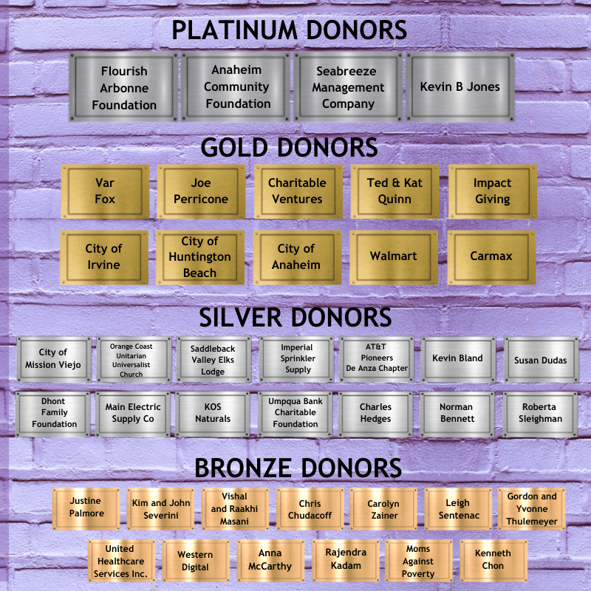
Opportunities
- Acquiring partnerships → more donors/support/awareness (potential connection?)
- Improving social media presence (potential of current social media - ig?, need for new one?
- Increasing awareness of youth stories → more attention to organization as a whole
- Promoting existing operations in OC
- Partner with schools on training programs to satisfy GE (Chapman service inquiry, other school’s community service) requirements (mutually beneficial relationship) (- check 2020 annual report in 2025 vision section)
The most significant opportunity the organization has is acquiring partnerships. Such associations provide several options for success. StandUp for Kids is delighted to have received the best possible ratings from industry whistleblowers Guidestar and Charity Navigator. This is because they practice financial openness and guarantee that each dollar given is utilized following their goal, thus attracting investors. Volunteers returning after staying in the homes for extended periods have enormous potential for promoting awareness and funds. Reaching out to these volunteers both before they go and after they return might assist in cementing the volunteer's connection to both investors and the organization.
Threats
- Rival organizations particularly those with larger presence
  - Mary’s Kitchen, Youth Centers of Orange, Huntington Youth Center, CASA Youth Center, Family Promise of Orange County, Orangewood Foundation
- Effects of pandemic
- Small population = smaller pool of people interested in volunteering = lack of volunteers
Rival Organizations are the main challenge. The growing number of similar organizations is one of the most severe threats to StandUp for Kids. Several other charities provide donor trips to see sponsored children, and some of them are better supported. World Vision is one of the largest. They operate on a similar model to child sponsorship, but with a much more donor-friendly website that allows donors to select a kid. Their website also provides innovative methods to donate, such as catalog shopping or microfinance.

Objective
One primary objective of the organization would be increasing donations to reach out to a vast majority of kids who require assistance without limiting the number of children who get help.
Strategies
The first strategy the organization can use to achieve the above objective is by promoting its fundraising efforts after studying possible contributors and creating a positive image in people's minds. It is a simple, effective, and beneficial method of encouraging more individuals to give to the cause. Another strategy the organization can use is building its brand equity to achieve its targets.
Tactics
The first tactic for promotion can be done through social media or by getting a brand ambassador to attract wealthy donors. The second tactic is building brand awareness, captivating pictures and video, a typeface, a high-quality website, and text supporting brand guidelines. This raises brand familiarity and understanding and gives potential contributors confidence to donate to a reasonable cause. A well-branded nonprofit inspires individuals to contribute money by instilling confidence and trust in them. The third tactic would be updating the organization’s resources and tools when required. Continuously assessing your digital toolbox for areas in need of development will help you identify any issues and plug any gaps as needed. The fourth tactic is putting a twist on the typical fundraising strategy. The organization must not let its advocacy get too monotonous! They should keep donors interested in what is ahead by continually exploring fresh fundraising ideas. The last tactic that the organization can use is providing growth opportunities because growing donor relationships ensures the flow of donations (Guo & Saxton, 2020).

References
Guo, C., & Saxton, G. D. (2020). Social Media and Nonprofit Advocacy: The Beginning of a New Paradigm. In The Quest for Attention (Pp. 1-25). Stanford University Press.
StandUp For Kids. (n.d.). Getting Kids off the Street. https://www.standupforkids.org/

