Occupational Therapy
Name
Course
Date

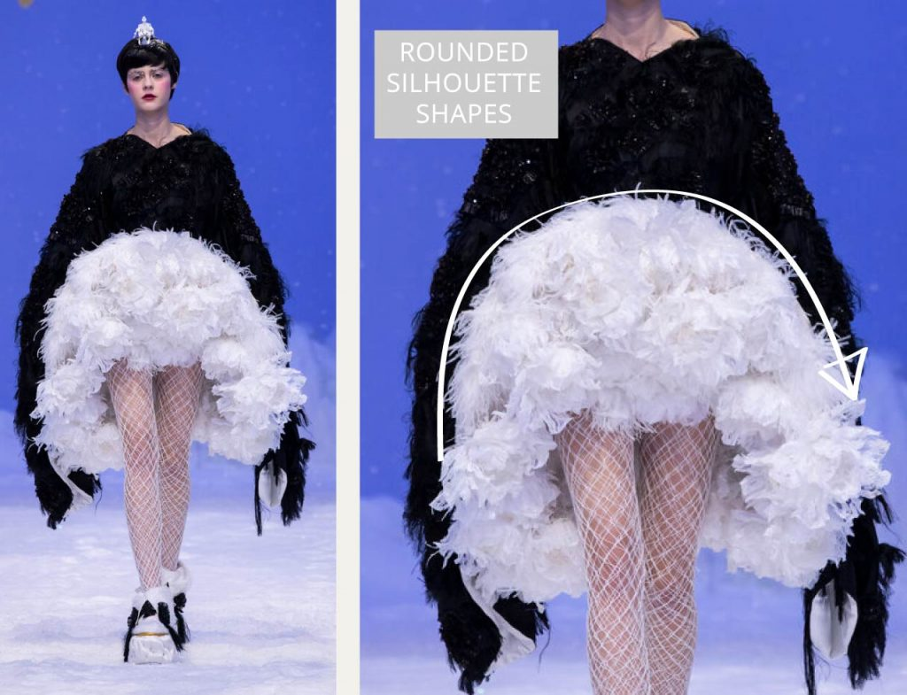
Elements and principles of design
Any good designer manages to use the fundamental elements of design to create a strong, unified and dynamic composition. The piece above is from the Dior Spring-Summer 2020 collection. In my opinion, it incorporates, shape, space, colour and texture to create a balanced and outstanding visual piece. Shape, in fashion design refers to form of the garment i.e. its silhouette. This dress has rounded silhouette shapes to create extreme volume. The shape is more organic than geometric giving it a soft, serene, calm and feminine appearance. As the first thing people usually notice about a garment is its colour. This dress uses black and white, which are neutral colours. However, the use of these 2 colours together creates a contrast that makes the individual colours pop out more and makes the dress stand out. The dress also has a unique texture mainly because of the fabrics that have been used to make it (Reverse Textiles at Guo Pei Haute Couture, 2020). The texture is tactile, because of the use of coarse and stiff materials, giving the dress an actual 3D texture. The dress also shows emphasis. This is because of the fabrics used, the use of contrasting colours and the use of rounded shapes. In terms of rhythm, the dress has a rather graduated rhythm. This dress also manages to achieve harmony in a unified way; the design seems whole.

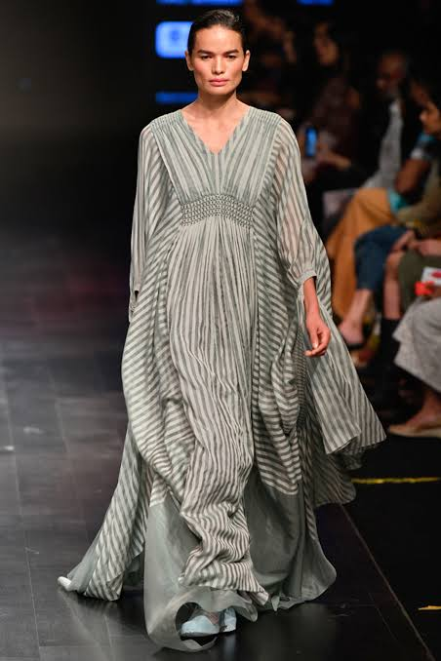
Elements and principles of design
Any good designer manages to use the fundamental elements of design to create a strong, unified and dynamic composition. The item in the picture is a grey draped kaftan dress by Aashni + Co. It incorporates several elements and principles of design. The kaftan has vertical lines which accentuate the model’s height and convey strength. The silhouette is a straight column or tubular silhouette and makes draws attention and smoothens out body lines (Park, 2009). The colours on the kaftan are neutral, adding to its elegance. The kaftan achieves regular rhythm through the repetition of lines and colours. Harmony is also achieved through unity as its silhouette matches the body shape of the model and the garment. Style lines are also consistent.

References
Park, Y. (2009). Design elements & principles. University of Texas-Austin.
Reverse Textiles at Guo Pei Haute Couture. (2020, March 26). The Cutting Class. https://www.thecuttingclass.com/reverse-textiles-at-guo-pei-haute-couture/

