English as a Medium of Instruction in Higher Learning Education

Abstract
This study examines the uses, importance, and profits of using the English Language as an Intermediate form of Instruction in higher education institutions and the problems it encounters in several local communities. The effects of the linguistic instructional methods in universities and secondary and primary schools have faced many challenges. Still, they have made their way into the global language of communication. In this research review, I explore the researches done by several scholars and their findings on the challenges and importance that the usage of English as Lingua Franca (ELF) has brought to the global community. Based on English language proficiency, most evidence shows that different geographical locations and levels of education have been impacted by local dialects, which is the major setback for EMI's prosperity across the world.

Key Words: English Medium Instruction (EMI), English as Lingua Franca (ELF), local Dialects

1.0 Introduction
Many of the world's nations have independent national languages. But in recent years, with the increase in international relations, the English language has become rampant. It has quickly spread, overtaking languages kike French which was the most spoken language worldwide. Presently, English is the global language of intercommunity communication. Though many nations embrace their national language and would not want to spoil their cultural values and their first language, they are forced to include it in the school curriculum to facilitate communication with foreigners who do not understand the native language. The historical time before the 20th Century, the French was the Lingua Franca. This was so because France had the prestige of the age of Louis the XIV. With the global spread of the British empire, English gradually began to spread during the 20th Century. Besides, the commercial dominance of the United States further contributed to the increased spread of English. A researcher like Jennifer Jenkins (2009) believes that the English language will hold its position as the current firs Lingua Franca for generations to come because superpower countries like China, France, Russia, and Germany, among other G-20, conduct most of their international businesses in English.
What is the meaning of English as ELF? ELF's actual meaning is the utilization of English as a common means of messaging in educational practices (Jenkins, 2009). The English language, as much as it is emerging as an international language in almost all areas in the world, both remote and urban centers, present different forms of communication. The three mainly spoken English dialectal are the ones of
- British
- America
- Australia, and
- Other dialects such as Canadian and Ugandan English, among others
These English types vary in pronunciation and accent, and partly spelling, but all the other aspects of English like tenses remain constant. This makes the language the best Lingua Franca of all the languages in the world.
Each country embraces its native language and the first language of communication in all aspects, including business, education, and medicine, among other major economic sectors. With the increase and improvement in international relations, many countries now embrace EMI universities, colleges, and polytechnics. According (Ernesto et al. (2019), the growth of EMI in higher learning institutions has created desirability in developing research fields and teaching in non-English speaking nations. This, therefore, has made the language an essential means of communication and a medium of tuition in institutions of higher schooling levels in many nations of the world. The table below shows the countries of the world that use EMI entirely in their school (all levels)
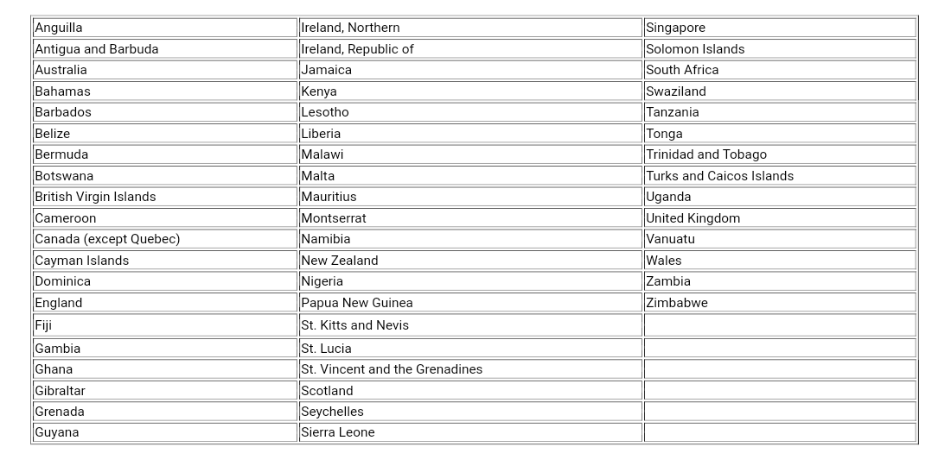

2.0 Literature Review
Research has been done by many scholars on English as an instruction medium in higher education institutions. Although the rate of English growth depends on the individual country, its users' net impact remains the same. According to the studies done by Galloway (2017), the use of the English language in teaching affects the amount of content delivered and the student's rate and quality of absorption. His research further indicates that many students studying Science, Technology, Engineering, and Mathematics (STEM) tend to shift from their native language when they join universities to become proficient in the language. Also, EMI helps speed up a person's movement up the social and economic ladder, especially for graduate learners. Though the most commonly used medium of communication in primary and secondary levels are local native languages, governments have ensured that the form of Instruction in universities is English (Emrije, 2015).
Most school systems allow and promote English as their national language, especially in European and North-American countries. For instance, Macedonia made it a law for the inclusion of English as an official communication dialectal in private and public universities in the country in the administering of tuition. Although incorporating the language in universities as the only medium of Instruction has not changed the school's academic and educational structure, research shows that it has some advantages to the instructors and students. Heidi Karvonen's (2017) study explored the profits of using EMI instead of the local dialects. Although a UNESCO report (1953) encourages regional dialects as a medium of communication in early childhood and primary education for more than half a Century, monolingualism has proven to be the best form of communication. English dominates most of the African countries as the language of training in secondary and higher learning institutes. Thanks to the language, learners and graduates can quickly move from one country to another and continue either with their education or work without changing communication language.
Therefore, the thesis proceeds from conducting research and identifying the research question to establish the effectiveness of English as an instruction medium in higher learning institutions. Then, it will further explain the benefits of the language to international communities.
3.0 Research Methodology
In most countries, educational teaching processes are done in a dialect other than the learners' local dialect, mostly in English. In researching the importance and reimbursements of EMI, researchers must consider all education levels, including primary, secondary, and universities and colleges, and the effects of the language at each stage. Students are also the key part and the driving engine of the education system and must also be factored in while identifying Instruction's language. According to (Ernesto et al., 2017), linguistic researchers have to reach a consensus on what type of English should be used in international education systems as an instructional medium. In doing so, many factors like geographical area and the growth development patterns across the world. The model created was tried utilizing data from a longitudinal investigative trial, and a procedure for evaluating the archetypal was also based on one-time outline data was innovative.
Stage 1: Identifying the objective of the analysis
Stage 2: Categorize the research question
Stage 3: Distinguish applicable studies
Stage 4: Deliberate on purpose
Stage 5: Represent the data in chart form
Step 6: Order abbreviates that disclose the conclusions.

Objectives of the Analysis
This review's primary objective is to analyze and synthesize EMI usage and locate its content concerning other languages. As said by (Shohamy 2012), higher learning institutions cannot be disconnected from their broader setting since their lessons are interlinked, requiring a universal medium of Instruction.
Identifying the Research Question
In contextualizing the importance of EMI, the mobility of learners is a necessary factor. Using English as an international language can be made possible in all the classes in any part of the world. The following review of questions can be a point of focus in the study on EMI.
- How can EMI be defined to cater to all the regions of the world?
- How is the world growing and developing to help in the growth of EMI patterns worldwide?
- What do teachers and instructors believe about the EMI?
- What are the students' beliefs towards EMI? Is the EMI motivating?
- Is there evidence showing that the proficiency of English increases EMI outcome?
- What subjects are affected by EMI in higher learning institutions? How?
In answering the above research questions, various stakeholders must be considered. The role played by students, teachers, parents, administrators, and the government is crucial in ensuring that the findings of the questions posed are deductible with enough pieces of evidence. The literature by Alvesson and Sandberg (2011) provide evidence that a good research question has to be problematic. Problematizing a research question increases the chances of quickly recognizing the answers needed and may lead to more influential theories. This is the main essence of my research paper. Students and teachers are part of the research questions asked above. Students, for instance, at higher institutions of learning, come from different countries and backgrounds. Therefore, being a scientific knowledge language that can benefit technological improvements, the 21st Century generation of learners and educators require EMI in learning establishments.
Study Selection
According to the geographical areas and the levels and educational phases, the research findings were indicated as in the table below. From the research findings, the English language dominates the Schools in Europe, America, and Australia. Asia and Africa, on the other hand, are poorly represented.

Charting the Data
Table 1: Regional Distribution and country
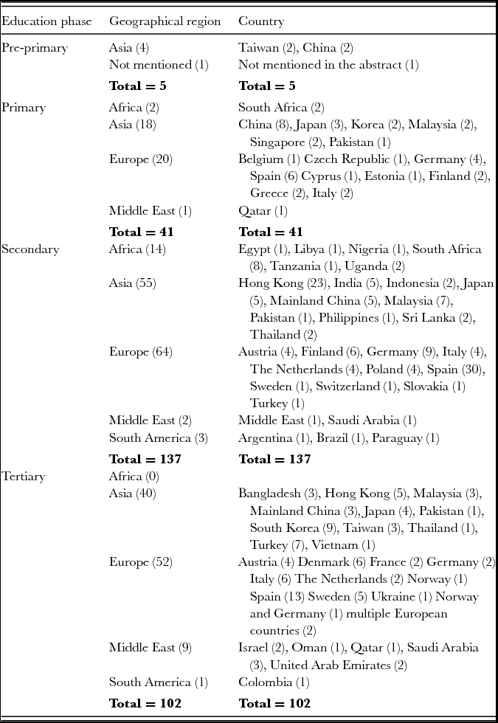

Items |  | Students |  | Teachers
 |  | Mean | SD | Mean | STD DEV | Sig. | d_{Cohen}
The dominance of English textbooks | Rationalized | 5.048 | .953 | 4.757 | 1.168 | .059 | −.286
The dominance of English textbooks | Applicability | 4.534 | 1.039 | 4.514 | 1.162 | .887 | −.019
The dominance of English textbooks | Cohesive | 4.767 | 1.061 | 4.576 | .994 | .164 | −.183
The dominance of English textbooks | Engrossed | 4.360 | 1.262 | 4.311 | 1.072 | .752 | −.040
The dominance of English textbooks | Resourceful | 3.968 | 1.207 | 4.676 | 1.112 | .000ª | .599
Teaching effectiveness | Not clear | 4.074 | 1.123 | 3.695 | 1.417 | .064 | −.316
Teaching effectiveness | Not extensive | 3.878 | 1.199 | 3.559 | 1.489 | .137 | −.251
Teaching effectiveness | Deciphering PowerPoints | 4.307 | 1.107 | 2.729 | 1.412 | .000ª | − 1.332
Medical humanities | Respect | 5.063 | .741 | 4.529 | .615 | .000ª | −.738
Medical humanities | Health integrity | 4.984 | .768 | 4.529 | .706 | .002ª | −.599
Medical humanities | Communication skills | 4.820 | .863 | 4.294 | .836 | .001ª | −.612
English proficiency | GE skills | 4.757 | 1.018 | 4.892 | .973 | .328 | .134
English proficiency | Hypothetical speaking | 4.799 | .979 | 4.973 | .860 | .182 | .184
English proficiency | Hypothetical reading | 5.185 | .930 | 5.135 | .816 | .685 | −.056
English proficiency | Hypothetical writing | 4.937 | .954 | 4.946 | .858 | .941 | .010
Self-learning | Categorizing problems | 4.413 | .945 | 4.324 | .742 | .424 | .100
Self-learning | Raising queries | 4.180 | 1.171 | 4.324 | .923 | .342 | .130
Self-learning | Seeking for responses | 4.862 | .947 | 4.392 | .791 | .000ª | −.519
Self-learning | Sovereign rational | 4.683 | .908 | 4.405 | 1.019 | .033 | −.296

Table 2: Teacher’s and Student’s Views on EMI

4.0 Discussion

The research about the medium of Instruction in schools affected teachers and students. Therefore, the instructors and learners must be the most vital part of all the research studies about this topic. Lectures view the use of EMI as advantageous (Macaro et al., 2018), but still, the problem arises in the lack of English proficiency by many students and even some lecturers, which highly slows down the delivery of the curriculum. The study further urges that EMI should not be institutionalized independently but instead based on eliminating the negatives and exploiting the positivity. Such methods include

Encouraging students to improve their competencies in the language. This enhances the student’s listening and linguistic skills essential for future study and careers and further promotes the ELF's appropriateness.

Elimination of the long-term adverse effects of learning based on content. The use of EMI, as earlier discussed, enables a proper and better understanding of the STEM subjects. Therefore, the researches done must ensure to capture the effects of content-learning in English language improvement.

Most conducted research does not provide measurable improvement in English as the second language, and they do not show comparisons with other countries. To establish ELF improvement, a minor detail in English changes as the Second language needs to be recorded down for reference.

The local dialects have an impact on the use of EMI. Most research otherwise indicates that English is eroding the local dialect. Is this good or bad? It is suitable for English because the objective is to promote the language to the international Lingua franca. Makin English, the formal communication both in writing and speaking, is catastrophic for the local language. Since there is no evidence to support this fact, it is assumed that the first language prospers in the presence of English. Evidence by Phillipson (2006) points out that the local dialects equally erode English the same way English erodes it.

Successive transition in the language from primary to secondary to tertiary institutions is necessary to promote English proficiency. Since the language cannot be separated in different education stages and cannot cause downward pressure, it is important to introduce it at lower levels. Students advance with it upwards from pre-primary to tertiary learning. Several types of research indicate that teachers and tutors object to the introduction of EMI at lower levels.

The planning, implementation, and resourcing of the EMI must be done carefully, with the most considerable consideration being the universities and other tertiary learning institutions like colleges and polytechnics. Preparing teachers is among the elements that must be well resourced. This is another area of the research lacking evidence. There are currently no limitations that identify the competencies of teachers in teaching through the use of EMI. Teacher preparedness and responsibility to students facilitated the level of ease or difficulty the student will have to adapt to EMI.

5. 0 Limitations of this review

According to (Ernesto et al., 2017), most books and other non-electronic data are absent in the current research database. Besides, the little pieces of evidence present do not include an in-depth review of the researches done on the topic. This is so because some countries like Tanzania are now beginning to embrace EMI in their higher learning institutions. Still, most researchers have not yet included the country in these changing situations.

Also, there is no reliability on the title-based studies. They present information with a lot of vagueness, indistinctness, and lack of intelligibility, making the survey more challenging than the research findings. Besides these factors, the sources also are biased basing on the geographical location. Finally, since most of the research studies are conducted in the natural institutional setting, the most systematic data collected data are limited (Yang et al., 2019). In comparing the effect of using EMI among the students whose first language is English (EMI) and the ones whose first language is not English (non-EMI), it poses a challenge of the differences in case studies.

6.0 Conclusion
Many researchers ask about this topic is where the EMI will be in a decade or a century to come? No one knows the future and predicting it is equally impossible, especially when there are plentiful variables to be considered. Policymakers and university managers within their powers will not be swayed away by the social, cultural, and sociolinguistics objections offered to the implementation of the usage of EMI not only in higher schooling but also in higher education also other lower levels of learning. Through building the current state of research on EMI, political leaders who we know are the most influencing factors in policymaking can be persuaded to embrace the use of EMI. Further, English can also be made the one and only Lingua Franca through the growing international relation. This is possible with enough planning and systematic reforms of preparing and resourcing the education system worldwide.
References
Agai-Lochi, E. (2015). English as a Medium of Instruction in university education. Procedia–Social and Behavioral Sciences, 199, 340-347.
AlBakri, S. (2017). Effects of English medium instruction on students' learning experiences and quality of education in content courses in a public college in Oman.
Alvesson, M., & Sandberg, J. (2011). Generating research questions through problematization. Academy of management review, 36(2), 247-271.
Coleman, J. A. (2006). English-medium teaching in European higher education. Language teaching, 39(1), 1-14.
Dearden, J. (2014). English as a medium of an instruction-a growing global phenomenon. British Council.
Doiz, A., Lasagabaster, D., & Sierra, J. M. (Eds.). (, 2012). English-medium instruction at universities: Global challenges. Multilingual matters.
Fenton-Smith, B., Humphries, P. & Walkinshaw, I. (2017). English medium instruction in higher education in the Asia Pacific: From policy to pedagogy. Dordrecht: Springer.CrossRefGoogle Scholar
Jenkins, J. (2009). English as a lingua franca: Interpretations and attitudes. World Englishes, 28(2), 200-207.
Karvonen, H. (2017). ENGLISH AS A MEDIUM OF INSTRUCTION Benefits and Challenges as Viewed By Founders of International Schools in Ethiopia (Doctoral dissertation, Master" s Thesis. the University of Turki).
Macaro, E., Curle, S., Pun, J., An, J., & Dearden, J. (2018). A systematic review of English medium instruction in higher education. Language Teaching, 51(1), 36-76.
Shohamy, E. (2012). 10 A Critical Perspective on the Use of English as a Medium of Instruction at Universities. English-medium instruction at universities: Global challenges, 196.
Yang, M., O’Sullivan, P. S., Irby, D. M., Chen, Z., Lin, C., & Lin, C. (2019). Challenges and adaptations in implementing an English-medium medical program: a case study in China. BMC medical education, 19(1), 15.

