Name:
Instructor’s Name
Course
11/14/2020

Climate Change
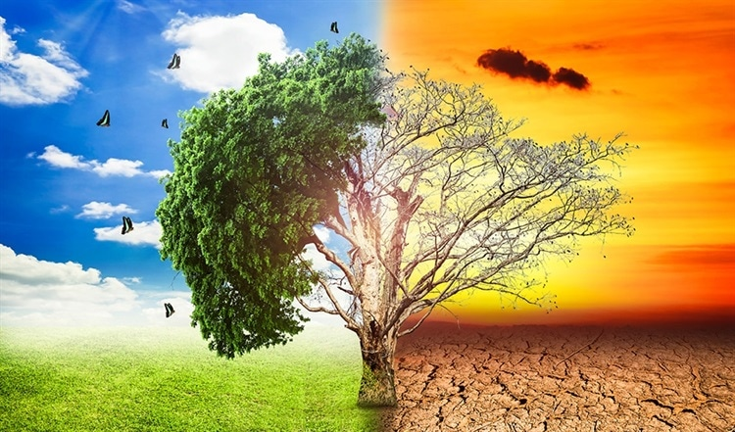
Image Source: https://www.azocleantech.com/article.aspx?ArticleID=898

Detailed Description and Analysis of the Photograph
There is no better way for explaining the impact of climate change than using pictures such as the one provided above. The picture speaks more by just demonstrating how global warming have impacted the ecosystem. Apparently, the picture plays on the uncertainty of what will happen if humankinds do not change or stop doing things that contribute to global warming and this is central to the usage of the picture in the article where it is incorporated.
Context in which the image was found and the presented
To find this picture, I was exploring one of the hottest and controversial topics in the world “climate change” and narrowed the search to “climate change projections”. There were numerous results, but this one particular picture has a lot of meaning in regard to the topic of interest. It triggers a social as well as an emotional concern that people should not ignore at an individual level. Art could be used as a hammer with which to shape reality or as a feather that tickles through a difficult idea and this is exactly what the picture is trying to do- to change people’s perceptions (Roosen pg.3). The context in which the picture is presented is to partly warn people about global warming that is an existential crisis in the world and to offer a different look at the power of taking care of the ecosystem.
Questions about the Image and Thoughts it Provokes
People tend to not react to things unless they are actually happening to them right then. In regard to this, one of the greatest questions the picture raises are: Is global warming happening right now? If yes, does people realize its impacts, if they do¸ what are they doing to stop it?
As mentioned earlier, the picture is provoking a lot of thoughts. First, it is providing a clear visualization of the problem at hand, which is especially important in regards to climate change. It helps people stop perceiving climate change so to speak global warming as an abstract issue that poses no direct threat.
Summary of the Selected Readings
- Roosen, Liselotte J., Christian A. Klöckner, and Janet K. Swim. "Visual art as a way to communicate climate change: a psychological perspective on climate change–related art." World Art 8.1 (2018): 85-110.
This article describes how art could be used not only to communicate critical issues that are often abstracted such as climate change. According to the reading, there are many challenges faced by people who have been trying to call for action against things that contribute to climate change. The topic is a controversial one as there are people who continue to criticize the impacts of global warming regardless of the available footprints on the planet.
The reading relates to the picture because besides highlighting the major challenges, it also highlights some of the themes made obvious on the picture. The source speaks to the chosen photograph by explaining how art has the very special ability to tap into people’s emotions that probably could make them react by taking proper measures to prevent the negative effects they see on the picture. Furthermore, the reading discusses how art incorporate metaphors that address abstract issues through symbolic representations of the reality.
In the following quotation, the author(s) emphasizes the use of visualization in
Quotation from the reading
“Climate change is viewed by many as a very abstract problem that is hard to visualize in a way that relates to their everyday lives, which can result in the issue being ignored and in the individual’s failure to act and take adequate measures to resolve the problem. When problems are easier to visualize, such as air pollution, people find it easier to relate to them”
- Botkin, Daniel B., et al. "Forecasting the effects of global warming on biodiversity." Bioscience 57.3 (2007): 227-236.
This reading reflects on the forecasts which scientists make on possible outcomes of global warming. The reading is relevant because it provides warns that are expected to trigger some reflection on their meaning and perhaps motivate people to consider changing their attitudes towards global warming. Furthermore, the reading sparks a conversation of what needs to be done to stop the existential crisis from growing bigger.
The interpretation of the provided photograph is deliberately less ambiguous. However, this reading provokes further questions regarding how accurate is the image in telling a story of destruction from different perspectives even without illustrating the causes of the problem.
According to the authors, previous work on climate change has failed to adequately account for mechanisms that lead to the questionable causes of the changes. It renders the theme integrated on the photograph controversial while it gives some suggestions into the requirement for more accurate and reliable forecasting based on reliable evidence and in this case integration of the causes that were left out by the artist.
Conversation between self and the two Scholarly Readings
The above photograph was chosen to specifically show the beauty of a biodiversity that is not destroyed at the forefront of climate change as opposed to the devastation that’s happening. It gets people inspired, moved, want to protect, and preserve the environment to avoid the consequences of not doing so.
Police Brutality
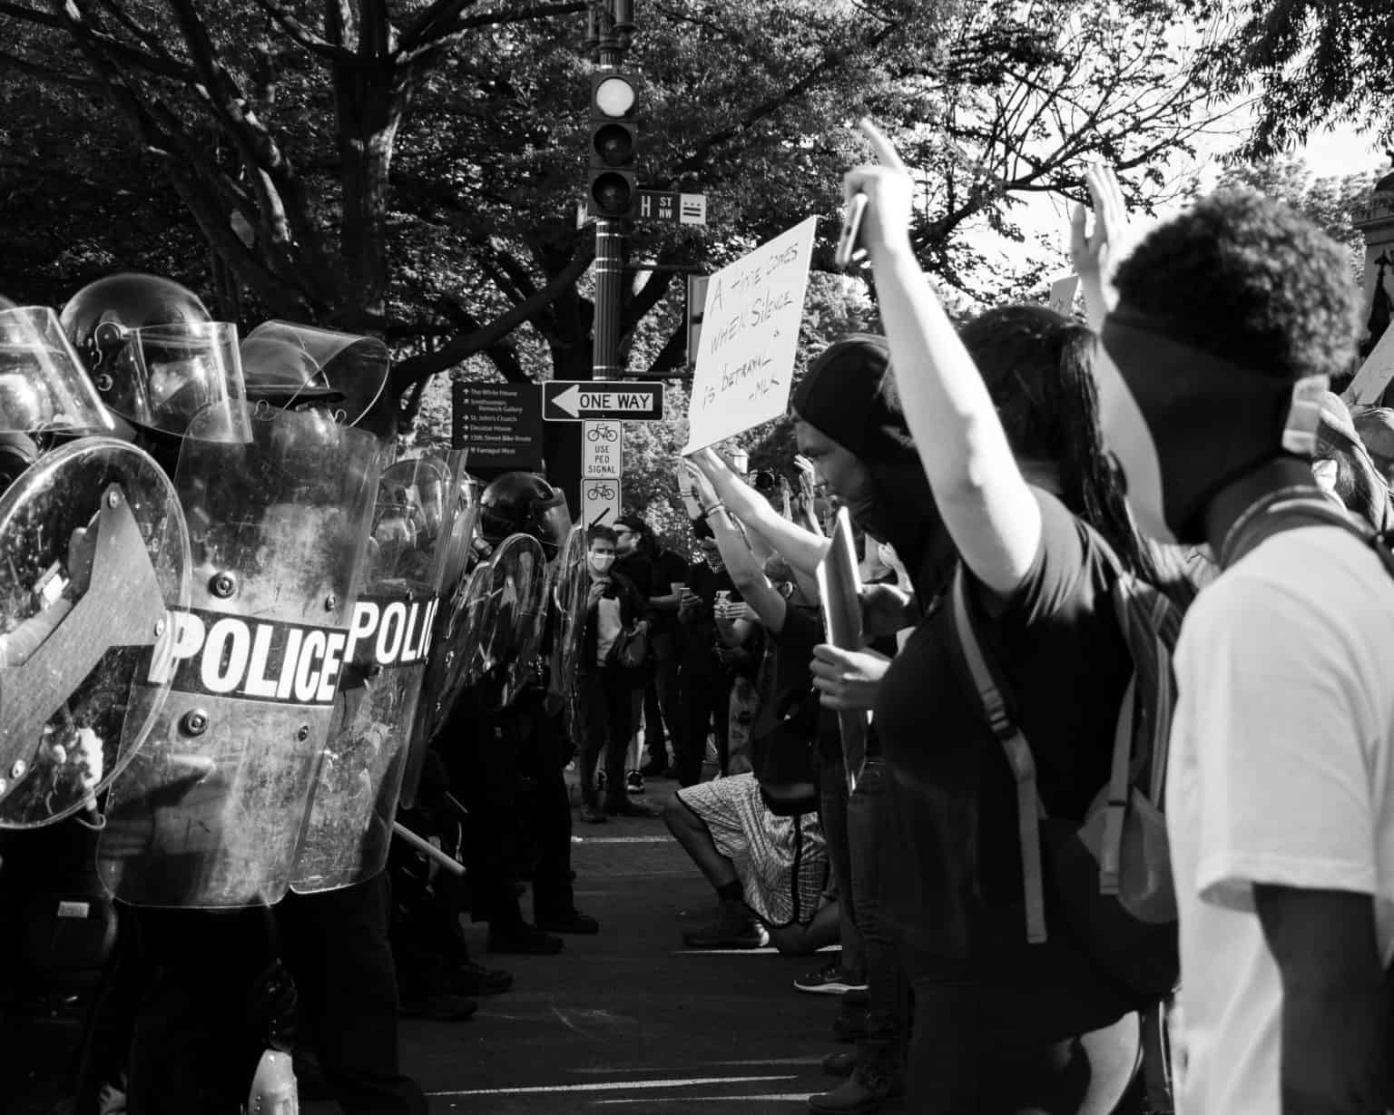
Detailed Description and Analysis of the Photograph
Police brutality is one of the hottest topics in the world. The photograph provided above has a lot to tell when it comes to fighting against the issue, which is steeped deep in racism per se. Looking closely at the photograph one would identify two things: armoured police officers who seem to be ready to confront and civilians who are trying to raise their voices. Between the two groups is a gap that symbolically represents lack of conversation or address of the issue of police brutality.
As mentioned earlier, police brutality is steeped deep in racism. Therefore, if the issue will ever be addressed, then artists believe that racism should be the first thing to be handled. The photograph is focused around protest and this implies that in order to be heard, people has to speak louder.
In recent years, there has been so many incidences of police officers killing innocent people specifically Black people. Lack of accountability and justice in law enforcement has thus far proved resilience that as a result continues to make the issue of police brutality even worse. As demonstrated on the photograph, vulnerable people are filled with futility especially when they see law enforcers try to rail them and criminalize their attempt to air their grievances. The photograph demonstrates how a conversation about police brutality is seen as a reprobate that is always suspended and, therefore, an issue that perhaps will not be solved any soon.
Context in which the photograph was found
Police brutality is a topic immensely explored and, therefore, it was easy to find the photograph by just searching online. Keying “policy brutality” in the search box returned numerous results related to the phrase in question. Figuring out the context in which the phrase was used in one of the selected search results was something that really helped with finding the photograph in the article where it is embedded. By looking at the photograph one would just understand what the article is talking about as it’s placement and context grabs audience attention even before they start reading.
Questions about the Image and Thoughts it Provokes
Some of the questions the photograph raises include:
- Will there be a solution to police brutality if the same law enforcers who are expected to protect the people are the same people to frustrate their attempt to seek justice?
A thought provoked by the photograph is that by eliminating racism, perhaps the society will be a safe haven for everyone and this will be one way of ending police brutality.
Summary of the Selected Readings
- Smith and Rodriguez. Police Brutality Is Not Just A Criminal Justice Issue, But A Public Health Issue Too. NCRC, 2020
In their article, Smith and Rodriguez explain that police brutality is not only a criminal justice issue, but also a public health issue. When police officers shoot or beat people, they cause damages in their bodies, which is the reason why the issue is considered as a health public issue. The issue is also referred to as social determinant of health. While defining the phrase “social determinant of health”, the authors try to explain how police brutality is the leading cause of stress and chronic diseases among vulnerable groups.
Quotations from the reading
Smith and Rodriguez states that “ The repetitive racism that Black Americans experience causes an “allostatic load” that wears down health.” Also, they explain that policy brutality is a public health issue because “it disproportionately affects vulnerable people such as Black Americans. Through structural change, the issue can be solved and as an outcome improve people’s socioeconomic as well as their health.”
- Cooper, Hannah, et al. "Characterizing perceived police violence: implications for public health." American Journal of Public Health 94.7 (2004): 1109-1118.
This reading discusses how police violence impacts people’s health. Also, it highlights race and gender as some of the determinants of public health. According to the article, all people affected by violence whether it is police officers or the victims have negative impacts on their health.
Quotations
“Police brutality is more than a law enforcement issue, but as well as a public health crisis (Cooper and Hannah, et al).” In the article, the authors also state that “police brutality is something that if viewed from a public health perspective, can be prevented and controlled.”
Conversation between self and the two Scholarly Readings
Relating these quotes with the message presented on the photograph, the only solution to the issue of police brutality is “intervening and trying to prevent it”. This goal can only be achieved if the issue is not only handled through criminal justice approaches, but also through public health approaches.
The two readings indicate that there is a model that fits the issue of police brutality more as a public health issue as opposed to a criminal justice issue. If public health approaches are brought in then they could help prevent and reduce violence and the negative consequences of police brutality. Just the same way doctors look at diseases, people should start talking about cause and prevention of police brutality.
As the photograph demonstrates, people do not have to speak louder to be heard. Designing and signing into law proper polices will have the issue solved.

Works Cited
Botkin, Daniel B., et al. "Forecasting the effects of global warming on biodiversity." Bioscience 57.3 (2007): 227-236.
Cooper, Hannah, et al. "Characterizing perceived police violence: implications for public health." American Journal of Public Health 94.7 (2004): 1109-1118.
Roosen, Liselotte J., Christian A. Klöckner, and Janet K. Swim. "Visual art as a way to communicate climate change: a psychological perspective on climate change–related art." World Art 8.1 (2018): 85-110.
Smith and Rodriguez. Police Brutality Is Not Just A Criminal Justice Issue, But A Public Health Issue Too. NCRC, 2020

