Name
Institution
Course
Date
Climate of unintended Consequences
- By Bret Stephens/ New York Times Editor. May 4, 2017.
https://mobile.nytimes.com/2017/05/04/opinion/climate-policy-ethanol.html?reference=https://www.nytimes.com/topic/subject/ethanol

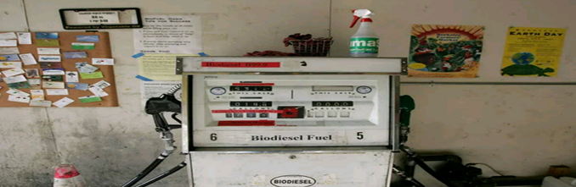
“Climate of unintended Consequences” is an article by Bret Stephens. It talks more about how the climate has changed due to the presence of biofuels.
Key Words: Ethanol and Biofuels
The author argues that George W. Bush made a huge contribution concerning the increase of production of alternative sources of fuel such as ethanol. This concern was spearheaded by increased advertisements of ethanol and biofuel as the main fuels that the future would depend on.
Technological advancements cropped in regarding the production of ethanol and biofuels. Increased production of ethanol was also strategic as it was meant to achieve independence in production and evade any form of terrorism as a result of transportation of these biofuels. The production merely doubles and up to now, it is produced in large quantities which cannot compare to the oden days.
The consumption of motor gasoline has also improved causing more demand for more fuel. Alternative sources of energy such as wind and solar energy have faced stiff competition from the production of ethanol and biofuels. Because of its advantages, countries have continued to use it in large quantities and it is depended upon to provide energy to motors. Scientist have researched on the issue of ethanol consumption and found out that it is a major contributor to the formation of ozone layer which reduces global warming.
This happens when a chemical produced from consumption of ethanol and biofuels react with light from the sun to form the ozone layer. When cars which use ethanol as their source of energy are driven, they emit a chemical which helps in the process of ozone layer which absorbs the strong sun rays which are harmful to human beings and crops. Hence, ethanol is important to the world as it helps them evade consequences of global warming.
In conclusion, this article is important for the reader as it provides a brief history of when ethanol and biofuels started being consumed. Throughout the article, the author emphasizes on the usage of ethanol and how it burns without polluting the environment. As a result, it even allows the ozone layer to form and when this happens, human beings are free from the effects of global warming.

Bret Stephens is journalist in America and has worked with the New York Times magazine. He was borne in 1973 and since then, he has upheld his passion in journalism and editing. Early this year, he was featured by New York Times magazine as one of their renowned political analysts. He has also worked with Wall Street Journal as both a journalist and an editor.

