Name
Instructor
Course Title
Date
Euclid and his Mathematical Theorems
Biographical Information
Euclid was a prominent mathematician famous for his collection of 13 books on geometry. Born around 365 B.C, he grew and flourished in Alexandria, Egypt, during the reign of the first Ptolemy. He is thought to have attended Plato Academy in Athens. Euclid taught and founded a school in Alexandria (Heath). He is considered as the father of geometry because of his outstanding contribution to the subject. Euclid’s textbook, the “Stoicheion” or “Elements,” is considered the most successful mathematical textbook of all time (Grattan-Guinness, 355). The Elements is a clear and comprehensive compilation of all know the mathematics of the time, which offered a great explanation of the works of Pythagoras, Hippocrates, Theudius, Theaetetus, and Exodus.
The total concepts enumerated in the book were 465 theorems and proofs, which were expounded by the use of a compass and a straight edge. To establish proven theorems, the book, Elements, models for the mathematical argument followed logical deductions from initials deductions which Euclid gave definitions, postulates (drawing line from any point to any point) and axioms which he referred as ‘common notion’ (Health). He wanted to base geometry on ideas that were obvious and simple to understand that no one could doubt.
The five general axioms are;
- Things which are equal to the same thing are equal to each other.
- If equals are added to equals, the wholes are equal.
- If equal is subtracted from the equation, the difference is equal.
- Things that coincide with one another are equal.
- The whole is greater than a part.
The geometrical postulates are;
- It is possible to draw a line from any point to any point.
- A finite line can be extended continuously in a straight line.
- With any center and distance it is possible to create a circle.
- Right angles are equal to each other.
- If a straight line crossing two straight lines makes the interior angles on the same side less than two right angles, the two straight lines, if produced indefinitely, meet on that side on which the angles are less than the two right angles.
The volume of elements also contained mathematical formulas for calculating the volumes of solids like cones and pyramids. It also offers proof about geometric series, perfect and prime numbers, and the algorithms for computing Greatest common divisor, GCD, and the least common multiple LCM algorithms. Elements also offered a series of theorems on numbers and integer properties, which informed the early conceptualization of the number theory. The Elements is a collection of 13 books, with each set of books dealing with a specific area of mathematics. Books 1-6 deal with the plane geometry, 7 to 9 deal with the number theory, book ten deals with the Exodus theory of irrational numbers, and 11 to 13 deals with solid geometry. As advanced earlier, Euclid’s discoveries were few and what he mostly did was base his work on those who had contributed to maths before him. Most of the proofs for those earlier works were his, and it can be said he added value to the works of his predecessors. From his works, Euclidian geometry arose, which is the study of points, lines, planes, and other geometric figures.

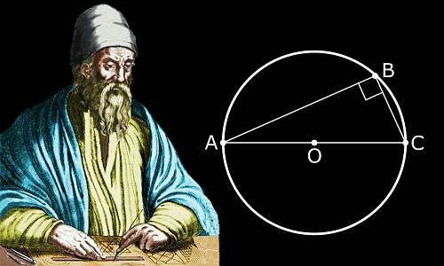
Figure 1: Euclid is widely regarded as the father of Geometry.
Euclid Theorems
Euclid contributed to the development of many theorems through his postulates. He did not only state the postulates but went a bit further to offer the proof for the statements (Janičić, Predrag, and Kordić, 723). His theorems include “pons asinorum,” derived from proposition 5 of book one and is commonly known as the Isosceles triangle theorem. The sum of the angles theorem is a significant theorem that Euclid advanced. Some original contributions from Euclid which is extant include the first Greek treatise on perspective, and the phaenomena, an introduction to mathematical astronomy.
As explained earlier elements do not contain original work of Euclid for the most part. Some contributors who shaped elements include:
- Theudius who was a member of platonic academy who is said to have produced venerable elements which Euclid depended on while authoring his book.
- Hippocrates of Chios who is believed to have originated the use of letters to refer to geometric points and figures in propositions. He is credited with establishing the construction of cube root and invention of the reduction technique.
- Theaetetus of Athens who contributed to irrational lengths which is included in book x of Euclid elements.
- Eudoxus of Cnidus who advanced the proportional theory which led to the development of observational astronomy.
The Isosceles Triangle theorem
The theorem state that angles opposite the equal sides of an isosceles triangle is equal themselves (Eberl). This statement also means that if two angles of a triangle are equal, then the two sides are also equal.
To prove that opposite sides and angles are the same, a bisector is introduced on the base, making the two triangles share a common side; applying the SAS congruence criterion, the two angles are equal. This theory has been developed over the years while still maintaining the original statements that Euclid made.
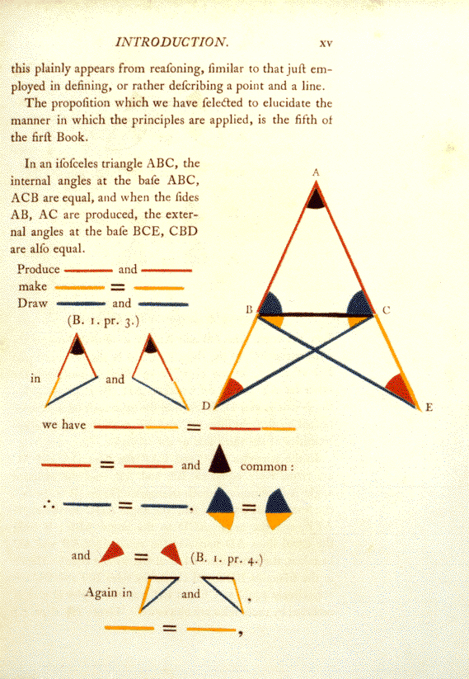
Figure 2: An early edition of Elements showing part of proof for the isosceles theorem.
Euclid added a second conclusion to the isosceles theorem. He observed that if equal sides of the triangle are extended below the base, then the angles between the extensions and the base are also equal. Although Euclid never used this conclusion, proof of it can be found by drawing auxiliary lines to the sides of the triangle. Questions arise over why Euclid opted to include the second conclusion, given that it made proof more difficult. Later mathematicians thought that the second conclusion was necessary to ensure that other propositions which Euclid did not cover were tested under it and rejected if there was no proof. This second proof today is relying upon the Side-Angle-Side, which was also a postulate by Euclid.
- Sum of the Angles of a Triangle Theorem
This theorem holds that the sum of interior angles of a triangle equals 180°. While Euclid did not use the words stated prior, his triangle postulate posited that the sum of angles of a triangle is equal to two right angles. In his first book, Euclid stated, “In any triangle, if one of the sides is produced, then the exterior angle equals the sum of the two interior and opposite angles, and the sum of the three interior angles of the triangle equals two right angles” (Bryne). As seen in figure 3, the initial triangle is ABC. We extend line B.C. to point D. We then draw a line C.E. which is parallel to line A.B. Because A.C. and C.E. are parallel alternate angles ACE and BAC are equal to each other. The exterior angle ECD equal the interior and opposite angle ABC because A.B. and E.C. are parallel and are on the same straight line B.D. ACE was earlier proven equal to BAC; thus, angle ACD is equal to the sum of BAC and ABC’s two interior and opposite angles.
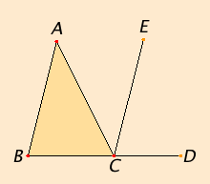
Figure 3: Sum of the angles proof
The sum of the angles ACD and ACB equals the sum of ABC, BCA, and CAB. Keeping in mind that the sum of angles ACD and ABC are equal to two right angles is equal to the sum of ABC, BCA, and CAB. Since the latter statement has been found valid, the theorem as postulated by Euclid that the sum of interior angles in a triangle is equal to two right angles has been proven true. The parallel line theorem holds a central place in the proof of the sum of angles of a triangle theorem.
All the theorems that Euclid participated in writing were all related to maths. Though not famous because of the originality of the ideas, Euclid combined all his predecessors’ maths knowledge and put them together in books. He is much credited for combining all the mathematicians who existed before and during his time and coming up with a book that was easy to understand and therefore making it easier to impart knowledge to other scholars who came after him. His explanations were also straightforward, thus simplifying the perceived complex subject for understanding by many. Some of his postulates can be applied in physics subjects and are not just limited to mathematics.
In geometry, where Euclid is considered the founder, there have been many improvements, although most Euclid postulates still hold up to date. Before the 19th century, geometry, one of the oldest branches of mathematics, was exclusively devoted to Euclidean geometry. The Euclidean geometry includes the line, point, plane, distance, angle, surface, and curve, forming its basis (Krause). However, several discoveries were made during the 19th century, which expanded the scope of geometry, which has continued over the years. Geometry now boasts of several other sub-branches and influences mathematics, having its application in almost all sciences, including architecture, graphics, and arts.
Another development in the field of geometry is one of the rise of non-Euclidian geometry. This is geometry that was not covered by the postulates of Euclid. The field is not large and it mainly explain hyperbolic geometry, it deals with hyperbolic and spherical geometries which differ with Euclidian geometry although they are closely related.
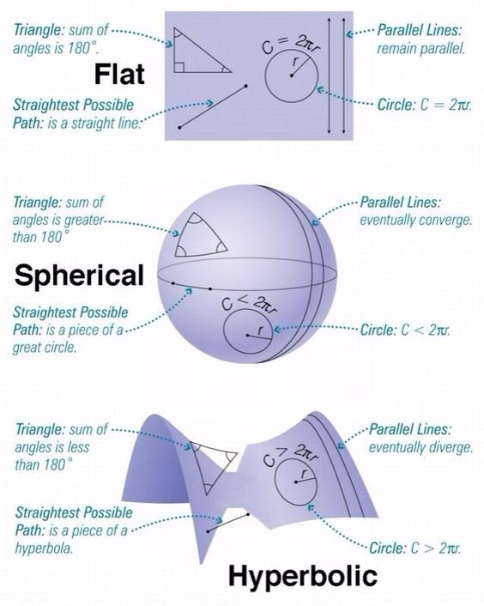
Figure 4: a comparison of Euclidean, spherical and hyperbolic geometry.
The non-Euclidian geometry developed along two historical threads; one it was in the search to understand the movement of the stars and planets in seemingly hemispherical sky. The second manner in which this geometry arose was by trying to proof Euclid five postulate about parallel as a theorem or to modify it. The end result was a theorem which save for the parallel postulate inculcated all the other geometry aspects as advanced by Euclid. The influence of Euclid in the development of geometry is evident because most of his postulates form the basics of the subject through which further progress was able to be made.

Work Cited
Byrne, Oliver. The first six books of the Elements of Euclid: colored diagrams and symbols are used instead of letters for the greater ease of learners. William Pickering, 1847.
Eberl, Manuel. “Basic Geometric Properties of Triangles.” Archive of Formal Proofs (2015).
Grattan-Guinness, Ivor. “Numbers, Magnitudes, Ratios, and Proportions in Euclid’s Elements: How Did He Handle Them?” Historia Mathematica 23.4 (1996): 355-375.
Heath, Thomas Little, ed. The thirteen books of Euclid’s Elements. Courier Corporation, 1956.
Janičić, Predrag, and Stevan Kordić. “EUCLID-THE GEOMETRY THEOREMS PROVER.” Filomat 9.3 (1995): 723-732.
Krause, Eugene F. Taxicab geometry: An adventure in non-Euclidean geometry. Courier Corporation, 1986.
Vitrac, Bernard. “Euclid.” The Encyclopedia of Ancient History (2013).

