Income Inequality
Name
Institution
Course
Date

- How are income and wealth currently distributed in the U.S. today? Use at least three different sets of statistics to illustrate what economic inequality means.
It is broadly said the U.S has been undergoing increasing income inequalities. Incomes include the income streams from profit from carrying out business, rents, dividend, commissions, salary, wage, and interests on saving accounts. The financial crisis 2007-2009 in the United States of America is the trust breakdown that took place among banks (Beaumont 2018). The subprime mortgage crisis was the cause of the financial crisis 2007-2009. The subprime mortgage crisis was caused by the unregulated derivatives use. The Federal lowering interest rates, the securitizing of loans, the pushing into mortgages and housing by the United State government and increasing and huge current account deficits are the main factors which contributed to the financial crisis 2007-2009. The crisis occurred because the banks were able to create too much money, too quickly (Boianovsky 2013). The banks spent the money in speculating the financial markets as well as pushing up the mortgage and houses prices. Each time banks offer loans, new money is created. In just seven years, the banks doubled the quantity of cash and amount of debt in the economy. The debts eventually became unpayable since very little of the too much money created by the banks and other financial institutions went to other sectors outside the financial sector. The levels of personal debts along with the prices of houses were pushed up by lending a large amount of cash into the property markets. Interests had to be paid on each loan that banks created, and eventually, the loans became unpayable since debts were rising faster than incomes. People stopped paying back the loans because they were too expensive and banks found themselves bankrupt. This eventually caused the financial crisis in 2008 (Fisher 2016). The countries involved were majorly the United Kingdom and the United States of America.
The unemployment rate in the United States for the past 4 years has tumbled from eight percent in January 2013, 40-year low of 4.3% (Beaumont 2018). Nevertheless, the decreasing rate has been reduced by the interventions of the government. The U.S parliament has developed the monetary policy goals and objectives that promote and encourage maximum employment in what is known as "dual mandate" as well as the stability of price. The Federal Government is using expansionary monetary policies to foster the growth of the economy (Fisher 2016). The unemployment rates in the United States for six consecutive months have stood at 5.0%, 15-year low which is slightly higher than the market expectations of 4.9%. There are still a lot of debates with regard to the economic health of the United States regarding the Great Recession even though the employee has returned to pre-crisis levels, and the labor market has significantly recovered. Additionally, the economy of the United States is still facing various crucial difficulties and challenges of moving forward, even though the worst effects of the recession are now fading away (Fox and Erickson 2018). Deterioration of infrastructure, government budget deficits, large current accounts, increased medical cost and pension, rising income inequality, and the wage stagnation is all issues facing the economy of the United States.
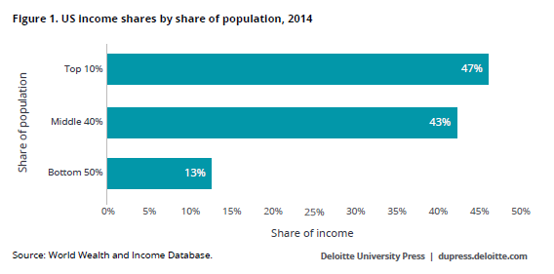
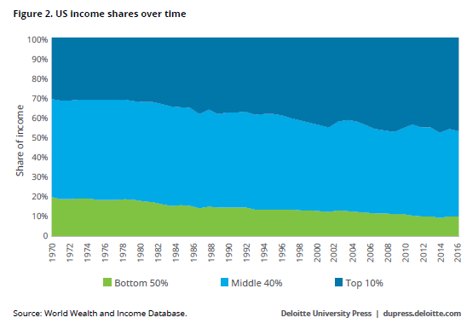
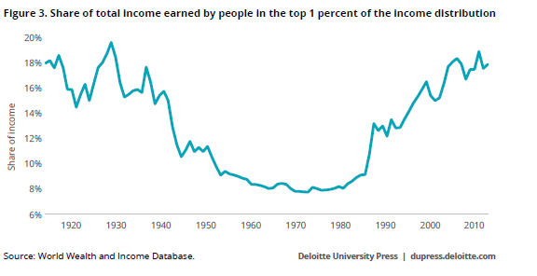
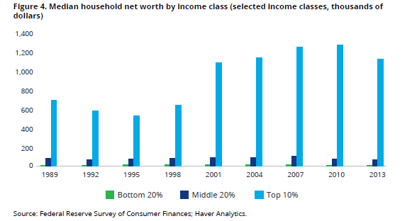
- What are the long-term factors (going back at least three decades) responsible for the current state of economic inequality? Consider economic, political, and demographic/social trends that might help to explain the growing level of inequality.
Since Federal Bank opted to pursue an expansionary monetary policy, it mandated a decrease in the rate of discount, carried out an open market purchase of government bonds or mandated a decrease in the requirements of reserves (Hanappi 2013). There is a decrease in the money purchasing power, the rise in the price level and consumers would not wish to spend more money on buying during the times of higher interest rates and high rate of inflations. By lowering the interest rate, the spending of the consumers increase and the economic growth and development stimulate (Harrison 2018). The Federal Bank tries to accomplish stable economic growth, maximum employment, and stable prices by regulating the interest rate. The U.S government tends to increase the government spending to stimulate the economic growth and development. This has led to fiscal deficits. The largest portion of government spending is supported by the state laws and regulations. Donald Trump government included tax cuts and incentive to foster economic growth during the financial crisis. On the fiscal policy side, the government cuts stimulus expenditures and taxes to avoid and prevent further economic deterioration (Borsoi and Teles 2018). On the hand, the monetary policy like the reserves has tackled the economy’s weakness with both traditional policies and unconventional policies.
A recession leads to a recessionary gap that means that in a full employment situation or scenario, the aggregate demand is at a lower level. The financial crisis 2007-2009 in the United States of America plunged the nation into a deep and long recession and had a disastrous impact on the economy of the U.S. The disturbing impacts included large declines in GDP due to long-lasting and serious unemployment. The decline in the GDP because of the sharp increase in unemployment triggered other afflictions. The GDP declined because in net worth, the households lost $ 17 trillion. Moreover, the prices of homes decreased by 32%. Assets in retirement accounts lost $ 2.8 trillion that was about a third of their values and the stock market declined. The consumer expenditures that usually make up two-thirds of gross domestic product dropped at a yearly rate of about 3.5%. Sharp increases in the United States business bankruptcies and business financing dried up and all these would lead to decline of gross domestic product in the long run. Commercial real estate would also take a thumping and commercial vacancies sharply increase. 20% of all office spaces were not occupied meaning that very few households would secure jobs. This would mean that in the long term, the gross domestic product of the country would decline because the various factors that contribute to the GDP were all negatively affected.
- What are the short-term factors responsible for more recent trends in economic inequality? What events/policy decisions have taken place since 2008 that would help to explain the current state of economic inequality?
The government, banks, and consumers all contributed to unregulated lending and borrowing that in turn established a downward escalating economy (Fisher 2016). As a result to the elimination of the two critical clauses (a 20% down payment and the verification of income, the government never regulated the housing markets at all. Realizing the scale of the banks’ errors, the United States stock market lost all the investment confidence (Fox and Erickson 2018). The panelist of economics predicts that increasing inflations, accelerated by the depreciation of the U.S dollars, will squeeze the households' incomes and depress the consumers' expenditures which in the recent years have been a core economic growth and development driver. The inflation rates have been accelerated by the excess loans offered by the banks and financial institutions for the past years. The Fed predicted the yearly rate highest levels in October 2017. Exceptionally, the high inflation rate accelerated mainly by the sterling pound’s strength, decreasing prices of oil, and prices of the supermarket that kept down the costs of imports from 2014 to 2015, was households’ finances boon (Hanappi 2013). Other economists are however speculating that with the current state global economy, there is a possibility that the Bank of the U.S is going to raise the interest rates even more. Today the Central Bank of the United States of America has been interested that domestic inflation pressures may soon go up. To stave off inflation, Central Bank of America shall tighten the rates of interest and it shall ease the rates to increase economic growth (Boianovsky 2013). If the Bank of England Reserve wanted to pursue a contractionary monetary policy, it could mandate an increase in the rate of discount, carry out an open market sale of government bonds or mandate an increase in the requirements of reserves.
United States economy is currently getting out from the period of considerable financial crisis after the financial crisis 2007-2009 (Borsoi 2018). The government of the U.S intervened by investing billions of U.S dollars to help maintain economic stability. In order to stabilize the financial system, the government of the U.S propped up large floundering companies and organizations. The government also launched a stimulus package to use for the next ten years to improve and boost the economy. The economy has been on a slow and uneven recovery. Through expansionary monetary policies enacted by the government through the Federal Bank, the economy has gotten more help and support (Boianovsky 2013). The expansionary monetary policies include holding interests rates the lower levels, as well as the unconventional government practices purchasing large financial assets, amounts to hold down long-term rates of interest and increase the supply of money that is practice commonly known as "quantitative easing". Such policies enhance investment in the U.S. The central bank controls money supply and credit by using monetary policy and fiscal policy to accomplish stable economic growth, maximum employment, and stable prices by regulating the interest rate (Beaumont 2018). Through expansionary monetary policies, the government has able to promote investment within the economy.
- Is the level of economic inequality we are currently experiencing harmful to the overall US economy? Provide evidence to support your analysis.
A recession leads to a recessionary gap that means that in a full employment situation or scenario, the aggregate demand is at a lower level. The government shall typically increase the expenditure in order to minimize this gap that shall directly increase the curve of the aggregate demand. To reduce the contractionary gap, we should reduce the taxes and increase the spending of the government. The policy of expansionary is developed in stimulating the economy during the business-cycle contraction anticipation. Ceteris Paribus (other factors held constant), increase in the spending of the government on services as well as goods would be expansionary policy and therefore increases the aggregate demand. Larger government budget deficits increase the borrowing demand. Increase in the demands for borrowing increase the increase in the interest rates magnitude, as a result crowding out more private sectors (Fisher 2016). The expansionary fiscal policy may make the government take much time to recognize that there is having challenges and problems. A recession is not officially realized until there are two consecutive negative growth quarters. Expansionary fiscal policy can also take state quite a lot of time to formulate, debate, and implement. The recognition lag problem is that the period the state realizes and reacts to the recession; there is already self-correction of the recession. The expansionary fiscal policy might then overheat economy setting the country for another crash of the market.
- What role did the issue of economic inequality play in the 2016 and 2018 elections? Do you expect it to be an important feature of the 2020 elections?
The relationships between measured economic inequalities and political sentiments are so significant to comprehend, even though it is counter-intuitive at first glance. In fact, the actual divergent is true, because Donald Trump did not prevail in the states where the inequality increased but rather in the states that had minimum inequality rise. For exact results are that the fourteen results that include Columbia District with the greatest rise in the income inequalities for more than a quarter-century, without exceptions, voted for Democrat candidate, Hillary Clinton. The reasons are that in America, the voters do not react to inequalities at the levels of the state nor do they perceive inequality directly. Instead, the state-level inequality measures the political and economic features of the states.
States where inequalities have sharply rises such as Connecticut, California, New Jersey, and New York tend to have rich towns where rapidly and large increasing immigrant, low-income, and minority communities and where liberalism reigns. This is the reason they are not equal. And both their political communities’ branches yet fall within the Democratic Party circles. On the other hand, Republic states tend to be rural and suburban with minority voting blocs and not so rich in the cities which are either kept from polls or somewhat smaller from the polls by whatever voter suppression means may be available, particularly in this era of post-voting-rights. Moreover, we can also see that the vital states won by Trump such as Ohio, Pennsylvania, Michigan, and Wisconsin, are all states in which industrial decays have limited the minority growth voting populations and the great cities wealth. These states were always electoral battlefields and were often divided comparatively narrowly. The balance shifted towards the republicans in 2016, not because inequality increased but because they had not increased by adequate.
Ultimately, we may see that across Southwest and South, Arizona to Texas to North Carolina, inequality has been increasing in states long safe for the Republicans. The states are undergoing their rise among comparatively among Hispanic and other immigrants and liberal urban professionals. Both forces slanted toward Democracy Party. In 2016, for example, in Texas, Clinton acquired 3% more of the vote Obama obtained in 2012.
References
Beaumont, P.M., 2018. ECESIS: an interregional economic-demographic model of the United States. Routledge.
Boianovsky, M., 2013. Before Macroeconomics: Pareto and the dynamics of the economic aggregate. Revue européenne des sciences sociales.European Journal of Social Sciences, (51-2), pp.103-131.
Borsoi, N.D.S. and Teles, V.K., 2018. Fiscal multipliers in bad times: does the nature of a recession matter?.
Borsoi, N.D.S., 2018. Does the nature of a recession matter?: some calculations on fiscal multipliers (Doctoral dissertation).
Fisher, F.M., 2016. Adjustment processes and stability. The new palgrave dictionary of economics, pp.1-6.
Fox, M.J.V. and Erickson, J.D., 2018. Genuine Economic Progress in the United States: A Fifty State Study and Comparative Assessment. Ecological Economics, 147, pp.29-35.
Hanappi, H., 2013. Money, Credit, Capital and the State.In The Two Sides of Innovation (pp. 255-281).Springer, Cham.
Harrison, L.E., 2018. The Pan-American dream: do Latin America's cultural values discourage true partnership with the United States and Canada?.Routledge.

