Exam 1 MAST418.618 2021 Name: ____________________________________

Expected answer lengths are in parentheses after each question.

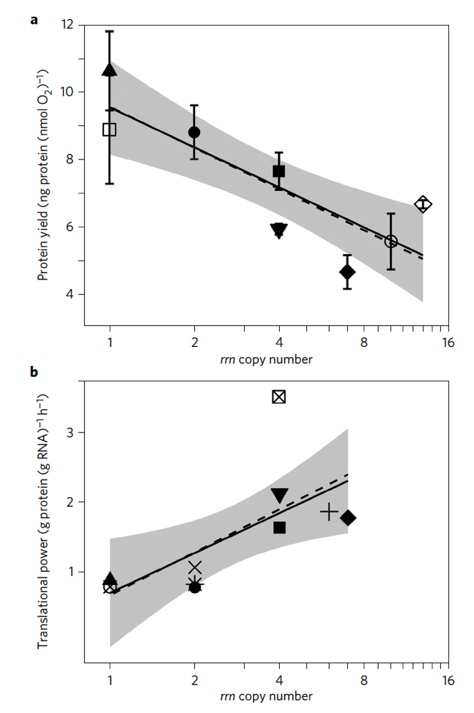
- In the Roller et al. 2016 paper, this graph of protein yield or translational power vs ribosomal copy number was used to help explain how ribosomal genes are representative of microbial growth strategy. (answer: labels and 1 paragraph)
10 pts
- Label where a copiotroph and an oligotroph would be on the top graph (make sure to distinguish which is which).
- What explains how organisms with 1 copy of a ribosomal operon (rrn) make more protein per O₂ than one with 10 copies?

- Arrange these organisms from smallest to largest: zooplankton, viruses, protists, bacteria (1 line)
5 pts

- What is the “great plate count anomaly” and how has it impacted microbiology? (~2 paragraphs)
10 pts

10 pts
- What are some reasons that genome sizes vary between bacteria and eukaryotes? (max 3 paragraphs)
- Give an example of a fermented food that is a combination of both bacterial and eukaryotic fermentation. Explain briefly how that fermentation occurs in the food and what cycle of the food preparation it occurs in. (max 3 paragraphs)
10 pts

2 pts
- Silica is important for which type of microbial cell? (1 sentence)

- What is a limiting nutrient for bacteria in the surface ocean in the middle of the Atlantic Ocean? (1 sentence)
2 pts

- Explain how cells can maintain their osmotic balance in the ocean. (1 paragraph)
6 pts

15 pts
- What is an advantage of motility in the ocean for a microbe? What is a disadvantage? What is an alternative lifestyle? (max 3 paragraphs)

- What is a characteristic of microbial communities regarding their diversity and evenness? (max 3 paragraphs)
10 pts

2 pts
- What is an OTU? (1 sentence)

2 pts
- Name 2 different ways that you can obtain an organism’s genome. (max 2 paragraphs)

5 pts
- Describe a scenario where a cell may have an apparent concentration of DNA that is higher than what is expected based on its genome. (1 paragraph)

- Of the following: water, pH, temperature – which creates the greatest stress for microbial life? (max 3 paragraphs)
10 pts

1 pt
- Name a fermented food not yet mentioned in this exam. (1 sentence)

