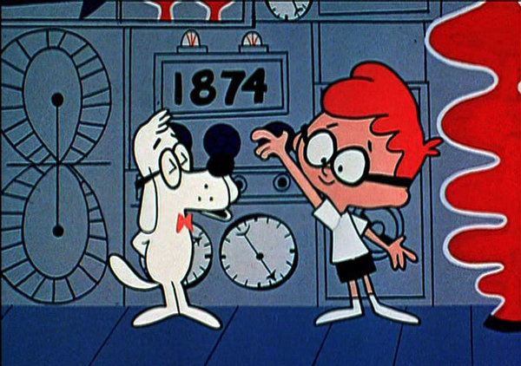
Name: [insert name here]
Mr. Peabody and Sherman turn the dial to set the date for the WABAC machine.

Mr. Peabody and Sherman embark on one of their adventures into the past to study chemotherapy agents. Using the WABAC (pronounced way-back) machine, they travel to the 1960s when paclitaxol (taxol) was discovered and determined to be a candidate for cancer treatment.

1.) Taxol can change the behavior of a cytoskeletal filament; what filament does it target? [1pt]

[your answer here]

Taxol, a chemotherapy medication, targets the microtubules of the cytoskeletal system in cells.

2.) There are two motor proteins that can move along this cytoskeletal filament; one can move in the direction of the + (plus) end and another can move in the direction of the – (minus) end.

2a.) What is the name of the motor protein that moves towards the + (plus) end? [1pt]

[your answer here]

The motor protein that moves towards the + (plus) or positive end of microtubules is kinesins.

2b.) What is the name of the motor protein that moves towards the – (minus) end? [1pt]

[your answer here]

The motor protein that moves towards the - (minus) or negative end of microtubules is called dyneins.

3.) The motor protein that moves along the + (plus) end uses what as an energy source to power its motion along the filament. What is the chemical that provides the energy for the motor protein? [2pts]

[your answer here]

The chemical that provides energy for kinesin that facilitates its movement along the positive end of the microtubule is Adenosine triphosphate(ATP). ATP is broken down into mechanical energy to facilitate the movement of the motor protein.

4.) Describe the major parts of the motor protein that can move alone the filament to the + (plus) end. (I’m looking for 3 major parts). [3pts]

[your answer here]

Kinesin has 3 major parts, a pair of globular heads, that bind to the microtubule and break down ATP. A stalk that is rod-like and is made up of 2 heavy chains and a tail that resembles a fan and has 2 light chains and 2 heavy chains.

We examined many different signaling pathways in class. Regardless of whether or not a signaling pathway went through a steroid hormone, a G-Protein Coupled Receptor or Receptor Tyrosine (RTK) Kinase/Mitogen Activated Protein Kinase (MAPK) receptor there are three generalized steps that occur after ligand binding.

5.) Describe a pathway with the 3 different steps (if you want to include more steps, you can for extra credit!) and include where the step occurs, outside of cell, cytosol, nucleus etc. [6pts]

[your answer here]

The steps involved in signaling pathways include are Reception; in which receptors from a cell bind to a ligand, a ligand is a molecule that accepts signals. This occurs outside a cell
Transduction; this is the 2nd stage in which the ligands enter the cell membrane of the target cells directly and bind to intracellular receptors in the nucleus of cell or they can bind to 2nd messengers on the cell membrane of the target cells. This can occur in the nucleus or cytoplasm.
Cell response; in this stage the effect of a signal can be amplified and changes will be observed in the cell. This can occur

You are studying a MAPK signalling pathway in yeast that is involved in mating signalling. You have isolated mutant yeast that are unable to respond to the mating factor and you suspect that the mutation is in the MAPK, Ste7.

- ) What protein status changes would happen to the Ste11, Ste7, and the Fus3 protein if Ste7 is mutated? [4pts]

[your answer here]

The Ste11 protein will be phosporylated in the mutant yeast while the Ste7 and the Fus3 will not be phosporylated in the mutant yeast.

The protein changes that would occur if the Ste7 was mutated would be a reduction in the RNA levels transcribed from the gene sets.

7.) Which protein will be phosphorylated at the sites you expect? (don’t worry about the sites per se, just if it would be phosphorylated or not) [4pts]
[your answer here]

The Ste11 protein will be phosporylated in the mutant yeast while the Ste7 and the Fus3 will not be phosporylated in the mutant yeast.

Your experiments reveal that the Ste11 protein is phosphorylated normally, but Ste7 and Fus3 are not phosphorylated in the mutant yeast. You determine that the Ste7 protein is wild-type and has no mutation that would impact function in the yeast. You then realize that the only remaining component to investigate is the Ste5 protein that acts as a scaffold to bring Ste11, Ste7 and Fus3 together. This implies that protein-protein interactions have been altered in your yeast that are unable to respond to the mating factor signal.

The interaction between Ste5 and Ste7 has been disrupted.

Please give me 2 experiments that can prove that Ste5 and Ste7 interact under wild-type circumstances and when there is a mutation, Ste5 and Ste7 cannot interact.

8.) Experiment 1. Use confocal microscopy to examine the Ste5-Ste7 interaction. [6pts]

[your answer here]

Using the confocal microscopy, the laser will illuminate the interaction of ste5 and ste7 under wild-type circumstance; phosphorylation will occur while eliminating background fluorescence while in the case of a mutation, there will be no emission as phosphorylation will not occur.

9.) Experiment 2. You clone Ste5 and Ste7 and then transform them back into yeast. You have determined that the Ste5 and Ste7 interaction requires specific domains of Ste5 and Ste7. Ste5 has a blob domain and Ste7 has a wiggle domain.

9a.) You must first determine that the blob and wiggle domains are necessary for the Ste5-Ste7 interaction. Give me a transgenic experiment to test that these domains are necessary for protein-protein interaction [4 pts].

[your answer here]

A transgenic experiment that could be employed is the Maximum Likelihood Estimation method where the probabilty of interactions between the pair of domains is measured.

9b.)You have proven that the blob and wiggle domains are necessary for Ste5-Ste7 interaction.
Give me a transgenic experiment to test if the blob and wiggle domains are sufficient for a protein-protein interaction [4 pts]

[your answer here]

A transgenic experiment that could be employed is the Maximum Likelihood Estimation method where the probabilty of interactions between the pair of domains is measured.

10.) Which of the following ligands can cross the plasma membrane to signal? [2 pts]

a.) Ca²⁺ b.) glucocorticoids (including cortisol, estradiol, testosterone)

c.) glucogon d.) epinephrine

[your answer here from the a-d above]

Glucorcortids(including cortisol, estradisol and testosterone) are an example of ligands that can cross the plasma membrane to signal with intracellular receptors in the nucleus or cytoplasm.. Glucorcortids are steroids.

11.) Question 10 was an example of a ligand that can cross the plasma membrane to signal.

11a.) What physical property of this ligand allowed it to cross the plasma membrane? [2 pts]

[your answer here]

Glucorcortids are hydrophobic steroids and can thus diffuse into plasma membrane.

11b.) Why can’t the other ligands physically do this? [2 pts]

[your answer here]

The other ligands cannot cross the plasma membrane to signal as they are hydrophilic, thus, they bind to 2nd messengers on the cell membrane of the target cell.

12.) Upon activation of the G-protein complex, what does the α subunit exchange to then disassociate from the trimeric complex? I’m looking for the molecule bound to the α subunit when it is separate. [2pts]

[your answer here]

The alpha sub-unit binds to the Guanosine triphosphate molecule(GTP) when the complex is active and the sub-unit has separated from the trimeric complex.

13.) The G-protein complex effector in this can result in the production of cAMP. What is the protein that makes the cAMP (the protein is located in the plasma membrane)? [2pts]

[your answer here]

The integral membrane protein that makes the cAMP is the adenyl cyclase, this is the activated effector molecule.

14.) The α sub-unit hydrolyzes GTP into GDP, thereby deactivating itself. Is the α sub-unit an example of a timer or a switch? [2pts]

[your answer here]

The alpha sub-unit is an example of a timer. This sub unit deactivates in 2 ways, it could either slowly hydrolyze GTP into GDP thus deactivating slowly or the GTPase activating proteins(GAP) could speed up the deactivation process.

15.) A protein binds to the phosphorylated receptor to prevent binding of the trimeric G-protein complex. That protein is known as? [2pts]

[your answer here]

The Arrestin protein binds to the phosphorylated receptor to prevent binding of the trimeric G-protein complex.

