Sweeper Company
The information about Sweeper Company and the calculations are discussed below;
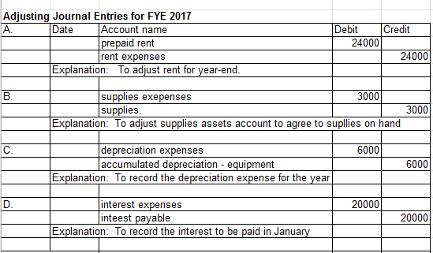
The adjusting entries are entered in the excel sheet as above.
The adjusting entries for the prepaid rent, supplies on hand, depreciation expenses and interest to paid, are journalized as above.

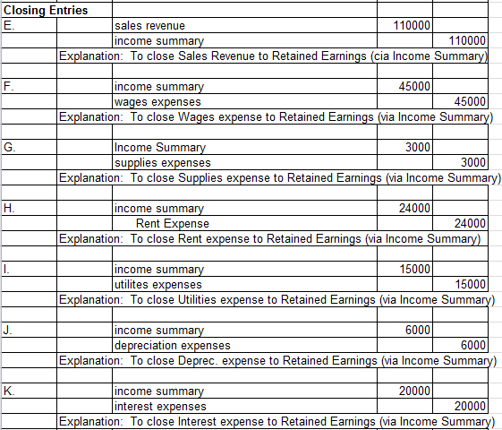

The above shows the closing entries of the revenues and expenses and retained earnings as above
The journal entries are posted in the following T-accounts namely;
- Cash
- Accounts receivables
- Equipment
- Accumulated depreciation
- Notes payable
- Common stock
- Supplies
- Prepaid rent
- Accounts payable
- Interest payable
- Retained earnings

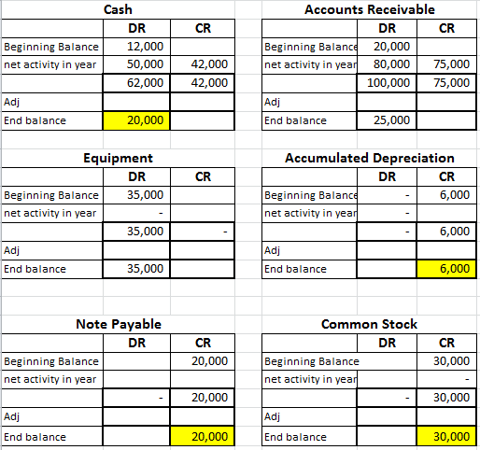

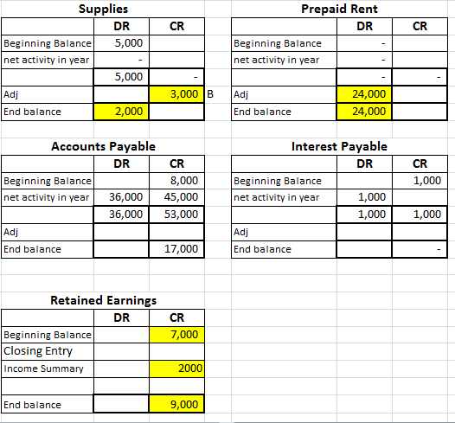
The balance sheet transactions are listed as The sales revenue, wages expenses, supplies expenses, rent expenses, utilities expenses, depreciation expenses, interest expenses are as follows;
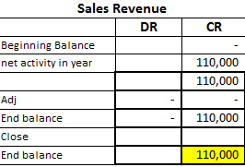
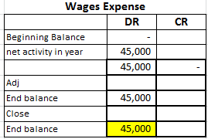
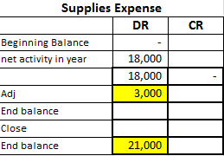
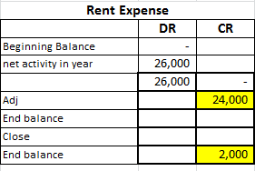
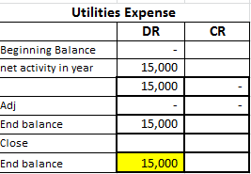
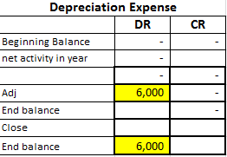
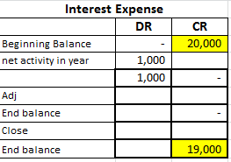

The income summary showing total revenues and expenses and net income are calculated as follows;
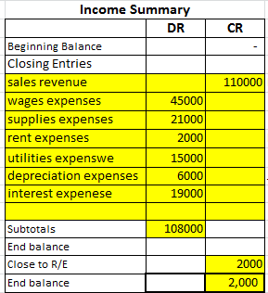
The revenues – the expenses = net income or loss
The above income summary shows net income the revenues are greater than the expenses so it gives the net income.
The adjusted trial balance and adjustments are depicted as follows;
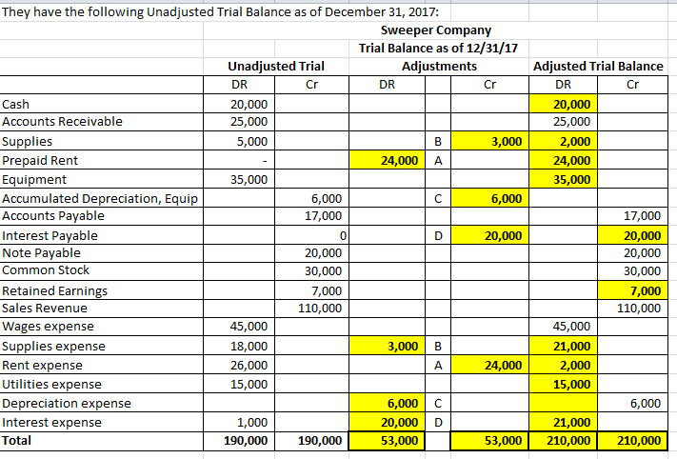
The statement of cash flows like operating activities, investing and financing activities are listed a follows;
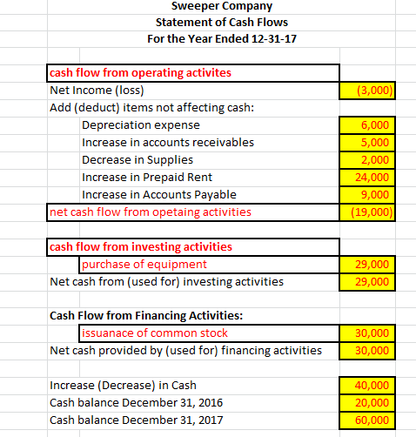

The income statement are calculated as below
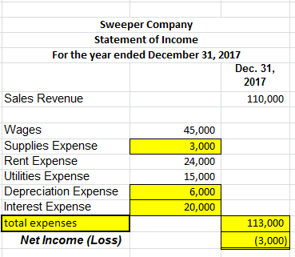
The statement of retained earnings is calculated as below;
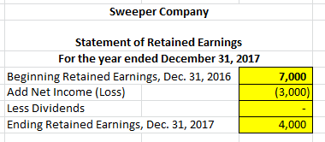
The balance showing assets and liabilities of two years are calculated as below;
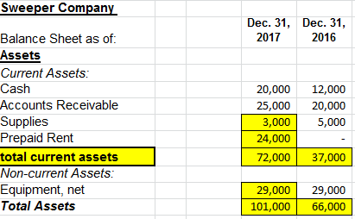
The total assets of the balance sheet of the two years is calculated as above
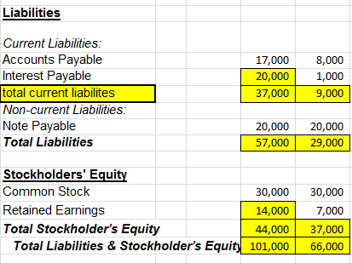
The total liabilities of the two years are calculated as above.
The sweeper company’s financial statements are shows that the profit of the company is increased when compared with the previous year.

