Oil Industry
Name
Institution
Date

The Oil industry has become quite sensitive to the global market shits given that the currency exchange as entangled into the oil prices movement in the global market. For instance the major driver of lower prices of Oil in the global market is a strong United States Dollar currency. This more often than not goes unnoticed in the global market analysis of the Oil Industry. Given the oil prices are dominated by the United States Dollar, whenever the US Dollar strengthens, the prices of oil fall for the consumers of the United States of America when everything else is held in equilibrium (Volkov, & Yuhn, 2016). There is the exception however, that the oil prices do not experience the same shifts in other regions as product purchases by consumers is not dominated by the US Dollar. A fall in the oil price of the US Dollar dominated regions does not, therefore, experience similar shifts whenever the Dollar Strengthens.
The implication given by this relationship between oil prices and currency exchange rates are significant for the oil refinery industry and they influence the global growth, national budget and also geopolitics. The figure below, for example, show the price change of crude oil since the peak of prices in the year 2014, June 19th. The price, in the wake of the Corona Virus Pandemic, has had the biggest drop in prices in the Oil industry and has yet to recover even 50% of the prices in the peak of 2014. From the left top are the oil importers including Japan, South Korea and Europe while on the right are oil exporters including Nigeria, Norway and Russia. Despite a general decrease of oil prices in all currencies, there is clarity in that the fall has not been equally experienced.
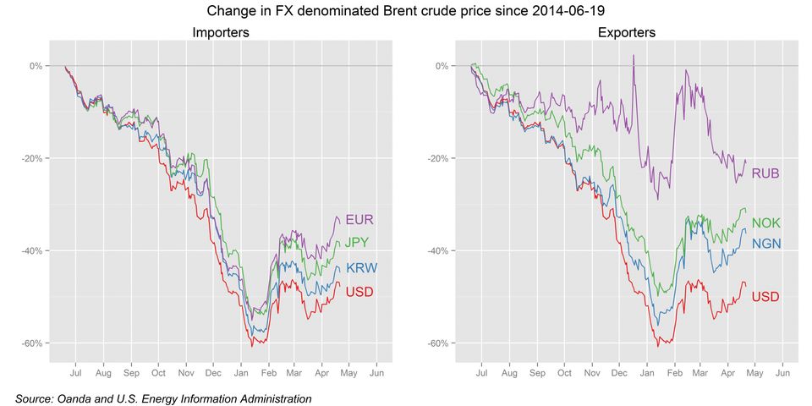

Weakening economic growth outside the United States of America is anticipated to give the economy a shot in the arm as oil prices keep falling (Volkov, & Yuhn, (2016). Falling oil prices in the importing countries means lower cost of consumption and therefore increase the disposable income which translate to lower cost of production and improving accounts in the importing nations.
Contrary to general expectation, whenever currency rates drive down the oil prices, the result is not accelerated demand for oil products in other countries as is the case in the United States of America. A lesser fall of prices, as can be seen in the charts above, is noticeable for the economic zone dominated by the Euro Currency, EUR, where the Eurozone oil price have fallen only by 14% lesser than those of United States of America Dollar and regions dominated by the UD Dollar since June. It remains therefore, that the Euro zone economies have not experienced the level of economic lift that the United Sates of America has experienced as a result of low oil prices.
Oil exporters whose currency is not dependent on the US Dollar currency, oil price have a less decline. Russia (RUB), Norway (NOK) and Nigeria (NGN) clearly show this patter n as opposed to their peers like Saudi Arabia, Iraq and Iran. Not to mention, a fall in oil prices has a significant damage on the economies and the national budget of these countries and the oil industry as a whole. Given that the lower oil prices are arising from exchange factors, the lower prices are due to the rise of the dollar cushions (Habib, Bützer, & Stracca, 2016). Utilizing a dollar dominated price to analyze the pressure of the oil producing nations that are not pegged on the US Dollar exchange rate is a misleading outlook on the oil industry as whole. Using Russia, as an example, Ruble dominated oil prices only fell at 7% from June 19th, when the oil prices were at peak up until March 2nd 2015 where they fell in term of Ruble as their currency grew in strength. The fall in rubble dominated price however, was not as bad as experienced in other regions where Russia sells its oil. Since a cheaper Ruble makes it more expensive, the net macroeconomic effect of Ruble depreciation is highly dependent on the current account of Russia (Habib, Bützer, & Stracca, 2016).
The exchange rates have a great impact in the inflation of economies and thereof impacting oil prices. The best way that a plyer in the oil industry can benefit the shifts of currencies is to diversify the business in regions that have oil prices dominated by different currencies and not only US Dollar dominated regions. There are different customs to predict forthcoming deviations in rates. For example, the use of econometric models then exchanges rates forecast and the parity in purchasing power.

References
Habib, M. M., Bützer, S., & Stracca, L. (2016). Global exchange rate configurations: do oil shocks matter?. IMF Economic Review, 64(3), 443-470.
Volkov, N. I., & Yuhn, K. H. (2016). Oil price shocks and exchange rate movements. Global Finance Journal, 31, 18-30.

