Exercise 11: Upheaval Dome Virtual Field Trip

Geology Lab 111 Name__________________________________________________
Objectives:
- Learn about the geology of Canyonlands National Park
- Recognize and use learned terminology and ideas from structural geology, sedimentary rocks, igneous rocks, and mineralogy
- Learn how to assess and compare competing geological hypotheses
The virtual field trip is at
https://vft.asu.edu/VFTUpheavalDome/panos/UpheavalDome2020/UpheavalDome.html

For this you must:
- Allow Adobe Flash Player to work in your browser. Go to your browser’s preferences to do this. Look up how to do this if you don’t know how to do it.
- Have a good internet connection. This will not work in an offline environment at all.
- Do not click back on your browser. You will be taken out of the field trip.
- Know how to create a screenshot with your particular device. Look this up if you don’t know how to do it.
- When watching the videos, you may want to hit the “CC” button so it shows captioning. That might help you follow along especially if some of the words are unfamiliar (like the names of rock units). But do beware, I noticed that on the “Possible breccia” video the closed captioning mistook the spoken word for breccia as “wretches,” “Brett Jay,” and “brushes.”

For Everyone in the Group

Watch the introduction and tutorial videos and answer the following questions:
- This virtual field trip takes place where? What city is nearby? What state is this? What national park?

- What do most geologists think Upheaval Dome represents?

Then Click “Start Trip”
When you see this view
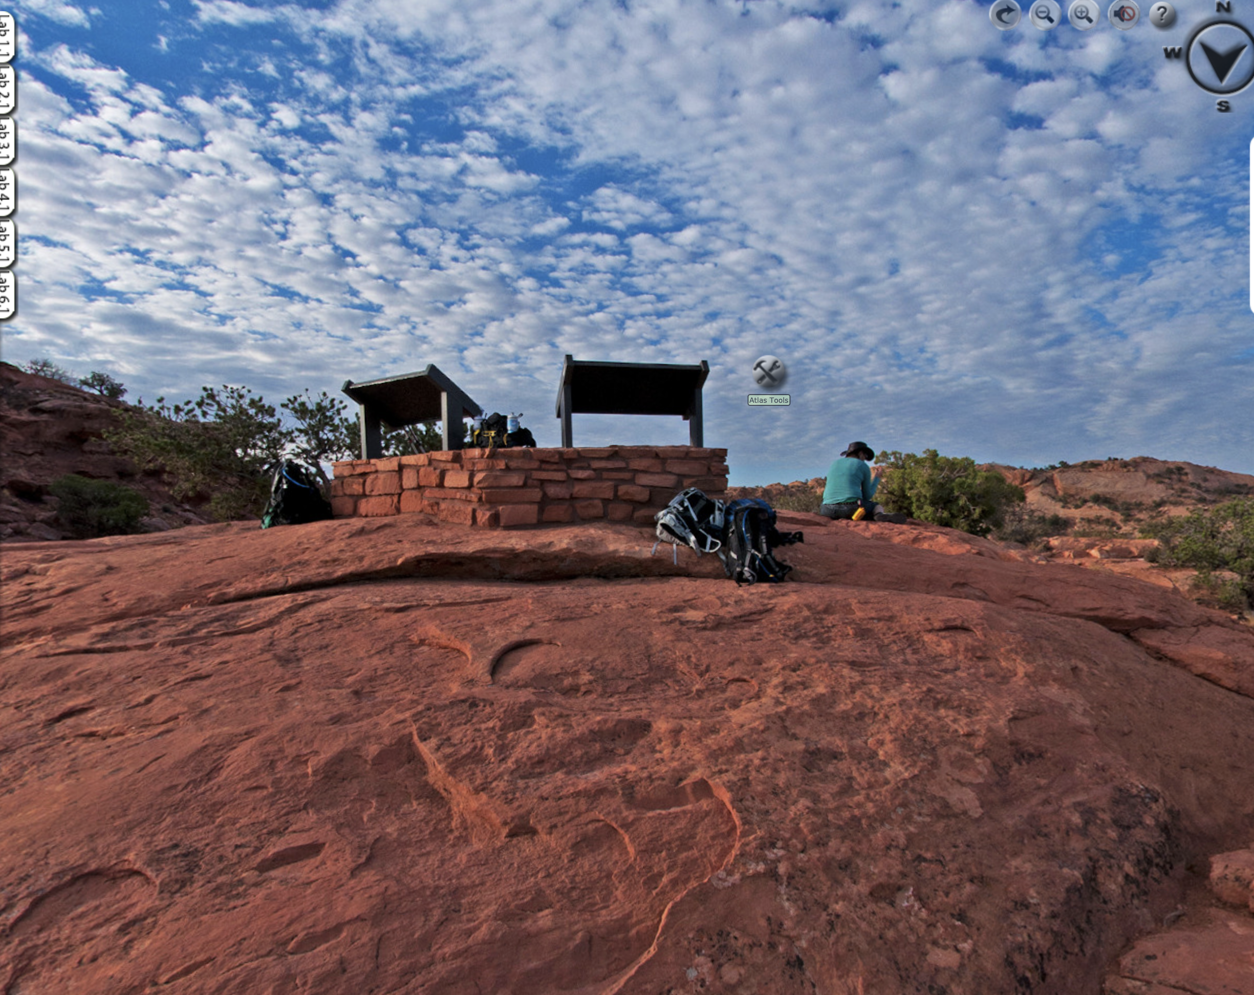
click on “Atlas Tools” near the middle of the image.
A popup subwindow in the lower left will appear.
Click on “Canyonlands GEO Atlas.”
Within this Atlas, find the answers to the following questions.
Under “Show me the rocks”
- Make a list of the 11 different sedimentary rock layers found in the Park. For each one list its name, age, and depositional environment. Go from top to bottom.
Name | Age—Years Ago and Period | Depositional Environment

- During what two geological Eras were the rocks in this area formed? Note, Eras are longer than Periods. You need to refer to the geologic time scale to answer this.

- What rivers flow through the Park? Use the Interactive geologic map link.

- In what district of the Park are there lots of faults? Use the Interactive geologic map link.

- Explore the district from question 6 and answer the following:
  - When did the grabens form?

  - How did the grabens form?

  - What is a graben? Insert a screenshot from this part of the material to illustrate your answer.

  - What kind of fault is associated with horsts and grabens? Look this up.

  - What kind of stress did this area experience to form these faults, horsts, and grabens? You should remember this from what you learned about these faults.

Click out of the Canyonlands GEO Atlas and click the “Media” tab to close that subwindow.

Move the image over to the view over Upheaval Dome.
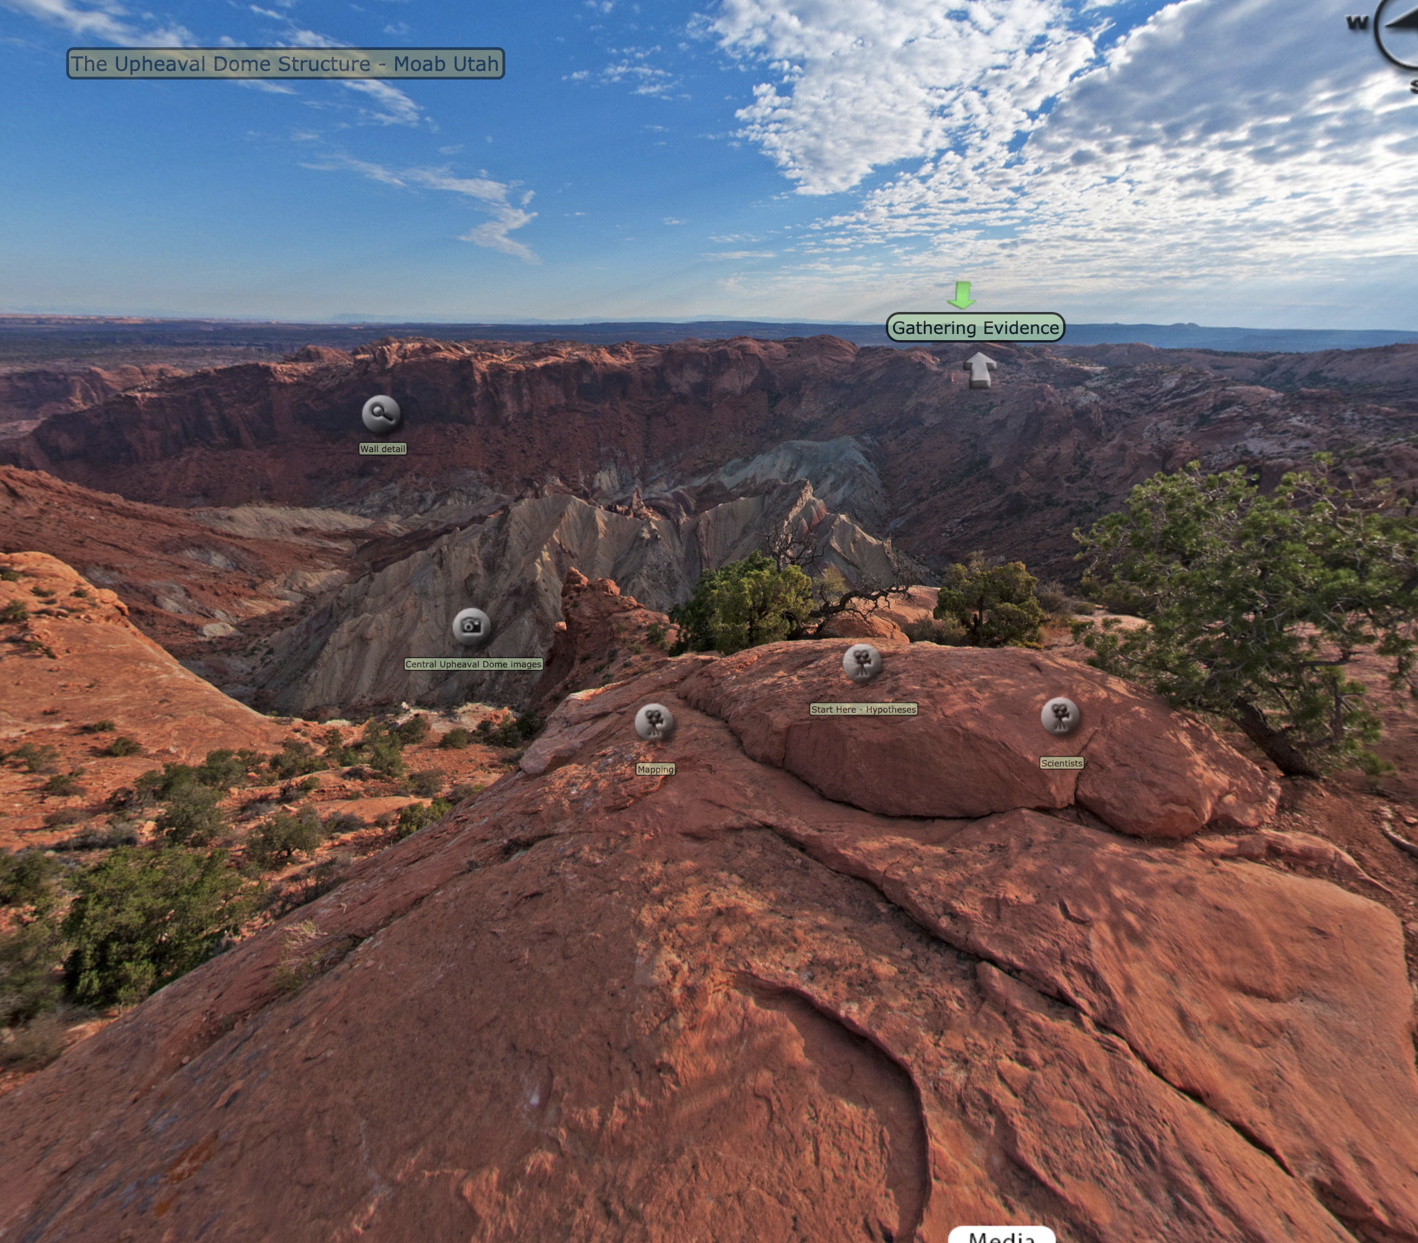
Near the middle of the image you will see “Start Here—Hypotheses.” Click on that.

Start Here--Hypotheses
- What led Gene Shoemaker to first think that Upheaval Dome might be an impact crater?

- What is the salt dome hypothesis for the formation of Upheaval Dome? Watch the “Salt dome” video under Sediments for question #27 to better understand this idea.

- What is the name and age of the formation in this area that is made of salt and what is its stratigraphic position in the area (meaning is it a layer near the bottom, in the middle, or near the top of all the different sedimentary layers)?

- What is so special about the behavior of salt as a rock when it is buried under other rocks? Would you say the salt behaves in a brittle or a ductile fashion?

- What energy resource is associated with salt structures?

- Watch the Salt history video. In it, Dr. Hudec mentions the “Salt Men of Iran.” Check it out online and insert a picture of one of them here. Amazing.

- In the Impact preference video, Dr. Hudec makes an assertion about the popularity of the impact hypothesis. What is it and do you think it is a reasonable assertion or one that involves emotion? Why or why not?

Now click on Mapping to the left and watch “Dome problems”
- What did Dr. Hudec discover about the type of stress that formed the structures within Upheaval Dome after he mapped it?

- What problem did that cause for the salt dome hypothesis? Explain. What structures would form over a salt dome? (Look back at the answers in question 7—no salt dome there, but same type of stress. Also, check out this video.
https://www.youtube.com/watch?v=QzuhWYlg7wc

Close that subwindow and go to “Exploring the terrain.”
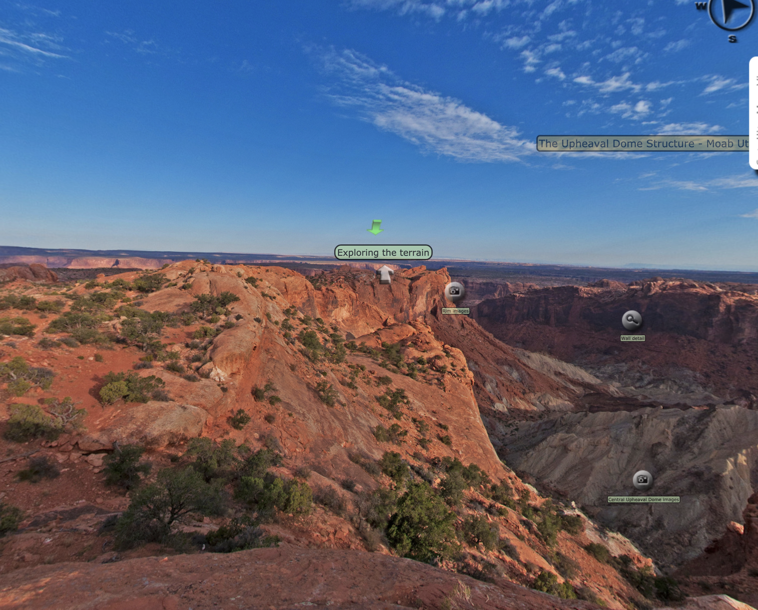

Exploring the terrain
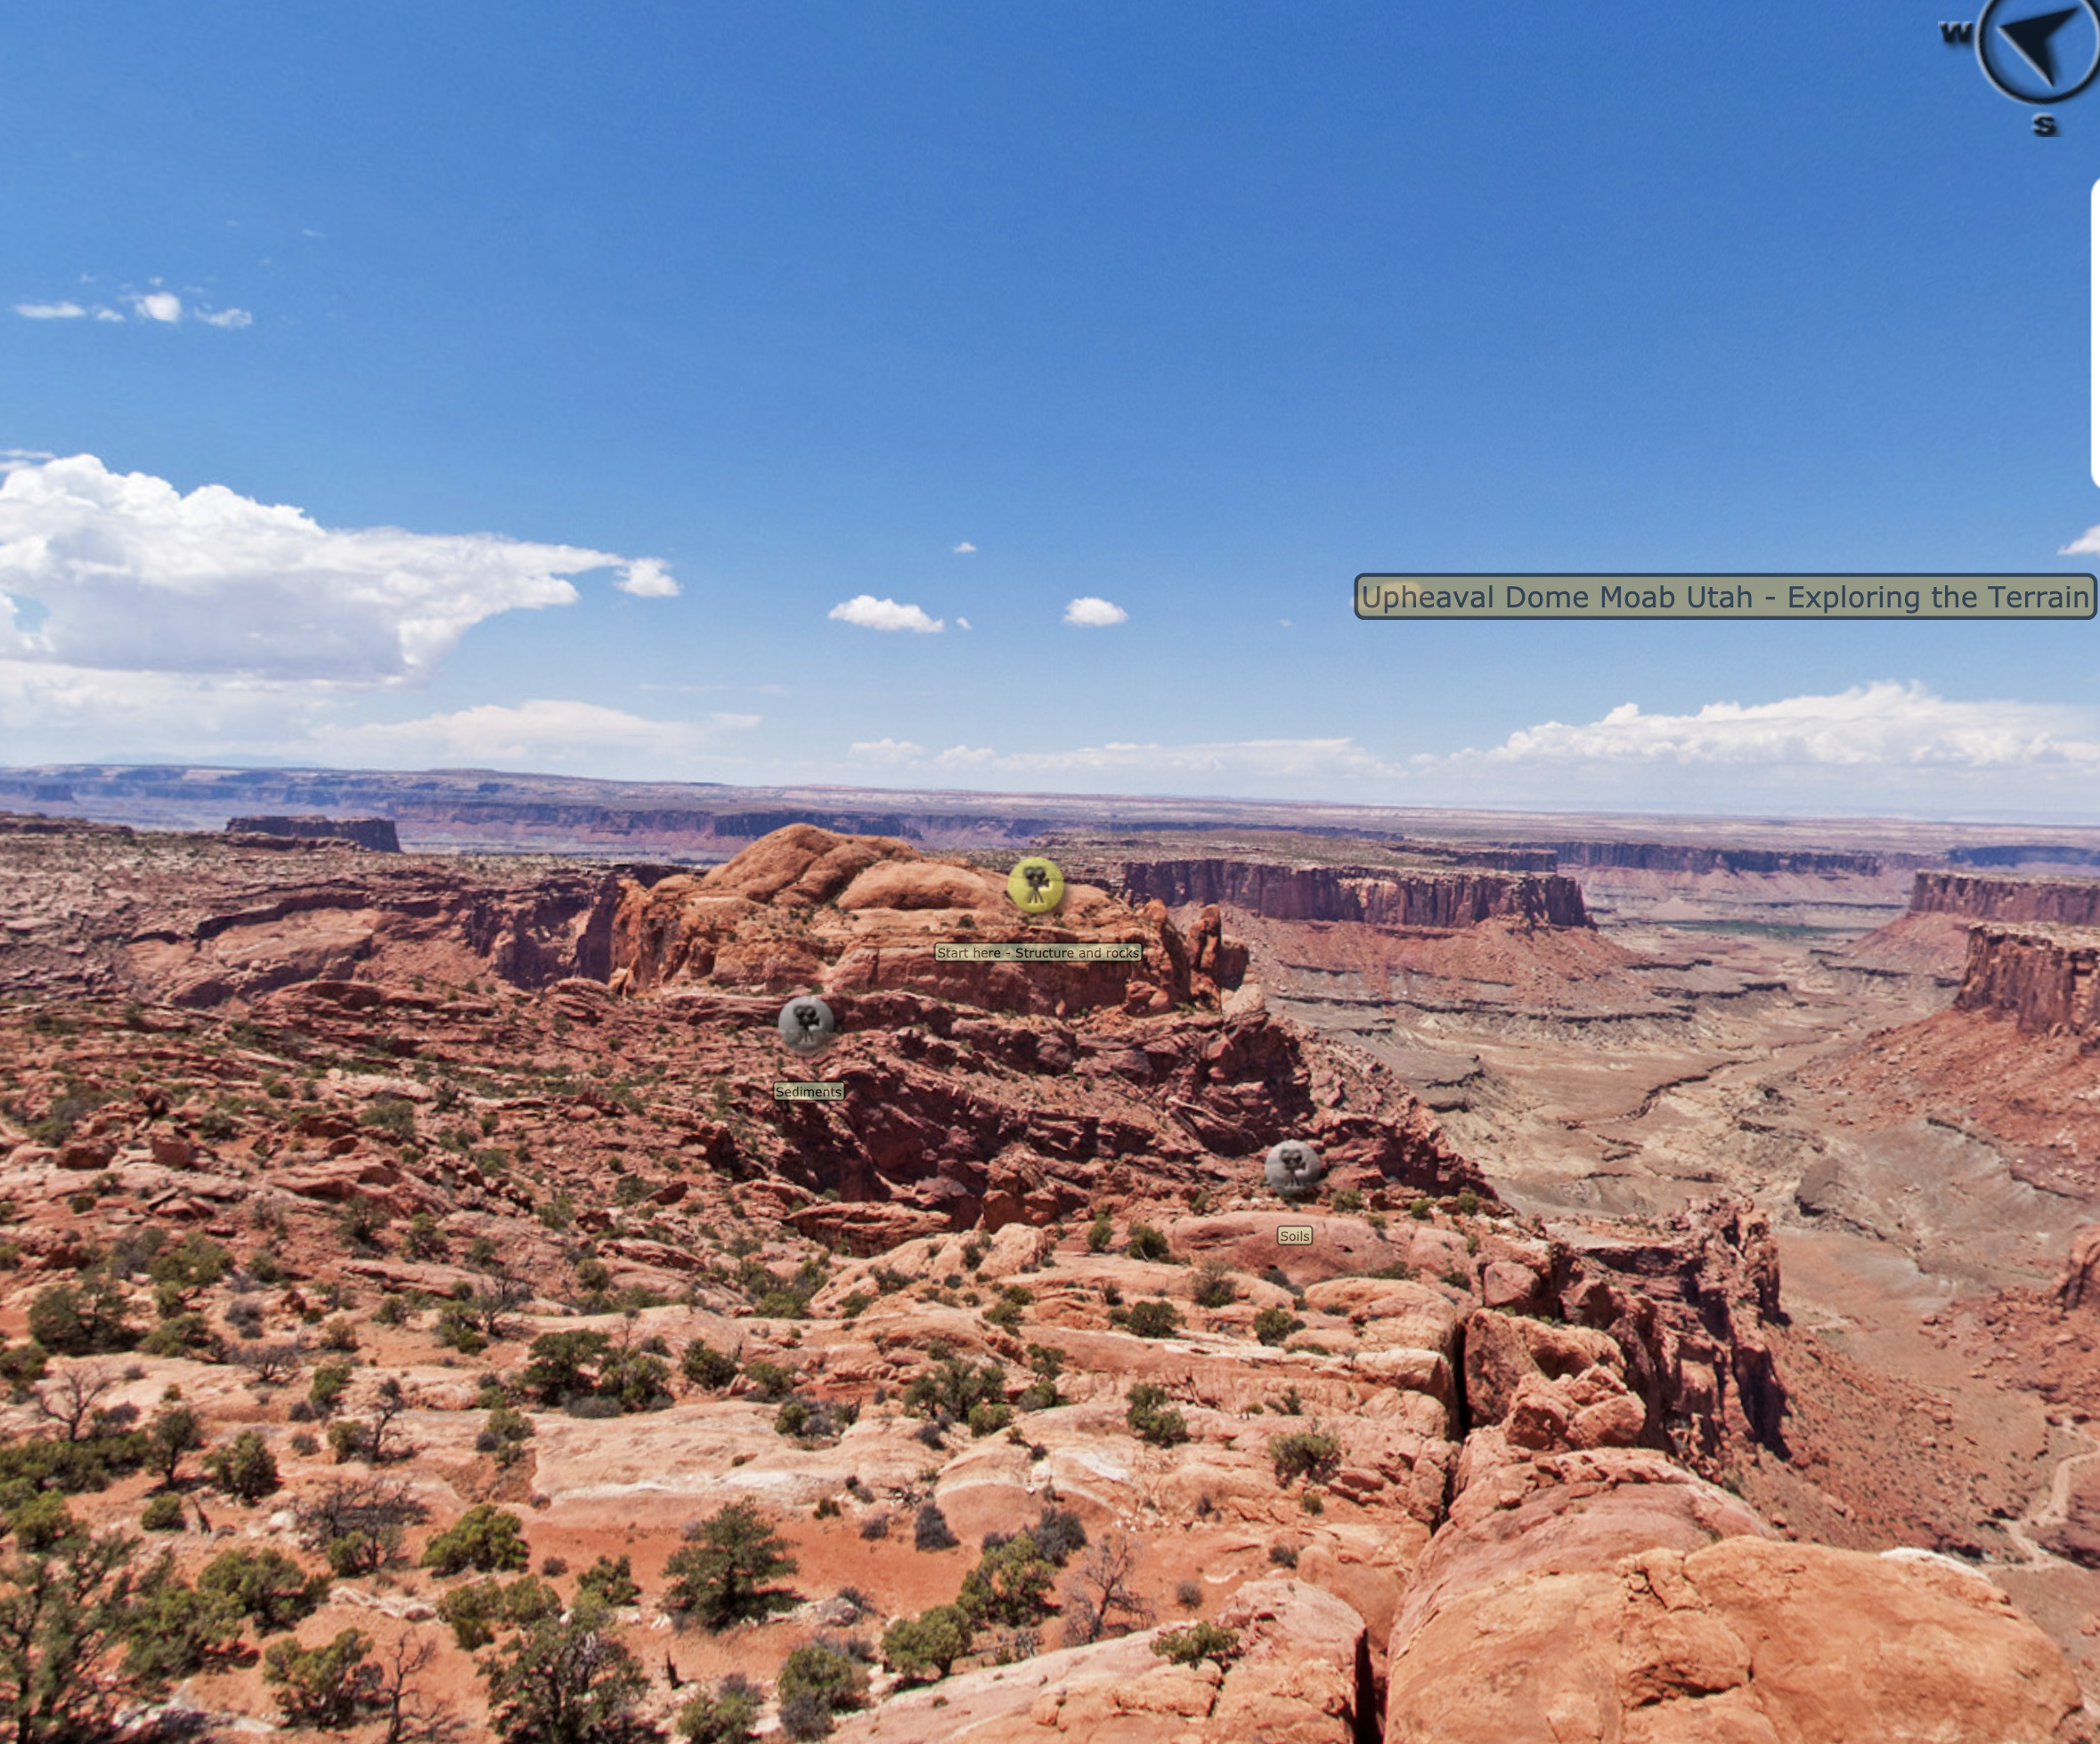
Click on “Start here—Structure and rocks.” Watch “Structure of the Colorado plateau” and “Thickness changes” to answer the following questions.
- Why is Upheaval Dome considered a dome?

- According to Dr. Hudec, what kind of evidence would indicate that there was a salt dome structure at Upheaval Dome?

- Think about the age and position of the salt in this area. As the sediment of the overlying formations was deposited over millions of years, we would expect the salt to have behaved in the way that Dr. Hudec describes. What exactly does he say about the actual structure of the overlying rocks around Upheaval Dome? You can quote word for word here if you want (use the CC option for assistance).

Click out of that and click on “Sediments” to the left and watch one of the videos about crossbedding, the “Desert varnish” video, the “Ground water erosion” video, and the “Salt dome” video to answer the following questions.

- Take a screenshot and insert it here to show what crossbeds are.

- How does crossbedding develop and what does it represent?

- What is desert varnish?

- What is desert varnish made of?

- What causes desert varnish to form?

- Why is there uncertainty regarding the formation of desert varnish?

- Would desert varnish be a definitive sign of microbial life on Mars if we discover desert varnish there?

- What is ground water sapping? Use the CC on this video to help you here if needed.

- Watch the Salt dome video and refer back to the answer from question 9. You can copy and paste that answer here to explain how a salt dome might have formed Upheaval Dome.

Click out of that and click on “Soils” to the right and watch the videos to answer the following questions.
- Get a screenshot of the cryptobiotic soils and insert it here.

- What are cryptobiotic soils?

- What are stromatolites? Look it up. Insert a picture of the living ones found at Sharks Bay in Australia here to illustrate your answer.

Click out of that and pan to the right.
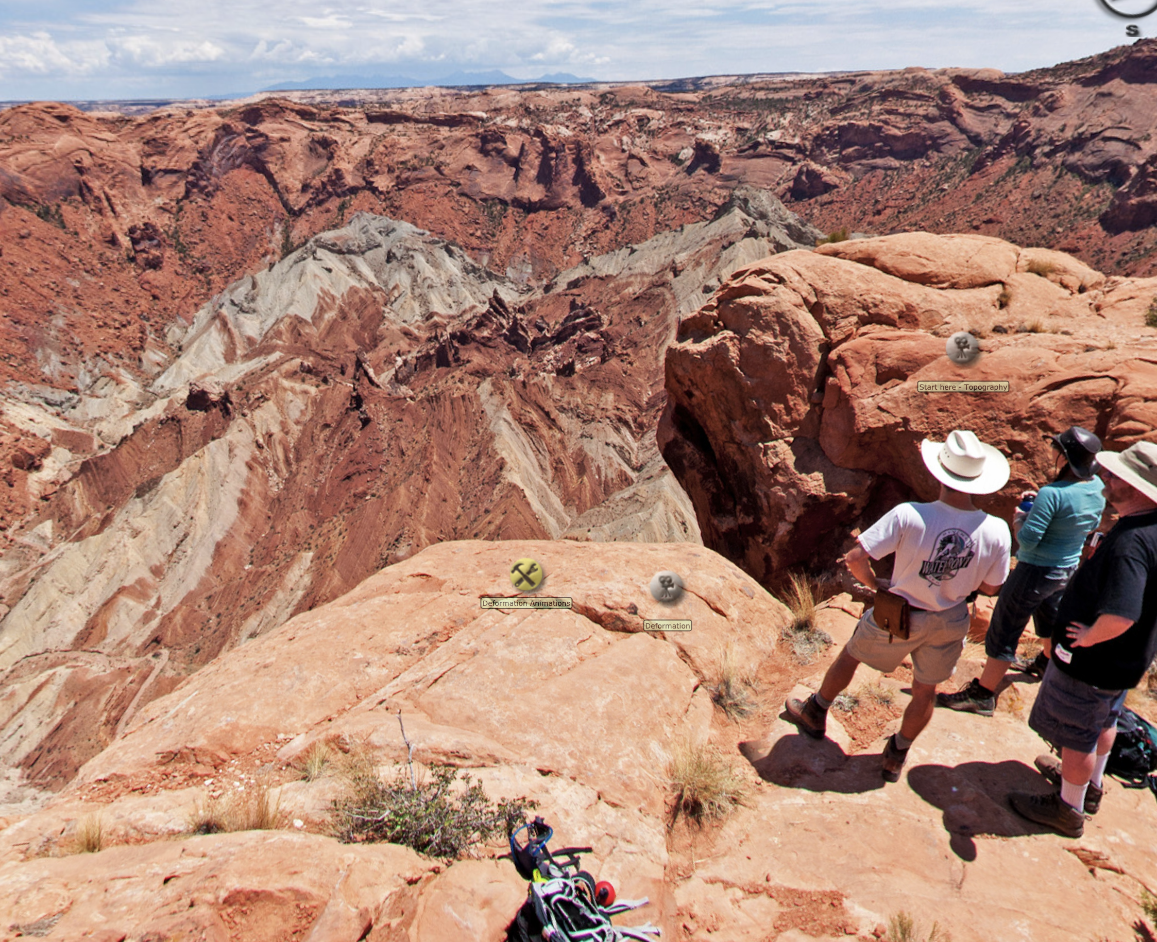
Click on “Deformation Animations” and watch the crater animation. Compare it to the video in this link https://www.youtube.com/watch?v=QzuhWYlg7wc on salt diapir (dome) formation and answer the following questions.

- How does the formation of an impact crater compare to the formation of a domed up area of a rising diapir of salt or to the area underneath a rising diapir of salt? Take screenshots and annotate them if you like to compare the two processes. Create extra space here if needed.

- Would you expect there to be more faults at the bottom of an impact structure compared to the area underneath a rising diapir of salt?

Click out of that and click on “Start here—Topography” near the man’s white hat and watch the videos to answer the following questions.
- What is going on with the White Rim Sandstone within the central part of Upheaval Dome as discussed in the “Ring syncline” video.

- What is inverted topography?

- Why are the rock layers around the edge of the structure folded?

Click out of that and click on “Deformation” to the right of “Deformation Animations” and watch the videos to answer the following questions.
- In the “Folded riverbed” video, take a screenshot of the folded sandstone he is talking about and insert it here.

- In the “Thrust fault” video, take a screenshot of the thrust faults he is discussing and insert it here. Draw a line on it showing where you think one of the thrust faults is. A thrust fault is a low-angle type of reverse fault, so look for a fairly flat, but slightly inclined lineation that seems to separate overlapping layers of rock.

- What kind of stress causes folding and thrust faulting?

- Dr. Hudec discusses the pros and cons of impact and salt dome in three of the videos. What is his conclusion from the evidence?

Go to Gathering Evidence.
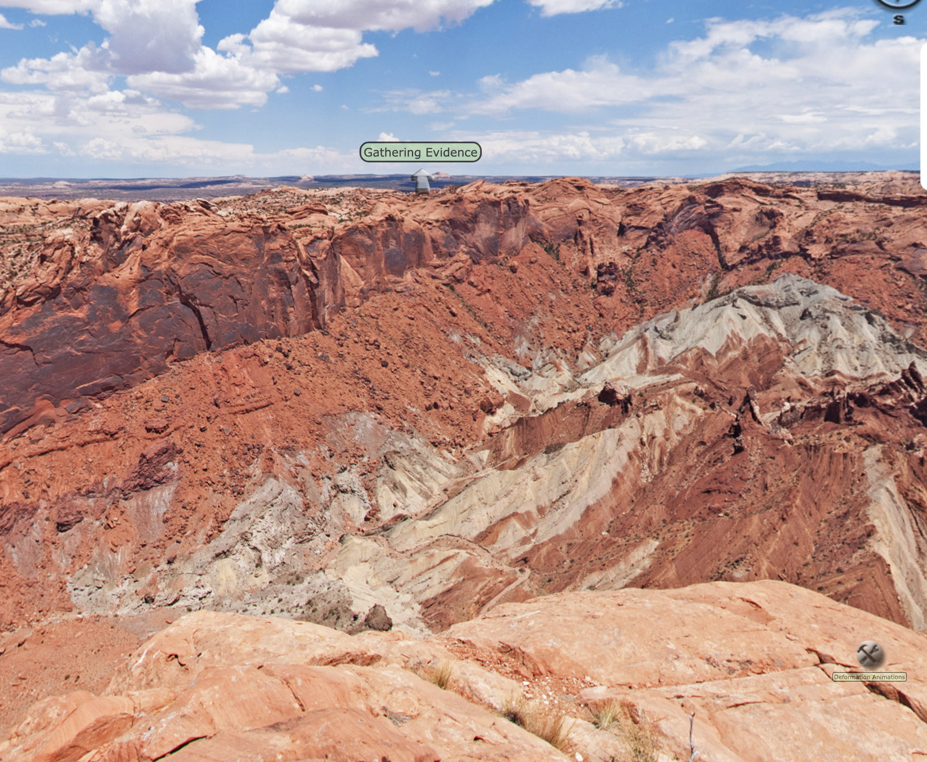
Gathering Evidence
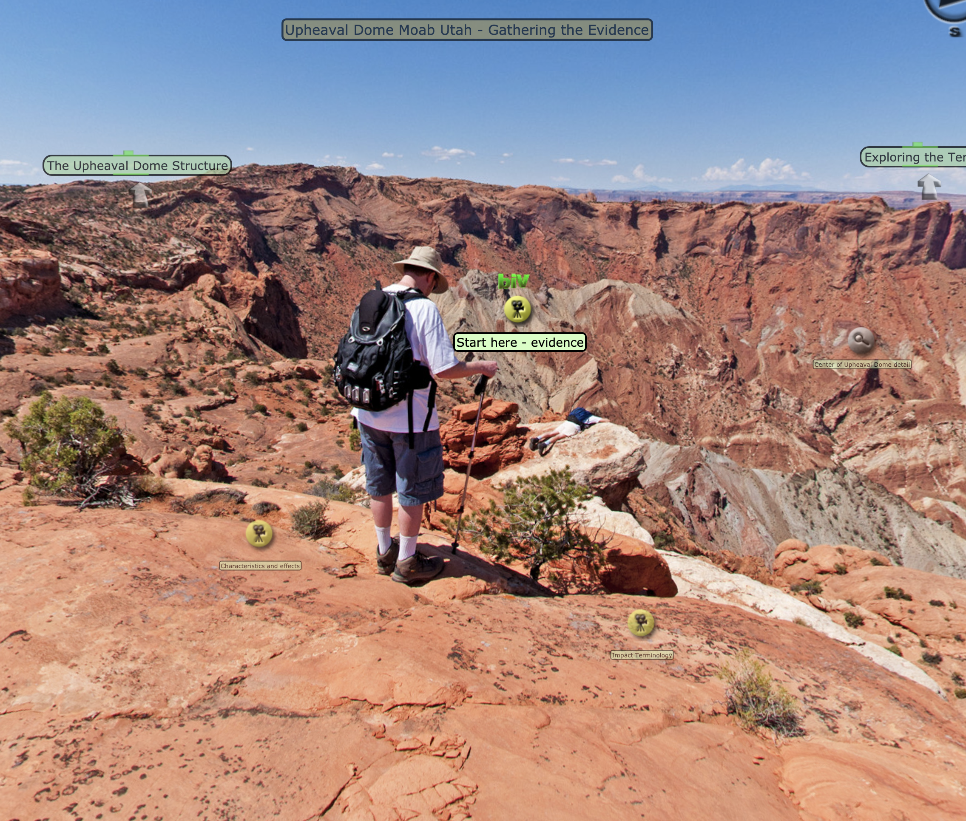
Watch the videos under “Characteristics and effects” and answer the following questions.

- How did erosion affect the crater in the impact crater model?

- How do the salt dome people invoke the idea of erosion to support their model?

Click on “Fractures, faults, and features” to the right to watch videos to answer the following questions.
- What is shocked quartz and how is it evidence for an impact?

- Is there enough shocked quartz at Upheaval Dome to require formation by impact? Explain.

Go back to the area to the left (questions 41 and 42) and click on “Start here—evidence” to answer the following questions.
- What is the evidence for an impact at Upheaval Dome?

- What is the evidence for a salt dome forming Upheaval Dome?

- Discuss with your team what they thought about this and record your team’s conclusions here. It is fine to disagree. If you do, just briefly summarize why. If you feel no conclusion is possible, explain what you feel you would need to be convinced one way or the other.

