Exercise 12 Criticality of Metals

Geology Lab 111 Name___________________________________________

Objectives:
- Introduce concept of metal criticality
- Learn which elements are of interest and why
- Think through possible solutions

To understand the concept of metal criticality, read the abstract from “Criticality of Metals and Metaloids” by T.E. Graedel et al. published in the Proceedings of the National Academy of Sciences of the United States on March 23, 2015.

“Imbalances between metal supply and demand, real or anticipated, have inspired the concept of metal criticality. We here characterize the criticality of 62 metals and metalloids in a 3D “criticality space” consisting of supply risk, environmental implications, and vulnerability to supply restriction. Contributing factors that lead to extreme values include high geopolitical concentration of primary production, lack of available suitable substitutes, and political instability. The results show that the limitations for many metals important in emerging electronics (e.g., gallium and selenium) are largely those related to supply risk; those of platinum group metals, gold, and mercury, to environmental implications; and steel alloying elements (e.g., chromium and niobium) as well as elements used in high-temperature alloys (e.g., tungsten and molybdenum), to vulnerability to supply restriction. The metals of most concern tend to be those available largely or entirely as byproducts, used in small quantities for highly specialized applications, and possessing no effective substitutes.”

The entire paper: https://www.pnas.org/content/pnas/early/2015/03/20/1500415112.full.pdf

In the paper, the authors present their methodology as well as their results. Understanding their methodology is beyond the scope of this class, so we will move forward without questioning their methodology. However, it is important to realize that a detailed analysis like this has many different data inputs, some of which may be flawed. Their methodology also includes statistical analysis which we are not evaluating. In short, instead of questioning their results (as academic peers of the authors would) we will accept their results and use them to think through some of the issues related to metal supply.

Consider this graphic from the paper:

Here is a list to decode the names of the elements:

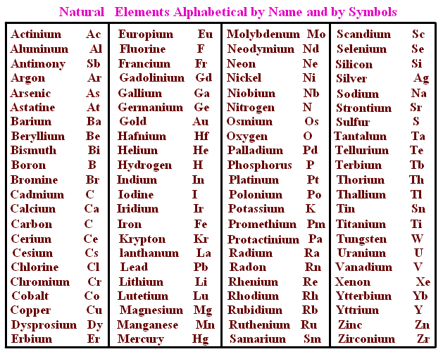
Parts per million is concentration. 1 part per million = 1ppm = 1 gram of something per million grams of the whole thing.
10⁰=1; 10¹=10; 10²=100; 10³=1000; 10⁴=10,000; 10⁵=100,000; 10⁶=1,000,000

- What is a circuit board? Look it up if you don’t know.

- Using Figure 1, which elements have concentrations of 10⁵-10⁶ppm on a circuit board?

- Using Figure 1, which elements have concentrations of 10⁰-10¹ on a circuit board?

Even the elements with the lowest concentrations on a circuit board are required to create the circuit board. Let’s consider one of them, Eu, europium. The United States Geological Survey (USGS) creates data sheets for all critical metals and other mineable materials. Use the data sheet from the USGS for Europium to answer the following questions. https://pubs.usgs.gov/periodicals/mcs2020/mcs2020-rare-earths.pdf

  - To what group of metallic elements does Eu belong?

  - What two other elements shown to be required in circuit boards in Figure 1 belong to this group of metallic elements?

  - What are the two minerals named by the sheet that are mined for this group of elements?

  - Insert and label a picture for each of these minerals below.

  - Under the column, “Salient Statistics—United States”, the first row shows production in the United States. Why was there no production during 2016 and 2017? (Read the doc—it tells you)

  - Where does the U.S. mine these elements? (Also in the doc)

  - On the last page, under “World Production and Reserves,” how much did the U.S. produce in 2019? How does U.S. production rank in comparison to production elsewhere in the world—is it the #1 or #2 producer or is it a lower rank producer?

  - Reserves are an estimate of how much is available to mine. If the world continues to have mine production like it did in 2019, how many years can the world continue to mine these materials before the known reserves are gone? To calculate this, divide the total reserves by the total production in 2019 and express your answer in years.

Scroll down to next page

Now look at Figure 6 from the Graedel et al. article.
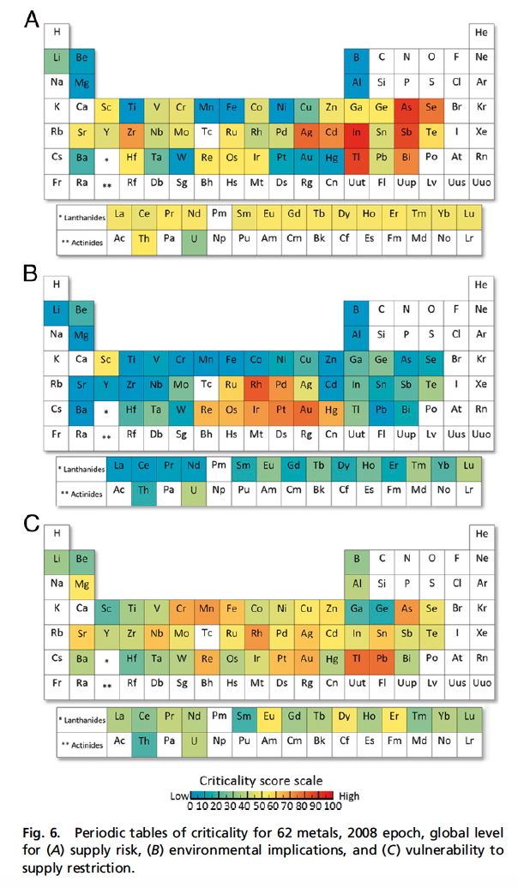
Fig. 6A shows the supply risk of elements. An element with a high supply risk is one that has small reserves and small production but high demand. High supply risk elements also are those elements that are typically recovered as byproducts from the mining of other elements (for example indium is a byproduct of zinc and copper mining).
- Which four elements have the highest supply risk?

- Of these four elements, which are required for circuit boards (refer back to Figure 1)?

- What do you think it means for an element to have a high supply risk from a business perspective?

Fig. 6B shows the environmental implications for mining, refining, and using different elements. An element with a high environmental implication is one that is costly to remove from the Earth and refine and one that can leave lasting damage to the environment where it is mined, refined, and/or used even when great care is taken.
- Which three elements have the highest environmental implication criticality?

- What is the current price per ounce for each of these three elements in U.S. dollars?

- Which of these three elements are required for circuit boards (refer back to Figure 1)?

- What do you think is typically done to minimize the need to mine these materials?

Fig. 6C shows the vulnerability to supply restriction. Elements with a high criticality for this index are those that are widely used on the world, national, and/or corporate level and where the substitution of the element with another is not possible.
- Which five elements have the highest vulnerability to supply restriction?

- One of these five elements is quite common. Which one is it? (Look up abundance in the Earth’s crust of each of these elements—Wikipedia is a good resource).

- What is this common element that is so vulnerable to supply restriction used for? (Again, look it up—just look up the element and look in the Wikipedia article).

- What is the criticality of Eu for vulnerability to supply restriction?

Look at this website. https://www.dla.mil/HQ/Acquisition/StrategicMaterials/Offers/ Watch the video if you like—it is fascinating.
- What does this U.S. government agency do?

- Click on “Materials of Interest” on the left side of the page. Which of the elements that you identified above as having high criticality (questions 4-14) are not listed by this US government agency as a material of interest?

- What questions would you have regarding why these elements are not listed?

- Click on “Sales” on the left—just for your own interest. You can contract to buy stockpiled materials from the U.S. government. I wonder if the price is right?

