Exercise 9: Metamorphic Rocks

Geology Lab 111 Name_________________________________________________________________
Objectives:
- Learn how to identify a foliated and a non-foliated metamorphic rock.
- Learn how to identify some metamorphic rocks by name.
- Link ductile structures with metamorphic rocks
- Learn the common protoliths for some metamorphic rocks
- Learn how to use the concept of metamorphic facies

Good Online Resource: http://geologycafe.com/gems/chapter9.html

Metamorphic rocks form when the minerals in a rock recrystallize—meaning new minerals grow from chemical reactions happening to the older minerals. These chemical reactions can be caused by changes in the temperature or pressure or by fluids such as water passing through the rock. All of this happens when the rock is in a solid state—so there is no melting.

Any rock can metamorphose. That means igneous rocks, sedimentary rocks, and even metamorphic rocks can be metamorphosed. When metamorphic rocks experience a second round of metamorphism, we say they have been re-metamorphosed. The protolith is the original rock from which the metamorphic rock formed.

Foliated metamorphic rocks form under conditions where rocks experience stresses that create folds, boudins, or shear zones.

Part 1: Find one photograph for each of the following types of foliated rocks. (21 points)
- Slate in the landscape as bedrock
- Phyllite (close up photo of rock)
- Greenschist (close up photo of rock)
- Blueschist (close up photo of rock)
- Orthogneiss (close up photo of rock)
- Paragneiss (close up photo of rock)
- Stretched metaconglomerate (close up photo of rock)
For each photo,
  - cite the url for the photo and location info if available
  - annotate the photo with labels or drawings indicating the foliation
  - name the protolith of the rock.

Rocks that have become DUCTILE are at temperatures and pressures where metamorphism will occur. Ductile structures such as folds (anticlines, synclines), boudins, and shear zones are often formed while rocks undergo metamorphic change. Not all folded rocks are metamorphic; some folded rock layers form close to the surface if the rock is weak sedimentary rock.

Part 2: Find one photograph of each of the following types of structures in metamorphic rocks. (12 points)
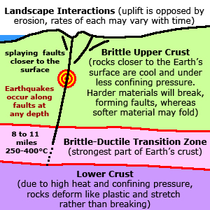
- Folding (close up photo of a rock)
- Boudinage (close up photo of a rock)
- Shear zone (close up photo of a rock)
For each photo,
- cite the url for the photo and location info if available
- annotate the photo with labels or drawings indicating the structure
- name the type of metamorphic rock in the photo
- name the type of stress that caused this structure to form.
Nonfoliated metamorphic rocks form in a variety of ways. Hydrothermal metamorphism or metasomatism is when hot fluids with dissolved materials pass through rock and cause chemical reactions. Many economically valuable deposits of copper, gold, silver, and other metals are formed in this way. Another way is when the heat from magma or lava bakes the rock it touches, causing contact metamorphism. Another way is by regional metamorphism in which differential stresses are not significant enough to cause foliation to form.

Part 3: Find one photograph of each of the following types of nonfoliated metamorphic rocks. (33 points)
- Marble (close up photo of a rock)
- Quartzite (close up photo of a rock)
- Hornfels (close up photo of a rock)
- Greisen in place within its host rock
- Skarn (close up photo of a rock)
- Eclogite (close up photo of a rock)
- Serpentinite (close up photo of a rock)
- Amphibolite (close up photo of a rock)
- Charnockite (close up photo of a rock)
- Gold ore
- Copper ore

For each photo,
- cite the url for the photo and location info if available
- name the protolith of the rock
- type of metamorphism: contact, regional, or metasomatism (hydrothermal)

The temperatures and pressures required to create different types or facies of metamorphic rocks with particular minerals in them has been worked out.

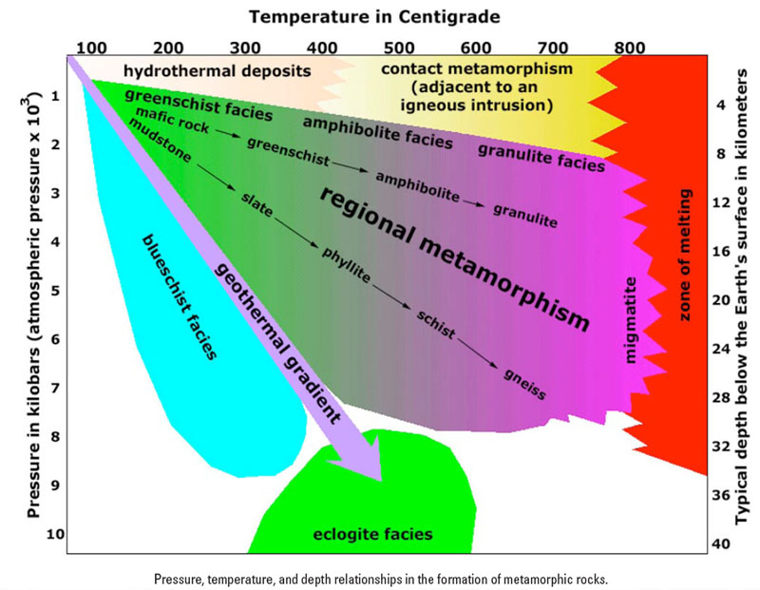

Part 4: Use the chart provided to answer the following questions. (10 points)
- Where can you find natural occurrences of glaucophane in California? Search this and select mindat.org sites for your research.
- What is the age range of these rock glaucophane-bearing rocks?
- Glaucophane is a mineral found in blueschist facies metamorphic rocks. Under what tectonic conditions do blueschist facies rocks form?
- What was the plate tectonic setting of California during the time these glaucophane bearing rocks formed?
- The Mendenhall Gneiss is found in the San Gabriel Mountains, close to Glendale. It is a granulite-migmatite facies metamorphic rock. How many kilometers of uplift and erosion occurred to expose this rock? Give your answer as a range with a minimum and a maximum value.

Part 5: Try to use what you have learned to name the 7 metamorphic rock samples that are in the bag you were given. The samples are small—just try your best to identify them. (7 points) What you likely have in your bag are slate, phyllite, schist, gneiss, quartzite, marble and perhaps another example of schist, phyllite, or slate.
Photo of rock | Name of rock | Observations

