Fastening
Name
Institution
Date

HW part 1
Important steps to install bolts with proper torque
Aircraft fasteners are important in ensuring the safety of aircraft since they play a major role in maintaining balance, which is essential in normal functioning of aircrafts. Installing bolts with a proper torque is critical in developing a greater understanding on important processes, which provide a greater understanding on key processes that define a positive understanding on proper focus on individual safety and wellbeing. The initial step that has been highlighted in the videos include using a torque wrench and a suitable technique. A torque wrench is a hand held screwing tool and it is used effectively in setting the force of the bolt. The torque wrench is important in this case, considering that it enables an operator to measure the rotational force that is applied to the bolt and ensure that it functions properly.
Torque loss on bolted joints is another important element, which provide a critical understanding on important elements highlighting the loss of torque over time. Within the initial 24 hours after the joint has been fixed, 10% of the torque is lost. The more torque that is lost creates a very difficult focus where it increases the chance of flange leak. Applying lubrication to reduce friction is important in developing a string focus on the need to ensure that the chances of bolt failure are significantly reduced. The sequence of tightening is important and thus must be effectively defined where it would be possible to improve the underlying focus on the strategic fixing of bolts in a manner that they are successfully held. Bolt up process provides a critical understanding on key processes that are integrated which outline important processes that define positive focus on better performance with less chance of error.

Explain the use of correction factors when torque wrench adaptors are used to reach tight spaces.
The correction factors are used to provide an estimation of the total understanding on important processes that need to be considered in developing a string understanding on key concepts that define a better variation based on the torque wrench adaptors that are integrated to reach tight spaces. It provides a better focus on the target space identified which is essential in providing a stronger integration on key concepts, which define the size of the target space that can be considered in determining torque wrench adaptors.
A bolted joint is among the commonly used joining methods, which require strong consideration in developing a stronger focus on the need to develop safe designs. The distribution of the torque in a bolt takes into consideration various process with a key focus on the correct tension preload. Therefore effectively reviewing the tension elements provide a better understanding on torque distribution in a bolt, which focus on achieving a string outcome.
Why measure and control torque if bolt tension is really the important parameter when securing bolts?
Measure and control processes that are integrated in this case are based on critical evaluation on key concepts that are considered in ensuring that bolt tension is significantly reduced. Therefore when securing bolts, the underlying tension must be taken into consideration as well as the underlying size. Thread locking is an important concept, which provide a better understanding on important elements, which define a positive understanding on important processes that define successful engagement under which it would be possible to achieve an improved level of success based on key processes that are considered in securing bolts.

Links
https://www.youtube.com/watch?v=WP7fGDCCKrI
https://www.youtube.com/watch?v=kTwpA2yJ81o
https://www.youtube.com/watch?v=fN9b3ByRh7A

HW Part 2
Important riveting steps to install flush, countersunk rivets
A rivet is a mechanical softener which plays an integral role in fastening considering its unique design and the underlying focus on providing a greater influence on important processes in designing and developing strong elements which define positive change. the riveting steps that are integrated to install flush and countersunk rivets is based on the design that is being developed although it is important in developing a positive focus on how these processes can be effectively achieved. Building of aircraft is strategically developed based on important elements that define positive change. Using countersunk rivets is very important in aerodynamics. The countersinking process is achieved through use of special countersink drill bit that drills by widening slightly at the top of the hole. The widening that is developed provide a crucial focus allowing a screw to set exactly even or slightly below the level of the board that is being screwed. Therefore ensuring that a given project is specifically developed based on a very different focus on the underlying objectives.

The rivets holes are drilled at the center to provide strengthen the rivets that will be integrated within the holes to provide support without developing tension. Pressure must be applied in ensuring that the rivet countersunk and not countersinking it too deep. Therefore, the top of the rivet must be flush with the plane. Accuracy is an important aspect that provides a very strong understanding especially considering the importance of drilling rivet holes in a planned and a well organize manner. Therefore, accuracy of the holes is based on meeting the specifications that have been outlined in determining important processes that define positive focus on key processes that must be embraced. De-burrying is an important process, which outline key processes that define critical focus on important processes that help in maintaining the much-needed standards. Burrs are likely to be created during normal drilling. Using a large drilling machine is able to provide a key focus on the targeted level of accuracy.
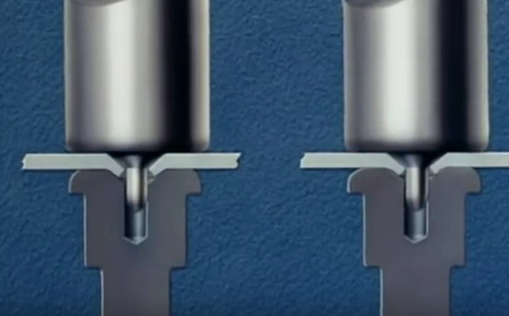
Important rivet dimensions.
Rivet dimensions are organized based on strategic understanding on the underlying design and important processes that have been considered. The finished rivet should have a formed head and 1* 1/3 the diameter of the rivet itself and ½ the diameter of the rivet height. In order to provide the desired support which is able to support the weight of the entire system without significant pressure and tension. Getting the correct angle is essential in creating an improved understanding on important processes that are essential in providing a critical focus on important measures that are be considered in developing a better understanding on the underlying dimensions of rivet.
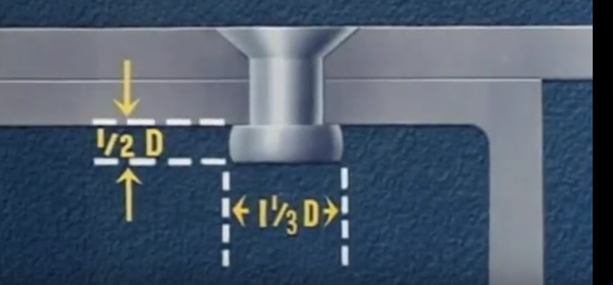
Spacing and edge distance needs to be effectively organized where it is easier to allow for the desired space which is essential in providing a string focus on important concepts, which define the level of engagement integrated. The size of the hole that is drilled must be proportional to the rivet that is inserted in order to provide a better focus the space and reduction of tension that exists. It is important to ensure that there is better organization based on important processes that are developed. The whole process requires effective planning based on the design that has been outlined which provide the specific dimensions and measurement, which provide a highly integrated focus on important processes that outline high level of efficiency and safety.

Link
https://www.youtube.com/watch?v=IDbTUt3OG9s&t=162s

