Fauvism
Student Name
Institution Affiliation
Date

Fauvism
Fauvism refers to the artwork that was created by Andre Derain and Henri Matisse between 1905 to 1910. The work was characterized by the presence of ferocious brushwork and intense colors (Crave, 2010). The name originated from Louis Vauxcelles after he saw an artwork in Paris in 1905. The art was interested in the theories of colors, which were developed in the 19th century. The use of complementary colors was utilized to ensure that the painting was bright. For example, the art of Madame Matisse which reflect both black and brown colors, which makes the portrait to be more vivid. The picture presented by fauvism has a creamy texture on the surface, which creates the consciousness of the paint by the viewers. The object that is painted and its color is the main subject of the portrait. For example, in the painting named "the wild beast of Paris," trees were presented with blue colors with contrasting colors of human bodies. This image showed emotions through the symbolic art of the paintings. The paintings had various matters that they presented.
The artists were influenced by primitive designs, Southern and Central American, Polynesia, and African designs, which originated from textiles, masks, and attention to the texture. The use of color is essential in this art to pass information. The art of fauvism was dominated by the use of brushstrokes and bold paintings that were recognized. Paying attention to the fauvism artistic work, it is easy to see the stroke paintings that were used to paint the art — for example, the portrait of Henri Matisse done by Andre Derain in 1905. The artists used the technique to present the complexity of objects. The depth of perception is weakened in this art because of the lack of refined shading. This suggests that the aim of fauvism was not to accurately present the appearance of the art physically but to deliver a meaningful message.

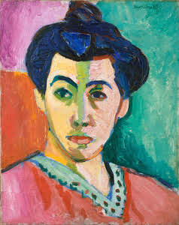
Portrait of Madame Matisse
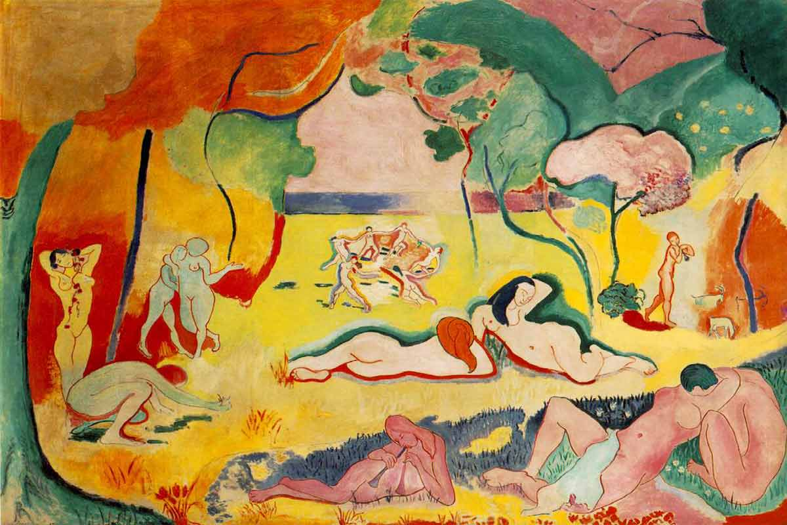
The wild beast of Paris

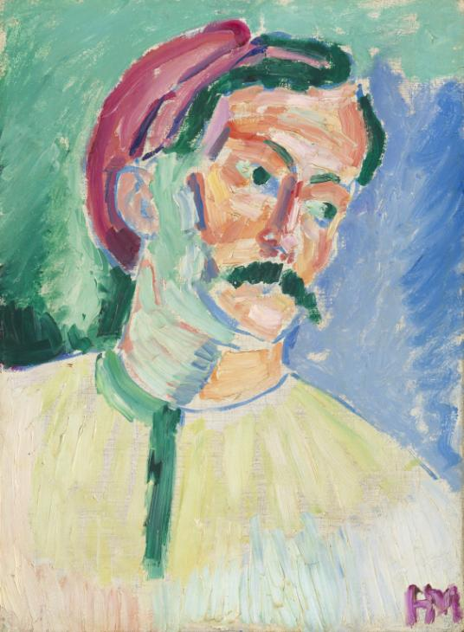
Henri Matisse’s Portrait

Reference
Crave, C. (2010). Fauvism [Video]. Retrieved from https://www.youtube.com/watch?v=1ttA2S8Faqw

