Restaurant Completion and Expansion
Name
Institution of Affiliations

Abstract
The restaurant industry is a very dynamic industry. There are changes that take place in the industry which companies must be able to deal with in order for the company to continue making profit. The concept of expansion in the restaurant industry will not usually entail the physical expansion because once the physical components of the restaurant are dealt with other aspects of expansion usually crept in. In that concerned when it comes to expansion the restaurant must have and elaborate roadmap that is supposed to guide them through the journey of expansion. The final report will look at the expansion, the needs and the requirement that an entrepreneurship restaurant may require in the process of expansion process and issues that may arise during the process of expansion and how those challenges will be faced. The report will address expansion in terms of space expansion, human resource and technology application and automation

Contents
Chapter 1 Introduction 4
Chapter 2 Literature Review 4
Chapter 3 Research Methodology 5
Chapter 4 Research Findings and research 6
Chapter 5 Conclusion 10

Chapter 1 Introduction
A successful business venture needs to consider different stages of development to remain relevant and profitable. It is essential that the business managers gain insight into the pointers for the stages including completion of the development stage of the business. When a restaurant has established his brand such that it is frequented by the loyal customer such a restaurant is usually destined for greatness. Another indication for the completion of the development and founding stage of the business is often the constant complaints from loyal customers about particular aspects of the restaurant. In the case of the successfully launched restaurant under consideration, was the fact that most customer required that the restaurant expands its services with regard to the excellence of its delivery. Most customers had the feeling that the Restaurant needed to be more spacious and also have braches in other areas as it was already established as a quality service provider in the restaurant industry. Some concerns were raised that the waiters serving at the restaurant had become too sluggish and that the manual mode of payment was too slow and could not allow other individuals to use their cards to pay. These customer concerns were little indications that the initial stage of the restaurant was completed and it was time for business to expand was due and the business had to move to the next regarding quality of service or risk losing some of their best clients and hence risk closure. Additionally, the expansion of the restaurant floor size would mean that there will be a need for more people to work in the restaurant. There will also be a need for automation of the services in the restaurant to make things move smoothly. These final paper will analyses the steps that were taken to ensure that the restaurant has been expanded to this current status

Chapter 2 Literature Review
Developments of restaurants that are owned by small-scale business owners usually face many challenges. According to Davidsson, Achtenhagen & Naldi (2010), the problems of finances are the primal top challenges that are met by the entrepreneurs who will need to venture in the small restaurants when it comes to the matters of expansion. In Kuriakose(2013)have asserted that many individuals stayed away from their dream of development because they cannot afford the high cost that is usually accompanied with the elements of the physical expansion of the restaurant. One of such value that may accompany the physical expansion of the restaurant is the cost that associated with the human resource that may be required once the process of expansion has been completed. Even among the restaurant managers who can get around the financial constraints the physical expansion usually attract other financial limitations that may be associated with the operation of the restaurant once the process of expansion as take place. Once a restaurant has been expanded regarding physical spaces the challenge that usually arises is the element of staffing which means that management has to employ more other staff members. According to Sherif Kamel and restaurant will have to expand its terms of capacity, space and information technology infrastructure for such expansion to be considered to be complete (2003). Automation has been found to be a very integral part of scaling up in the restaurant world currently. The expansion regarding human resource needs to do for the restaurant to function effectively. There is a huge difference between hiring and scaling up. Hiring is the normal process of getting someone or people who can do the work. Conversely, scaling up is the process by which the manager hires competent employees with the primary intention of making the company to achieve its growth objectives (Harnish & Gazelles Inc., 2014).

Chapter 3 Research Methodology
The research was unstructured research where there was not much emphasis on a particular structured format of acquiring information. This flexibility worked to help garner as much as there could be about the business. The research adopts the case study design. The target population for this research were the customers of from all ages. The restaurant owners who have successfully passed in the stage of expansion transition in their businesses and few employees. The study will be having a sample of four respondents for each group of the respondents that have been named above, but due to the particular nature of customers, there will be ten customers in the sample population. The methodology of sampling is expected to ensure that there is a proper presentation of the customer needs and that every need of the customer is heard efficiently. The research will use the face to face interview as the research instruments. The reason for the use of face to face interview is to get to understand the recall concerns of the clients are rising and get to understand what the other business owners believe in when it comes to expansion. The methods are the best methodology because it may allow the researcher to seek clarification to new insights that may arise during the process of interview.
Primary data will be collected through face to face interview with the respondents. The researcher will prepare questionnaire with close-ended questions for the interview to seek a non-biased response from the respondents and ensure that results were favorable to the objective of the study. Secondary data will be obtained from published government documents and articles concerning the growth and expansion of the small enterprise. The secondary data may be collected from the government department that deals with issues that concern the restaurant industry.

Chapter 4 Research Findings and research
When it comes to the issues of expansion most the respondents most respondents asserted that one of the works of the managers is to expand business and asserted that it was indeed a need to develop. For all the restaurant owners who asked the questions that concerned the expansion of the restaurant, 100% stated that indeed it was time for expansion and appreciated the fact that finance was a major issue when it came to the problems that dealt with expansion. Both the managers advised the restaurant to go for a loan. Another important thing that they all agreed was that in this case, a good manager would go for expansion most importantly because it was something that had been requested by the clients.
Clients wanted the restaurant to expand because they felt that the small spaces were not allowing them to conduct specific activities in the restaurant search as holding a meeting. They wanted the restaurant to also move from the manual method of payment to the point of sale format to ensure that there was speedy delivery of service. Some the clients had asserted that some of the employees were not behaving professional enough.
Among the employees that interviewed most had the opinion that expansion plan was supposed to consider their welfare. They continued that they were entitled to better wages and other benefits such as the insurance which had to be included in the process of expansion
When it came to the matter of expansion in terms of information technology and automation. The managers who were questioned were of the opinion that Automation was a very integral part of information technology with had to be taken seriously. The employees wanted Automation so that the machine can make their job of payment very easy. Another important element was the integration of the elements of the web 2.0 which were supposed to be used in the marketing of the restaurant. The components of web 2.0 will be integral in making sure that the millennia’s interest are included in the restaurant. Millennia’s age group appreciates the use of social media and integrating the use of social media will increase the number of millennia’s that will be frequenting the restaurant. The sites that will be included in the It structure will are included in the table below

Facebook | Social networking site connecting family, friends and acquaintances
Linked In | Social networking site primarily used by business professionals
My space | One of the original social networking sites. Primarily used for friend to friend communications
Twitter | One of the newest iterations of social networking. Helps the “tweeters” keep track of what everyone is doing in real time.
Blogger | Blogs were launched in 1999 (blogger.com) and create a forum for individuals to speak and report anything on their minds
You tube | One of the most popular social media sites, where individuals upload and share video clip

The issue of expansion of human resource was deemed to be necessary for the process of scaling up the managers who were questioned asserting that scaling up had the primary function of making sure that the new restaurants will be efficiently operated. Failing to scale up after an expansion was not an option. The following pie chart was derived for individuals that would like to make orders from the comfort of their home
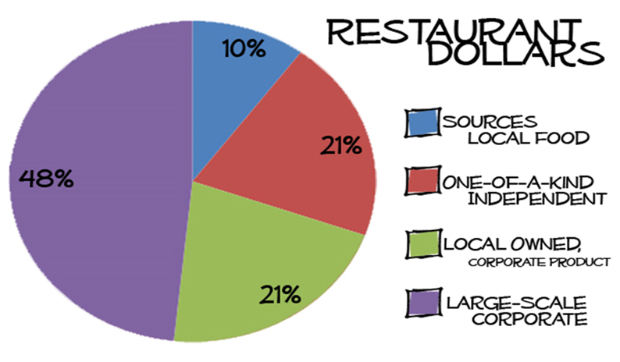
Among the managers that were interviewed the had an agreement that capital investment was significant in the project I factor which came to manifest itself at the end of the project was completed, and it became clear that the project had used a lot of money. The capital that was required was the capital to enlarge and maintain the scale of business operation. In the end, the capital was acquired from the donations of family members since the business is entrepreneurship. The initial profits that had been made were also set back to be used in the company.
Among individuals that were interviewed about 63% of the respondents agreed that the location of the restaurant is very significant in determining the business it attracts. The site of the company proved to be an integral part of any business because the location of the company was found to determine the market share that it commands. Hence the location of the results was found to be very important by the respondents especially when the restaurants were planning to come up with another chain. Therefore, setting a restaurant located in an isolated area may an advantage such that the restaurant may command all the share in that area. In that concerned that restaurant may be viewed as if it is having unlimited access to the consumers (O'Neill, & Mattila, 2006). On the same note, if the method of expansion was viewed as Setting a restaurant in a city or a crowded area, it will present stiff competition for the market share in that area. In that concerned, if the business were looking at options of setting up another branch a strategic location of the company would increase its performance, attracts business investors and thereby enables expansion of the business input to other areas.
Another thing that individuals were asked about was the organization culture of the restaurant. Fifty percent of the respondents agreed that restaurant organization culture was a very integral part of any restaurant. They asserted that organization culture was like the identity of the restaurant and it was an essential element of any business. There was an agreement among the 50% that when a restaurant had an active organization culture, there were chances that their productivity would increase
5% of restaurateurs agree that restaurant organization culture increases the productivity of the employees and thereby its profitability. The business efficiency which is ensured for a productive organizational culture provides stabilization of the business, increased customer satisfaction and therefore improved the performance of the restaurant (Upneja, & Dalbor, 2001). It thereby raises the prospect of expansion of the restaurant. It also attracts investors input into the business.

Chapter 5 Conclusion
The project turned out to be a success because of an action plan that was established. The customers increased, and the loyalty was renewed because most of the customers so the process of expansion as a direct reaction to their concerns. The fact the employee issues were dealt with effectively by increasing their benefit and make them feel as the business values them.
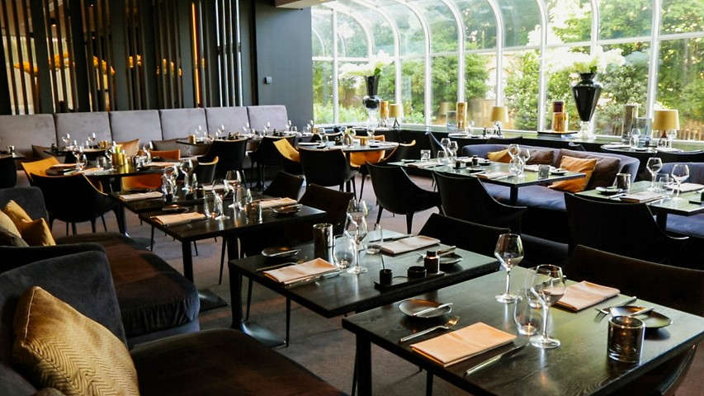

The automation of the company has also effected a factor which made work easy for the workers who were working in the restaurant. The business maintained their location where they have some clients already. After the implementation of the plan entirely there is an overwhelming change in sales.
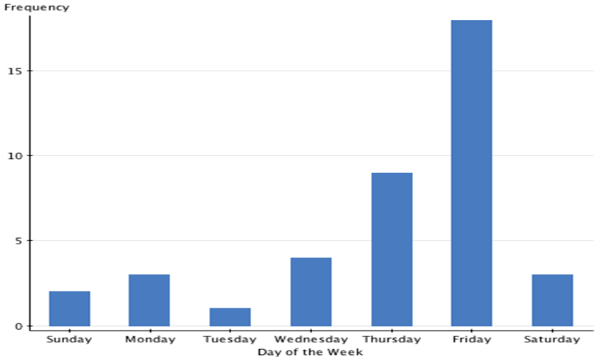
The current sales that are being reported are exceeding the yearly goals which are a wholly significant factor. With the increase of the number of individuals that are working in the restaurant the time that is taken for individuals to receive their orders has been lowered greatly.

References
Kamel, S. (2003). Managing globally with information technology. Hershey, Pa: IRM Pres
Harnish, V., & Gazelles Inc.,. (2014). Scaling up: How a few companies make it... and why the rest don't.
Davidsson, P., Achtenhagen, L., & Naldi, L. (2010). Small firm growth. Boston: Now.
In Kuriakose, S. (2013). Fostering Entrepreneurship in Azerbaijan.
Giousmpasoglou, C. (2016). Restaurant and restaurant management education.
O’Neill, J. W., & Mattila, A. S. (2006). Strategic restaurant development and positioning: The effects of revenue drivers on profitability. Cornell Restaurant and Restaurant Administration Quarterly, 47(2), 146-154.
Upneja, A., & Dalbor, M. C. (2001). An examination of capital structure in the restaurant industry. International Journal of Contemporary Hospitality Management, 13(2), 54-59.
O’Neill, J. W., & Mattila, A. S. (2006). Strategic restaurant development and positioning: The effects of revenue drivers on profitability. Cornell Restaurant and Restaurant Administration Quarterly, 47(2), 146-154.

Appendix
Structure of the Company
Owners
Position Staff
Chef
Line cooks
Dishwasher
Pantry

Position Staff
Servers
Hosts
Waitresses
Position Staff
Bar Backs
Bartenders
Cleaners

Asst. Manager
Kitchen Manager
Asst. Manager

General Manager
Bookkeeper

