Name __________________________________
Answer each question with the correct response. (2 pts each)
- A favorable variance occurs when:
- Budgeted revenues exceed actual revenues
- Budgeted expenses exceed budgeted expenses
- Actual revenues exceed budgeted revenues
- Actual revenues exceed actual expenses

- An unfavorable variance occurs when:
- Budgeted revenues exceed budgeted expenses
- Budgeted expenses exceed actual expenses
- Actual revenues exceed budgeted revenues
- Actual expenses exceed budgeted expense

- The management concept that involves through planning and corrective action only when actual results are not consistent with the budget is called:
- Performance reporting
- Management by exception
- Responsibility reporting
- Variance analysis

- The comparison of budgeted results compared to actual results and the resulting variances is called:
- Budget analysis
- Performance report
- Responsibility report
- Variance report

- The concept of modifying the original budget to a budget based on the same activity level as actual results is called:
- Budget performance
- Budget analysis
- Modified budgeting
- Flexible budgeting

- The two budget variances for direct materials are:
- Price variance and usage variance
- Price variance and rate variance
- Spending variance and efficiency variance
- Spending variance and usage variance

- The two budget variances for direct labor are:
- Price variance and usage variance
- Spending variance and rate variance
- Rate variance and efficiency variance
- Spending variance and usage variance

- The two budget variances for variable overhead are:
- Price variance and usage variance
- Spending variance and rate variance
- Rate variance and efficiency variance
- Spending variance and efficiency variance

- When preparing a flexible budget, total budgeted fixed overhead does not change because:
- Actual fixed overhead usually equals the budgeted fixed overhead
- Fixed overhead does not behave on a per unit basis
- Fixed overhead and variable overhead are the same amount
- Fixed overhead per unit stays the same

- When preparing a segmented income statement, total fixed expenses are split up between:
- Variable and fixed
- Direct and indirect
- Product and period
- Direct and common

- When preparing a segmented income statement, each segment’s contribution margin less their direct fixed expenses equal the:
- Operating income
- Segment margin
- Gross margin
- Net income

- Which of the following statements is true as activity levels change:
- Variable costs per unit remain the same
- Variable costs in total remain the same
- Fixed costs per unit remain the same
- All of the above
- None of the above

- Examples of variable costs would include:
- Direct materials, direct labor, and fixed overhead
- Direct labor, supervisor’s salary, and factory rent
- Direct labor, direct materials, and sales commissions
- Direct materials, property taxes, and variable overhead

- The three components to a manufactured product’s cost included:
- Direct materials, direct labor, and manufacturing overhead
- Direct materials, work in progress, and finished goods
- Direct materials, direct labor, and finished goods
- Direct materials, variable overhead, and fixed overhead

- Costs that are partly variable and partly fixed (mixed) are known as:
- Semi-fixed
- Semi-variable
- Overhead
- Relevant

- Reclassifying a traditional format income statement’s total costs (cost of goods sold and operating expenses) into variable and fixed costs produces an income statement known as:
- Gross margin format
- Contribution margin format
- Segment margin format
- Operating margin format

- In the cost formula Y=a+bX, which of the following is true:
- a= fixed costs
- b=variable cost per unit
- Y=total costs
- X=# of units produced
- All of the above

- The formula for Contribution Margin Ratio is as follows:
- Sales less variable costs
- Sales divided by contribution margin
- Contribution margin divided by sales
- Contribution margin plus variable costs

- The formula for calculating break-even point in units is as follows:
- Fixed expenses divided by contribution margin
- Fixed expenses divided by contribution margin per unit
- Contribution margin divided by fixed expenses
- Contribution margin per unit divided by fixed expenses

- Total sales less break-even sales is known as:
- Margin of safety
- Contribution margin
- Gross margin
- Operating leverage

- Magnification of the effect on operating income resulting from a change in revenue is called:
- Operating leverage
- Indifference point
- Break-even point
- Margin of safety

- Which of the following statements is not true:
- Manufacturing overhead includes all manufacturing costs except direct materials and direct labor
- Product costs include direct materials, direct labor, and manufacturing overhead
- Period costs are included in the inventory along with product costs
- All costs are indirect costs except for raw materials and direct labor

- Which of the following statements is not true:
- Total costs can be split into product costs and period costs
- Total costs can be split into direct costs and indirect costs
- Total costs can be split into variable, fixed, and mixed costs
- Total costs can be split into overhead, period, and product costs

- The three types of inventory accounts typically found on a manufacturing company’s balance sheet would include:
- Raw materials, direct labor, and manufacturing overhead
- Raw materials, work in process, and manufacturing overhead
- Raw materials, work in process, and finished goods
- Raw materials, direct labor, and finished goods

- Beginning inventory plus cost of goods manufactured equals:
- Cost of goods sold
- Cost of goods available for sale
- Ending inventory
- Cost of goods used

- Cost of goods sold plus ending inventory equals:
- Cost of goods available for sale
- Cost of goods manufactured
- Beginning inventory
- Manufacturing overhead

- Beginning inventory plus purchases or production less ending inventory equals:
- Cost of goods manufactured
- Cost of goods sold
- Cost of goods available for sale
- Cost of goods used

- When comparing costing systems, the one most likely to be used if a company were manufacturing staples, flour, or salt would be:
- Job order costing system
- Process costing system
- Absorption costing system
- Direct costing system

- The costing system that only assigns variable costs to products and treats fixed overhead as a period cost is:
- Absorption costing
- Direct costing
- Process costing
- Job order costing

- Which costing system applies overhead on the basis of multiple cost drivers:
- Absorption costing
- Job order costing
- Variable costing
- Activity based costing

- Examples of which type of costs might include the company softball team, tuition reimbursement, charitable contributions, and public relations:
- Discretionary costs
- Committed costs
- Variable costs
- Fixed costs

- Which budgeting approach involves input from middle and lower level managers, who then identify more closely with the budget objectives?
- Zero-based budgeting
- Top-down budgeting
- Participative budgeting
- Continuous budgeting

- Which of the following budgets is not part of the master budget?
- Purchases or production budget
- Sales or revenue budget
- Gross margin or profit budget
- Cost of goods sold budget

- Which budgets are the very first budget and the very last budget to be prepared in the master budget, respectively?
- Sales budget and income statement budget
- Production budget and balance sheet budget
- Sales budget and balance sheet budget
- Production budget and income statement budget

- Which responsibility center does not generate any revenue for the organization?
- Cost center
- Profit center
- Investment center
- All of the above generate revenue

Complete the problems below. Be sure to show your work. (10 pts each)
- Audell Co. manufactures a single product. The original budget for Maywas based on expected production of 10,000 units; actual production for May was 9,500 units. The original budget and actual costs for the manufacturing department are shown below:
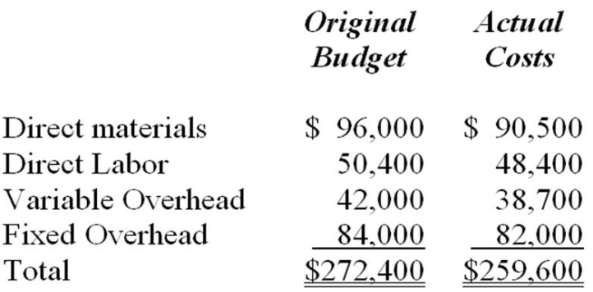
a) Prepare a flexible budget based on 9,500 units.

Item | Original Budget (A) | Flexed Budget [(A/B) *C]=D
 | (10,000 units) (B) | (9,500 units) (C)
Direct Materials | $96,000 | $91,200.00
Direct Labor | $50,400 | $47,880.00
Variable Overhead | $42,000 | $39,900.00
Fixed Overhead | $84,000 | $79,800.00
Total | $272,400 | $2,58,780.00

b) Then calculate the variances to complete the performance report.

Item | Original Budget (A) | Flexed Budget [(A/B) *C]=D | Actual Cost (E) | Variance (D-E)
 | (10,000 units) (B) | (9,500 units) (C)
Direct Materials | $96,000 | $91,200.00 | $90,500 | $700-U
Direct Labor | $50,400 | $47,880.00 | $48,400 | -$520-F
Variable Overhead | $42,000 | $39,900.00 | $38,700 | $1,200-U
Fixed Overhead | $84,000 | $79,800.00 | $82,000 | -$2,200-F
Total | $272,400 | $2,58,780.00 | $259,600 | -$820-F

- Charlotte Co. is divided into three segments and is interested in preparing a segmented income statement in order to better understand the operating performance of each segment. Fixed expenses in each division currently include an allocation of general (common) corporate expenses equal to 10% of the division's sales.
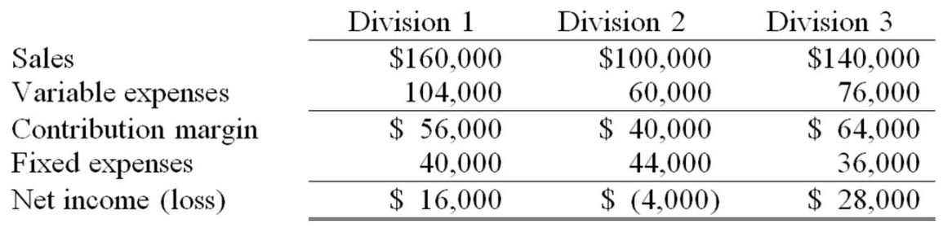
(a) Prepare a Segmented Income Statement for Charlotte Co.

 | Total Company | Division 1 | Division 2 | Division 3
Sales | $4,00,000 | $1,60,000 | $1,00,000 | $1,40,000
Variable expenses | 240000 | 104000 | 60000 | 76000
Contribution margin | $1,60,000 | $56,000 | $40,000 | $64,000
Direct fixed expenses | $80,000 | $24,000 | $34,000 | $22,000
Segment margin | $80,000 | $32,000 | $6,000 | $42,000
Common fixed expenses | $40,000
Net Income(loss) | $40,000
Direct fixed expenses:
Division 1= 40000-(160000*10%)
Division 2= 44000-(100000*10%)
Division 3= 36000-(140000*20%)
Common fixed expenses= (160000*10%)+(100000*10%)+(140000*10%)

38. |  | The standardsfor ONE case of Corona Juice are:  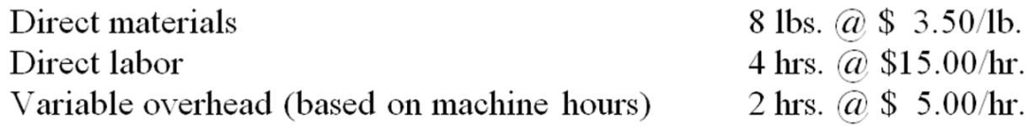  During the week ended May10, the following activity actuallytook place:  • 2,700 cases of finished product were actuallyproduced;  • 21,330 lbs. of raw material were used;  • 22,600 lbs. of raw material were purchased for inventory at a cost of $3.70/lb;  • 10,650 labor hours were worked at an average rate of $15.20 per hour;  • 5,740 machine hours were worked;  • $27,552 actual variable overhead costs were incurred, or $4.80/machine hour.  Calculate each of the following variances (formulas are given):  (a.) Price variance for raw materials purchased. (SP-AP) x AQ purchased  (b.) Raw materials usage variance. (SQ –AQused) x SP  (c.) Direct labor rate variance. (SP-AP) x AQ  (d.) Direct labor efficiency variance. (SQ-AQ) x SP  (e.) Variable overhead spending variance. (SP-AP) x AQ  (f.) Variable overhead efficiency variance. (SQ-AQ)x SP

(a.) Raw material purchase price variance:
(Std. price - Actual price) * Actual quantity purchased
($3.50 /lb. - ($83,620/22,600 lbs.)) * 22,600 lbs. = ($3.50 - $3.70) * 22,600 lbs.= $4,520 U

(b.) Raw material usage variance:
(Std. usage - Actual usage) * Std. price
((2,700 cases * 8 lbs.) - 21,330 lbs.) * $3.50 /lb. = (21,600 - 21,330) * $3.50 = $945 F
(c.) Direct labor rate variance:
(Std. rate - Actual rate) * Actual hours
($15.00/hr. - $15.20/hr.) * 10,650 hrs. = $2,130 U
(d.) Direct labor efficiency variance.
(Std. hours - Actual hours) * Std. rate
((2,700 cases * 4 hrs.) - 10,650 hrs.) * $15.00/hr. =(10,800 hrs. - 10,650 hrs.) * $15.00 = $2,250 F
(e.) Variable overhead spending variance.
(Std. rate - Actual rate) * Actual hours
($5.00/MH - ($27,552/5,740 MH)) * 5,740 MH =($5.00 - $4.80) * 5,740 MH = $1,148 F
(f.) Variable overhead efficiency variance.
(Std. hours - Actual hours) * Std. rate
((2,700 cartons * 2 MH) - 5,740 MH) * $5.00 /MH =(5,400 MH - 5,740 MH) * $5.00 = $1,700 U

