Question #2:
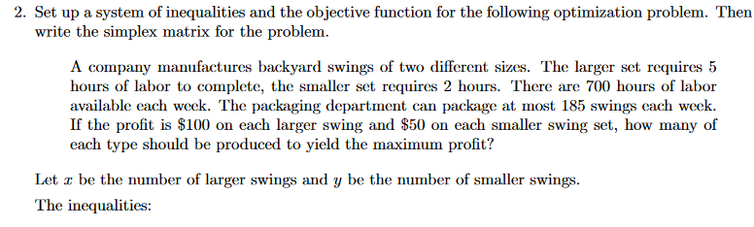The constraints are as follows:
Constraint 1: Every week, at most 700 hours are available for labor.
5x+2y≤700
Constraint 2: Every week, at most 185 swing sets are packed
x+y≤185
Therefore,
5x+2y≤700
x+y≤185
x, y ≥0
The Objective function:
The profit on larger set is $200 per unit and profit on smaller set is $100 per unit, therefore, the profit is given by
Profit=200x+100y
The objective is to maximize the profit.
Thus, the objective function is Max Z=200x+100y
The simplex matrix:
Iteration 1 | Basic Variable | Quantity | x | y | S1 | S2
0 | S1 | 700 | 5 | 2 | 1 | 0
0 | S2 | 185 | 1 | 1 | 0 | 1
 | zj | 0 | 0 | 0 | 0 | 0
 | cj-zj |  | 200 | 100 | 0 | 0
Iteration 2
200 | x | 140 | 1 | 0.4 | 0.2 | 0
0 | slack 2 | 45 | 0 | 0.6 | -0.2 | 1
 | zj | 28,000 | 200 | 80 | 40 | 0
 | cj-zj |  | 0 | 20 | -40 | 0
Iteration 3
200 | x | 110 | 1 | 0 | 0.3333 | -0.6667
100 | y | 75 | 0 | 1 | -0.3333 | 1.6667
 | zj | 29,500 | 200 | 100 | 33.33 | 33.33
 | cj-zj |  | 0 | 0 | -33.3333 | -33.3333

 | x | y |  | RHS | Dual
Maximize | 200 | 100
Constraint 1 | 5 | 2 | <= | 700 | 33.33
Constraint 2 | 1 | 1 | <= | 185 | 33.33
Solution | 110 | 75 |  | 29500

