Global Challenge – W21
Final Exam - 20%
Due SATURDAY, May 15, noon (12 am)
5% late penalty per day from Saturday, May 15, noon to Friday, May 21, midnight (23:59)
Not accepted after May 21, midnight (23:59)

Read carefully before starting:
- Download this document in a safe place (i.e. server rather than desktop). Answer directly on this sheet below each question. When finished, submit your completed exam in BOTH Lea & Turnitin.
- Remember that Turnitin.com checks for similarity. Therefore, if your answers are identical, or even similar, to those of your classmates or to any Internet source, the system will detect it and you will get “0” for your exam as well as a letter in your Vanier file. Is it worth it? Further, if you try using my exact words from the PowerPoints, I will notice!
* Hence, all your answers must to be IN YOUR OWN WORDS.
- All the answers must refer to the class material and to no other sources since this is not a research work but an exam on the material covered.
- Answer the questions thoroughly and in as much depth as possible within the word limit indicated for each question. Be specific, accurate, provided details and present examples if applicable.
- Your goal in answering these questions is to show me, even convince me, that you diligently covered the course material and that you understand it. Hence, integrate concepts & keywords from the course in your answers.
* Answer only ONE of the choices provided. (If you answer all of them, I will only grade the 1st one.)
** Please highlight or bold your choice for every question **

/5 | - Short answers (~70 w). CHOOSE 1 among the following.  - Present and briefly explain three ways (for what goal/purpose) land grabbing is taking place, using case studies presented in this course.  - Maathai made the connection between what and what? Explain.  - From a historical perspective, what is the value of such an article as D10 for advancing “true” development for the African continent?  Your choice? ANSWER:
/5 | - Short answer (~70 w in total). CHOOSE and FOCUS ON 1 of these questions from the Power Points and answer as best you can.  Your choice? ANSWER:  - What is the irony about “water” in one of the video on landgrab?  - What is Norris upset about?  - What does it take to avoid the Tragedy of the Commons?  - What does the ICC have to do with land grab and the environment?
/5 | - Images to words (~70 w). CHOOSE 1 among the following images. What particular points were made in the video about the image?  - 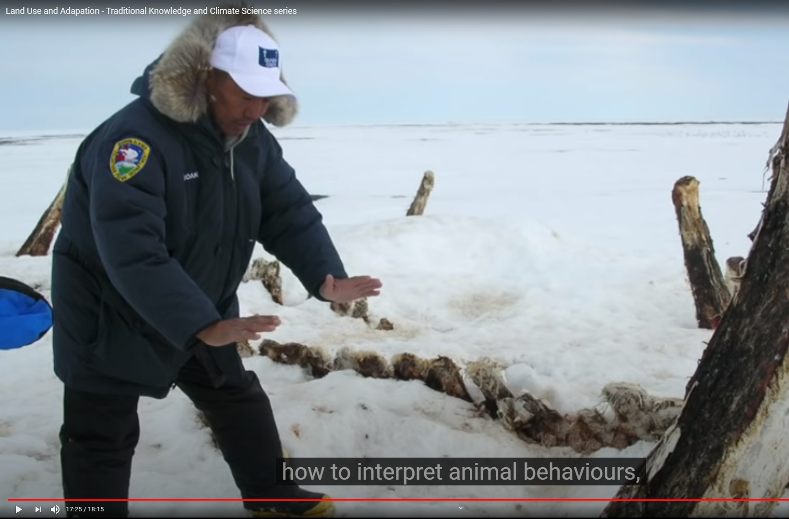 b) 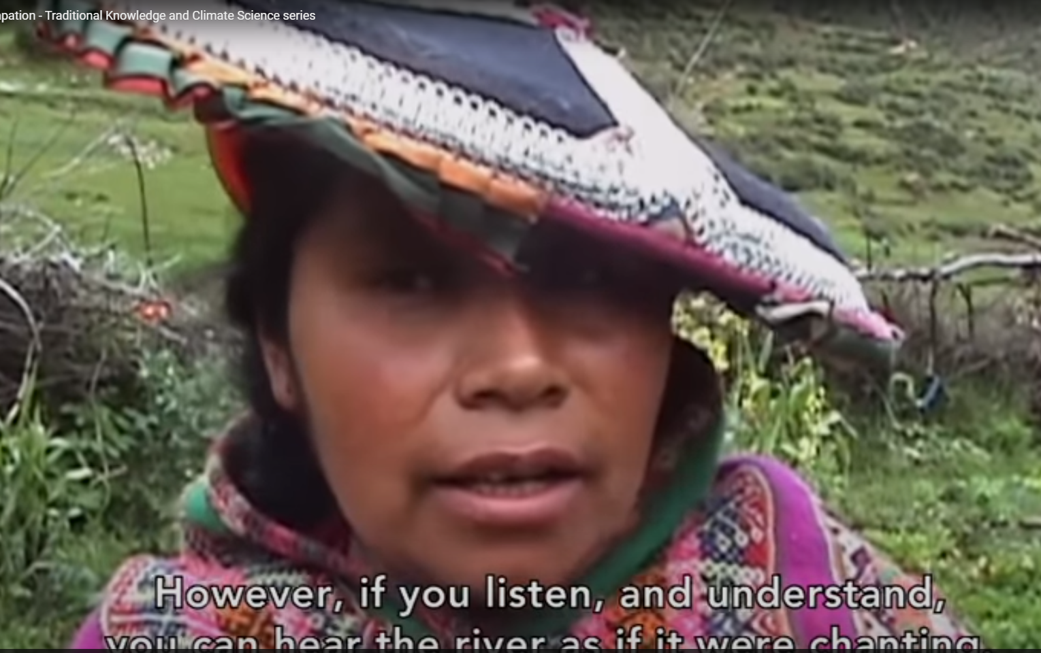  c) 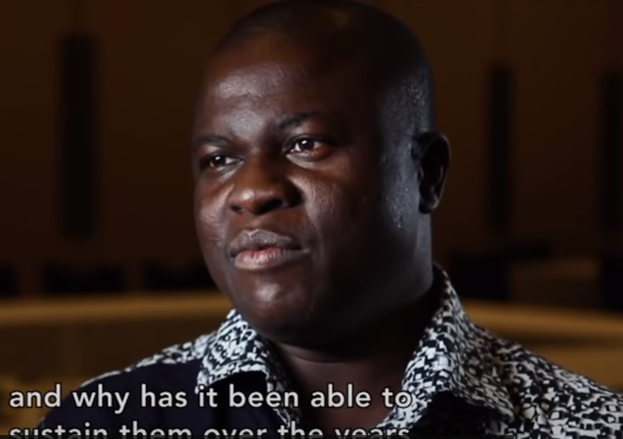 d) 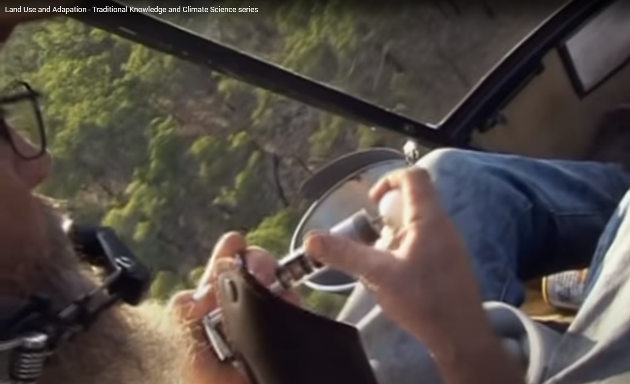  Your choice? ANSWER:
/8 | - Argumentative discussion (~150w). CHOOSE 1 among the following and argue for the statement by presenting specific proof/evidences from the course content.  - Indigenous presence on and control of their land is a key to environmental sustainability.  - “Goal: Takes ideas from ‘soft tech’ and advances it into more physical forms.”  - Colonial Science was used to put the blame on local practices for environmental disaster in Africa.  - “Land grabbing is different by its speed, by its extent, by the number of displaced people, by its often-irreversible damage to ecosystems.”  Your choice? ANSWER:
/10 | - Making connections (~200w). CHOOSE 1 among the following case studies and answer the 5 questions.  What is the particular land tenure system? Who does it empower? What are some socio-economic and environmental benefits? As you answer, integrate some concepts present along with this diagram:  PRR  - Women’s Conservation Group in Belize  - The Greenbelt movement in Kenya  Your choice? ANSWER:
/7 | - How does Franck Nlemba see modern technology and IK complement each other to promote certain facets of sustainability? (~120w).  Your choice? ANSWER:
/40 /20

Let’s welcome the summer
with all it brings to our lives!


Somewhere in my garden, April 2021

Thank you for having been my students

