Define in your own words:

a) Volatility smile
The volatility smile is a geographical model of implied volatility for many options with the same expiration date. Compared to the strike price, this implied volatility can lead to a descending line at both ends. Hence the phrase "smile". It should not be based on alternative standard Black-Scholes theories, which usually require perfectly flat volatility curves. The obvious volatility was first seen after the fall of stocks in 1987. The volatility smile is called because it looks like a smiling mouth. Implied volatility increases when the base value of an alternative out of the money or in the money, compared to at the money. It does not apply to all options. The Black-Scholes model, which is one of the main formulas for citing alternatives and their derivatives, is not expected to cause a smile of volatility.
b) Option intrinsic value
Intrinsic value is the measure of the value of assets. The Intrinsic value of an option corresponds to the current value of the option or in other words how much money you have. If cash is an option, it means that it is a positive gift for the buyer. A $ 30 call option for a $ 40 inventory requires $ 10 cash. If the buyer then uses an option, he can buy shares for $ 30 from the option and then sell shares in the market for $ 40 and receive a $ 10 payment. So the net value is what buyers will get. If you want to use the option now. For currency maintenance, net assets are calculated as the difference between the current price of the cost price and the exercise price of the option. For alternatives that do not have money or money, the value itself is always zero. This is because the buyer never uses an option that results in a loss. Instead, cancel the option and receive no benefits. Because it does not receive a payoff, it has no default value from the alternative.
c) The law of one price
The law of one price is one of the economic terms which means that the prices of identical assets or products are the same price throughout the world regardless of location, taking into account certain factors. It take into account a stable market where there are no transaction costs, shipping costs or legal restrictions, the exchange rate is the same and buyers and sellers do not control prices. The law of one price exists because price differences in various locations are eventually eliminated due to the possibility of arbitration. The arbitration option will be fulfilled if the trader buys the offer at a lower price in the available market and then sells it in the market where it is available at a higher price. Over time, strength in the equilibrium market will adjust asset prices. Prices are the basis for purchasing power parity. Purchasing power parity shows that the value of two currencies is the same if the shopping basket has the exact same price in both countries. This ensures that buyers have the same purchasing power in all markets throughout the world.
d) Historical volatility
Historical volatility is a statistical measure of the spread of a particular security advantage or market index over a certain period. This key number is generally calculated by determining the average deviation from the average price of financial instruments during a certain period. Using standard deviations is the most common, but not the only, method for calculating historical volatility. The higher the value of historical volatility, the more risky the security. However, this is not always a bad result because of the risk of working in both directions: bullish and bearish. Historical volatility does not explicitly measure the probability of loss, although it can be used. This measures how much the security price deviates from the average. For market trends, historical volatility measures the degree to which negotiated prices differ from the central or moving average prices. In this way, strong but regular market trends can be very unstable, even though prices change significantly over time. Values ​​do not vary dramatically from day to day, but change over time at a constant rate.
e) In-the-money option
In the money or ITM is an expression that mentions to an option that holds intrinsic value. Thus it specifies that the option has value in the strike price that is favorable in contrast to prevailing market price of the underlying asset: An ITM call option means the option holder has chance to purchase the security under its present market price. An ITM put option means that the option holder can sell the security above its present market price. If the option contract is in the money, it has intrinsic value. A call that gives the buyer the right, but not the obligation, to buy the asset at the price specified in the currency on or before a certain day when the current price of the current asset is higher than the price agree with what is called the strike price. Buyers can exercise their rights under an option contract and obtain the underlying value at a value less than the present value. This means that the conversation has intrinsic value.

Part II. Problems

Problem 1 (35 points)

Consider a 3-month put option. Suppose that the underlying stock price is $25, the strike $26, the interest rate is 5% p.a., stock volatility is 6% per month. Use the same data to answer questions a) – h).

- What is the level of annual volatility (compute)?
Annual Volatility: Monthly Volatility * (12)^(1/2)
= 6 * 12^(1/2) = 20.78% (aaprox)
- Define in your own words implied volatility.

Implied Volatility: It refers to the volatility in returns of the stock over the life of the option. It is impacted by the chnages in the demand and supply of the underlying options and the expectations of the market eith regards to the stock price. If the implied volatility is high, it shows the market has an opinion that the stock might move in large swings in any direction, whereas low implied volatility means that the market thinks that stock will not move too much due to option expiration.

- How would you compute implied volatility? Explain (no need to compute).

Implied Volatility is calculated by doing reverse calculation in Black Sholes Model formula, by taking the market price of the option as the intrinsic value of the option. Steps to calculate are numerated below:
1. Take inputs required for BSM formula like Market price of stock, market price of option, strike price of stock, time to expire and risk free rate.
2. Apply the inputs in the formula:
C = SN (d1) – N (d2) Ke -rt
Where,
- C: Option Premium
- S: price of the stock
- K: Strike Price
- r: risk-free rate
- t: time to maturity
- e: exponential term
3. Now start trial error method to find the implied volatility which will render LHS= RHS
4. It can also be calculated by interpolating between 2 rates

- What is the probability of stock price going down (Note: use annual volatility, number of steps in a tree is N=3)?

Probability of stock price going down:
Up move and down move factor:
U=size of the up move factor=e^(σ√t) = e^((0.2078)*(3)^(1/2))= 1.365
D=size of the down move factor=e^(−σ√t) = 1/U = 1/1.365= 0.733
σ is the annual volatility of the underlying asset’s returns and t is the length of the step in the binomial model.
Probability of up move= (1+ rf- D) / (U-D) = (1+ 0.05- 0.733) / (1.365- 0.733) = 50.16%
Probability of down move= 100- 50.16= 49.84% (approx)

- Build the binomial tree for the underlying asset (stock). Note: the tree nodes can be edited. Show computations for first up and first down nodes.

e) Binomial tree for stock price movement
Up movement: St = St-1*u
Down movement: St = St-1*d
t = | 0 | 1 | 2 | 3
 |  |  |  | 34.15
 |  |  | 30.78
 |  | 27.74 |  | 27.74
 | 25 |  | 25
 |  | 22.53 |  | 22.53
 |  |  | 20.31
 |  |  |  | 18.30

- Compute the price of the European put option using a 3-step binomial tree. Show computations for terminal and two non-terminal nodes.

Value of Put Option = MAX(Strike price-Stock price, 0)
Mean payoff = p*Upward stock price + (1-p)*downward stock price
(Payoff)t = (Mean Payoff)t+1 / (1+r)^1
where r = Interest rate per month = 0.417%
t = | 0 | 1 | 2 | 3
 | Put premium | Mean payoffs | Payoffs | Mean payoffs | Payoffs | Mean payoffs | Payoffs
 |  |  |  |  |  |  | 0.00
 |  |  |  |  | 0.00 | 0.00
 |  |  | 0.88 | 0.88 |  |  | 0.00
 | 2.28 | 2.29 |  |  | 1.75 | 1.75
 |  |  | 3.67 | 3.69 |  |  | 3.47
 |  |  |  |  | 5.58 | 5.61
 |  |  |  |  |  |  | 7.70

- If the market price on the European put option is $1.5, what should be the price of the European call option of the same strike and maturity to prevent arbitrage?

- Compute the price of the American put option using a 3-step binomial tree. Show computations for two non-terminal nodes.

Problem 2 (20 points)

Assume that the futures price of GPB on Wednesday, April 29, is given as follows:

Month | Open | High | Low | Last | Change | Settle | Estimated Volume | Prior Day Open Interest
MAY 20 | 1.2444 | 1.2484B | 1.2391A | 1.2471B | +.0019 | 1.2452 | 434 | 1,484
JUN 20 | 1.2427 | 1.2488 | 1.2391 | 1.2474 | +.0018 | 1.2454 | 49,905 | 159,127

Assume that the spot price on Wednesday: 1.2552

Youexpect to make a 400,000 payment in British Pounds on close of business day, Wednesday, April 29. You decide to hedge your risk with futures contracts. Assume you that you enter into the position at close of day on Monday, April 27 at the futures price of 1.2422. The size of one futures contract on British Pound is 62,500 pounds.

  - Describe the position you decide to enter (long or short, how many contracts and contracts maturity).

Since you would be receiving GBP and you wish to lock into the GBP price at present, you would sell GBP futures (short) at 1.2422. This will lock in your GBP exchange rate on Monday itself for the Wednesday receipt. The number of contracts will be (400000/62500) which will be 6 (rounded since the contracts cannot be in decimal). Hence, you would short 6 contracts

  - Document the price gain or loss every day that your position is open (Tuesday and Wednesday).

We first calculate the Tuesday closing price from Wednesday price and price change given to us. The Wednesday price for May 20 contract is 1.2471 and it has increased by 0.0019 since previous day hence Tuesday price must have been (1.271 - 0.0019) which is 1.2452. Now we can document the price gain/loss on the short position for Tuesday & Wednesday.

  - What is the total cost in US$ after you have closed out your futures position, and completed the spot market transaction?
Change in Price on Tuesday = 1.2444 – 1.2452- = -0.0008; since it is a short position and price has gone down it is a positive change. The contract size is (6* 62500) 375000, hence the net gain is (375000*-0.0008) = -300
Change in Price on Wednesday (from Tuesday price) = 0.0019; since the price has moved up and it is a short position, this is a negative change for the client. The net loss will be (375000*0.0019) = 712.5

  - What would have been the total cost in US$, if you had not hedged? Did you benefit from hedging?

Total amount can be sold at 1.2422 for 6 contracts of GBP62500 i.e total of GBP 375000 (375000*1.2422)=$465,825
The rest amount of GBP25000 can be sold at spot on Wednesday (25000*1.2552)=31380
Total Proceeds=$497,205

  - What would be the effective price per British Pound?

If there was no hedging, then the GBP would have been converted in the spot market which was higher than Monday levels. There will no cost as there would no hedge. The net USD amount would have been $497,205. No there was no benefit of hedging in this case.
The effective price per British Pound (497,205/400000)=1.2430

Problem 3 (20 points)

Suppose you are given the following prices for the options on ABC stock:

Strike (in $) call put
15.0 1.6 2.0
17.5 1.2 2.5
20.0 0.9 3.2

- Suppose you take the following position: long one call with strike 15.0, short two calls with strike 17.5, and long one call with strike 20.0. Please draw the payoff at maturity.

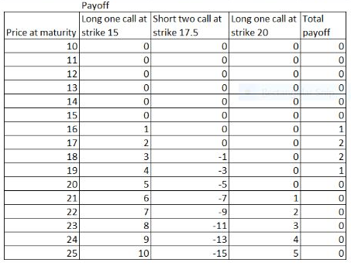
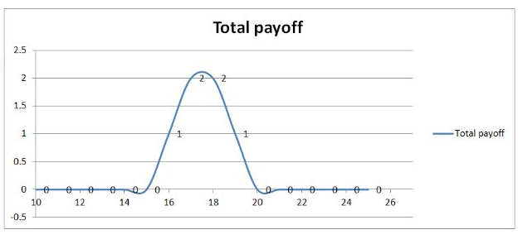
Calculation:
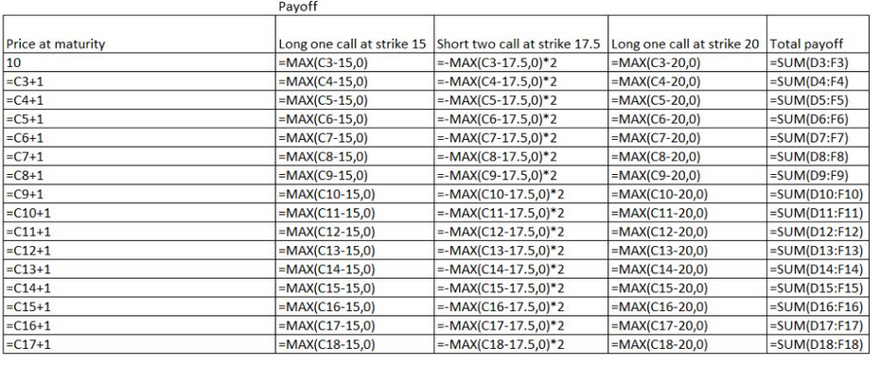

- What would be the total gain (loss) on the above position if the stock price at maturity turned out to be S(T) = 16 (taking into account the price of the options)?

Total Gain:
Payoff =1
Premium =-1.6+2*1.2-0.9=-0.10
Profit =1-0.10=$0.90

- Suppose you decide to buy a 15.0 straddle (1 long call + 1 long put with the same strike of 15.0). Please draw the payoff at maturity.

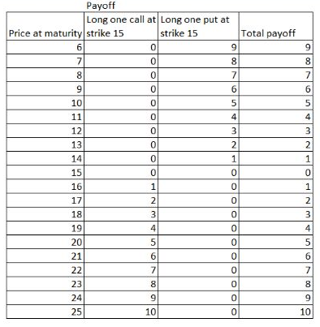
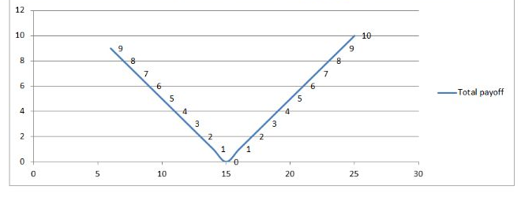
Calculations:
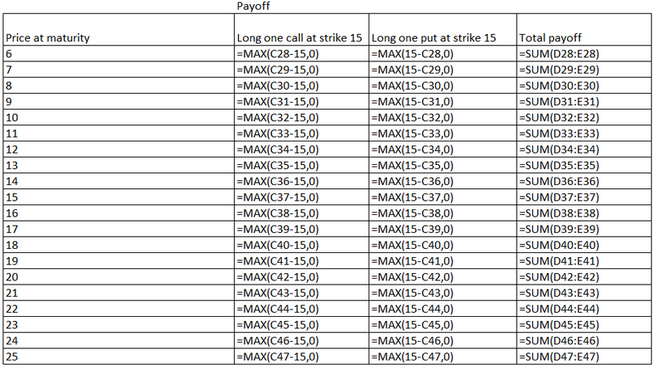

- Over what range of underlying stock price (at maturity) will you lose money (after taking into account the price you paid for the options)?

Premium =3.70
Lower =11.30
Upper= 18.70
We will lose money at 11.30 to 18.70.

Problem 4 (15 points):

Suppose you are given the following data:

2-month option on XYZ stock:
Underlying S = 48.1
Strike X = 50
Put price = $2.2

- What should be the price of call to prevent arbitrage if 2-month interest rate is 6% p.a.?
From the put call parity equation
c+ K/(1+r) = p+S
Where c and p are call and put option premiums respectively
K is the strike price of the options =50
r is the interest rate for 2 months = 6% per annum =1% for 2 months
and t is the time period = 2 months = 1 period
S is the spot price = 48.1
So the price of call option should be
c= 2.2+48.1-50/1.01 = 0.795
Price of call option should be $0.795

- If the actual call price was $1.3 how would you implement an arbitrage opportunity?
1. Today, Buy the put option and stock for $2.2 and $48.1, Simultaneously sell the call option for $1.3. Fund the net amount of (2.2+48.1-1.3) = $49 by borrowing the same at 6% p.a. or 1% or 2 months
2. After 2months, if Stock price> 50, put option becomes worthless, short call option will be exercised , so sell the stock at exercise price of $50, repay the loan amount of $49*1.01 = $49.49 and take the remaining amount as arbitrage profit
3.After 2months, if Stock price< 50, Call option becomes worthless, long put option will be exercised , so sell the stock at exercise price of $50, repay the loan amount of $49*1.01 = $49.49 and take the remaining amount as arbitrage profit

- Compute your payoff at maturity.

The payoff at maturity in both cases will be $0.51 for $49 borrowed and one put option purchased and one call option shorted.

