

Fluid Mechanics
Professor: Roger Dickey
TA: Zhongfeng An
Lab Title: Viscosity Measurement
Date of lab: February 4, 2013
Date of report: February 16, 2013
Report by: Orlando Burns
Group: A

- Abstract
The laboratory quantifies the ratio of dynamic viscosity to density of water and motor oil. Time is recorded by use of a capillary tube viscometer whereas a viscometer constant temperature bath records temperature. The procedure involved dipping two capillary tubes in a bath, one with water and another with oil. Hen pressure was applied until the fluids passed the top marks at the tube. The timer started recording the drop in each fluid as soon as the fluid passed the first mark. The timer stopped at the bottom mark. The procedure was then repeated at different temperatures of 30°C, 45°C, and 60°C. The calibration recorded in the water tube was 0.002(mm2/s2) and oil was 0.25 (mm2/s2). This value was multiplied by the time recorded to obtain the Kinematic Viscosity at the given temperatures. The kinematic viscosity of water was found to be 0.8(mm²/s²) at 30°C and 41.7(mm²/s²) at 60°C whereas oil had 171.5(mm²/s²) at 30°C and 41.7(mm²/s²) at 60°C. Both fluids recorded an inverse relationship between temperature and kinematic viscosity.
- Introduction
The basis of the laboratory is to quantify the value of kinematic viscosity of water and oil. The purpose of these measured values is to relate these values to temperatures at different levels. The significance of viscosity regulates how a product should be handled, stored, or discarded. The instruments adopted for this experiment were a modified Ostwald capillary-tube viscometer and a Viscometer constant temperature and controls. The fluids have no velocity relative to the boundary within the experiment resulting in a parabolic velocity profile. Shear force occurs between the fluid and the walls of the capillary tube. The average speed of each fluid is calculated differently. The calibration constant is given, which is multiplied by time to acquire the kinematic viscosity. The relevance of the Viscometer constant temperature bath is to ascertain that both fluids are at the same temperatures.
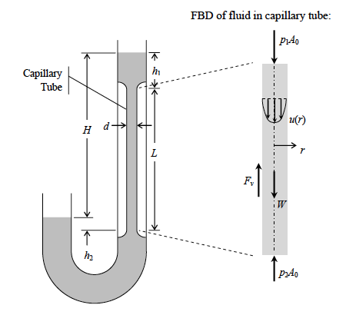

Figure 1-Schematic of Typical Capillary tube viscometer and FBD (Free Body Diagram) of the fluid in the capillary tube
The fluid experiences a force called shear stress, which occurs between the fluid and the wall. The shear stress is given by the equation below.
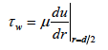 (1)
μ= dynamics viscosity
τw= shear stress
r= radial coordinate from the tube centerline
The average speed of the fluid in the tube is given by the following equation.
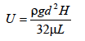 (2)
U=average speed of fluid
ρ=fluid density
g=gravitational force constant
H=average height difference between upper and lower fluid surfaces during test
L=capillary tube length
d=capillary tube diameter
The average flow speed is a slight different equation than the one above it is described below.

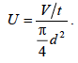 (3)
U=average flow speed
V=volume of fluid
t=time
d= diameter
By combing Eq (2) and (3) and soling for μ gives
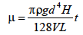 (4)
The kinematic viscosity ,v, is simply the ratio of dynamice viscosity to density therefore gives
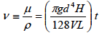 (5)
- Experimental Setup:
This lab requires a modified Ostwald capillary tube viscometer to measure the kinematic viscosity of the liquids. The Figure 2 shows a typical Modified Ostwald capillary Viscometer.
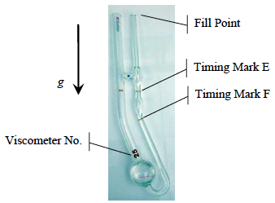

Figure 2: Typical Modified Ostwald Viscometer
The calibration constants for several different sizes of viscometers are given in Table 1. The calibration is considered as a constant. The only other factor required is the time, t. The kinematic viscosity will be determined by applying the equation (6)
v=Ct (6)
C=calibration
t=time (sec)
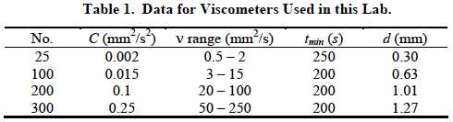
The capillary tubes will be placed in a Viscometer constant temperature bath because temperatures need to be at the same levels for both liquids when recording the data.

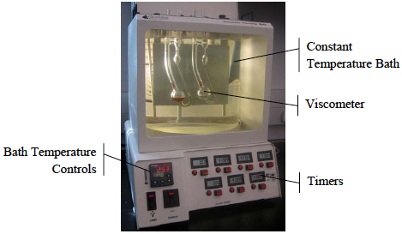
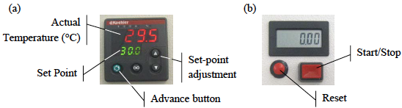
Figure 3: Photograph of Viscometer Constant Temperature Bath and Controls (a) (b)
- Procedure
Before the experiment begins, the Viscometer constant temperature bath needs to be filled with water to a point that it will cover both viscometers. The volumes of the liquids are known but a secondary test is relevant. The secondary test requires a rubber pump to be pressed at the opening of the viscometer capillary tube to draw the fluid until each fluid covers the marks completely. The controls regulate the temperatures of the bath. For the viscometers to obtain thermal equilibrium, an allowance of 5 minutes should be granted before commencement. The viscometer has two calibrated marks, the top and the bottom. The temperature of the bath is verified at 30°C before a rubber pump is used to draw the fluid beyond a top mark calibrated on the tube. The timer starts after the fluid reaches the calibrated top mark and records the time the fluid takes to reach the bottom calibrated mark. The time taken is verified with a table provided to ascertain it is within allowable limits. The procedure is first repeated at the same temperature before it is adopted at different temperatures twice in each case; 45°C and 60°C. The time and temperatures are recorded in a table format.
- Results:
Table 2, Experimental Data for Water
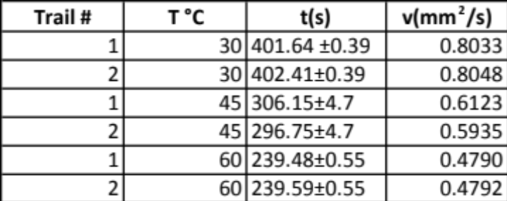
The Table 2 shows the experimental data recorded for water.
Table 3, Experimental Data for Oil
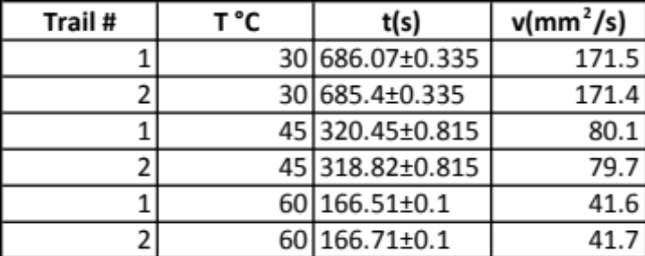
Table 3 shows the experimental data recorded for oil.
The last 2 recorded data entries at 60°C were not in range for what Table 1 shows.
Graph 1. Viscosity vs Temperature for Water
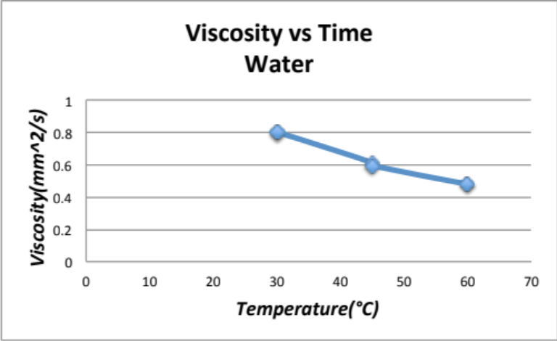
Graph 1 shows the relationship between temperature and viscosity for water.
Graph 2. Viscosity vs Temperature for Oil
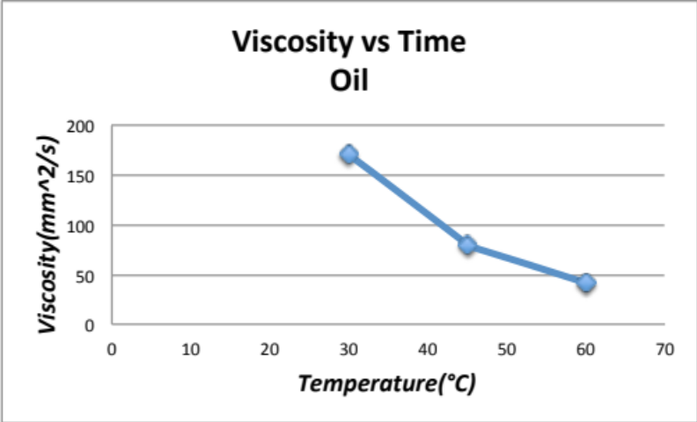
Graph 2 shows the relationship between temperature and viscosity for oil.
- Discussion:
The purpose of the experiment is to obtain and record the viscosity of water and oil. The results indicate a relationship between temperature and viscosity of the fluid. Water viscosity recorded low values at lower temperatures and dropped with every increase in temperature. The temperatures facilitated the flow of the fluids. Oil records higher viscosity values than water but oil also experienced a decrease in viscosity with an increase in temperature. The results were compared to other publications and the closeness of the results grants this experiment credibility. The results illustrate an inverse relationship between temperature and viscosity. The hand-eye coordination in starting and stopping the timer is deduced as the most major error. The experiment also records an error in the values for oil at 60°C since they did not fall within the specified range in the table. The time recorded was below the minimum value of 200 seconds attributed to failure to reach thermal equilibrium. These errors resulted in wrong results and an increase in the repeat procedures at different temperatures is stated as a credible solution.
- Conclusion:
The Modified Ostwald capillary tube Viscometer is a reliable tool in the determination of the values of viscosity of water and oil. The results indicate that oil is more viscous than water at any temperature. The relationship between temperature and viscosity is observed to be inversely proportional. Inverse proportionality dictates that the value of viscosity decreases with every increase in temperature independent on the fluid used.

- Appendix:
A1. Sample calculation of uncertainty analysis
A2. Sources and citation
Munson, Bruce Roy. Fundamentals of Fluid Mechanics. Hoboken, NJ: John Wiley & Sons, 2013. Print.
Viscosity Measurement, Fluid mechanics Handout
Uncertainty Analysis Handout

