

Fluid Mechanics
Professor: Roger Dickey
TA: Zhongfeng An
Lab Title: Viscosity Measurement
Date of lab: February 4, 2013
Date of report: February 16, 2013
Report by: Orlando Burns
Group: A

- Abstract

The lab is designed to measure the kinematic viscosity of two different fluids water and motor oil. To perform the lab a capillary tube viscometer and viscometer constant temperature bath were used to record time and temperature. One capillary tube was filled with water and the other was filled with motor oil and they both were in the bath. First pressure was applied to the capillary tubes by using a small ball pump to raise the fluid pass the top mark on the tube. Once pressure stopped being applied the fluid would start to drop back down and as soon as the fluid passes the first mark the timer is clicked to start recording the time. The timer is stopped till the fluid passes the bottom mark. These basic procedures were performed at 3 different temperatures 30°C, 45°C, and 60°C. The capillary tubes each had a different Number these numbers corresponded to the Calibration. Water tube had a calibration of 0.002 (mm²/s²) and oil had a calibration of 0.25 (mm²/s²). This number was multiplied by time, t, and that’s how the value for the kinematic viscosity, v, was obtained for the specific fluid at a given temperature. When compared at 30°C water had a v=0.8(mm²/s) and oil had a v= 171.5(mm²/s). When compared at higher temperatures water’s v=0.48(mm²/s) and oil’s v=41.7(mm²/s) this was at 60°C. The most notable thing is that both fluids v fell significantly but oils v took a more dramatic fall. It is safe to say that both fluids kinematic viscosities depend on temperature.

- Introduction

The purpose of this lab is to measure the kinematic viscosity of water and motor oil. Viscosity is being measured because it is important to find out how it relates to different fluids and if temperature influences the kinematic viscosity value. Viscosity is an important factor in chemistry, industry, and many types of manufacturing practices. The viscosity of a substance determines how it should be handled, stored, and discarded. This experiment required 2 main instruments a modified Ostwald capillary-tube viscometer Figure 2 and a Viscometer constant temperature bath and controls Figure 3. The Figure 1 shows a basic schematic representation of how fluid flowing down a capillary tube due to gravity. This basic configuration is known as a capillary tube viscometer. The No-slip boundary condition is present in this experiment and this is the fluid in the middle flows fastest while the fluid against the walls remains motionless. The FBD of the flowing fluid results in a parabolic velocity profile across the tube.

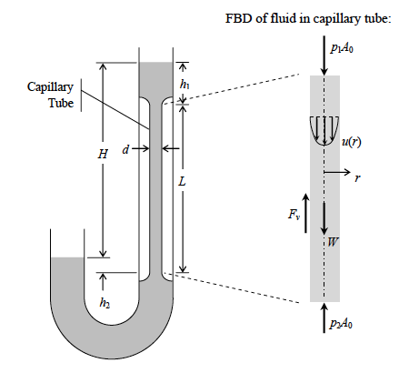

Figure 1-Schematic of Typical Capillary tube viscometer and FBD(Free Body Diagram) of the fluid in the capillary tube

The fluid experiences a force called shear stress, which occurs between the fluid and the wall. The shear stress is given by the equation below.

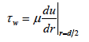 (1)
μ= dynamics viscosity
τw= shear stress
r= radial coordinate from the tube centerline

The average speed of the fluid in the tube is given by the following equation.

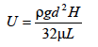 (2)
U=average speed of fluid
ρ=fluid density
g=gravitational force constant
H=average height difference between upper and lower fluid surfaces during test
L=capillary tube length
d=capillary tube diameter

The average flow speed is a slight different equation than the one above it is described below.

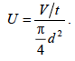 (3)
U=average flow speed
V=volume of fluid
t=time
d= diameter

By combing Eq (2) and (3) and soling for μ gives
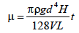 (4)

The kinematic viscosity ,v, is simply the ratio of dynamice viscosity to density therefore gives
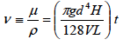 (5)

- Experimental Setup:

This lab requires a modified Ostwald capillary tube viscometer to measure the kinematic viscosity of the liquids. The Figure 2 shows a typical Modified Ostwald capillary Viscometer.
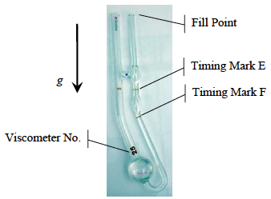

Figure 2: Typical Modified Ostwald Viscometer

The calibration constants for several different sizes of viscometers are given in Table 1. The calibration constant is known therefore the only other factor, which will be needed, is the time, t. The kinematic viscosity will be determined by applying the equation (6)

v=Ct (6)
C=calibration
t=time (sec)

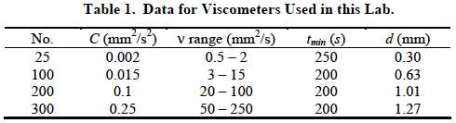

The capillary tubes will be placed in a Viscometer constant temperature bath because temperatures need to be at the same levels for both liquids when recording the data.

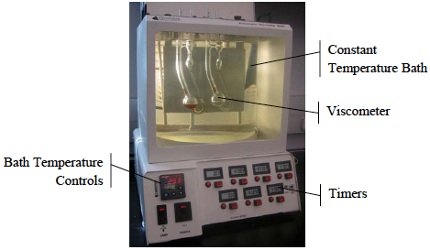
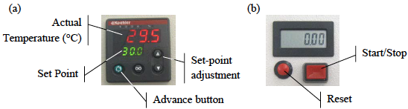

Figure 3: Photograph of Viscometer Constant Temperature Bath and Controls (a) (b)

The procedures for performing this lab are pretty simple and once followed should produce accurate results. First the bath needs to be prepared by having enough water to cover the viscometers. One viscometer with No. 25 will contain water and the viscometer with No. 300 with contains SAE30 motor oil. The volumes of the liquids should have been set but to be sure just use the rubber pump and place in the opening of the viscometer and apply pressure once the fluid covers the marks completely the volume is acceptable. Next use the controls (see Figure 3 (a) and (b)) to set the temperature to 30°C the red numbers need to be at 30°C. Allow for the viscometers to reach a thermal equilibrium, therefore waiting for about 5 minutes after the desired temperature is reached should be adequate time. Next Record the temperature and use the rubber pump to apply pressure to the tube until the fluid reaches a few millimeters above the top mark E. After it reaches a height above the mark remove the pump and wait for the fluid to reach the mark E and start the timer to record how long it takes the fluid to drain down to the bottom mark F. Record the time it takes and verify with Table 1 that it is within the allowable time t. These steps are to be repeated once more for the same temperature. Next repeat the steps for 2 different temperatures being at 45°C and 60°C. Make sure to record the temperatures and time in a table format.

- Results:

Table 2. Experimental Data for Water
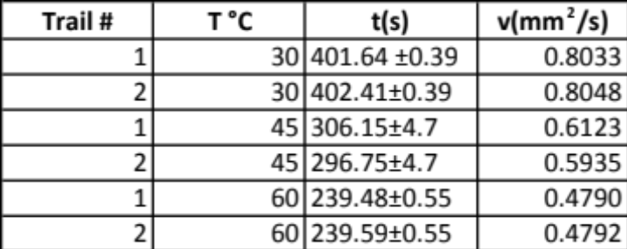
The Table 2 shows the experimental data recorded for water.

Table 3. Experimental Data for Oil
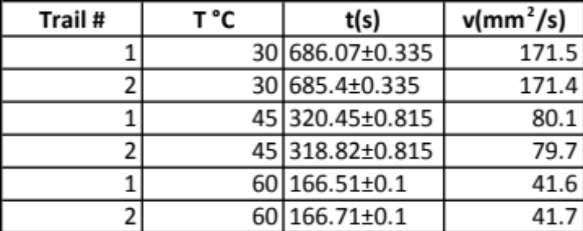
Table 3 shows the experimental data recorded for oil.
The last 2 recorded data entries at 60°C were not in range for what Table 1 shows.

Graph 1. Viscosity vs Temperature for Water
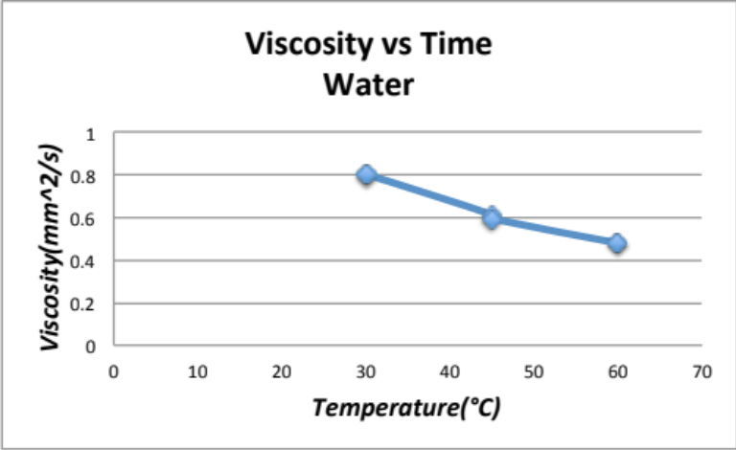

Graph 1 shows the relationship between temperature and viscosity for water.

Graph 2. Viscosity vs Temperature for Oil
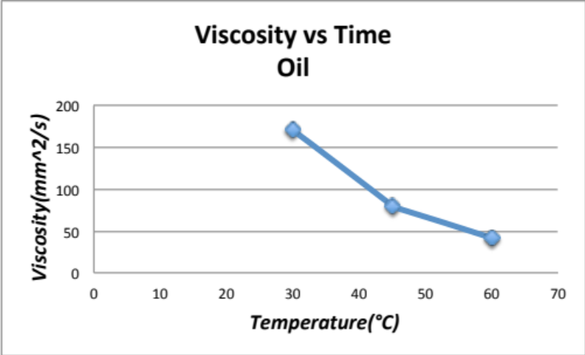

Graph 2 shows the relationship between temperature and viscosity for oil.

- Discussion:

The objective of the experiment was reached because the viscosity of water and oil were obtained and recorded. Based on the results it is clear that temperature is related to the viscosity of the fluid. Water’s viscosity was very low from the start but when the temperature is increased the viscosity even got lower and it was half of what it started it out to be. The temperature allowed for the fluid to become more fluid or allowed it to “Flow” even more. When compared to oil water is much less viscous. Oil’s viscosity is very high to start with but when the temperature was increased it also decreased its viscosity. When the graphs were compared to those of other publication they corresponded pretty close giving our results more creditability. A liquid’s viscosity tends to decrease as its temperature increases. The experiment did encounter some errors. The main error or uncertainty comes from the hand and eye coordination when to start the timer and when to stop the timer. The person responsible for the controls of the timer could not have started the time and stopped it at exactly when the fluid reached the marks. Another error encountered was that for the oil data the last 2 recorded times at 60°C (Table 3) were not in range for what Table 1 said it should have been at. The time was below the minimum time of 200 seconds. The reason for this error can be explained by the thermal equilibrium not being reached. The data was probably recorded before the water bath was at thermal equilibrium and this caused for wrong results to occur. The best way to reduce these errors are by doing more than just 2 recording for each set of temperature points. This will help increase the accuracy of the results.

- Conclusion:

The Modified Ostwald capillary tube Viscometer was very accurate in obtaining the viscosities of water and oil. From the results it is clearly notable that water has very low viscosity compared to oil. The main conclusion drawn form the experiment is the relationship between temperature and viscosity. When the temperature increases the viscosity decreases.

- Appendix:

A1. Sample calculation of uncertainty analysis

A2. Sources and citation

Munson, Bruce Roy. Fundamentals of Fluid Mechanics. Hoboken, NJ: John Wiley & Sons, 2013. Print.

Viscosity Measurement, Fluid mechanics Handout

Uncertainty Analysis Handout

