Lab Title: Bernoulli Equation Experiment
Date of lab: February 18, 2013
Date of report: March 4, 2013
Group A

Abstract:

This lab is designed to study the flow through a Venturi tube using the setup shown in Fig. 1. The airflow for the Venturi tube will be supplied by the AF10 Airflow Bench as shown in Fig. 3. Once the airflow is turned on the static and total pressures are measured by moving the pitot-static probe at different locations inside the duct. The pressures are measured using the manometer bank in Fig. 3 and Fig. 4. Two manometers are used to measure the static pressure and total pressure separately. The pressure in the air box is also measured. The pressure in the air box is constant and the reading was 90 mm/Pa. The static pressure measurements varied for the different location from a range of -3 mm/Pa to -103 mm/Pa. The total pressure head was also constant around 90 mm/Pa. These results were graphed and compared concluding that the pressure and velocity fluctuate while passing through the different portions of the Venturi tube.

Introduction and Objective:

The purpose of the lab is the application of Bernoulli’s equation to measurement of flow velocity with pitot tube and compassion of the velocity measurements to the predicted velocity based con conservation of mass.

Bernoulli’s Equation can be considered to be a statement of conservation of energy principle appropriate for flowing fluids. The qualitative behavior that is usually labeled with the term “Bernoulli effect” is the lowering of fluid pressure in regions where the flow velocity is increased.

$\frac{p}{ρg}+\frac{V^{2}}{2g}+z=H,$ (1)

p= Fluid pressure (static pressure)
ρ= Fluid density
V= Velocity magnitude (speed) of the flow
g= Gravitational acceleration
z= the height of the streamline from a specified coordinate origin
H= Total head

A very important property of eq. (1) is that the total head, H, is constant along a streamline in inviscid flow. The viscous effect is negligible for fluids like water and air. By rearranging Bernoulli’s equation another form can be obtained.

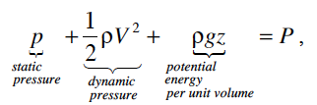
(2)

P= Total pressure, which is also constant along a streamline in inviscid flow and is equal to the pressure fluid.

The potential energy term of the Bernoulli’s equation is negligible for this experiment. Hence after further simplifying eq. (2) to

$p+\frac{1}{2}ρV^{2}=P$, (3)

Eq. (3) indicates that p must decrease if V increases along a streamline, and vice versa.
Like any other equation certain conditions need to be valid before applying the equation. When applying Bernoulli’s equation it is important that these conditions apply.

- Steady flow
- ρ is constant
- Negligible losses (viscous effect and heat transfer)
- Applies along a streamline

Condition 2. Implies that the flow is incompressible. This condition means that it can safely be applied in fluids that traditionally are compressible such as air. Only if the Mach number of the flow is sufficiently small. The Mach number is defined as

$Ma=\frac{V}{a}$, (4)

a= Speed of sound in the fluid medium

If Ma<0.3 everywhere in the flow, then this means the flow is considered incompressible condition 2 is satisfied.

Experimental Equipment and Procedure:

In this experiment we will be studying the flow through a Venturi tube using the setup shown in Fig. 1. When observing the Venturi tube there is a divergent portion and convergent portion with the divergent portion being longer in length. This variation in the cross sectional area causes a variation in the flow velocity and pressure in the tube. The conservation of mass for steady incompressible flow indicates that the flow speed at an arbitrary location in the tube, V, is related to the speed in the throat, V_{t}, agreeing to,

$AV=A_{t}V_{t}$, (5)

A= cross sectional area at an arbitrary location
A_{t}= location a throat

Eq. (5) can be rearranged to

$BV=B_{t}V_{t}$, (6)

B= widths of the channel at the corresponding locations (Fig. 1)

The geometry of the Venturi tube provides a way to predict the velocity ratio

$\frac{V}{V_{t}}$, (7)

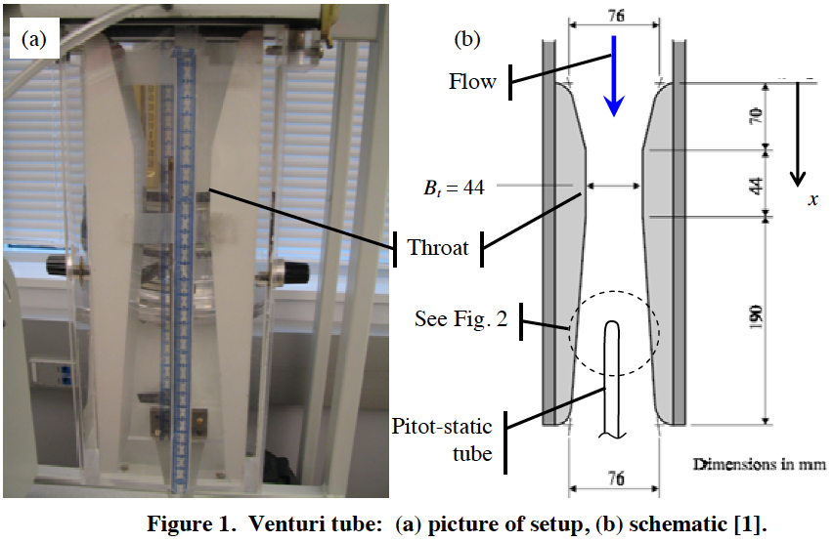

Using the pitot static tube the velocity variations along the Venturi tube can be measured. The pitot static tube measured both the static pressure and total pressure and with both P and p known Bernoulli’s equation (Eq. 3) can be used to find the local flow speed as,

$V=\sqrt{\frac{2(P-p)}{ρ}}$, (8)

This Eq. 8 can also be applied to the throat, V_{t.}
$V_{t}=\sqrt{\frac{2(P-p)}{ρ}}$, (9)

Dividing eq. 8 and 9 gives

$\frac{V}{V_{t}}=\sqrt{\frac{(P-p)}{(P_{t}-p_{t})}}$, (10)

Velocity ratio can be compared to expected velocity ratio by,

$\frac{V}{V_{t}}=\frac{B_{t}}{B}$, (11)

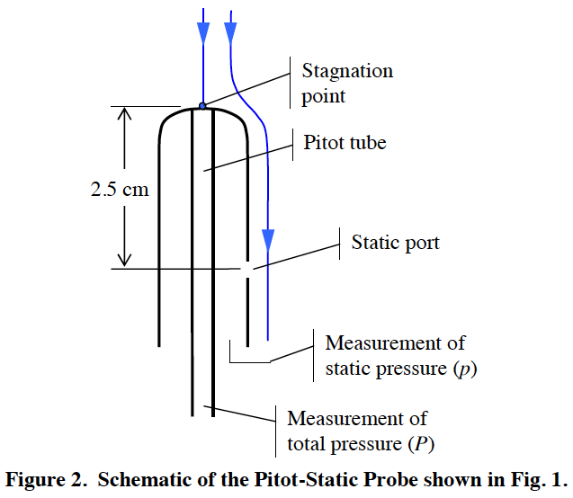

The procedures for this experiment are pretty basic and easy to follow.
Turn on the AF1o airflow bench to get airflow going through the Venturi tube. Next record the total pressure inside the air box. The static and total pressures are also measured separately at different locations by moving the pitot static probe. To measure the pressures use the manometers and each measurement uses 2 manometers.
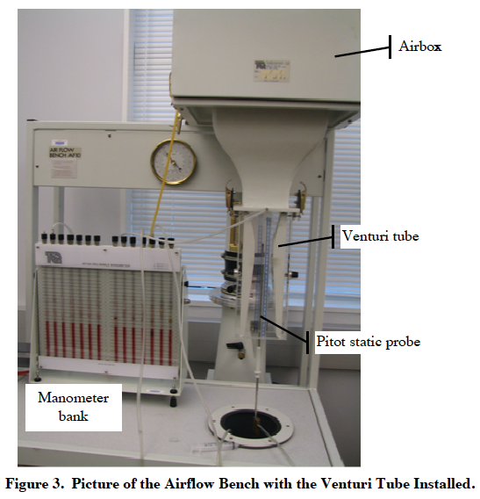

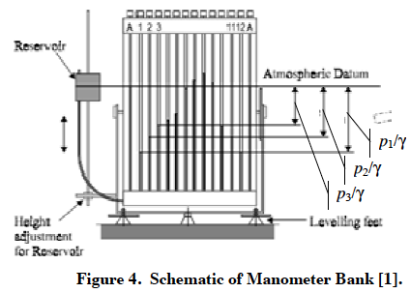

See appendix for question answers.

Results of Experiment and Interpretation:

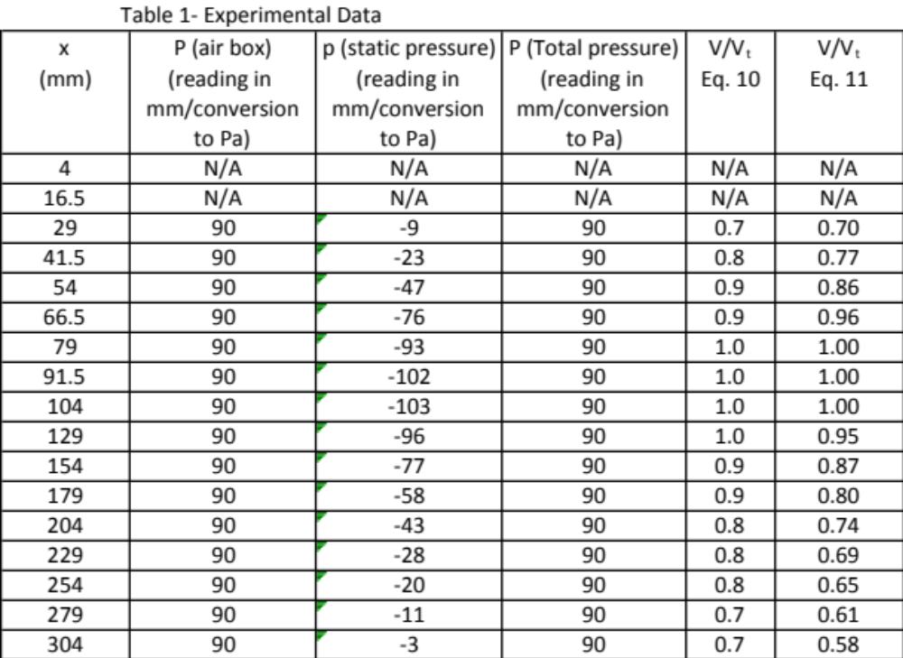
Table 1 shows the experimental data recorded for the experiment and the velocity ratios calculated as well.

Discussion:

The results for this experiment show that the objective was completed. The static and total pressure values were found in the Venturi tube and these results are shown in Table 1. Also the velocity ratios were calculated which are also found in Table 1. The result did agree with the theory of Bernoulli’s equation because the pressure in the air box was held constant and the static pressure can clearly be seen to fluctuate due to the divergent and convergent portions of the Venturi tube. This means that when the air is flowing through the convergent portion its velocity decreases because of the space it passes through decrease as the air reaches the divergent portion the velocity increases. The pressure relates the opposite to how velocity reacts. The convergent portion experiences high pressure or increases pressure while in the divergent portion it experiences low pressure or decreased pressure. Some sources of uncertainty were found during the experiment. The major uncertainty would be that it was difficult to read the pitot tube and make sure it was on the proper value of x (mm). This could have caused for the results to be inaccurate.

Conclusion:

This experiment allowed for the study of flow through a Venturi tube. The measurements of static and total pressures in the tube were recorded and analyzed. The results showed that the pressure and velocity changed when it passed through the different portions of the Venturi tube. Overall the lab was successful in observing how airflow passes through a Venturi tube. Pressure and velocity do not have a proportional relationship.

Appendices:

A1. Sample calculation of uncertainty analysis and other calculations

A2. Sources and citation

Munson, Bruce Roy. Fundamentals of Fluid Mechanics. Hoboken, NJ: John Wiley & Sons, 2013. Print.

Bernoulli Equation: Measurement in a Venturi Tube, Fluid mechanics Handout

Uncertainty Analysis Handout

