Due 10/2
Production management
Instructions (See Below)(Use Microsoft excel)

*****Assignment

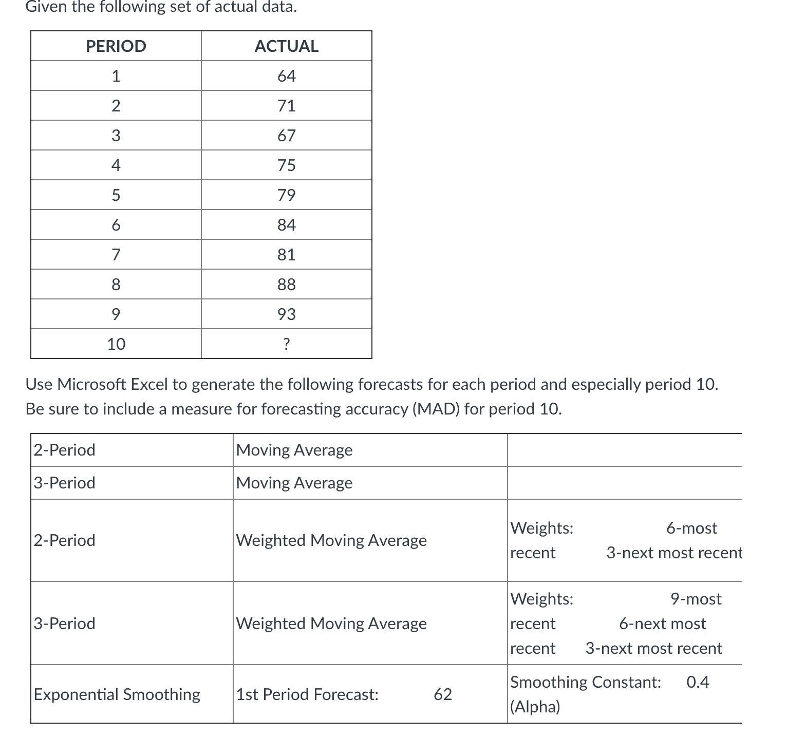

Moving Average-2 period
Period | Demand | Forecast | Error | |Error| | Error^2 | |Pct Error|
1 | 64
2 | 71
3 | 67 | 67.5 | -0.5 | 0.5 | 0.25 | 0.75%
4 | 75 | 69 | 6 | 6 | 36 | 8%
5 | 79 | 71 | 8 | 8 | 64 | 10.13%
6 | 84 | 77 | 7 | 7 | 49 | 8.33%
7 | 81 | 81.5 | -0.5 | 0.5 | 0.25 | 0.62%
8 | 88 | 82.5 | 5.5 | 5.5 | 30.25 | 6.25%
9 | 93 | 84.5 | 8.5 | 8.5 | 72.25 | 9.14%
TOTALS | 702 |  | 34 | 36 | 252 | 43.21%
AVERAGE | 78 |  | 4.857 | 5.143 | 36 | 6.17%
Next period forecast |  | 90.5 | (Bias) | (MAD) | (MSE) | (MAPE)
 |  |  |  | Std err | 7.099

Moving Average -3 period
Period | Demand | Forecast | Error | |Error| | Error^2 | |Pct Error|
1 | 64
2 | 71
3 | 67
4 | 75 | 67.333 | 7.667 | 7.667 | 58.778 | 10.22%
5 | 79 | 71 | 8 | 8 | 64 | 10.13%
6 | 84 | 73.667 | 10.333 | 10.333 | 106.778 | 12.30%
7 | 81 | 79.333 | 1.667 | 1.667 | 2.778 | 2.06%
8 | 88 | 81.333 | 6.667 | 6.667 | 44.444 | 7.58%
9 | 93 | 84.333 | 8.667 | 8.667 | 75.111 | 9.32%
TOTALS | 702 |  | 43 | 43 | 351.889 | 51.60%
AVERAGE | 78 |  | 7.167 | 7.167 | 58.648 | 8.60%
Next period forecast |  | 87.333 | (Bias) | (MAD) | (MSE) | (MAPE)
 |  |  |  | Std err | 9.379

Weighted Moving Average- 2 period
Period | Demand | Forecast | Error | |Error| | Error^2 | |Pct Error|
1 | 64
2 | 71
3 | 67 | 68.667 | -1.667 | 1.667 | 2.778 | 2.49%
4 | 75 | 68.333 | 6.667 | 6.667 | 44.444 | 8.89%
5 | 79 | 72.333 | 6.667 | 6.667 | 44.444 | 8.44%
6 | 84 | 77.667 | 6.333 | 6.333 | 40.111 | 7.54%
7 | 81 | 82.333 | -1.333 | 1.333 | 1.778 | 1.65%
8 | 88 | 82 | 6 | 6 | 36 | 6.82%
9 | 93 | 85.667 | 7.333 | 7.333 | 53.778 | 7.89%
TOTALS | 702 |  | 30 | 36 | 223.333 | 43.71%
AVERAGE | 78 |  | 4.286 | 5.143 | 31.905 | 6.24%
Next period forecast |  | 91.333 | (Bias) | (MAD) | (MSE) | (MAPE)
 |  |  |  | Std err | 6.683

Weighted Moving Average- 3 period
Period | Demand | Forecast | Error | |Error| | Error^2 | |Pct Error|
1 | 64
2 | 71
3 | 67
4 | 75 | 67.833 | 7.167 | 7.167 | 51.361 | 9.56%
5 | 79 | 71.667 | 7.333 | 7.333 | 53.778 | 9.28%
6 | 84 | 75.667 | 8.333 | 8.333 | 69.444 | 9.92%
7 | 81 | 80.833 | 0.167 | 0.167 | 0.028 | 0.21%
8 | 88 | 81.667 | 6.333 | 6.333 | 40.111 | 7.20%
9 | 93 | 85 | 8 | 8 | 64 | 8.60%
TOTALS | 702 |  | 37.333 | 37.333 | 278.722 | 44.76%
AVERAGE | 78 |  | 6.222 | 6.222 | 46.454 | 7.46%
Next period forecast |  | 89.333 | (Bias) | (MAD) | (MSE) | (MAPE)
 |  |  |  | Std err | 8.347

Exponential Smoothing

Period | Demand | Forecast | Error | |Error| | Error^2 | |Pct Error|
1 | 64 | 62 | 2 | 2 | 4 | 3.13%
2 | 71 | 62.8 | 8.2 | 8.2 | 67.24 | 11.55%
3 | 67 | 66.08 | 0.92 | 0.92 | 0.846 | 1.37%
4 | 75 | 66.448 | 8.552 | 8.552 | 73.137 | 11.40%
5 | 79 | 69.869 | 9.131 | 9.131 | 83.379 | 11.56%
6 | 84 | 73.521 | 10.479 | 10.479 | 109.804 | 12.48%
7 | 81 | 77.713 | 3.287 | 3.287 | 10.806 | 4.06%
8 | 88 | 79.028 | 8.972 | 8.972 | 80.503 | 10.20%
9 | 93 | 82.617 | 10.383 | 10.383 | 107.815 | 11.17%
TOTALS | 702 |  | 61.925 | 61.925 | 537.529 | 76.90%
AVERAGE | 78 |  | 6.881 | 6.881 | 59.725 | 8.55%
Next period forecast |  | 86.77 | (Bias) | (MAD) | (MSE) | (MAPE)
 |  |  |  | Std err | 8.763

Based on forecast results using MAD, 2 period-Moving Average method and 2 period Weighted Moving average method are the best method compared to the other three methods as we can see in Forecast Table 1. The purpose of this comparison is to find the most suitable method. The lowest the MAD is the better the forecasting method accuracy is. The small error means there is only a small difference between the actual demand and predicted demand.

