Friction

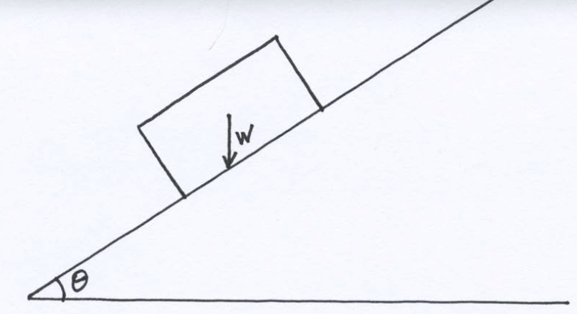

Assume the weight of the box is 500 N for all problems below.

- If θ = 20º and μ_{s} = 0.15, will the box begin to slide down the ramp?

- If θ = 10º and μ_{s} = 0.15, will the box begin to slide down the ramp?

- If θ = 5º and μ_{s} = 0.15, will the box begin to slide down the ramp?

Bonus 1: What will be the exact critical ramp angle (θ) at which point the box will overcome the maximal friction force and begin to slide down the ramp? Hint: it’s somewhere between 5º and 10º, but I would not attempt to calculate the infinite number of solutions.

Bonus 2: What would be the exact critical ramp angle (θ) at which the box would overcome the maximal friction force and begin to slide down the ramp if μ_{s} = 0.45?

- A football player pushes a 670 N tackling sled. The coefficient of static friction between the sled and grass is 0.73 and the coefficient of kinetic friction between the sled and grass is 0.68.
  - How much force must the player exert to start the sled in motion?
  - How much force is required to keep the sled in motion?
  - Answer the same two questions with a 100 kg coach standing on the back of the sled (note units of measurement)

