Implicit Association Between Race and Weapons compared to? Title should describe the study
Kyra S. Fuleihan
Psychology 1200

97%
Wonderful job!!

17/18An implicit association test (IAT) is a social psychology measure, designed to assess the strength of an individual’s implicit, automatic associations between concepts. It measures the speed of an individual’s response. An IAT measures the association of two target concepts with an attribute (Greenwald, McGhee, & Schwartz, 1998). When the categories that are highly associated share a response key, the response is faster than when less associated categories share a key (Greenwald et al, 1998). This difference is able to measure the differential association of the concepts with the attribute (Greenwald et al, 1998). The IAT has been indicated to be sensitive to near-universal evaluative differences, expected individual differences in evaluative association, and consciously disavowed evaluative differences (Greenwald et al., 1998). An implicit association is an unconscious, automatic thought, while an explicit association is a stated, conscious thought. Individuals can hold negative implicit associations about a certain group of people and their explicit attitudes may not reflect their implicit associations. Humans have implicit attitudes because they inherently categorize things to simplify material.
Stereotypes are sets of beliefs about a certain group of people. They can be based on race, ethnicity, age, sexual orientation, gender identity, mental illness, etc. These beliefs shape our judgements of individuals who fit in the groups. However, many stereotypes are inaccurate. Stereotypes guide cognition, including memories of events and interpretation of ambiguous actions. An implicit bias can create false memories. Eyewitness identification is prone to false memories (Helm, Ceci, & Burd, K. A, 2016). Identification errors can result from implicit associations someone has with a suspect's face (Helm et al., 2016). The more a witness implicitly associates an individual face with a certain crime, the more likely it is that the memory of that person committing the crime is a false memory (Helm et al., 2016). Many stereotypes can be very harmful and can negatively affect people. The legal system is based on the idea of innocent until proven guilty. However, this has been questioned for cases involving minorities because jurors could have an implicit or explicit racial bias (Morrison, DeVaul-Fetters, & Gawronski, 2016). Current research shows that legal professionals are very good at identifying jurors with implicit racial bias that are consistent with their legal interests (Morrison et al. 2016). Professionals who were the defense lawyers of a Black defendant were more likely to exclude jurors with implicit racial bias, while those who were the prosecutors did the opposite (Morrison et al. 2016). Disproportionate minority contact (DMC) refers to the representation and treatment of racial and ethnic minorities in the criminal justice system and it is a large problem in the juvenile justice system (Desai, Chapman, Fralzer, & Borum, 2012). A study explored if mental illness could be a factor to explain DMC, and 482 detained youth were interviewed (Desai et al. 2012). Racial minorities faced a lower risk of violence, but are disproportionately represented among detention populations compared to their proportions in the general population (Desai et al. 2012). The study found that DMC was not explained by mental illness, seriousness of charges, violence risk, age, or gender but was explained by……..? this is the main point of the study (Desai et al. 2012) Efforts to reduce DMC need to focus on systemic intervention and reducing the racial disparity in decisions made in the court system (Desai et al. 2012).
Many different things could affect someone’s implicit bias, including age, race, and gender. Black Americans are more likely to be stereotyped as criminals than people from any other racial background (Devine & Elliot, 1995). However, there is not much data on if a person’s race/ethnicity has a correlation with their implicit bias. This study is looking at if there is a relationship between an individual’s race/ethnicity and their implicit bias. White people have had more positions of power and control in the media, so it is possible that they have been able to influence people’s implicit bias with their own. Media outlets have promoted racial biases that demonize black families and idealize white families in reference to poverty and crime (Rodgers & Robinson, 2017). The hypothesis of this experiment is that white people have an implicit association with black people and weapons.
Methods 11/12
Participants:
The participants consisted of 1084 people who completed a MyPsychLab activity. Six hundred and twenty three participants were white or European American (376 female and 244 male, 577 right handed and 46 left handed). One hundred and sixty nine participants were black or African American (117 female and 50 male, 151 right handed and 18 left handed). One hundred and three participants were Hispanic or Latino (74 female and 29 male, 97 right handed and 6 left handed). Ninety one of the participants were Asian American (46 female and 44 male, 86 right handed 5 left handed). Nine of the participants were Native American (4 female and 5 male, 9 right handed). Eighty nine of the participants were other ethnicities (47 female and 39 male, 84 right handed and 5 left handed). The ages ranged from 11-75 but the average and standard deviation are unknown.
Materials/Measures:
The study used an implicit association test found on MyPsychLab.
Procedure:
To complete this study, each student completed the Implicit Association Test on MyPsychLab. To do this, they logged on to mypearson.com and went to the course PSYC-1200-C01. The activity could be found in the course calendar under items due. The IAT asked the student to classify a set of words and images into groups. The goal was to classify them as fast as possible without making any errors. The activity consisted of 7 trials. Trials 1, 2, 3, 5, and 6 were practice trials to give the student experience with the sorting the test requires. Only that data from trials 4 and 7 were used to determine the students implicit association. In trial 1, White Americans were placed on the right side and Black Americans on the left. In trial 2, weapons were placed on the right side while harmless objects were on the left. In trial 3, White Americans and weapons were placed on the right side and Black Americans and harmless objects were placed on the left. Trial 4 remained the same as trial 3. In trial 5, Black Americans were placed on the right side and White Americans were placed on the left. In trial 6, Black Americans and weapons were placed on one side while White Americans and harmless objects were placed on the other. Trial 7 remained the same as trial 6. How were the results analyzed? Only certain trials right?
Results 8/8
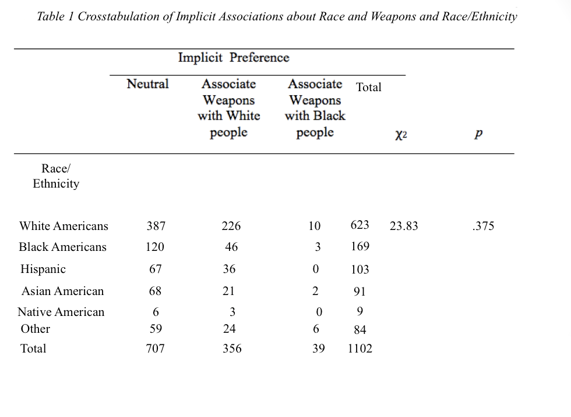
Nice table!

The hypothesis was that white people have an implicit association with black people and weapons. The results showed that 387 (62.1%) White or European Americans were implicitly neutral, 226 (36.3%) implicitly associated weapons with White people, and 10 (1.6%) implicitly associated weapons with Black people. The independent variable was race/ethnicity and the dependent variable was implicit preference. Participants race are not significantly related to their implicit associations of race and weapons x²(10) = 23.83, p = .375. This indicates that the hypothesis was not supported. Nice job on this section!
Discussion
The aim of the study was to determine if a person’s race affected their implicit associations of race and weapons. The results showed that the participant’s race is not related to their implicit associations as measured by the IAT. The hypothesis was that white people have an implicit preference for black people and weapons, so it was not supported. The implications of this study could be that there are other things which more heavily influence a person’s implicit association than their own race, and variables such as gender and age should be examined. This study could also imply that the recent news coverage of school shootings mostly perpetrated by white males has created an availability heuristic that causes people to associate white people with guns. This could raise questions about an implicit bias with gender and weapons. Another study would be needed to come to a conclusion. It could use an IAT with gender instead of race.
This study is limited because the IAT may not be an accurate measure of a person’s association between race and weapons. Some students who completed the activity thought there was a learning curve, and believed it became easier to complete the activity as they got further into it, because they got used to the activity and understood how to complete it. Others, found that it was easier to respond quickly in the beginning because by the end of the activity the labels had already been in different places and it became confusing to keep track of where they were. Handedness could also have played a role because a person may have been able to answer more quickly with their dominant hand. A strength of the study was the large sample size, however, there was a much larger sample size of females than males, and a much larger sample of white or European Americans than any other race/ethnicity. If another study on race and weapons were to be conducted, a test that is less dependent on the order categories are shown should be used. There should also be an equal sample size of each group being tested. This study should also be expanded by including images of people from different socioeconomic groups, instead of only the upper middle class. Wonderful

References 4/4
Desai, R. A., Chapman, J., Fralzer, P. R., Borum, R. (2012). Mental illness, violence risk, and
race in juvenile detention: Implicit for disproportionate minority contact. American Journal of Orthopsychiatry, 82, 1, 32-40.
Devine, P.G. & Elliot, A.J. (1995). Are racial stereotypes really fading? The Princeton Trilogy
revisited. Personality and Social Psychology Bulletin, 21, 1139-1150.
Greenwald, A. G., McGhee, D. E., Schwartz, J. L. K. (1998). Measuring individual differences
in implicit cognition: The implicit association test. Journal of Personality and Social Psychology, 74, 6, 1464-1480.
Helm, R. K., Ceci, S. J., & Burd, K. A. (2016). Can implicit associations distinguish true and
false eyewitness memory? Development and preliminary testing of the IATe. Behavioral Sciences & The Law, 34(6), 803.
Morrison, M., DeVaul-Fetters, A., & Gawronski, B. (2016). Stacking the Jury: Legal
Professionals’ Peremptory Challenges Reflect Jurors’ Levels of Implicit Race Bias. Personality And Social Psychology Bulletin, 42(8), 1129-1141.
Rodgers, N., & Robinson, R. (2017). How the news media distorts black families. American
Psychological Association.

