Determine the types of symmetry the following equations have
- $x^{2}+2y^{2}=16$
Substituting x with -x, if the equation remains the same with the original equation then the graph is symmetrical about the y-axis
$2y^{2}=$(${-(-x)}^{2}+16$
=$2y^{2}={-x}^{2}+16$
The graph is symmetrical about the y-axis

2.$y=\left(- 2\right)x^{2}+4$ replace x with (-x)
$y=\left(- 2\right){(-x)}^{2}+4$
$y=\left(- 2\right)x^{2}+4$
The equation remains the same as the original
Hence the graph is symmetrical about the y-axis

3) 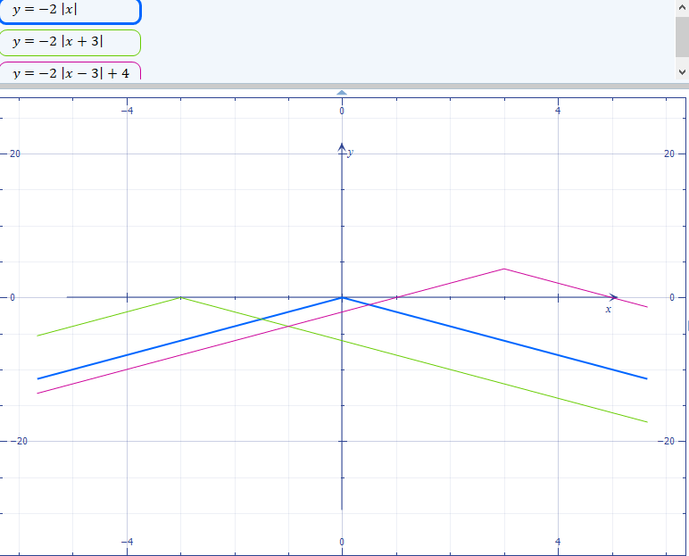

$y=\left(- 2\right)\left|x\right|$ The basic equation
$y=\left(- 2\right)\left|x + 3\right|$ Horizontal shift to the left by three units
$y=\left(- 2\right)\left|x - 3\right|+4$ vertical shift up by 1 unit

4) 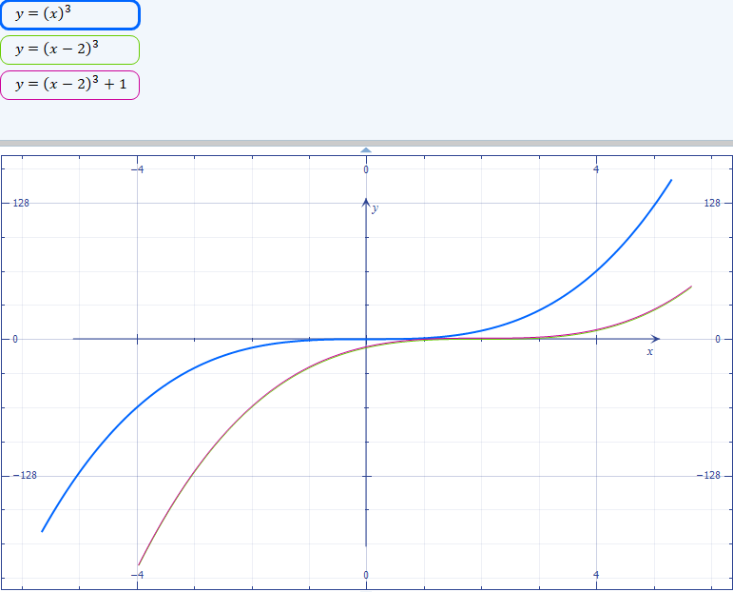

$y={\left(x\right)}^{3}$ is basic function
$y={\left(x - 2\right)}^{3}$ horizontal shift right 2 units
$y={\left(x - 2\right)}^{3}+1$
The functions shift the graph one unit to the right and up by one unit

5)$y=\left(- \frac{1}{2}\right){\left(x + 3\right)}^{2}+2$
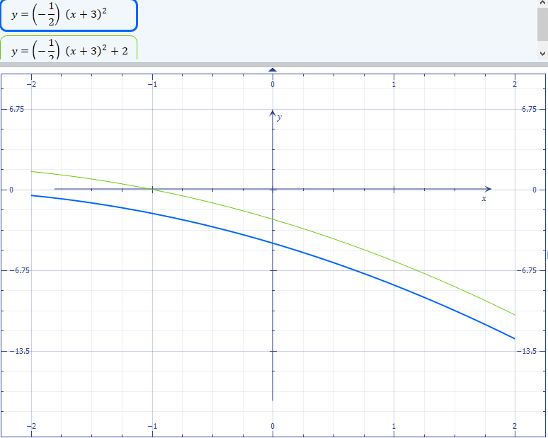

$y=\left(- \frac{1}{2}\right){\left(x + 3\right)}^{2}+2$ The equations shift to the right by two units
$y=\left(- \frac{1}{2}\right){\left(x + 3\right)}^{2}$ , -1/2, produces a reflection

6)
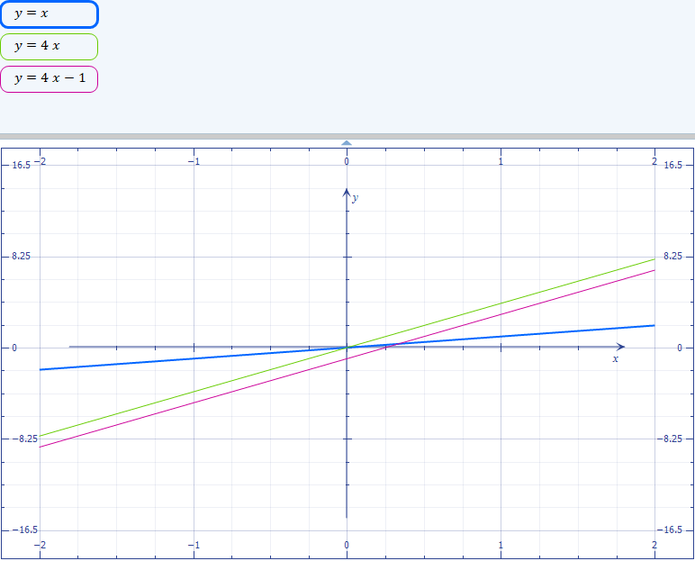

$y=x$ is a basic equation
$y=4x$ produces dilation ,the graph stretches vertically

$y=4x-1$
The graph shifts negatively by one unit.

7) 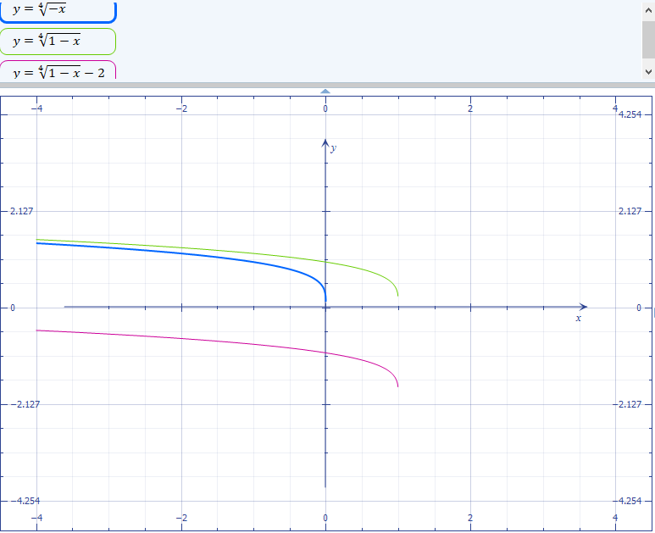

$y=\sqrt[4]{-x}$ basic equation

Equation $y=\sqrt[4]{-x+1}-2$ shifts the graph downward by 2 units

7)$y=\frac{1}{x+2}-3$

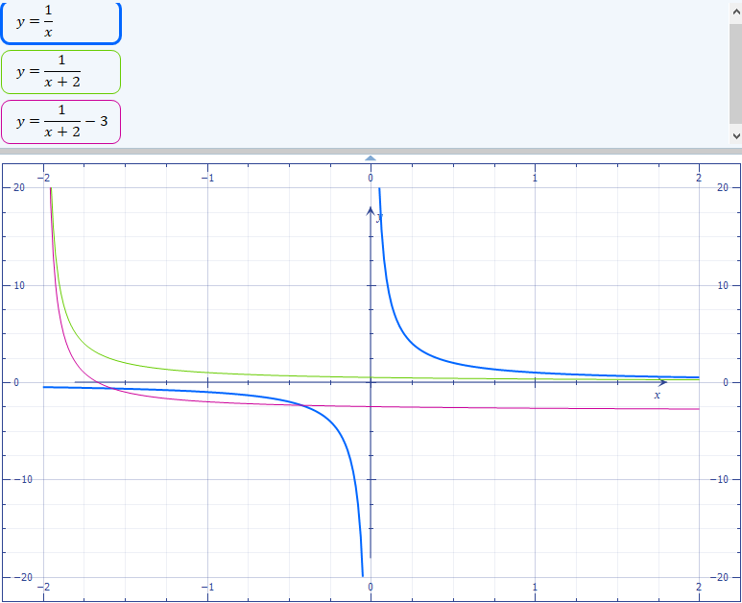

$y=\frac{1}{x}$ basic function
$y=\frac{1}{x+2}$ horizontal shift to left 2 units
$y=\frac{1}{x+2}-3$ vertical shift down 3 units

