Hierarchies of Life

Pre-Lab Questions
- Create your own mnemonics to help remember the categories (groups) in the Linnaean classification system
- How is today’s Linnean classification system different from the one Carl Linnaeus created in the 1770s?
- Why do you think it important to use bionomial or the scientific Latin names (example: Asterias ruben) when describing species instead of common names (example: common starfish)?
- Pick your favorite species (animal, plant, fungi, protist or bacteria), do a web-search to find the binomial name as well as the family, order, class, phylum, kingdom and domain it belongs to.
- How closely related is the species you chose in Question 4 to humans? What is the smallest category or group both species belong to?

Experiment 1: Classification of Common Objects

Data Tables
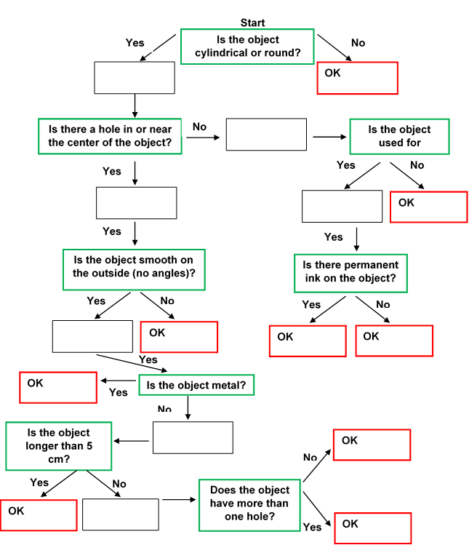

Post-Lab Questions
- Did you find that the items grouped together as you worked down the flow chart had similar characteristics in terms of their appearance? What about function?
- Do you feel that the questions asked were appropriate? What questions would you have asked to devise this classification flow chart? What objects would be grouped together with your system?
- Do you think it is more or less challenging to classify living organisms in comparison to objects? Why?
- Pick 10 household items (e.g. spoon, book, paper clip, etc.) and design a taxonomic classification system to categorize them, similar to the one in Figure 8. Make sure you ask enough yes/no questions so that each item ends up in its own box or category at the end.

Experiment 2: Classification of Organisms

Data Tables
Table 2: Classification of Organisms
Organism | Domain | Kingdom | Defined Nucleus | Mobile | Photosynthesis | Unicellular
Salmonella
Ants
Zoo Flagellate
Wolf
Morning Glory
Euglena
Shiitake
Pseudomonas
Spruce
Death Cap Mushroom

Post-Lab Questions

- Did this series of questions correctly organize each organism? Why or why not?
- Do you feel that the questions asked were appropriate? What questions would you have asked?
- Which kingdom do you believe is most challenging to categorize correctly? Explain your answer
- If you have snorkeled or gone scuba diving off the California cost you may have come across bull kelp, a type of brown algae that belong to the Protist kingdom. Research this species and find at least one characteristic that would cause it to be incorrectly categorized using the system you used in this experiment.
- Write two questions each for the animal, plant, fungi and protist kingdoms (8 questions total) that can be used to categorize species within the kingdoms in a classification system like the one used in this experiment. (Hint: think about species within each kingdom and what makes them different from other species in that same kingdom)? Defined Nucleus

