Geometry (Pappus configuration)
Name
Institution of Affiliation
Course Code
Date
Geometry (Pappus configuration)
Exercise 1
In the proof of Pappus theorem, we have silently assumed that the (yellow) Menelaus triangle is non-degenerate, i.e. that the three vertices are not collinear. Show that this follows if we assume that the two lines through 𝑝1, 𝑝2, 𝑝3 and 𝑞1, 𝑞2, 𝑞3 are distinct. Exercise 1 In the proof of Pappus theorem, we have silently assumed that the (yellow) Menelaus triangle is non-degenerate, i.e. that the three vertices are not collinear. Show that this follows if we assume that the two lines through 𝑝1, 𝑝2, 𝑝3 and 𝑞1, 𝑞2, 𝑞3 are distinct.

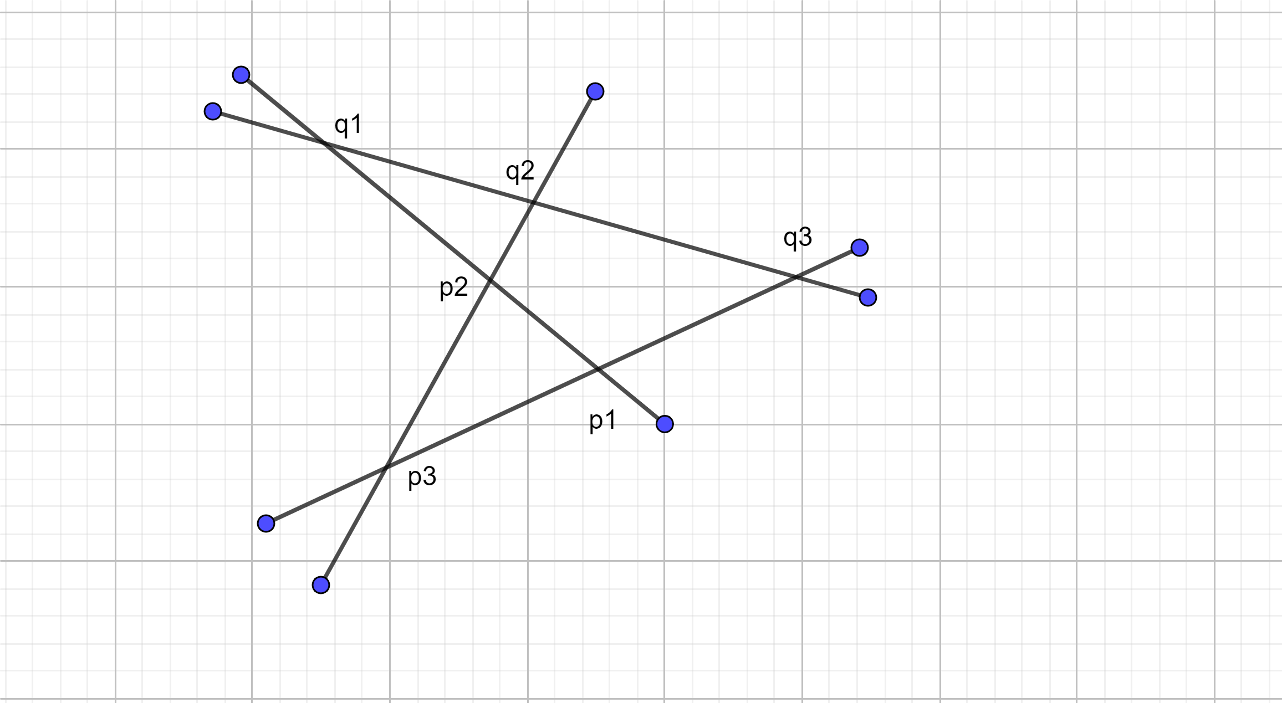
Let p1, p2, p3, be three points in an affine plane 𝔽 2 that are not collinear. Let pq1q2 divide the segment 𝑃q1q2 in the proportion q1q2 ≠ −1. Then the three points q1, q2, q3 are collinear if and only if q1q2q3= −1.
We choose p1 as the origin if the affine plane f2 and thus can treat f2 as a vector space. Choose p1, p2 and p1, p3 as the basic vectors of f2. Thus, we can abbreviate ap1, p2+bp1p3 as $\left(\begin{aligned}a \\ b\end{aligned}\right)$.
By assumption,
- q1 = 1 1 + q1 (𝑃1 + q1𝑃2) = 1 1 + q1 $\left[\begin{aligned}q1 \\ 0\end{aligned}\right]$
- q2 = 1 1 + q2(𝑃2 + q2𝑃3) = 1 1 + q2 $\left(\begin{aligned}1 \\ q2\end{aligned}\right)$
- q3 = 1 1 + q3 (𝑃3 + q3𝑃1) = 1 1 + q3 $\left(\begin{aligned}0 \\ 1\end{aligned}\right)$
the points q1, q2, q3 are collinear
Exercise 2
Let 𝑝1, 𝑝2, 𝑝3 and 𝑞1, 𝑞2, 𝑞3 be six distinct points in the affine plane ℝ 2. Assume that the lines 𝑝𝑖 𝑞𝑗 and 𝑝𝑗 𝑞𝑖 meet in three distinct points 𝑡𝑖𝑗 for all pairs 1 ≤ 𝑖 < 𝑗 ≤ 3. Show that if 𝑝1, 𝑝2, 𝑝3 and 𝑡12, 𝑡23, 𝑡13 are both collinear, then also 𝑞1, 𝑞2, 𝑞3 are collinear
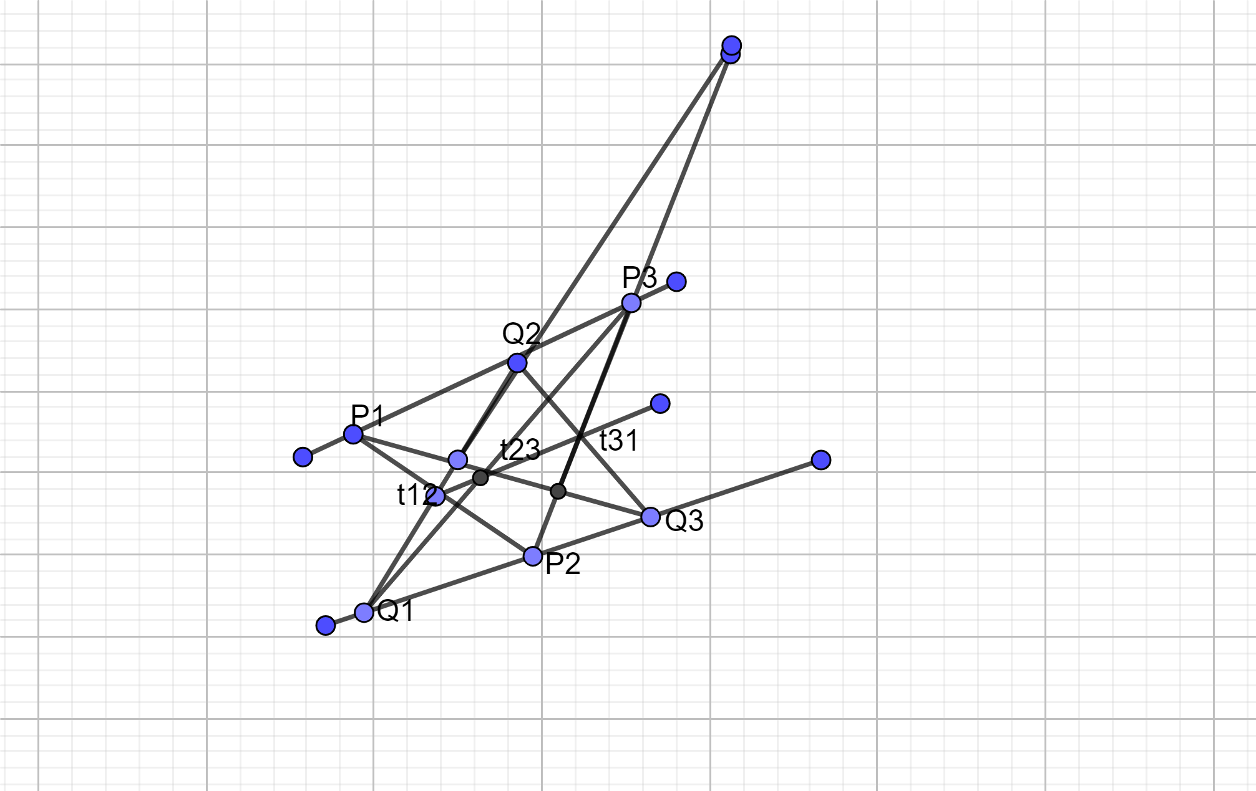
Let’s first assume that t12t23t31 = -1. We have to show that 𝑇12, 𝑇23 and 𝑇31 /p1, p2, p2/q1, q2, q3 are collinear. Denote the dilation of 𝔽 2 with center at 𝑇𝑖𝑗 that maps 𝑃𝑗 to 𝑃.
- (t12q1/q2t12)/(t23p3/t23q1)/(t31p3/t31p2) =1
- Thus, q1, q2, q3 are collinear, and the theorem is proved.

Exercise 3
The following puzzle is played on the set of points ℤ 2 with integer coordinates in ℝ 2. The red points 𝑝1 = (0, 0), 𝑝2 = (1, −1), and 𝑝3 = (−2, 1) are ‘mirrors’, and the player has a blue peg placed on some point. A move consists of jumping with the peg across any of the three mirrors. For instance, if the peg is at the point (1, 0), we can jump to (−1, 0), (1, −2), or (5, 2), depending on which mirror we use. Find a sequence of jumps that takes a peg at position (1, 0) to position (1, 2) that is different from the solution below.
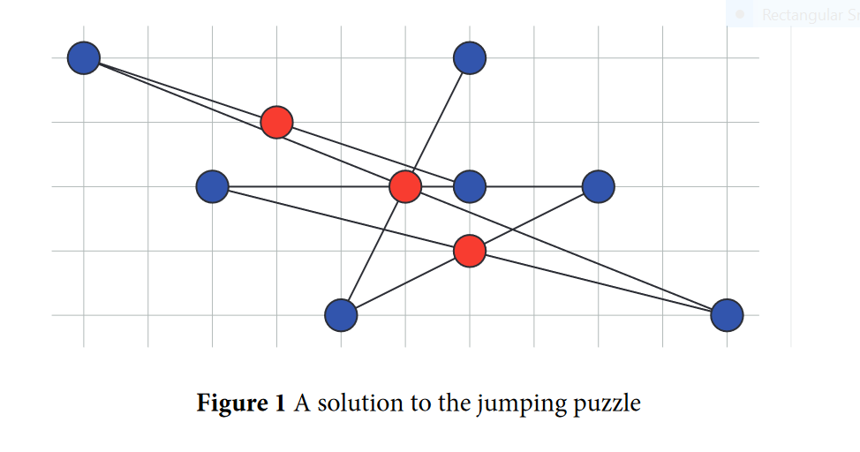
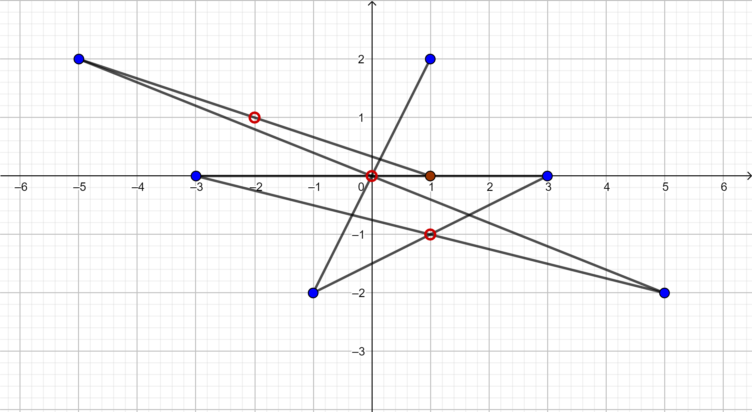
- P1(-5,2)
- P2(5, -2)
- P3(-3,0)
- P4(3,0)
- P5(-1, -2)
- P6(1,2)
Exercise 4
In this exercise, you will ‘design’ a Pappus configuration with the six points on two horizontal lines, and the line of the intersections a vertical line. Let 𝑝1, 𝑝2, 𝑝3 be three distinct points on the line 𝑦 = −1 and 𝑞1, 𝑞2, 𝑞3 be three distinct points on the line 𝑦 = +1 in the affine (𝑥, 𝑦)-plane ℝ 2. Assume that 𝑝1 = (2, −1). The lines 𝑝𝑖 𝑞𝑗 and 𝑝𝑗 𝑞𝑖 meet in three distinct points 𝑡𝑖𝑗 for all pairs 1 ≤ 𝑖 < 𝑗 ≤ 3. Locate the points 𝑝2, 𝑝3 and 𝑞1, 𝑞2, 𝑞3 such that 𝑡12 = (0, 3), 𝑡13 = (0, −3) and 𝑡23 = (0, 0).
