Geopolitics in Argentina
Name
Institution

Geopolitics is the study of political influence and economic geography on politics and power of a state. The approach taken by the state determines whether impact on the country will be positive or negative to its citizens. Its' analysis focuses on a geographic significance on virtue in international relations with politics playing a major role in ensuring that harmony coexist in the long run within the border or forever leave the state at war. A case study on Argentina gives an insight on how the country has made efforts in the struggle to reduce government influence and open the economy. The country's top bosses embezzled funds from the public coffers and took huge debts from international bank thereby making the state broke. The result of the act was felt majorly by the citizens of which the wage rates and salaries were reduced as result of increase in inflation.
One of the most critical sectors in Argentina is its Industries, and a majority of the citizens earn their salaries and wages from these factories. As part of Argentina's government plan to reduce subsidies and state controls over the economy, the fuel prices have been tied to global oil prices to create an enabling environment. The government regulated oil exports and created programs that gave incentive to producers in order to sell domestically at prices below international rates. The fundamental goal was to limit the impact of oil prices on the domestic bill and to limit inflation.
In the quest to expand its marine territory, Argentina submitted its proposal to the Commission on the Limits of the Continental Shelf which was gladly accepted after three years. Argentina’s sovereignty made the commission to declare that they were not in a position consider and qualify parts of the submission. The move extensively depicted the influence that the country had globally (Fedirka, 2017). There has also been increased border dispute between Chile and Argentina. Calvert (1989) in his article states that the feud was solved in of the most political innovation. The two countries embodied a treaty of peace and friendship in 1984 which was conducted through a referendum and unanimously accepted. The outcry in Argentina at British over the military exercise in Atlantic further exposes the weakness and Sovereignty of Argentina based on how the state indulged itself in the issue. The country was at first silent only to cry foul later on. (Calvert 1989). Calvert further notes that the country’s national debt which was a result of embezzlement of funds and affected the previous government is also of concern. The misappropriation affected the general population resulting in low wages for the workers, inflation, high rate of external debt and negligence of the education sector. The result was a ruin of confidence on the state's economic policy from 32% to a paltry 6% which raises more concern about the legitimacy of the sitting government.
With the technological advancement, the world at large has become more civilized in solving disputes and handling technical territorial issues. Israel is a shrimp state but able to secure its borders from the continued attack from Palestine due to the advancement of information and technology. A country's ability to make sophisticated weapons makes it feared politically. The improvement in technology also ensures that the state can produce quality products globally and do quality marketing. Use of clean energy has contributed immensely to environmental conservation. Argentina is one of the world leaders in oil production has adopted technology in energy production. This measure helps in reducing conflicts with its neighbors based on environmental concerns. When peace reigns, citizens are assured of jobs and stable income, increased production from both agricultural sector and manufacturing sector, increased imports and exports due to peace enjoyed within border and increased bilateral agreements. Fitch (2009) established the sovereignty of Argentina, and the strength of its submission made it possible for the state to expand its borders to include the vast South Atlantic seabed. Moreover, when a country has no technological advancement, it tends to lag behind in economic development and products from its market are not competitive globally. Such states are always weak due to lack of sophisticated weapons to protect their borders and to gourd the citizens. It’s thus critical for each country to make sure that its technology is up to date it the fast-paced technology-oriented society. This measure will ensure that the state is competitive in its output and most importantly respected globally. Education should, therefore, be a top priority for any country that needs to scale up in technology and innovation.
Argentines debt and restructuring theory.
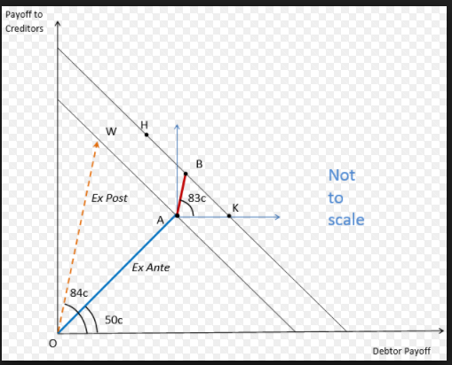
Trade recovery in 2017 and 2018 amid policy
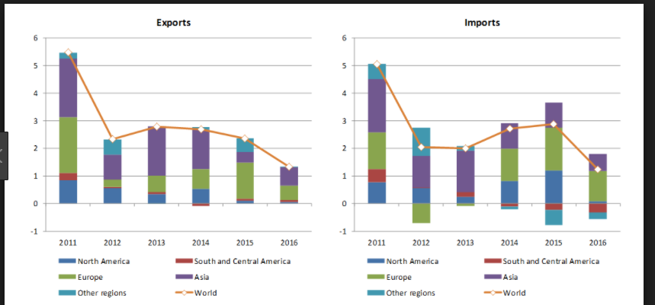
(Image curtesy of world history.com)

References
Calvert, P. (2014). Argentina: the primacy of geopolitics. The World Today, 45(2), 33-36.
Stratford (2013). Geopolitical Diary: technology's Impact on Geopolitics. Accessed July 31, 2013.
Ferdika, A. (2017).Argentina powers ahead with Economic Reforms: subsidies and price controls may soon be a thing of the past. Accessed October 2, 2017. https://geopoliticalfutures.com/argentina-powers-ahead-economic-reforms/

