- Functions
- $f\left(x\right)=x$
- Graph
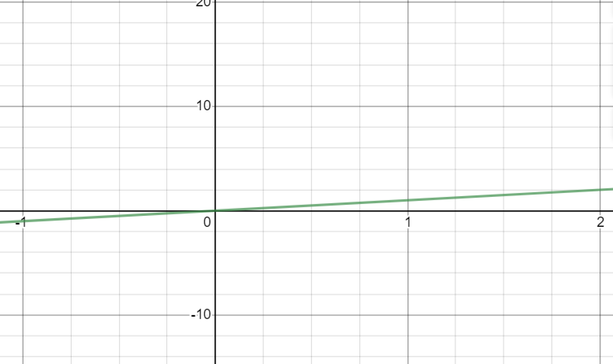
- Domain
$$(-∞,∞)$$
- Range
$$(-∞,∞)$$

- Intercepts
x-intercept=$\left(0,0\right)$
y-intercept=$(0,0)$
- Symmetries
Symmetric with respect to the origin
Transformation
$$g\left(x\right)=x-2$$
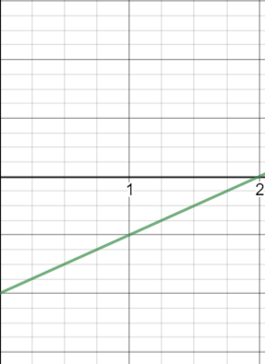
The graph is shifted 2 units downwards since d<0.
- $f\left(x\right)=x^{2}$
- Graph
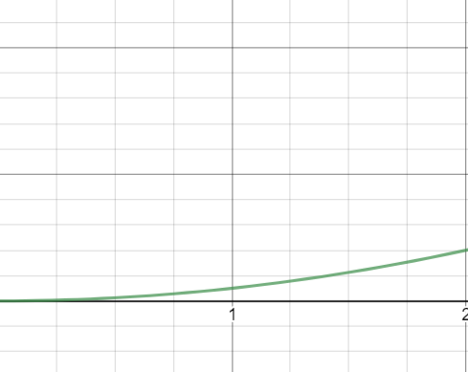
- Domain
$$(-∞,∞)$$
- Range
$$[0,∞)$$

- Intercepts
x-intercept=$\left(0,0\right)$
y-intercept=$(0,0)$
- Symmetries
Symmetric with respect to the y-axis
Transformation
$$g\left(x\right)=\frac{1}{2}{\left(x+2\right)}^{2}$$
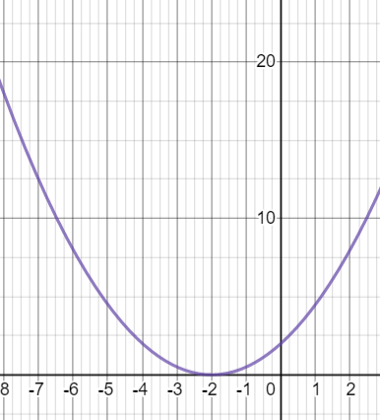
The graph is shifted 2 units to the left since c<0. Then is it compressed vertically by $\frac{1}{2}$ since 0<|a|<1
- $f\left(x\right)=x^{3}$
- Graph
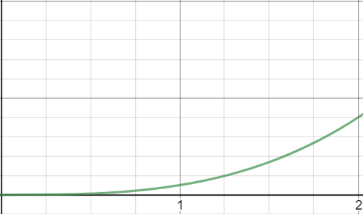
- Domain
$$(-∞,∞)$$
- Range
$$(-∞,∞)$$

- Intercepts
x-intercept=$\left(0,0\right)$
y-intercept=$(0,0)$
- Symmetries
Symmetric with respect to the origin
Transformation
$$g\left(x\right)={\left(\frac{1}{3}x\right)}^{3}$$
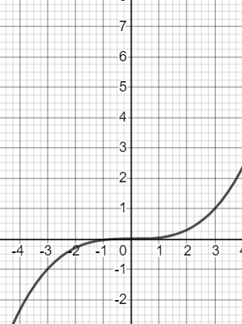
The graph is stretched horizontally is 3 units since 0<|b|<1.

- $f\left(x\right)=\sqrt{x}$
- Graph
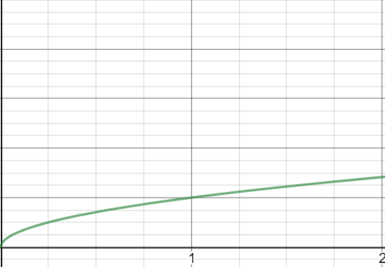
- Domain
$$[0,∞)$$
- Range
$$[0,∞)$$

- Intercepts
x-intercept=$\left(0,0\right)$
y-intercept=$(0,0)$
- Symmetries
Not symmetric
Transformation
$$g\left(x\right)=\sqrt{x-5}+1$$
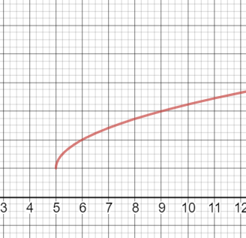
The graph is shifted 5 units to the left and then 1 unit upwards

- $f\left(x\right)=\sqrt[3]{x}$
- Graph
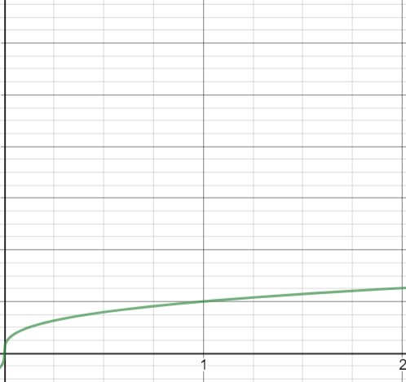
- Domain
$$(-∞,∞)$$
- Range
$$(-∞,∞)$$

- Intercepts
x-intercept=$\left(0,0\right)$
y-intercept=$(0,0)$
- Symmetries
Symmetric with respect to the origin
Transformation
$$g\left(x\right)=2\sqrt[3]{x}$$
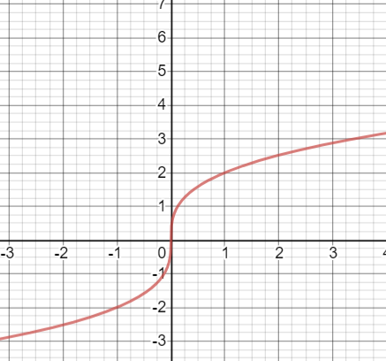
The graph is stretched vertically by 2 units since |a|>1
- $f\left(x\right)=\frac{1}{x}$
- Graph
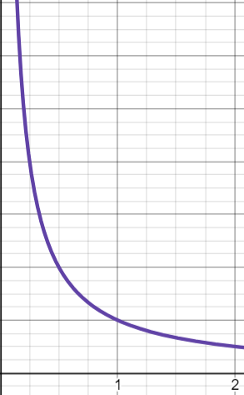
- Domain
$$(-∞,0)∪(0,∞)$$
- Range
$$(-∞,0)∪(0,∞)$$

- Intercepts
None
- Symmetries
Symmetric with respect to the origin
Transformation

$$g\left(x\right)=\frac{1}{x}-5$$
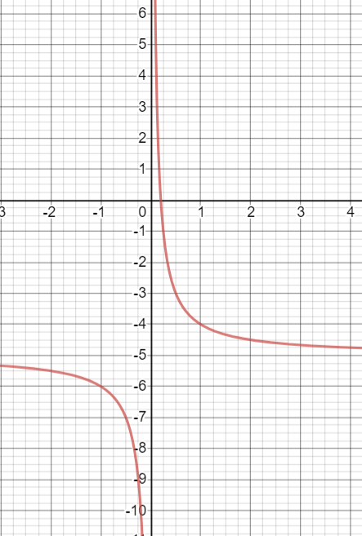
The graph is shifted downwards by 5 units.
- $f\left(x\right)=|x|$
- Graph
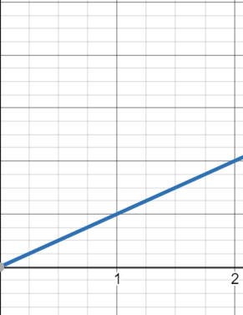
- Domain
$$(-∞,0)∪(0,∞)$$
- Range
$$(-∞,0)∪(0,∞)$$

- Intercepts
None
- Symmetries
Symmetric with respect to the origin
Transformation
$$g\left(x\right)=3|x-1|-5$$

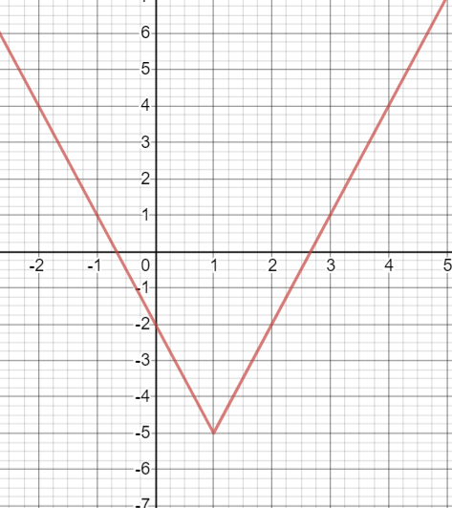
The graph is shifted right by 1 unit. Then vertically stretched by 3 units and then shifted 5 units downwards.
- $f\left(x\right)=⟦x⟧$
- Graph
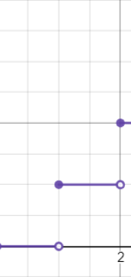
- Domain
$$(-∞,∞)$$
- Range
$$Z$$
- Intercepts
x-intercept=$[0,1)$
y-intercept=$(0,0)$
- Symmetries
None
- Transformation

