Painting and Finishing
Name
Institution
Course
Date

CONTRACTOR SCOPE
Indiana State University-Dreiser Hall Renovation
Terre Haute, Indiana
Contract number: W478 KB-09003
RTA SUBMITAL
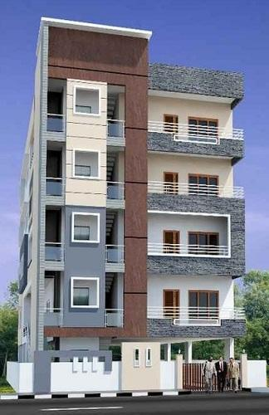
Project Team


General contractor
The contractor will confirm performing all work according to the specifications, plans, and standards of performance and following the owner's satisfaction. Additionally, the contractor will agree to get all the required licenses regarding his work. Further, for confirmation to the site superintendent of the time and date, the task will be ready for inspection and the inspection nature.
The contractor will also provide registration of workforce B.C. certification and the current clearance letter after providing clearance of workforce B.C. letters monthly. During the term at any given time, the contractor will give his compliance evidence and also any or all of the sub-contractors upon the owner's request. He will also conduct safety meetings weekly and provide the appropriate paperwork superintendent to the site as needed by B.C. Workforce.
GENERAL MAINTAINANCE OF THE SITE
- The contractor shall remove, dispose, and clean up all debris linked with his activity to the owner's provided bin.
- All activities, including equipment start-up, should be done during regular hours of working as per the city's bylaws.
- The contractor will be responsible for protecting other traders' work against any damage resulted from his forces of work.
- It will be the contractor's duty to ensure that all work performed will be through and functional and meet all requirements and codes applicable and to the final confirmation by the local jurisdiction governing authorities.
GENERAL RESPONSIBILITIES
- The contractor will be required to familiarize with the site and identify any potential challenges before beginning the task.
- Provision of more labor inclusive Saturday and overtime work safety personnel as needed from time to time for project schedule compliance without the owner incurring additional costs.
- Enhance cooperation with other traders to have a safe and smooth flow of activities. Also, give a sequencing of work detailed plan to the manager of the construction.
- Comply with all safety requirements, meetings, and reports according to bylaws, safety programs, and applicable regulations.
Sub-contractor #5: Painting and Finishing
Presented by:
Detailed Role & Scope:
The contractor will be responsible for providing all the required labor, supervision, tools, equipment, materials, and supply to finish surfaces as needed for the architectural drawings. The contractor will confirm he is an expert in the field and fully experienced and acknowledgeable in all areas of regulations, methods, procedures, codes, and requirements. Further, he will acknowledge that this expertise is relied on by the owner.
The scope of work will include, though not limited to, the following:
- Prepare and perform all concrete masonry units.
- Perform all the gypsum plaster
- Prepare and provide the necessary materials required for cement plaster
- Do and finish the wood doors, complete the wood carpentry as well as trimming.
- Prepare, provide, and fix hollow metal frames and doors.
EXTERIOR AND INTERIOR PAINTING
The scope of work will consist though not limited to the following;
- The contractor shall supply touch-up paint for each suit, upon the project completion, provide to the developer.
- Supply general paint that is of quality or equal for the task. He must get the owner's approval of similar quality product approval.
- Fill and sand flush all nail holes. Nails above the surface that is finished will be set by the contractor or reported to the site manager.
- The contractor will sand all the woodwork as needed between and before coats of paints.
- Conduct Finishing and priming all interior woodwork with two coats half-gloss finish.
- Sand all walls between coats to produce a final coat that is smooth.
- All walls to get two coats of latex premium quality and one primer latex quality.
- Prime all the exterior wood with one coat exterior premier.
- Other finishes product protection in the exterior and interior of the building while doing his task. Drop sheets will be applied over cabinets, carpets, and tiles. Remove or mask the door hardware and reinstall it subsequently.
- Repair and fill wood surface imperfections and minor drywall.
- Reinstall and remove electrical outlet and switch in areas of touch-up painting and finish.
- Provide a one-year material and labor warranty for all individual interiors and a two-year warranty for materials and labor of all exterior and common areas of the project.

