Geology
Student’s Name
Institutional Affiliation

Geology
Gypsum sedimentary rock is formed by evaporation and precipitation of minerals contained in water; the process occurs under certain special conditions such as temperature change. The rock is made of sulfur, calcium, oxygen, and water. Ions are dissolved under supersaturated chemical conditions. The ions are removed from water during evaporation and combine to form solid atoms arranged in an orderly pattern. The process entails a transition from a dissolved state to a solid-state in the form of a crystal. Precipitation causes sulfur bonding to form a sulfate compound. The sulfate compound reacts with water and calcium ions to create gypsum. Gypsum formation can occur in hot springs since the change in water chemistry initiates precipitation. As a result, a rock with crystalline structure is formed after undergoing some form of recrystallization in a process known as lithification (Britannica, n. d.). Gypsum deposits are the major constituent of sedimentary rocks formed years ago. They are used for a variety of applications, such as the construction of buildings. The rock is found in most parts of the world, with the largest deposits in between North America and Mexico.
Sandstone sedimentary rock Igneous Rock (Basalt)
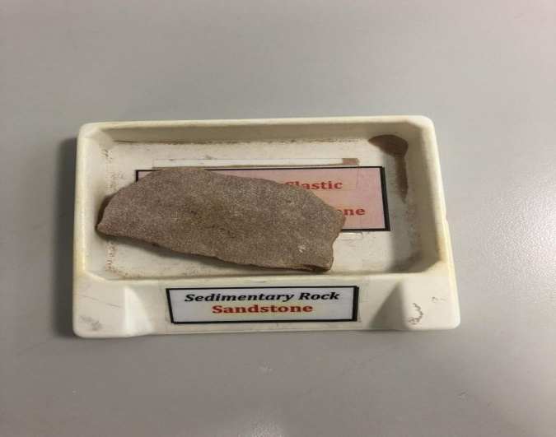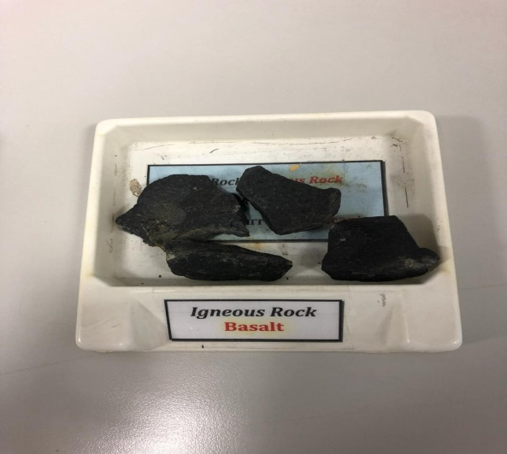
Gypsum is a soft rock that has colored crystals as well as pretty crystalline patterns found in deep layers of oceans or lagoons. Their formation is facilitated by the presence of calcium or sulfate ions in water. The sulfate and calcium content precipitate and accumulate in large water beds. Gypsum dissolves in water bodies after some time, and it is not often present in the sand. The rock is made of sulfate mineral with compounds such as calcium sulfate dehydrate. It is formed as a result of sulfide oxidation as well as pyrite oxidation or when calcium carbonate reacts with sulfuric acid. The presence of gypsum creates a favorable environment for oxidation due to their reductive properties. The sulfate can be reverted back to sulfide under such conditions due to the presence of sulfide-reducing bacteria.
Marble Granite
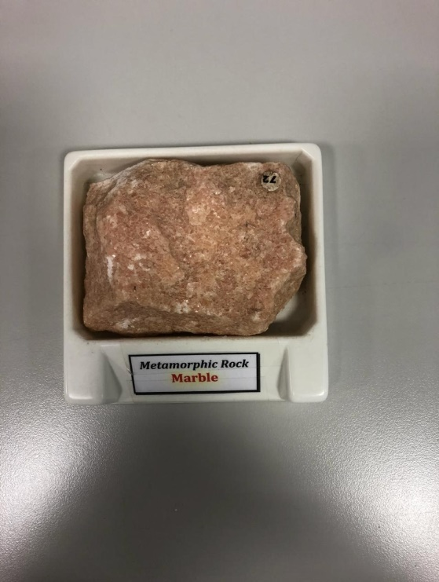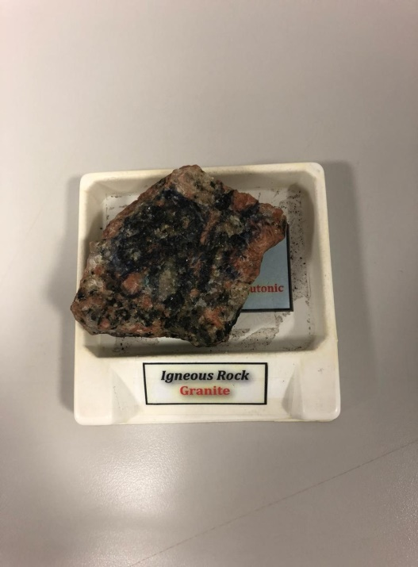

Calcite is a mineral that plays an integral part in rock-formation and is composed of calcium and carbonate ions. They are found in almost any part of the world, especially sedimentary, igneous, and metamorphic rocks. It is the major component of limestone. The hardness of the mineral on Moh’s scale is 3. It exists in multiple crystal varieties that appear in shades of orange, grey, red, yellow, brown, violet, and green and sometimes black. The mineral often dissolves in water. In this regard, the mineral can either be dissolved or precipitated by groundwater. The process occurs under suitable conditions of ion concentration and pH. The compound is insoluble in cold water, and it can only dissolve under optimal acid conditions to released carbon IV oxide. The property is referred to as retrograde solubility that shows that gypsum becomes less soluble with the increment of thermal conditions. Under the right conditions, dissolved calcite ions precipitate to form rocks such as gypsum. The removal of calcite compounds from rocks increases their permeability and porosity significantly. If the process continues for a long time, caves are formed.
Calcites are formed by crystallization of precursor phases that are ordered poorly in a process known as the Oswald ripening process. The crystallization of these minerals happens in two phases. The first phase entails dehydration and crystallization of nanoparticles to form vaterite particles. The vaterite is changed to calcite after they dissolve and precipitate in water bodies. In the second stage, crystallization of calcite occurs at a very slow rate. The process is dependent on the existing pH conditions and the availability of magnesium ions. A neutral acidic and alkaline condition is enough to form calcite in the process of recrystallization. Besides, calcite can be formed through biological mechanisms when microorganisms break down calcite during anaerobic oxidation of methane. The gas becomes oxidized due to the presence of sulfate ions in the process to form sulfate reducers. These reducers are compounds that facilitate precipitation.
Calcite is the building block of calcareous sedimentary rocks like limestone. Limestone is formed by the precipitation of calcium carbonate as well as when algal debris, shells, fecal, and coral transform into calcite in the process of digenesis (King, 2020). Limestone has 90% calcite and almost 50% calcium carbonate. Calcite is a form of calcium carbonate that consists of one calcium ion, one carbon ion, and three oxygen atoms. The mineral exists in a variety of shapes, but the white rhombic pattern is the most common one.
In addition, quartz has a hardness of 7 and is composed of majorly silicon and oxygen to form silicon dioxide. It is crystalline in nature. It vastly found on the earth's surface, and it majorly exists in sedimentary and metamorphic rocks. The rock is formed when individual oxygen atoms are attached to two tetrahedral atoms. The rock is chiral and occurs in two different forms, known as alpha and beta quartz. The rock can transition between the two phases based on the right conditions of temperature. The hardness property of the mineral makes quartz resistant to both chemical and mechanical corrosion. Their resistive properties make them mostly available in mountain tops. They occur in a variety of colors such as purple, grey, yellow, green, pink, red, black, brown, and white. The silicon IV oxide is linked in a continuous crystalline system to form tetrahedral patterns. There are numerous varieties of quartz, including gemstones. The rock is majorly used to make jewelry and carvings from hard stone. The rock can be classified as trigonal crystal due to its ideal crystalline shape (Minddat.org, n. d.). In this regard, the rock has a six-sided prism shape that terminates as six-sided pyramids on each end. Quartz crystals are often intertwined and sometimes distorted and result in the formation of rocks such as gypsum.
Quartz is the building of sedimentary, igneous, and metamorphic rocks, such as gypsum, and is found mostly on the crust of the earth. The rock is colorless and transparent and formed by the combination of hard crystals. As a result, they have a glass-like lustre that gives them a beautiful appearance.

References
Britannica. (n. d.). Evaporites. Retrieved from
https://www.britannica.com/science/sedimentary-rock/Organic-rich-sedimentary-deposits
King, M. H. (2020), Calcite. Geology.com. Retrieved from
https://geology.com/minerals/calcite.shtml
Minddat.org. (n. d). Quartz. Retrieved from https://www.mindat.org/min-3337.html

