Name:
Course:
Tutor:
Date:
The Neogeographic Approach
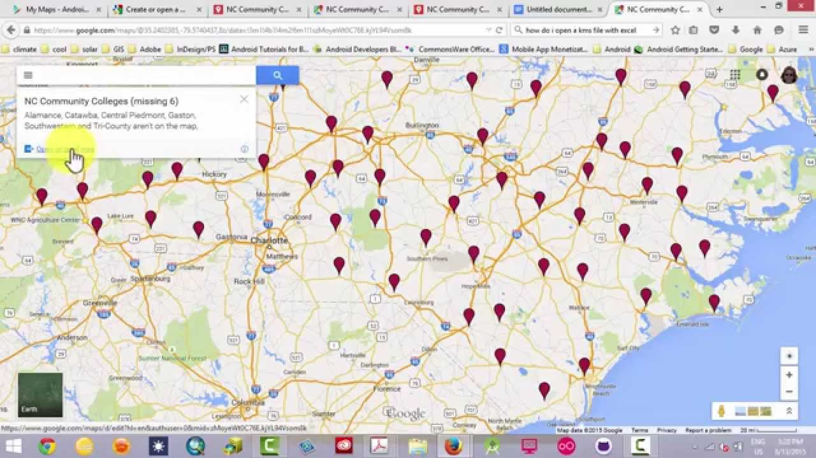
This KMZ map has been taken from Google Maps and used as part of demonstrated on how the map makers are used in georeferencing. The map is efficient in demonstrating Community colleges within the United States using Google maps. The use of the georeferencing has been helpful in proving that many communities and individuals throughout the country can use this mapped information to understand about the geographic locations of specific cities throughout the country. This is effective in understanding the distribution of these community colleges while at the same time being used to understand different and unique geographical locations throughout the country (Budig, 2021).
The main benefit of georeferencing of most of these maps is that it helps to provide real world coordinates of each pixel of the raster. This is focused on ensuring that the GPS device has understood the ground control points hence guiding one to have sufficient understanding of the world. These real world coordinates are effective in ensuring that individuals have achieved information that is highly accurate in understanding locations of every region (Budig, 2021).

References

Budig, B. (2021). Extracting Spatial Information from Historical Maps: Algorithms and Interaction.

https://www.youtube.com/watch?v=n7D2bbVYTJY

