Rousseau and Marx

Log on:
https://sso.laccd.edu/adfs/ls/idpinitiatedsignon.aspx?loginToRp=csprd.laccd.edu

Signin: escsso\881207011
Password: Alexandra99!

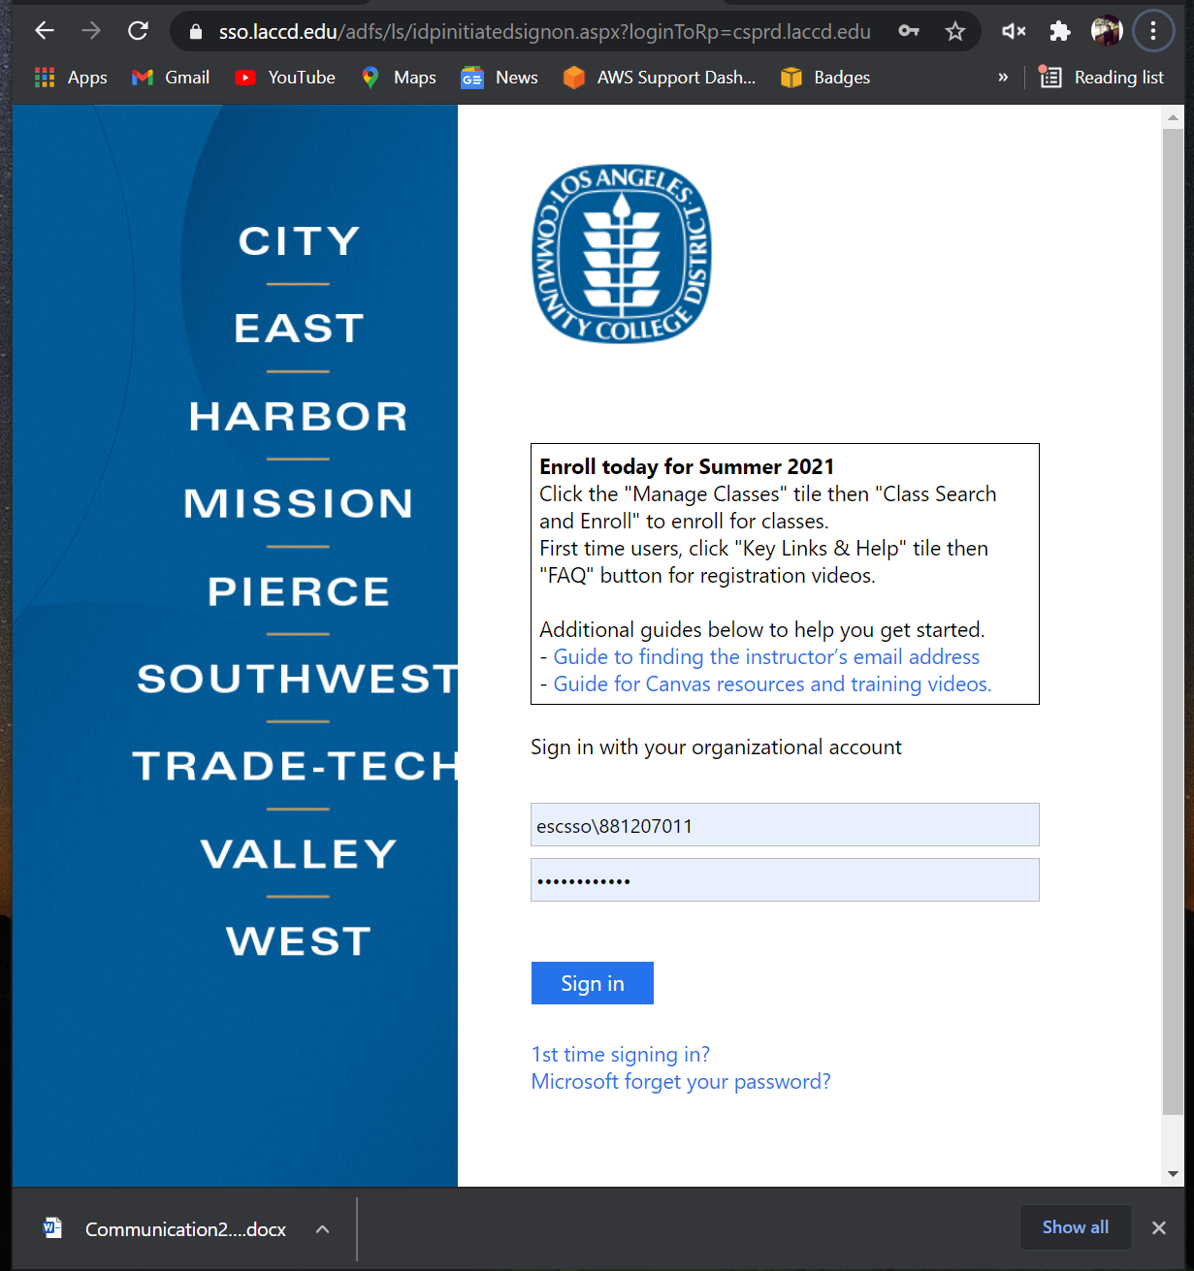

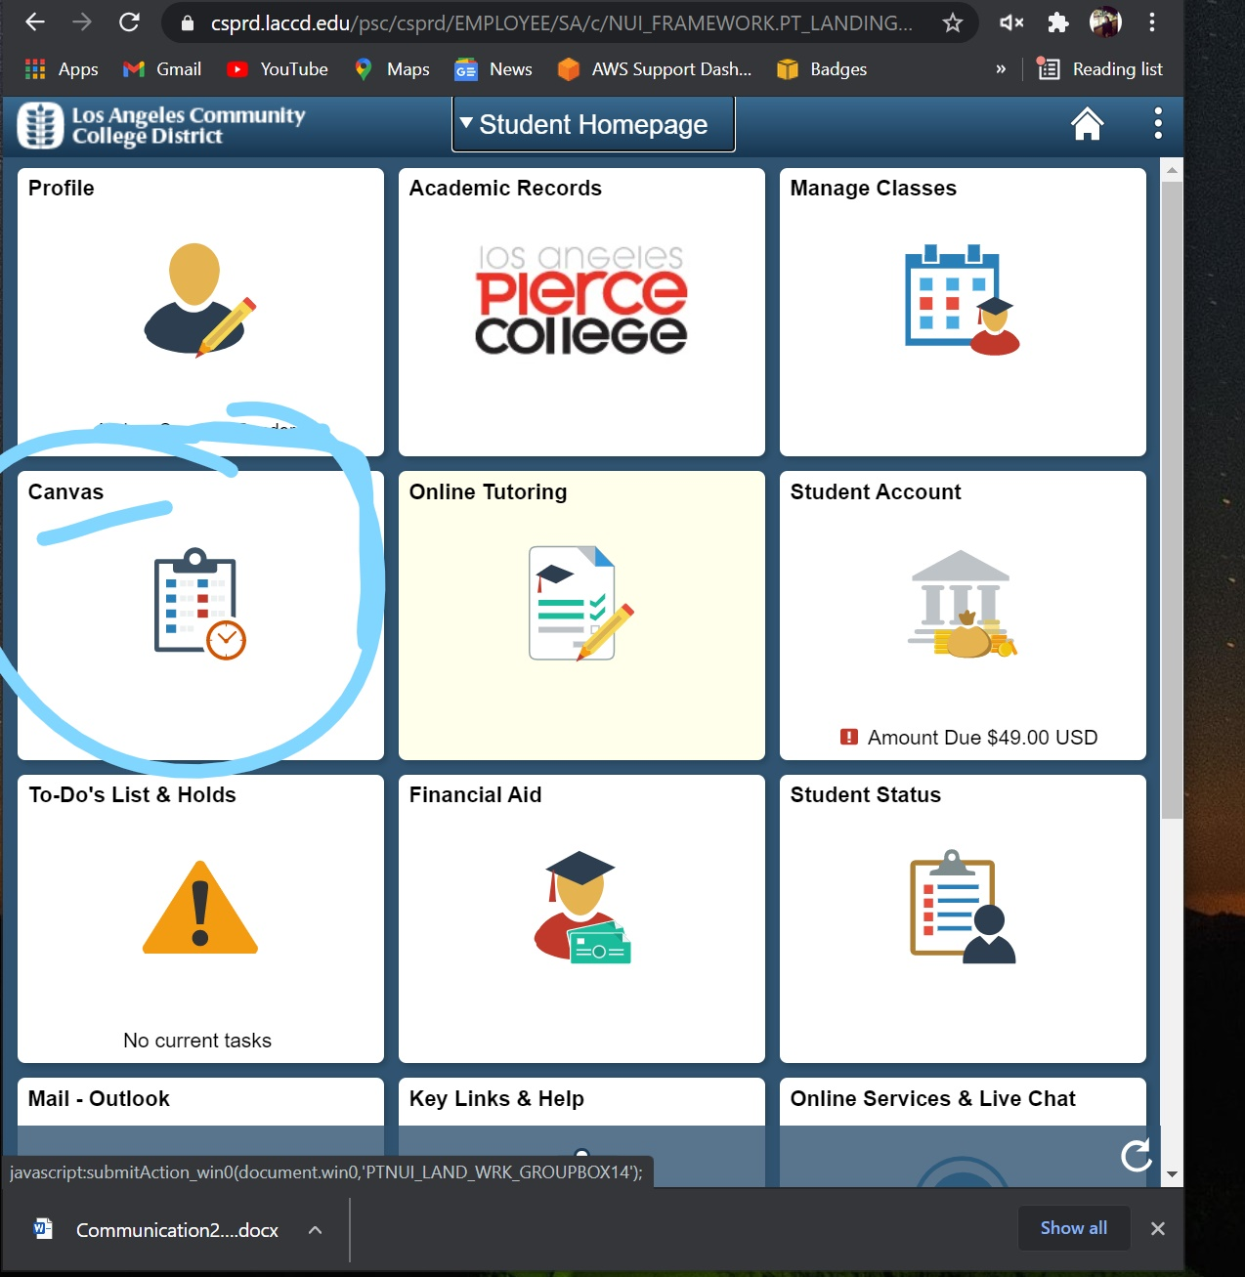

On MODULES VVVVV
