[Date]
Goodtime Inc.
Business Plan

December 2017

Ashton Soles

CEO & Founder

Goodtime

223 Ponte Vedra Drive

Fayetteville, Georgia 30215

6788605642

asoles23@gmail.com

Executive Summary

Business Overview

Goodtime Inc.
Date of formation: 08-23-2017
As Goodtime Corporation

Services Offered
Goodtime provides a unique planned and customized date/ event experience.
We are a recreational event scheduler service based out of Atlanta, GA.
Our management team has the experience and expertise to successfully execute and manage clients’ special requirements when it comes to planning events.

Mission
Goodtime’s mission is to become the world's leading event/nightlife scheduler app which helps clients to plan and customize events according to their taste while in the comfort of their phones.

Management Team Members

Name: Ashton Soles

  - Title: CEO & Founder

  - Background: Experienced Sales Manager with a demonstrated history of working in the telecommunications industry. Skilled in Event Planning, Microsoft Excel, Customer Service, Microsoft Word, and Sales. Strong sales professional with a Bachelor of Business Administration (B.B.A.) focused on Business, Management, Marketing, and Related Support Services from Florida A&M University.
Name: Josh Smith

  - Title: Vice President of Marketing

  - Background:

Name: Napoleon Robinson

  - Title: Vice President of Finance

  - Background:

Name: Preston Henderson

  - Title: Vice President of Technology
  - Background:

Name:

  - Title: Vice President of Operations
  - Background:

Industry Analysis

Industry Overview

- Goodtime operates in the Nightlife and events market.
- Total monetary sales in this industry last year: $24 Billion (Statista, 2017)
- Operators were in this industry last year: 100
- Industry's key product and service segments: Food, Beverages, Nightlife
Key market trends: The industry will become more fragmented with a larger range of niche markets, rising consumer interest in higher-quality food and beverages will boost industry revenue. The movement toward premium beverage consumption will benefit industry operators. The Restaurants & Leisure industry has experienced a 27% positive growth.

Key market statistics: The Bars and Nightclubs industry has performed modestly over the past five years, as consumer confidence and overall spending have continued to increase steadily. Consumer drinking patterns have also changed during the period, forcing seasoned bar operators to adapt their menus to suit changing consumer tastes. Although industry revenue has fluctuated since 2012, due to steadily increasing consumer spending, growth has been inconsistent (American Nightlife Association, 2018). This acceleration can be attributed to per customer spending surpassing previous levels. Much of the industry’s growth has been due to rising alcohol prices.

Relevant Market Size

Our relevant market size is the annual revenue that our company could attain if we owned 100% market share.
Our relevant market size is calculated as follows:
- Some customers who might be interested in purchasing our products and services each year? 10,000
- Amount these customers might be willing to spend, on an annual basis, on our products and services? $1,000
- Our relevant market revenue size: $10,000,000

As the analysis shows, our relevant market is large enough for our company to enjoy considerable success.

Competitive Analysis

Direct Competitors

- Direct Competitor #1: Groupon

- Direct Competitor #2: Eventbrite

- Direct Competitor #3: Date Night In.com

- Direct Competitor #4: Airbnb

Competitive Advantages

Goodtime is positioned to perform well based on superior products and service. Our company provides a unique experience unlike any services already out. This will allow us to capture market share.
Location: Our location allows us to better serve customers because:
Our location in Atlanta also allows us to have prime access to individuals seeking entertainment facilities.

Website/Application Layout
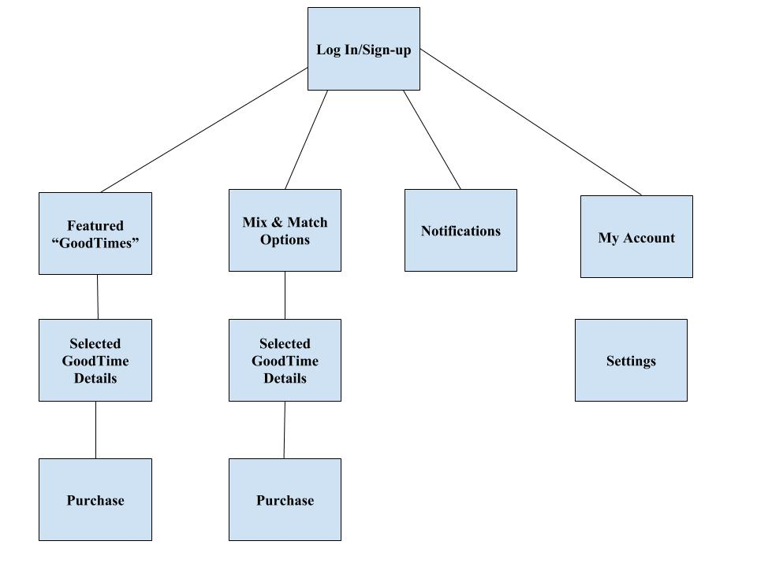Products, Services & Pricing

Product/Service #1 Name: Goodtime event

  - Product/Service benefits: Dates or connected events organized GoodTime user will be able to choose from different "Goodtime" Packages that will include multiple event nights for 2-6 people. These packages will include hand selected events that will create cultivated experiences.

  - Product/Service Price: $50-$500

Product/Service #2 Name: Goodtime Chauffeur

  - Product/Service benefits: Date night taxi allow users to enjoy the nights without the need to drive or remain sober.

  - Product/Service Price: $50-$100

Product/Service #3 Name: Date Adds ons

  - Product/Service benefits: Date adds-on: Candy, Flowers, Pre-date Grooming

  - Product/Service Price: $50-$100

Product/Service #4 Name: Date in Home Options

  - Product/Service benefits: Date adds-on: In-Home Chef, In-Massages

  - Product/Service Price: $50-$100

Marketing Plan
At Goodtime Inc., we recognize the significance of our competitors at different levels. In marketing, various theories can help us to distinguish our competitors. However, Porter’s five forces succinctly define the important factors that a business manager is supposed to put into consideration. The five forces as indicated include:
- Rivalry among existing competitors- There are many event organizing companies and websites all over the world. The event planning companies are mostly comprised of wedding planning websites and outdoor event planners. Even though this industry attracts a lot of competitors, there are few competitors in the date planning sector. The few existing companies in this sector are mostly involved with giving ideas on how one can plan for a date such as the “Thirty dollar date night company,” “Datevitation,” “How about we,” “Nifty date ideas” and “The dating divas” (Dynadot, 2018). In a sense, these are our major competitors even though we do not specialize in the same market niche. Since our core purpose will be to organize and make those moments come true, I believe that the competition for the same customers will be minimal and lesser still in the Georgia region where we intend to be the business’ center.
- The threat of new entrants- Since the capital involved is small; we look forward to having new entrants into this line of business. To Goodtime Inc., this will be a good thing since it will challenge us to provide “above-board” services. Before then, the company’s team members need to build a rapport with loyal clients who will stick with the company even in hard times.
- Bargaining power of suppliers- Bargaining power of suppliers or suppliers’ power is a concept meant to measure the ability of suppliers in influencing the company’s activities or the company’s ability to make a profit. Shortly, we intend to collaborate with various hookup site companies which offer people with the opportunity to mingle. By collaborating with the dating sites, we will offer a wholesome experience to people who have never met, and in time, this may be developed into a television show. Suppliers can control prices because of their influence, in Goodtime Inc.’s case, we will make it a point that we get direct clients rather than rely on referrals. We intend to have an advertising and marketing team which will be hired on short contractual terms to minimize the number of salaried employees. The advertising team will ensure that our external partners acting as a source of referrals do not have much power over the company.
- Bargaining power of buyers- Like in the bargaining power of suppliers, bargaining power of buyers or buyers’ power is mostly concerned with the number of clients a company has. In most cases, the lesser the number of clients, the more the power that they wield over the company. In Goodtime Inc.’s case, we will have individuals mostly. A large number of clients will ensure that the power of any one buyer is low. However, we intend to look into each unique client’s needs.
- The threat of substitutes- The main threat to the business is in the people’s ability to plan and execute the plans themselves. However, since our target market is the people between the age of 21 to 45 and bearing in mind that Georgia’s population of more than 10 million people has a median age is 31, then a fraction of that population will be good enough. On the same note, we intend to make company-planned dates to be a trending style where married couples, as well as the singles, get to meet and enjoy some quality time together.
We also intend to use marketing 4Ps in our marketing strategy.
- Product- Given the wide array of clients and their diverse needs, we intend to make a large number of packages that can suit clients’ needs. To do this, we will team up with various hotels, restaurants as well as taxi companies. We will forge a partnership where we will negotiate prices and make reservations with them through phone calls. This will help us reduce travel costs associated with the physical booking.
- Price- We want prices to be accommodating to all. For the various packages, we will offer prices that seek to satisfy any customer’s budget.
- Promotion- We will promote the company’s products and services through various marketing and distribution channels. We will invest heavily in social media marketing and word of mouth advertising. In order to achieve this, we will have to offer unique and high quality products and services which the customers will want to share with their friends and loved ones.
- Place- marketing is about getting a product or a service into the market at the right time, at the right price and at the right place. This means that a marketer has to put the place where the product is marketed into consideration.

Customer Analysis

Target Customer

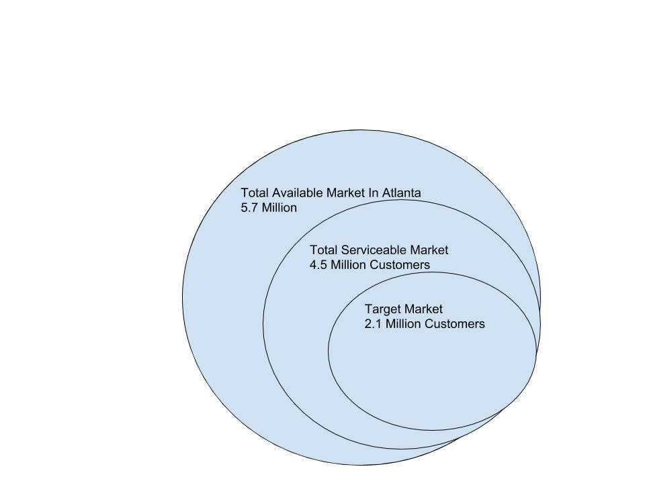

Age: 21-45

Marital Status: Single & Married

Education: Educated Professionals, Nightlifers, Young Adults

Activities & Interests: Art, culture, Music, Food, Skating, bowling, nature, wildlife, fitness

Promotions Plan

Goodtime will use the following tactics to attract new customers: promotions, advertising and holding of free social events from time to time.

We will conduct surveys via social media to research favorite

Blogs, Podcasts, etc: Online and social media marketing i.e. Email Marketing:
Email blasted
Instagram, Facebook, Twitter

Flyers: Event
YELP, Eventbrite, Word of Mouth / Viral Marketing: Word of mouth, Twitter, Instagram, Snapchat, and Facebook

Distribution Plan

Customers can buy from us through the following methods:

Company website: Goodtime.com

Company Phone: 6788605642

Distributors: Yelp

Operations Plan

Our Operations Plan details:

- The business will take place in stage where we will start by organizing functions will help people to meet and socialize. These meetings may be held at a small cost or at the expense of the company. These meetings will serve as the building block upon which word of mouth may be spread.
- We will also reach out to various hotels, restaurants and cab companies, getting contacts and partners with whom we can work together. This will form the “backbone” of the company. The company will reach out to them for menu prices as well as fare prices so that it may make informed decisions on the Goodtime package prices.
- We will then set up an office that will be the center of the business operations and seek the relevant permits for our functions.
- After getting the offices, we will make a timetable for the social gatherings, events and activities which will help us market ourselves as well as various promotional gigs. A timetable will help everyone within the company to remain focused as everyone will be aware of what is going on as well as the timelines. The timetable will act as part of the business plan which will help us realize the revenue targets by the timeframes.
- After word gets out that we are offering quality products, we will make an official launch of the Goodtime application. Launching the application will also help us to reach out to a wider audience from the online community.
- Certain organizations will be key to our promotion and advertisement campaign. Institutions such as churches and colleges will be our main target. In order to uphold a good reputation for the company, we need to have individuals respect each other and this will make us exercise significant control for the people attending our own events. It is important that word gets out that we conduct peaceful and mature events so that we may attract a large gathering. However, for this to happen we need to set limits to the number of people who can attend the events.

Key Operational Processes

The key day-to-day processes that our business performs to serve our customers are as follows:

Sales: Acquire partnerships with local vendors, restaurants and businesses for support users’ demand.

Marketing: Marketing the Goodtime app and website to drive user participation

Finance: Accurately account for business operations and adopt efficient pricing strategy to ensure profit.

Customer Service: Support customers thought use of the Goodtime Platform.

Milestones

The key business milestones that our company expects to accomplish as we grow include the following:

1. To Be Completed By: 2018-07-07

- Accomplishment #1: Launch Goodtime Application

- Accomplishment #2: Reach $10,000 in sales revenue 12/2018

- Accomplishment #3: Reach $50,000 in sales revenue

Financial Plan

Products, Services & Pricing

Product/Service #1 Name: Goodtime event

  - Product/Service benefits: Dates or connected events organized GoodTime user will be able to choose from different "Goodtime" Packages that will include multiple event nights for 2-6 people. These packages will include hand selected events that will create cultivated experiences.

  - Product/Service Price: $50-$500

Product/Service #2 Name: Goodtime Chauffeur

  - Product/Service benefits: Date night taxi allow users to enjoy the nights without the need to drive or remain sober.

  - Product/Service Price: $50-$100

Product/Service #3 Name: Date Adds-on

  - Product/Service benefits: Date adds-on: Candy, Flowers, Pre-date Grooming

  - Product/Service Price: $50-$100

Revenue Model

Goodtime generates revenues via the following:

Sales of products/services:
"Goodtimes" will be planned date packages that are coordinated and assess with a 10%-35% service fee.

Ex. Based on cost for two people
Bowling $24
Restaurant Meal $30
Concert Tickets $50
Services Fee $15.60
Total Goodtime Cost: $119.60

Ex. Based on cost for two people
Flowers $35
Painting Class $25
Restaurant Meal $49
Helicopters Ride $135
Services Fee $36.60
Total Goodtime Cost: $280.60

Advertising sales: Listing fees

Financial Highlights

Year 1 Revenues: $$10000

Year 1 Net Income: $4,000

Year 2 Revenues: $30,000

Year 2 Net Income: $17,000

Year 3 Revenues: $90,000

Year 3 Net Income: $50,000

Year 4 Revenues: $300,000

Year 4 Net Income: $150,000

Year 5 Revenues: $1,000,000

Year 5 Net Income: $646,000

Funding Requirements/Use of Funds

Product Development & Operation:

Storage
Graphene DB $4800(annually)
- 8GB RAM
- 20GB storage

Website/Hosting Winhost $47.40(Annually)
- 3 GB Disk Space
- 50 GB Bandwidth
- 10 FTP Users
- 100 MB Site Memory
- 1 SQL Database
- 500 MB SQL & MySQL
Requirements Documents (Application):
What does this need to able to do
Customer Needs
Talk through the customer needs
Speed: Customers want to able to access events options quickly.
Quality: User want quality and unique experiences
Location: Major cities
Price: $50-$500
Convenience: Customers want to able to access events options quickly.

PayPal (Free)
Payments/POS

Marketing: $2,000

Product Manufacturing: $0

Staffing: $2,000

Rent: $0

Other: $2,000

Other is defined as: Services cost and fees

App Flow Chart

Application Layout

- Tab 1 Featured “GoodTimes”
Packages of “GoodTimes”(1-3 preselected events)
2. Tab 2 Mix & Match Options (1-3 selected events)
3. Tab 3 Notifications
4. Tab 4 My “GoodTimes”
5. Tab 5 POS (Paypal)

Success Factors

Goodtime is uniquely qualified to succeed due to the following reasons:

Products and/or Services: Our Products and/or Services are superior to our competitors because we provide a seamless platform for user to selection from numerous dates and event for their social enjoyment.
Location: Our location allows us to better serve customers because: Our GoodTime events with be located within the metro Atlanta area.

Marketing: We have unique marketing skill sets that enable us to attract new customers at a low cost. These skill sets include: Goodtime competitive advantage involves tailored alternatives to the traditional nightlight experience

Exit Strategy

GOODTIME BUSINESS PLAN

We expect that investors will be able to cash out on their investment in our company via IPO.

We expect to achieve this goal by 2022.

References
American Nightlife Association. (2018). Industry - Nightlife association. Retrieved from http://www.nciaa.com/content.aspx?page_id=22&club_id=160641&module_id=29898
Dynadot. (2018). 5 websites to help you plan the perfect date. Retrieved from https://www.dynadot.com/community/blog/2014/02/websites-to-plan-perfect-valentines-dates.html
Statista. (2017). Topic: Bar & nightlife industry. Retrieved from https://www.statista.com/topics/1752/bars-and-nightclubs/

10

