GPS
by Student’s Name

Code + Course Name
Professor’s Name
University Name
City, State
Date

ABSTRACT
This exercise was performed using GPS hand held device whose data was later mapped on an ExpertGPS application laptop to view all the locations covered during data correction. Lake region was an ideal area so that the accuracy could be determined quite easily. Though the GPS device was not that accurate, the results were satisfactory
Contents
ABSTRACT 2
Theory 3
Procedure and experiment set up 3
a. Equipment 3
b. Procedure 3
Results 4
Discussion 5
Conclusion 6
References 6

List of figures
Figure 1: The distance covered around and about the lake 6
Figure 2: The contour map 6

List of tables
Table 1: GPS reading 5

Theory
An introduction to Garmin's handheld GPS and GPS RS20 was done. The Leica GPS R20 is a device that is mostly employed for land surveys and high precision mapping, while the ground-based GPS is used for navigation and positioning (El-Rabbany, 2012). The former has a 3 – 10 m accuracy while the former provides a millimetre level accuracy on the horizontal. However, either of the two is not very precise on vertical measurement.
The main objective of this lab exercise is to familiarize the use of GPS as well as to display the position on a given map using software. It shall also be proved that GPS can give a correct reading in all weather conditions.

Procedure and experiment set up

Equipment
- Laptop
- Garmin handheld GPS
- Connection cable

Procedure
Setting configuration of a GPS instrument was done by the technician to reduce the time required to perform the experiment. The location given by the following latitude and altitude was located first; latitude ($3° {00}^{'}.1''$) and longitude ($(101°{43}^{'}.2^{'})$. The old data on the GPS device was cleared up. The current position was set by pressing the pages button until the main interface menu appeared on the screen (El-Rabbany, 2012). The set-up menu was selected followed by the desired units. The coordinate system was set up. In the satellite interface mark waypoint was selected where the location name was determined and saved. Then, the students moved around and about a lake for data collection.
Downloading data from GPS was done by connecting it to the laptop via cable. Receive from the device icon was clicked. The downloaded data is displayed in a pre-installed map software.

Results
The GPS locations are shown in table 1 below;
Table 1: GPS reading
NORTHING ( LATITUDE) | EASTING( LONGITUDE) | ELEVATION | REMARKS
3˚00’ 18.00” | 101˚43’11.5” | 46 | L002
3˚00’ 18.23” | 101˚43’11.0” | 46 | L003
3˚00’ 18.50” | 101˚43’10.4” | 46 | L004
3˚00’ 18.80” | 101˚43’10.1” | 46 | L005
3˚00’ 19.20” | 101˚43’10.1” | 45 | L006
3˚00’ 19.70” | 101˚43’10.4” | 45 | L007
3˚00’ 20.30” | 101˚43’10.4” | 45 | L008
3˚00’ 20.60” | 101˚43’10.1” | 45 | L009
3˚00’ 21.10” | 101˚43’11.4” | 45 | L010
3˚00’ 21.90” | 101˚43’12.1” | 46 | L011
3˚00’ 22.20” | 101˚43’12.1” | 45 | L012
3˚00’ 22.80” | 101˚43’13.2” | 44 | L013
3˚00’ 22.30” | 101˚43’14.2” | 45 | L014
3˚00’ 21.30” | 101˚43’16.2” | 45 | L015
3˚00’ 21.00” | 101˚43’16.4” | 46 | L016
3˚00’ 19.00” | 101˚43’15.5” | 46 | L017
3˚00’ 17.70” | 101˚43’14.1” | 47 | L018
3˚00’ 17.30” | 101˚43’13.0” | 48 | L019
3˚00’ 17.40” | 101˚43’12.2” | 47 | L020

The distance covered around and about the lake is shown by the map and the contours in figures 1 and 2.
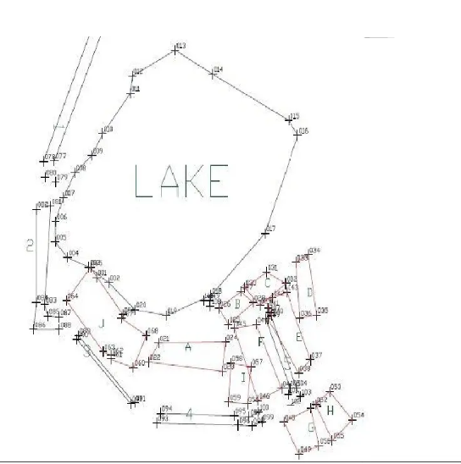
Figure 1: The distance covered around and about the lake

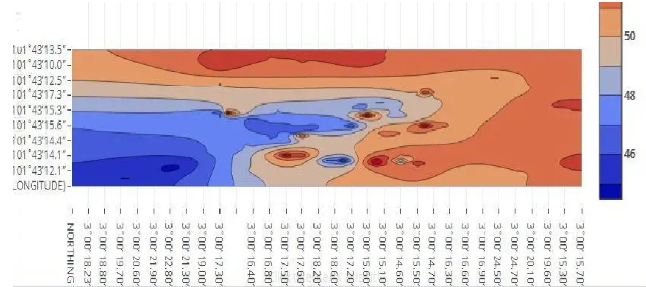
Figure 2: The contour map

Discussion
The exercise required a region around a lake with roads around it. The data was taking and saved for various points along the road surrounding the lake. About 20 points were recorded and saved around the lake (El-Rabbany, 2012). The data transferred to the PC was mapped on the ExpertGPS map application to plot all the location. All the view points were plotted as shown in the figure 1 above. However, it is not every point that appeared where it was recorded.

Conclusion
While all the objectives were achieved, errors were present since it is not every point appeared on the mapped exactly where it was taken. Some were between 3 to 7 m off the original point where they were recorded. However, the device produced reliable data that can be used for navigation. Where signals were stronger, accuracy was high as well.

References
El-Rabbany, A. (2012). Introduction to GPS: The Global Positioning System. Boston, MA: Artech House.
Xu, G. (2017). GPS: Theory, Algorithms and Applications.

