For this project, please go through the whole topic, and only need to do the “stakeholder identification and analysis” part.
I will show you a pic and a sample paragraph at the end of this docs, please use your own word and only do “stakeholder identification and analysis” part. Please also include a chart!!!
600 words!!

Team Project
The Team Project brings together some of the principal elements of the course; notably Communication and Communications Planning, and an understanding of the effects of ambiguity and complexity. It will also provide a simulation of the requirements of working in a virtual project management team.
The Situation - Boston University (BU) is located on a large inner-city campus that stretches for about two miles along Commonwealth Avenue, which is one of the main routes into central Boston from the west of the city. As a part of this campus, BU owns and operates the Nickerson Field sports complex, which was originally the home of the Boston Braves baseball team. BU purchased the field in 1953 when the Braves relocated to Milwaukee, and over the last sixty years or so the complex has been and is still used to host various BU sports teams.
The Nickerson Field site is at the western end of the BU Charles River campus, and is close to both bus and subway routes. The site is also only about a mile or so away from the Boston Redsox ballpark at Fenway. Over the years, this area has been developed by BU with many student housing units, a Fitness & Recreation Center, the Agganis Arena Ice hockey complex, the ‘New Balance’ multi-purpose sports field, and other BU facilities.
For your Team Project in this course, consider an effort by Boston University to own and operate a minor-league baseball franchise on the site of its Nickerson Field complex. The franchise would play 75 home games, primarily at night, between April and October, and would hope to draw large crowds from BU students and staff, and from local residents. The capacity of the Nickerson Field complex is 10,412.
Assume that you will be the Project Manager for the project to make this happen, and that you will be responsible for planning, organizing, and implementing the infrastructure to support this venture in anticipation of the franchise. This will include considering such elements as traffic management, security, services (including catering), cleaning, maintenance, and management of the facilities.
The marketing, ticketing, coaching and team management, and game scheduling will not be a part of your role.
The Team Task or Team Project is a ten-page research paper. Each team will be responsible for a single paper. This paper will require you as a team to carry out an analysis of the Nickerson Field project, identify the various stakeholders, and compile a Communications Plan for the project. This assignment consists of three deliverables.
- The team task in this project will be to write a paper, using research and materials from this course, to develop all of the elements of a communications plan for the selected project. I would expect that the plan will have some contingency to allow for changes in requirements that could and would emerge during the execution of the chosen project.
- In addition to the creation of team-submitted ten-page research paper, it is expected that each student will submit a second paper (approximately 250 words) on "Lessons Learned." These are to be submitted individually in a separate assignment area that is provided and will be graded as a second component to the Team Project.
- You will also be evaluating your team members in the evaluation form provided in the Assignments area of Vista. The Peer Evaluations will be used as a component of the members' individual grades. Please be as honest and forthcoming as possible.
Team Formation will be accomplished by dividing each section into two to three teams. Each team is to contain an average of five students, that is, no less than four or more than six members. During Week 2, you will be assigned to a team By the Student Administrator for the course.
The Division of Labor and Responsibility within the Team will be the responsibility of the team. The team may wish to follow strict project management guidelines requiring the selection of one of the five members as Project Manager. The work of research and findings could then be divided up one topic per remaining member of the team. There are numerous permutations of available resources that may be applied. The important factor in assigning these tasks and responsibilities is that it is a team decision and the team will succeed or fail based on that decision.
Just as with labor and responsibility, monitoring and/or motivating team members in task completion is a team responsibility. Your facilitator or instructor may advise you,
but actual leadership of the team will be the responsibility of the team or the team member given that responsibility.
Formatting - The paper format will follow American Psychological Association (APA) guidelines; team members will find information regarding the APA Style below.
As mentioned earlier, the requirement for the paper is ten pages (double-spaced, New Times Roman, size 12 font or equivalent). The cover page, which will contain a single- spaced Abstract of the paper, will also contain a title, the names of the team members, and a page number. The title page and bibliography as well as any amount of attachments and appendices do not count toward the required ten pages. You are encouraged to submit many references in your bibliography. Real research will yield many such references, but do not include citations that were not actually used in your research. This is ‘technically’ a form of cheating and may have a negative impact on your grade and standing in the university.
Content - The paper content should consist of research conducted by team members and their findings. The research should focus on Communication, Communication Planning , and complexity and ambiguity. You may also find some reference to improvised work creeping into your submission. The division of labor, as mentioned earlier, is a team responsibility and it is expected that the team will divide the work of research and writing equally among team members. Students should work to ensure that the quality of research and style of writing in the document does not change as the paper moves from one topic to another. This is a simulation of a project team effort, where many people work on different parts of the project but the project itself comes together and speaks in a single voice when communicating with the stakeholders.
This is a research paper and will require that team members find new facts, theories and figures that have not been previously discussed in the textbooks or lecture. Simply expanding on what has already been taught is an undergraduate task. This is a graduate research paper and students should aim to create work that would be worthy of publication in peer-reviewed journals.
The typical paper will contain:
- • Title Page with Abstract
- • Project Description with description of research and hoped-for findings
- • Main Body of the Report
- • Teams research and findings
- • Recommendations
• Bibliography • Attachments
and should be accompanied by:
- • Individual "Lessons Learned" papers from each team member
- • Peer Evaluations
Note: The use of bullet points, as seen above, should be avoided in the paper.
Project Grading - The Final Project grade will constitute twenty-five percent of the total course grade. Twenty percent of the total twenty-five percent will reflect the grade for the paper and the remaining five percent will be an individual grade for team participation. The paper grade will be determined by the facilitator and instructor. The team participation grade will be determined via peer evaluation plus a grade on the individual "Lessons Learned" submission.
- • The paper grade will be the same for all team members. It will reflect the quality and quantity of research, quality and quantity of findings, quality of language and adherence to format requirements.
- • The team participation grade will be the average of the grades submitted by fellow team members on the Peer Evaluation Form and the grade earned in the Lessons Learned submission
Both grading procedures are in sync with procedures used in project management consulting. That is, a single performance rating is assessed by the client for the entire team and individual work is usually assessed by peers. Individual performance usually determines who is assigned to the next team on the next project.
Submitting the Paper - When submitting your papers, you will find three separate submission areas—one for your Team Research Paper (one submission for the entire team), one for your "Lessons Learned" papers (individual), and one for your peer evaluations (individual). Be sure to turn in each component in the correct area. The ‘Lessons Learned’ paper does not contribute towards your grade for this assessment, but it is vital that it is correctly submitted. All of the submission areas are clearly labeled and are accessible via the Assignment Icon ( ) on the left-side of page at any time.
All of the components of this major assignment must be submitted by 11:59 PM ET on Day 7 of Week 6.
American Psychological Association Formatting Requirements
You are to complete the research paper using the American Psychological Association (APA) writing style and following the APA guidelines for formatting references. Proper attribution is required for all sources.
You can download the student style guide from the American Psychological Association website or you can purchase the APA style guide from the book store. As most referencing information is available either on the APA website or in the course documents (available here) the purchase of the guide is not essential. These sources will guide you in how to create references in your paper correctly.
Correct APA citations and APA reference formatting are essential.
Papers in this class are to be RESEARCH PAPERS. Remember that work that you use from other authors MUST be referenced. Since it is assumed that you know little about the topic that you are writing on it is expected that this paper will be an overview of many different sources of information. These must be attributed to their original author, using the American Psychological Association format. This is your paper and not the cut-and- paste of someone else's work.
The internet has led to a false sense of what research is all about. Those new to research tend to think that it means spending an afternoon surfing the internet and then an afternoon cutting from material available. Keep in mind the internet is:
- Not quality-oriented, as it has good stuff and not-so-good stuff. The internet does not know the difference.
- The internet should NOT be the sole source location for your research. That is to say I expect to see materials that are not available on the internet.
- Use the library. As an online student, you have access to academic journals. Academic research is far more valuable than random internet searches.

Sample pic and paragraph
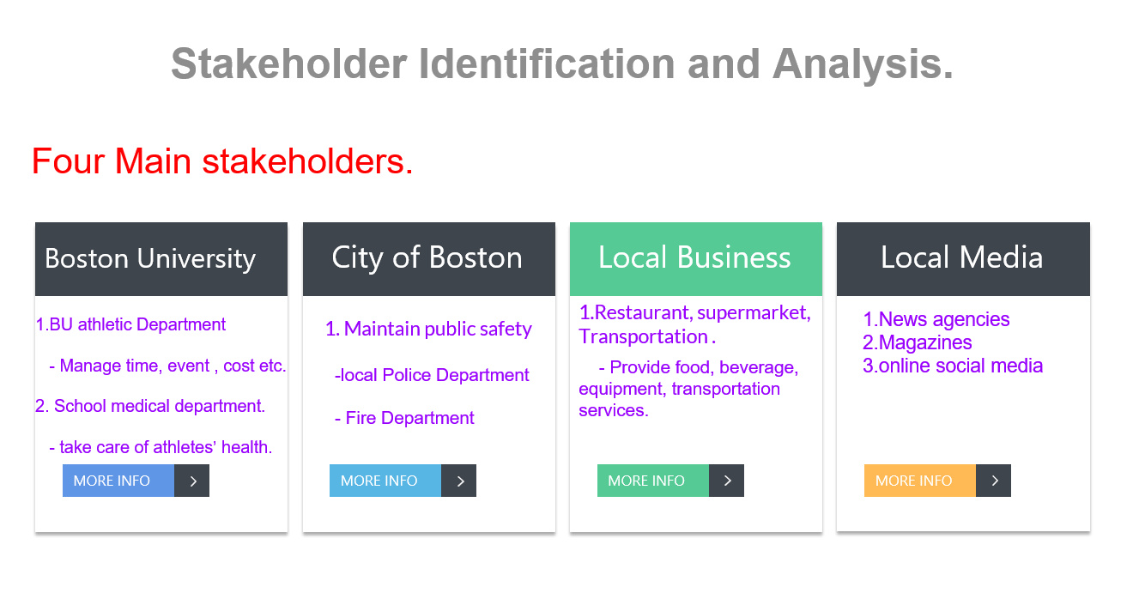
2. Stakeholder Identification and Analysis
The project communication plan includes various stakeholders, which refers to internal stakeholders and external stakeholders. There are some main stakeholders who will be important roles in the project, which is the city of Boston, students and faculty of the BU, residents and business sponsors, and other sports in Boston. In general, Boston University is the primary stakeholders because BU is the owner of the Nickerson Field, and BU has many critical stakeholders such as president of BU, athletics departments, students, staff, medical support team and so on. In addition, the City of Boston our group conducts a complete list about the specific information of all stakeholders within the project.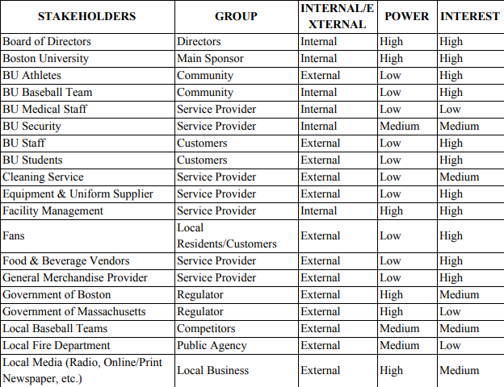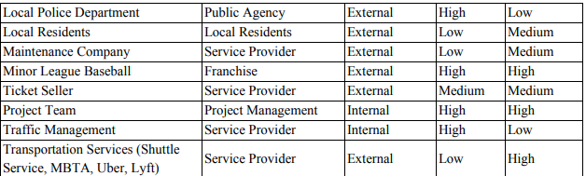

Boston University
In general, Boston university plays the most critical role in implementing this project. To be specific, the president of BU, Robert A. Brown is the most important stakeholder who needs to pay much attention to manage this project. In addition, some other departments of staff, students of BU who are essential to pay their effort on developing the project, which bring a positive impact on it. Especially for the BU Athletic Department, which is also an important part in developing the project. This department is referring to some important points such as cost, time, quality, effective communication, and events attendance. The next important stakeholder is the School Medical Department. During the period of competition, the School Medical Department plays an important role in taking care of the physical health and mental health of the team players. For example, if athletes are injured in the game, the medical team has to implement treatment immediately.

The City of Boston
In this project, the Boston government is also an extremely critical stakeholder which gives lots of support on traffic management and maintaining public security. Especially for ensuring people’s safety, because lots of people watch games, the street would be crowded, the Boston government will send local police and Fire Department to protect people safety if some emergencies happen during the game. Therefore, the city of Boston will spend lots of effort on the strong security support.

Local Residents and volunteers
Because the baseball games will be implemented in Boston Nickerson Field, Local residents play a medium interest role on this project, they are potential audience for baseball games, which they influence the income of the project. In addition, many volunteers are organized by residents who can potentially assist with BU to develop the project well. For example, these volunteers can help to guide the customers to find a correct parking place , and they can clean the place after games. Therefore, local residents and volunteers are significantly important parts which can improve the project success.

Local businesses
Undoubtedly, Local businesses are very necessary parts which have high interest. They can provide equipment, food, and beverage vendors, transportation services which include the school shuttle service, Uber, Lyft. Because Nickerson Field is a popular place which attracts lots of customers to visit. Therefore, this is a potential opportunity for those local businesses to increase their income.

Local Media company and online social media
Local Media includes news agencies, magazines and online social media platforms are high interest stakeholders. Because the local government attaches great importance to this event, it is a very beneficial opportunity for those media companies to report on it. In addition, online social media is also an important stakeholder, which will update the latest news about the events. It also provides an online platform for people to communicate their own thinking and reflection.

