Heineken Company
Name
Instructor
Course
Date

Introduction

Heineken has a proud and long heritage and history as an international brewer since its establishment in 1864 by the Heineken family (Araújo, 2015). The company is dedicated to enthusing customers everywhere, brew quality beers, and develop award-winning brands. The multinational company is a responsible, proud, and independent international brewer. Today, Heineken is the number two brewer globally, and number one brewer in the whole of Europe. In the last few decades, the company has greatly increased its exposure to the emerging markets that shall be a catalyst for its growth. The multinational corporation brews great beers, is dedicated to exciting and surprising their customers everywhere, and builds great brands. Currently, the Heineken beer products are broadly available and enjoyed in most cultures and nations worldwide. This research paper intends to examine the how Heineken Company operates in terms of return to shareholders, effectiveness, and efficiency on the basis of performance investment ratios and efficiency ratios (Karagiannopoulos, Georgopoulos, & Nikolopoulos, 2005). This examination establishes the market growth and the market share of Heineken in the global market.
The objective of Heineken Company
Short-term Objectives
- Increase the market share of the company in the global market.
- Increase the overall profitability of the company.
- Lead by innovation SMART.
- The objective is to grow the company in consistent and sustainable, while constantly improving the profits of the firm.
Long-Term Objectives
- Build award-winning brands by brewing great and quality beers.
- Optimize and expand the portfolio of the products of the Heineken.
- Commitment to exciting, enthusing and surprising our clients everywhere.
- Lead in the global business services through cool marketing
- Aims for sustainable growth as a segment leadership and a broad leader of the market.
- Embraced innovations as key components of their strategies in the packaging, communications, marketing, and production areas.
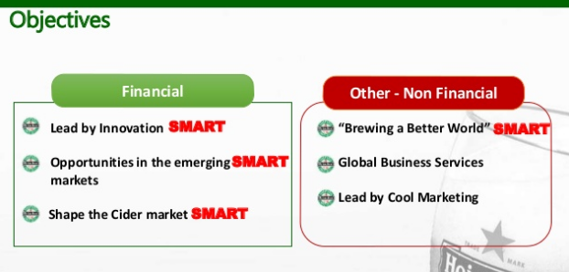
Mission
Our mission as Heineken is to be independent and a proud international brewer committed to exciting and surprising clients everywhere. We have a passion for respect for people, life enjoyment, quality, and respect for our universe.
Vision
Our vision to win in each market with a full brand portfolio and with Heineken in the markets we select.
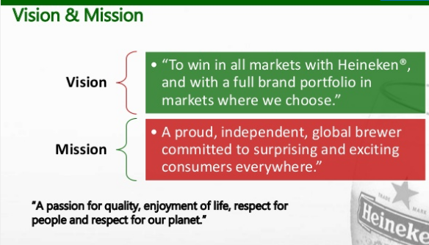
Strategy

The strategy of our company is driven by six seriously thought through the priorities of the business (Araújo, 2015). Ultimately, our employees execute them and our values set the borders. As a company, we are dedicated to the long-term creation of value. The strategy of Heineken is developed around six priorities of business for actions. They are built to allow the firm continue delivering the value of shareholder and growth, win in the international marketplace, and focus on the long-term business sustainability. The company has core competencies which allow the organization to function well in most segments, by influencing positively various major success aspects. The strategy of the business is to grow externally to strengthen the company position in maximizing possible profits in developed and high-growth markets(Karagiannopoulos, Georgopoulos, & Nikolopoulos, 2005). Essentially, the firm would carry out whatever is essential to get the organization represented worldwide.
The Priority to Achieve the Goals
- To pay attention to the markets where the company believes can win and acquire.
- To accelerate execution: the company commits to quicker decision makings and implementations.
- To accelerate cost reduction and efficiency.
- To accelerate sustainable growth of top-line.
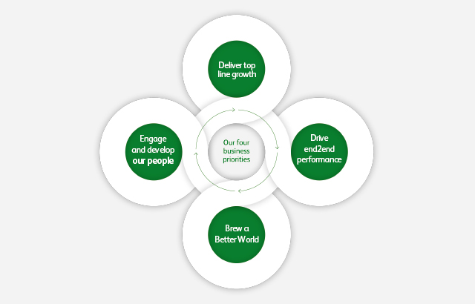
Business Summary
In the global breweries and distributors network, Heineken is one of the largest business entities. Additionally, the company manages and owns one of leading beer brands portfolios in terms of profitability and sales volume in the whole world (Araújo, 2015). In addition, Heineken has been able to remain corporate brands and leading consumer for more than one-hundred and thirty years globally. Heineken became the favorite beer brand in Europe and successfully exported to each part of the universe. Because Heineken functions with so many sub-brands in Cider and beer products categories, definitions of the populations on the basis of similar features is necessary for the provision of suitable goods to the respective group of clients. Heineken segments its brands on the basis of International, Regional, and Local brands as well as non-alcoholic and alcoholic brands that are suitable for certain group/age of clients(Karagiannopoulos, Georgopoulos, & Nikolopoulos, 2005). The company uses selective targeting strategies by operating in a large number of nations internationally such as paying attention to the regional markets with its brand's portfolio. Bringing customers together and sharing their moments of life is what Heineken brands have used in positioning itself in the global markets. The company is involved in brewing and selling of beer. It functions through five segments namely: Europe, Asia Pacific, Americas, Eastern and Middle East Europe, and Africa. The segments of Eastern and Middle East Europe and Africa include brands like Goldberg, Walia, Amstel, Primus, and Heineken. The segment of Americas includes brands like Dos Equis, Sol, Amstel, Tecate, and Heineken. The segment of Asia Pacific includes brands, like Bintang, Tiger, Larue, Anchor, and Heineken. The segment of Europe includes brands, like Strongbow Apple Ciders, Zywiec, Birra Moretti,Cruzcampo, and Heineken. In more than 190 nations, the company owns, sells, and markets more than 250 brands. Heineken is an international brand (Mineiro, 2017). The global brands of the company include Krusovice, Red Stripe, Tecate,Tiger,Affligem,Sol,Desperados, and Amstel.The brands of Heineken generated and sold under soft drinks, cider, third parties as well as another non-beer volume in consolidated organizations.
Target Market
From ten breweries companies controlling the global brewery industry for the past decade, the dynamics of the global market have transformed (Tiyavacharapong, 2004). Currently, the industry is controlled by 5 key participants that control fifty percent of the beer market in the whole world. The company targets to change the perception of the customers for the alcoholic drinks, acquisitions series by the Heineken and changing cosmopolitan and lifestyle. In the Retail segment, the company targets the clients in the age group of fewer than 35 years. Heineken also intends to expand its activities in the Asian Markets where its brands are more popular. The brands serve segments of clients such as B2B and retail. The company also intends to provide more drinks to Super Market Chains, Bars, Hotels Chains, and Restaurants in the Segment of B2B (Yunn & Yisheng, 2014). These segments shall be served by national distributors or Sales team of the Heineken.
Industry Analysis:
Porter’s five forces model
The bargaining power of suppliers
Farmers are the major raw materials suppliers to Heineken. The power of supplier threat is therefore high. The bottle Heineken supplier is offered by HeyeGlas Nederland that is supplied the worldwide distribution green bottle of Heineken beers. Beer is generated by yeasts, hops, barley, and water and these ingredients are supplied by the farmers(Karagiannopoulos, Georgopoulos, & Nikolopoulos, 2005). Heineken also recognized that the competitions for products of agriculture from the industry of biofuels which is influencing its costs.
The bargaining power of buyers
The buyers in the alcoholic and non-alcoholic beverages have a wide variety of drinks and beverages to choose from as there are various companies serving different types of beer. This shall raise the customer choice and therefore threat power of buyers' threat is high(Mineiro, 2017). For instance, the buyers have various brands to select from that match their taste and preferences like Tiger, Guinness, and Carlsberg. Therefore, the wide choice of selection for customers shall bring threats for Heineken.
The threat of potential new entrants
During the past decade, smaller brewers’ explosions have entered the breweries industry and market which make the sector much more competitive. The barriers in the beer industry are low. Today, Heineken is the number two brewer globally, and number one brewer in the whole of Europe(Tiyavacharapong, 2004). In the last few decades, the company has greatly increased its exposure to the emerging markets that shall be a catalyst for its growth. Therefore, the potential new entrants' threat to Heineken is relatively high. This shall force Heineken to consider creating uniqueness and innovation into products which may sustain competitive edges in the beer industry.
The threat of substitutes
Beers are types of beverages that have alcohol content. Nevertheless, the consumers can change take wines that also contain alcohol content (Yunn & Yisheng, 2014). Taste and preference of customers are not the same so that they have the right of selecting what they wish to enjoy. Therefore, this shall affect the market of beer together with the Heineken brands. Therefore, the substitute’s threats for beer industry are high.
The extent of competitive rivalry
Today, Heineken is the number two brewer globally, and number one brewer in the whole of Europe. In the last few decades, the company has greatly increased its exposure to the emerging markets that shall be a catalyst for its growth. It has accomplished the scale economy in the market not only in Europe but worldwide and holds about 30% of market share in the beer industry in Europe (Araújo, 2015). Because the beer industry is expanding, therefore, the competitions shall attempt to attain their targets of growth. Well established brewers such as Heineken tend to design their own strategy to beer market and because of scale economies, they shall generate unique and higher quality products that make their own position in the industry, therefore keep expanding to accomplish its targets.
Business Model:
Current Heineken
Who  - Sociable  - Young  - Trendy | What  - Experience (social and premium)  - Premium beer
How  - Event, festivals  - Retailers  - Food services | Why  - Efficient operations and logistics  - Good quality  - Brand
Beer Machine: Make Beer like Homemade Coffee
Strength/Assets  - Efficient operations and logistics  - Main clients are sociable, young, and trendy individuals.  - Brand premium image  - Advanced technology and good quality | New Model of Business  - Encourage people through the social media to invite friends to come and have a taste of homemade beers.  - Create recipes for beer-drinks and encourage others to share their own recipes via the social media platforms  - Provide different flavors to increase diversity.  - Utilize efficient operations and logistics in delivering high-quality tag of beer.  - Sell smart beer machines.

Innovation for Heineken: homemade beer
Who  - Sociable  - Young  - Trendy  - People who like home parties. | What  - Experience (social and premium)  - Premium beer  - Experience (trends and social status)
How  - Event, festivals  - Retailers  - Food services  - Subscribe/delivery beer tag  - Home-made by beer machines | Why  - Efficient operations and logistics  - Good quality  - Brand  - Increase sales channel  - Meet social needs

Heineken SWOT Analysis
Strengths
- Track record as a brewer with global success.
- Portfolio of brands: The brewer own over two hundred brands of beer worldwide in additions to its flagship Heineken Lager
- Strong Breweries networks
- Brand Marketing
- Product differentiation
- International development
- Excellent brand image.
Weakness
- Inadequate female costumers.
- Premium prices
- Average higher prices as compared to the competitors.
- Lack of young consumers.
- Difficulties to penetrate certain nations.
Opportunities
- Acquisition in the emerging markets such as Latin America, India, and Asia.
- Availability of the markets where Heineken where its greatest opportunities lay and where it has the greatest growth potentials.
Threats
- Stiff competitions from the largest brewers in the world such as Anheuser-Bush InBev
- Easy entrants to the breweries industry by smaller companies that may flood the market.
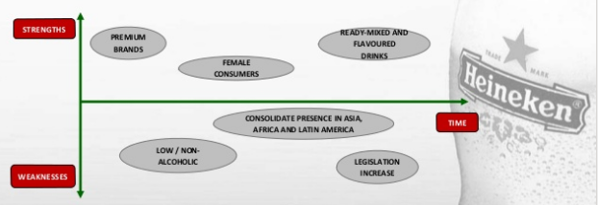
Competitive Position/Advantage:

1. Visibility in the market:
- Heineken has linked itself with various renowned events through sponsoring and partnership across various industry entities like James Bond Spectre, Rugby world cup, UEFA Champions League, and Formula 1.
- These relationships help in spreading the brand messages and keep it ahead of its peers.
2. Wide Product Portfolio:
- With broad brands portfolio in every category of products such as the regional and international brands, craft and variety cider brands, is what has helped the brands to retain their customers and increase the heart share that leads to wallet share and mindshare.
3. Market penetration
- The company is able to increase its market share in the currents such as Europe and North America.
4. Market Extension
- Expansions into the emerging in Africa, South America, and Asia
5. Diversification
- Introduction of innovative drinks to new markets in Asia, Africa, South America
6. Cost Leadership
- High bargaining power with economies of scale and suppliers.
- Scale and size via major acquisitions in Southern Africa, Mexico, and other regions.
7. Differentiation
- Top five internationally.
- An industry leader in the efforts of sustainability.
- Strong brands built for the products throughout the world.
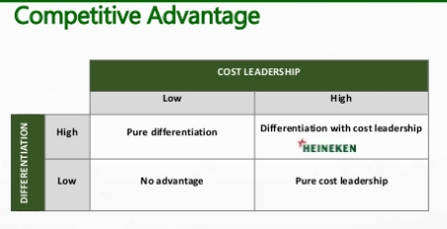
Competitors
Basically, it is eaten or be eaten. Each organization in the industry is just attempting to strengthen their international positions using any technique workable or practicable(Araújo, 2015). The biggest rivals of Heineken are Grupo Modelo and InBev. After InBev, Heineken is the largest company in the breweries industry worldwide. It has accomplished the scale economy in the market not only in Europe but worldwide and holds about 30% of market share in the beer industry in Europe. Because the beer industry is expanding, therefore, the competitions shall attempt to attain their targets of growth (Karagiannopoulos, Georgopoulos, & Nikolopoulos, 2005). Well established brewers such as Heineken tend to design their own strategy to beer market and because of scale economies, they shall generate unique and higher quality products that make their own position in the industry, therefore keep expanding to accomplish its targets.
Conclusions/Recommendations:
Heineken has the strategies to generate and sell beers in the manners which have positive impacts on the society at large in order to face the alcohol pressures in the global market (Mineiro, 2017). Heineken fosters awareness of strengths and weaknesses of alcohol with such strategies. This also encourages the consumers to remain accountable for their own actions. Heineken has strategies to hedge transactional exchange risks that postpone the impacts on the financial results of the company to solve the challenge with the risks of currency as the international markets are not stable in the money exchange. The company can sponsor a lot of activities of entertainment in the world in the intensification of the global marketing. This approach would bring the strongest Heineken brand name strengths. For example, Heineken is a major tennis championship sponsor like the Shanghai Open, Wimbledon, and Australia Open. Furthermore, the music strategy adopted by the company also remains a major area of sponsorship for the organization (Tiyavacharapong, 2004). The company can also adopt digital marketing and social media advertising together with a strict strategy for IT security in ensuring availability, confidentiality, and integrity of data and information.
Charts, graphs, tables and financial analysis
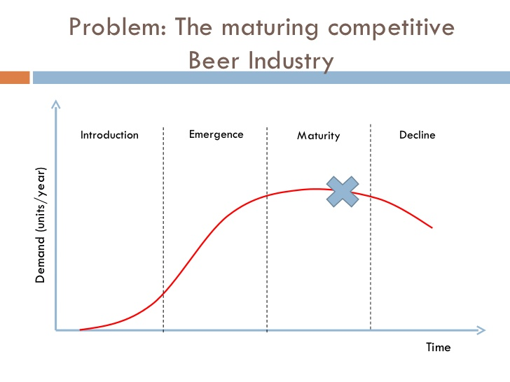
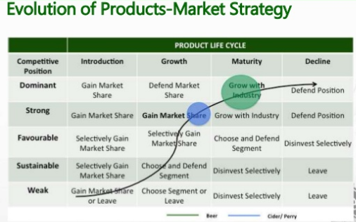
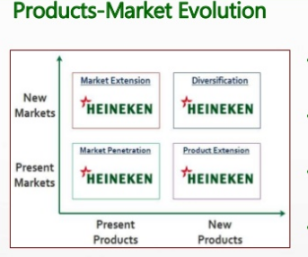
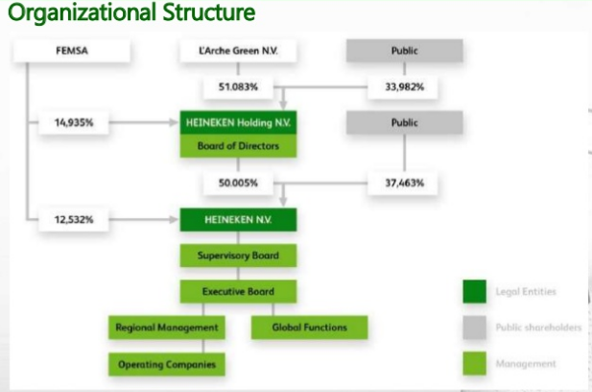

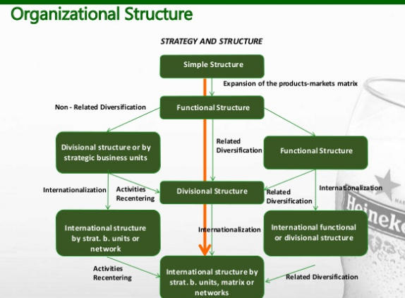

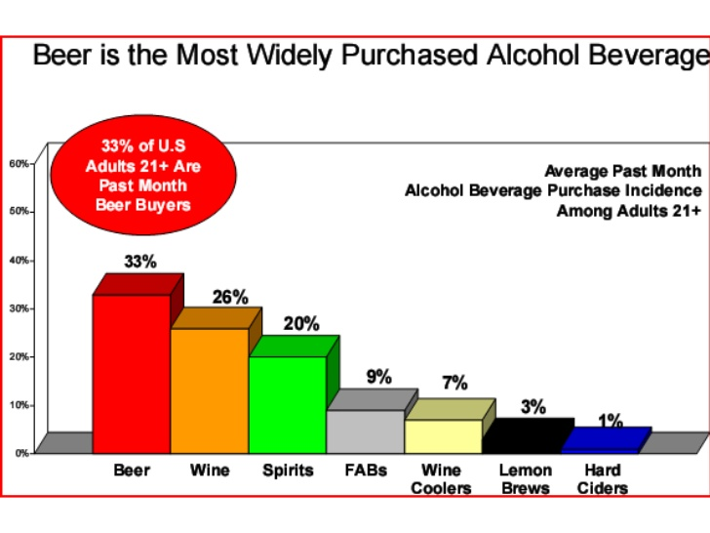
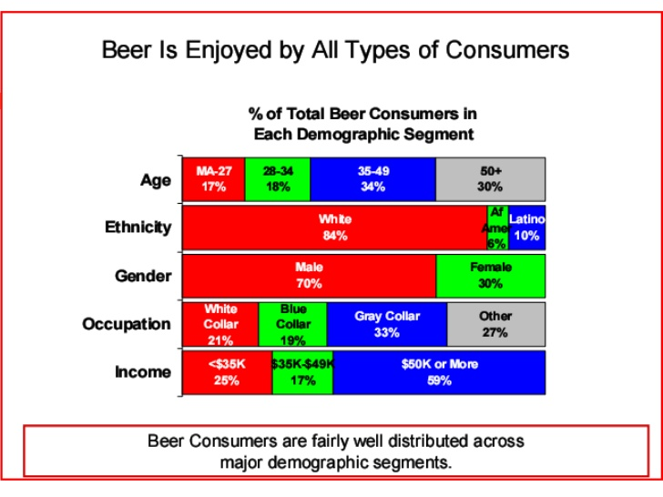
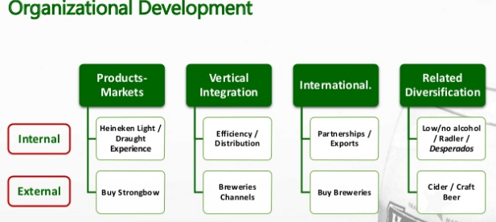
Financial Statements
Heineken Income Statements (in millions of euros)
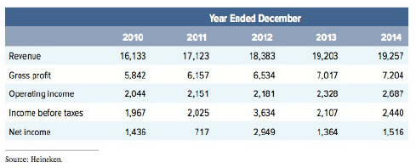
Heineken Balance sheet (in millions of euros)
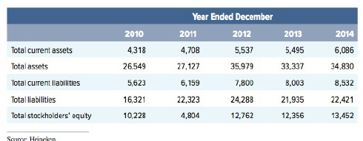
The 5-Forces
Threats of Substitutes  - Growing appreciations for wines  - Very little technical beer composition | Threats of New entry  - Since World War II, now new entrant in beer industry has cracked the top three sellers.  - Since not many alternatives use breweries, entry is risky  - $ 250 million required to construct four brewery barrel
Bargaining Power  - Demand “Budweiser” is elastic, E= -5.0  - Demand for beer is inelastic, E= -0.7  - No loyalty to a specific brand | Bargaining Power of Suppliers  - Larger plants and fewer brewers  - Many buying input suppliers  - Rising cost of major commodities such as aluminum, grain, and glass  - Horizontal mergers and acquisitions
The rivalry between established competitors
- Stiff competitions with the major rivals Grupo Modelo and InBev

SWOT analysis
Strengths  - Track record as a brewer with global success.  - Portfolio of brands: The brewer own over two hundred brands of beer worldwide in additions to its flagship Heineken Lager  - Strong Breweries networks  - Brand Marketing  - Product differentiation  - International development  - Excellent brand image. | Weakness  - Inadequate female costumers.  - Premium prices  - Average higher prices as compared to the competitors.  - Lack of young consumers.  - Difficulties to penetrate certain nations.
Opportunities  - Acquisition in the emerging markets such as Latin America, India, and Asia.  - Availability of the markets where Heineken where its greatest opportunities lay and where it has the greatest growth potentials. | Threats  - Stiff competitions from the largest brewers in the world such as Anheuser-Bush InBev  - Easy entrants to the breweries industry by smaller companies that may flood the market.

The combination of global strategies
Heineken functions through four notable segments of business like Global brands, Craft & variety, International brands, and Cider brands. The business segments of international brands are major drivers that include brands like Red Stripe, Tecate, Tiger, Sol, Krušovice, Birra Moretti, and Desperados. The International brands business segment is Stars in the matrix of BGC being the sole driver internationally. The Heineken group is the largest Cider producer in the whole world (Karagiannopoulos, Georgopoulos, & Nikolopoulos, 2005). With broad brands portfolio in every category of products such as the regional and international brands, craft and variety cider brands, is what has helped the brands to retain their customers and increase the heart share that leads to wallet share and mindshare.

References
Araújo, H. I. F. P. D. (2015). Equity valuation: Heineken NV(Doctoral dissertation).
Karagiannopoulos, G. D., Georgopoulos, N., & Nikolopoulos, K. (2005). Fathoming Porter's five forces model in the internet era. info, 7(6), 66-76.
Mineiro, M. (2017). HEINEKEN NV (Doctoral dissertation).
Tiyavacharapong, T. (2004). Marketing strategies for Boon Rawd Brewery's Singha Beer.
Yunna, W., & Yisheng, Y. (2014). The competition situation analysis of shale gas industry in China: Applying Porter’s five forces and scenario model. Renewable and Sustainable Energy Reviews, 40, 798-805.

